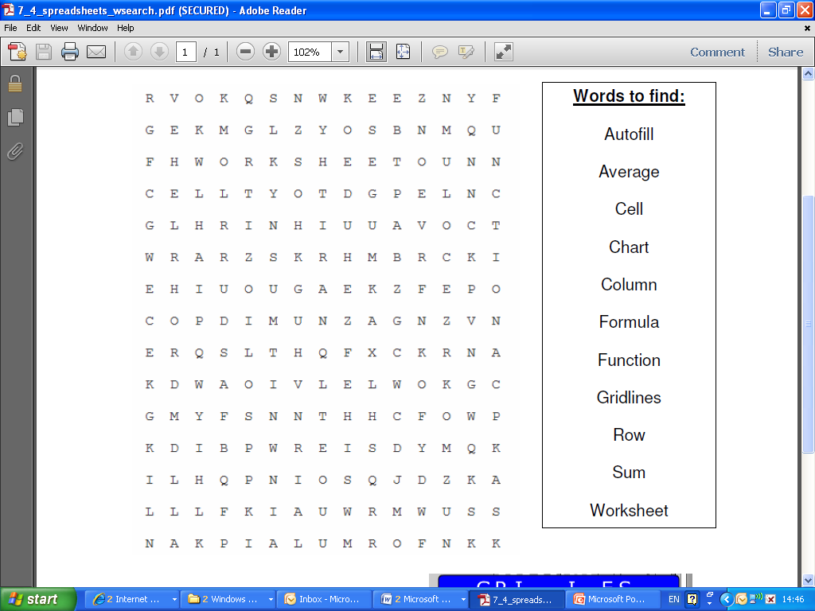

Student Name _____________________________________

Tutor Group _______________________________________ Mark: /15