Name___________________

What do you know already?

What is a computer variable? ____________________________________

In programming what is an operator? (Example)___________________________

What Python what does (a =7) mean? ______________________________

Why do programmers write comments? __________________________________

How many answered at start of lesson

How many answered later in the lesson How many correct?

**Exercise 2 – Allowing for input**

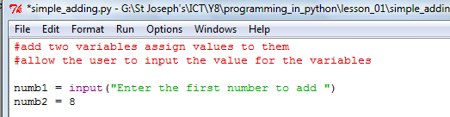Our program is static as it only adds up the same numbers each time. It would be good if we were able to change the input. Variable numb1 below now asks the user to input the value. Can you change your program so the user inputs both values?

What code did you have to write for numb2________________________________?

Can you think of a function we have already used____________________________?

**Exercise 3** – order of operation (**b**rackets, **i**ndices, **d**ivision, **m**ultiplication, **a**ddition, **s**ubtraction)

Can you now change your program so it works out the following: 3 x (7 - 3) = 12

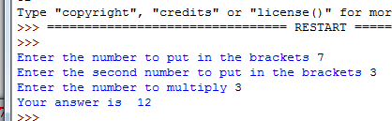Your program must work out the brackets first

**Tip**

**You will need another variable and some brackets**