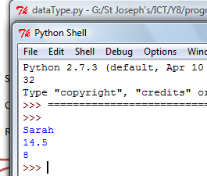**Exercise 1 – write name, age and year**

Select the right data type for

* Age
* Year
* Name

Save the program in your programming folder

Call it dataType.py

Remember to put the .py on the end!!

**Exercise 2 – concatenating a string to a number variable**

We can join strings and variables together to make a sentence. See if you can join the variables together to make one sentence

Example “Hello and welcome “ , name, “how are you? “



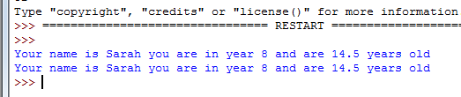

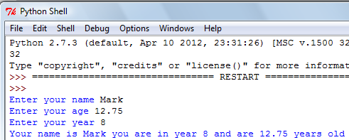**Exercise 3 – Adding input to our program**

Now we are going to add code to our program so that we can add data. This way our variables are not static

For a string data type use raw_input() E.g. month = raw_input(“Enter the month “)

Whole numbers can be entered using just input() E.g. = score = input(“Enter the score”)

Floating numbers need both E.g. Example = percentage = float(input(“Enter decimal “)