**Name___________________**

**Exercise 1 – write a program to calculate the area of a rectangle (Save it as rectangle.py)**

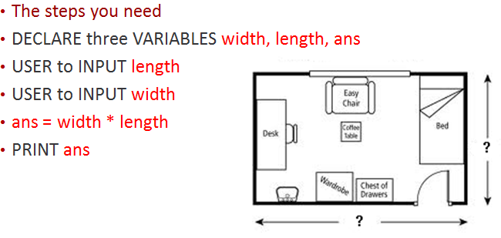

|  |
| --- |
| **Write your code here** |
|  |
|  |
|  |
|  |
|  |

**Exercise 2 – write a program to calculate the area of a triangle – (Save as triangle.py)**

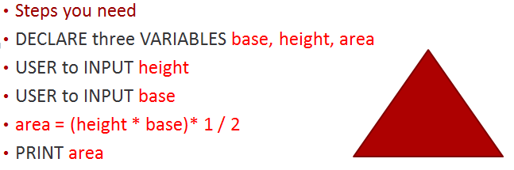The formula to work out the area = (base * height) * ½

|  |
| --- |
| **Write your code here** |
|  |
|  |
|  |
|  |
|  |
|  |

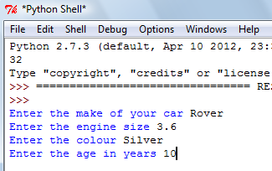**Exercise 3 - write a program that asks for the following: (Save as car.py)**

|  |
| --- |
| **Write your code here** |
|  |
|  |
|  |
|  |
|  |
|  |
|  |
|  |

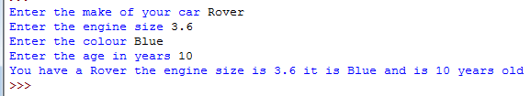Display the message in one sentence