**Name___________________**

**Exercise 1 – write a program that takes the name and age for two people.**

**It compares the ages and then says which one is older. (Save it as name_age.py)**

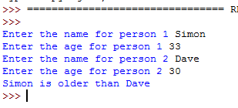**The algorithm would be**

***INPUT user1, user2***

***INPUT user age1, userage2***

***IF userage1 > userage2***

***PRINT “User1 is older than User2”***

|  |
| --- |
| **Write your code here** |
|  |
|  |
|  |
|  |
|  |
|  |
|  |

***IF userage1 < userage2***

***PRINT “User2 is older than User1”***

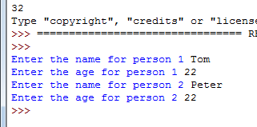**Exercise 2 the program above will not work if they are both the same age. Try it!**

**Add code that will test to see if the ages are the same. If so it will print out a message saying that they are the same age**

**Algorithm**

**IF userage1 == userage2**

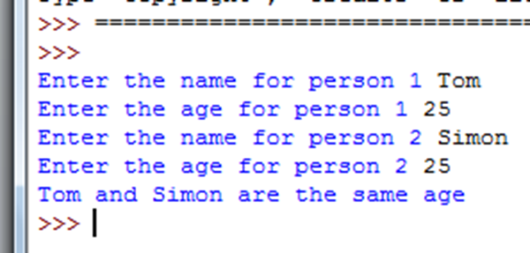**PRINT “user1 and user2 are the same age”**