**Name___________________**

**Exercise 1 – write a simple loop program that loops ten times (simple_loop.py)**

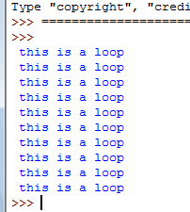 **Algorithm**

**upper = 10**

**FOR i in range (upper)**

**PRINT (Message)**

|  |
| --- |
| ***Write your code here*** |
|  |
|  |
|  |
|  |
|  |
|  |
|  |

**Exercise 2 – Ask the user how many times to repeat the loop (Save as userinput_loop.py)**

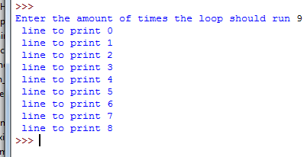**Algorithm**

**INPUT upper value**

|  |
| --- |
| ***Write your code here*** |
|  |
|  |
|  |
|  |
|  |
|  |
|  |

**For i in range (uppervalue)**

**PRINT (“message”, i)**

**Exercise 3 – Write a program that prints out the times table (Save as loop_from_one.py)**

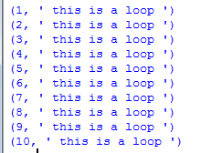**The loop above starts at 0 which means it is always one less than what you want. Change the loop so it reads like below. Adding 1 to i will start the loop at 1 NOT 0**

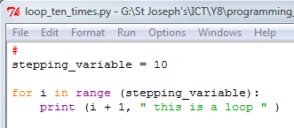

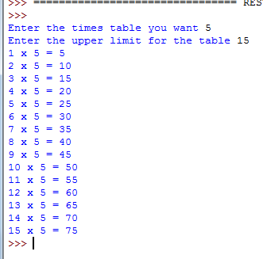**Exercise 4 – Creating a times table program (Save as times_table.py)**

**The algorithm**

**INPUT timestable**

**INPUT upperlimit**

**FOR i in Range (upperlimit)**

**PRINT (( i + 1) x timestable = (i +1)*timestable)**

**NOTE**

**PRINT (str(i + 1) + “ x ” + str(timestable) + “ =” str(i+ 1) * timestable)**