Pokémon: The Defenders

# Information Layer

Name:

Pokemon: The Defenders

Concept:

A tower defense game where the player places and manages 6 mobile towers to protect the entrance of a town/city from an army of creeps.

### Intended Audience:

Casual mobile gamers and fans of the Pokémon franchise. This targets players of all ages, from 6 and up. The cartoony nature of the source material will allow for younger player to enjoy it. The tower defence aspect will allow players of plats vs zombies and other TD mobile games to play as well. The inclusion of Pokémon will also appeal to fans of the role-playing series.

### The Player’s Role:

The player is a trainer with a 6 Pokémon party which function as towers. The player will deploy and return their Pokémon around a map to defeat an increasing stream of creeps who are trying to get into a city/town. There is a limited supply of creeps and the player must keep as many creeps out of the city as is possible. The game ends when all the creeps have been defeated by the player’s towers/ Pokémon (victory) or if enough creeps get into the city to destroy it (loss – which is dependent on the city/town and the progress of this will be displayed on screen for the player to see).

## Executive Summary

A two-dimensional tower defence game in which players will defend the entrance to a specific town from an invasion of enemy Pokémon. Players compete against the AI to defeat the creeps and stop them from destroying each city. This takes places on a variety of maps where the damage done by the creeps is tracked on the screen for the player to see. There are 6 pokemon which the player can select from before the defense and deploy during it. These pokemon can be recalled and redeployed at any stage to allow players to relocate them as needed. The pokemon will gain experience during this and will be able to level up and evolve (every 3 levels) once enough experience is gained. Pokemon automatically fire projectiles at enemies when deployed on the map and they will lose stamina, the longer they are deployed for. They must be recalled once their stamina reaches 0 and then be rested for a period of time before being redeployed. Creeps will move along preset paths defined in the levels.

# Gameplay Layer

## Genre

Tower defense. Specifically 2-D tower defense

## Core Mechanic

Placing Pokemon (towers) on the map in order to stop an army of invading Pokemon (creeps) from getting into a town. The towers will have offensive and defensive capabilities which the player will be able to make use of in order to keep the creeps out of each town. Each level will have a set number of creeps who will attack in ever-increasing waves until all the creeps have been defeated.

## Feature List

## Interaction modes

### Stage Select

### Challenge mode

### Shop

### Level Design

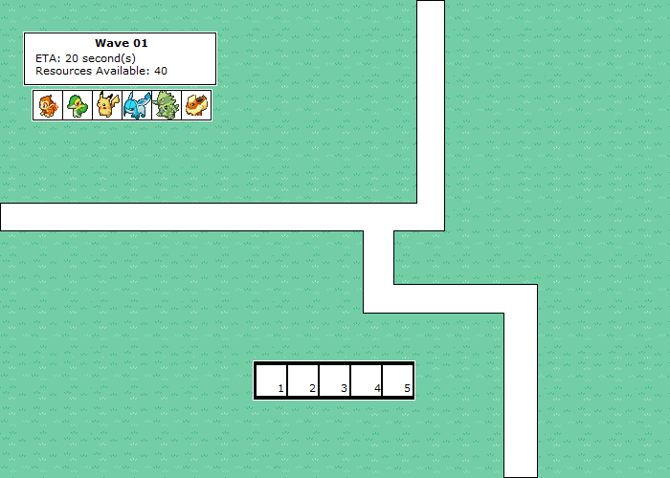

* An example of the Heads-Up Display with the potential path for the creeps in white. The Pokémon/ Towers available for use are marked in the upper-left hand corner as well as the wave number and the amount of time remaining before the next waves begins their assault.
* The lower middle of the screen contains an ability bar which can be used to switch between each Pokémon’s abilities. These will be attacks that Pokémon will continuously use until they are cancelled, returned or another ability in selected. These attacks will drain stamina at different rates depending on the strength of the attack being used.

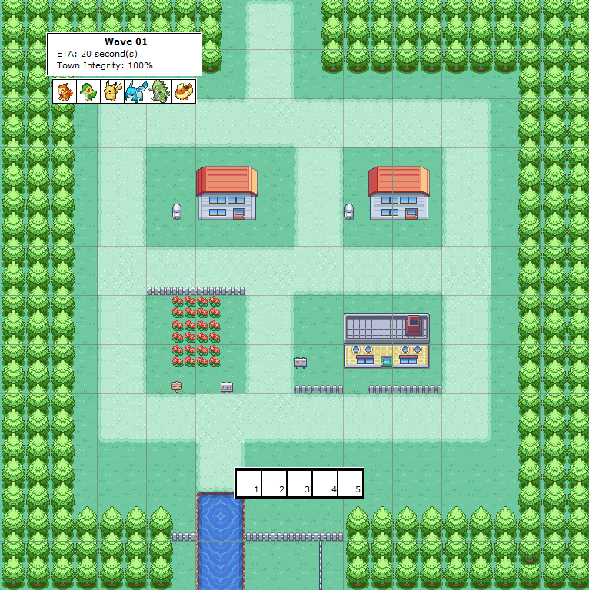

An example of a typical level. Creeps will enter from the top of the level and spread out into the town and begin destroy it.

### Artificial Intelligence (AI)

Artificial intelligence will be limited to creep path finding and following. Each map will contain a small list of paths which can be traversed and creeps will follow those paths. Early levels will only contain 1 path and later levels will contain branching paths, ending with levels that have multiple parallel and branching paths.

Game Logic/ Rules

# Presentation Layer

Main Menu

## In-game menu

Pause Menu

Heads-Up-Display (HUD)

## Sound Design

### List of sound effects which will be incorporated into the menu system and into the game.

Main Menu item selection

Tower stamina depletion sound

Soundtrack

Tower placement sound

Tower ready sound

## Artistic Style