変動するグローバル電子デバイス市場における在庫最適化に向けた時間的

センチメント・トピック分析技術

Demand forecast contextual explainability through topic and temporal Sentiment analysis

コルコスサヒム* ポールデブディープ** ガヤトリサラナタン** 三浦 康史*** 多鹿 陽介***

Sahim Kourkouss Paul Debdeep Saranathan Gayathri Koji Miura Yosuke Tajika

**要　旨**

近年のパンデミックや半導体不足により、グローバル電子デバイス市場は激しく変動している。これにより、顧客の発注見込みが大きくぶれ、過剰在庫や販売機会損失を引き起こしている。これに対し、我々はマーケットの最前線で営業活動を行っているグローバル9地域100名以上の営業の景況感とその理由を示す自然言語によるコメントを収集・活用することにより、当社グローバル電子デバイスの需要を予測結果を説明するAI技術を開発した。数値データ以外のデータであるオルタナティブデータを予測に活用する技術開発は金融情報学（Fintech）分野において活発に行われている。当社営業の自然言語によるコメントは当社ドメイン知識を含む将来の景況が記載されるとともに、これらの因果関係やニュアンスなど数値データにはない情報が含まれている。筆者らはこれらのデータから予測に有用な情報として時系列センチメント、および、トピック情報を抽出・分類する学習モデル開発し、予測モデルへの適用を行った。これにより、当社商品に適合した予測の妥当性説明を実現する。

**Abstract**

While the digitalization increase in manufacturing provides a growing amount of data that can describe assets and operations, supply chains as well as customer purchase patterns are becoming increasingly complex, and therefore harder to understand or predict. Recent Artificial intelligence models can resolve such complexity by using their ability to sort and analyze massive amounts of data and providing accurate forecasts. However, one of the biggest challenges for business executives today is to quantitatively grasp the demand volatility to make informed decisions. High accuracy alone is not enough to realize such responsible decision making, but it is also required to have an in-depth knowledge of the model’s behavior to improve confidence as well as create more realistic expectations. In previous works we have already developed models for accurate forecasts regarding stable and irregular demand periods. In this paper we propose a novel method that combines topic modeling and explainable machine learning through temporal sentiment analytics to provide a better understanding of our AI forecasting models. Our aim is to help users make informed decisions and avoid errors that could result in significant losses. Such explanations reinforce our AI models, increase confidence in the system, and help identify errors and performance problems. As an evaluation method, we compare our proposed method with conventional cases where the forecast is generated through relevant macroeconomic indices. We have presented our findings to internal sales department and have received highly rated feedback for this concept.

1 Introduction

Web news, search engines, and posts on social media, new data is constantly being produced in society today, and this has led to data science becoming a booming field in which all these data are analyzed to extract information and to generate new values. Digital transformation is driven by three major innovations -IoT (Internet of Things), AI (Artificial Intelligence) and Big Data analysis- which enables complete digitalization of business processes, unparalleled operational efficiency, and a disruptive business model approach.

* パナシンポインダストリー　技術本部　グローバル戦略部

Global Strategy Department, Engineering Division, Panasonic Industry

** パナソニックデバイスシンガポール　シンガポール技術開発センター

Singapore Technology Center, Panasonic Industrial Devices Singapore

*** パナシンポインダストリー　技術本部　プロセスデバイス革新センター

Process Device Innovation Center, Engineering Division, Panasonic Industry

問合せ先：miura.koji@jp.panasonic.com

In the manufacturing industry, it is a fact that amid drastic changes in the market structure, rapid and accurate grasp of demand trends, realizing flexible production planning to cope with fluctuations and optimal supply to customers is a vital requirement. For this purpose, there is an urgent need to collect big data such as sales and manufacturing data, and to effectively apply data-driven approaches based on Artificial intelligence technology to said sales and manufacturing activities.

In our previous works, we have developed intelligent models capable of providing accurate forecasts regarding stable and irregular demand periods and have proven that AI-based quantitive approaches can resolve complex forecast problems by using their ability to sort and analyze massive amounts of data.

In this paper we go a step further and propose a novel method that provides better understanding and explicability of such AI forecasts, by combining data mining techniques such as topic modeling and explainable machine learning through temporal sentiment analytics.

**Fig. 1: Product Supply Chain and Models**

2 Background

2.1 The long tail sales strategy

With the recent dramatic market structure changes in global electronics sales, the use of distributors for long-tail customers has become a key to profitable growth. Our company’s electronic components sales to long-tail customers have been increasing on a yearly basis and now has become more important than ever.

[Fig.1] shows the product supply chain for sales through a distributor. The supply chain consists of two mutually influencing parts: the distributor's side and the manufacturer’s side. While the distributor's part represents mainly the relationship between the distributor for long-tail customers and the long-tail customer itself, the manufacturer’s side embodies the relationship between the distributor and the manufacturer (our company). The complexity of such supply chains as well as the huge number of purchase patterns and the infrequency for long tail sales makes it very challenging to produce accurate forecasts based only on conventional qualitative forecasting methods such as subjective opinions and insights.

2.2 Importance of explainability in demand forecast

In our previous works, we have developed a technology for predicting accurate sales volumes on a part-numbered level for long-tail customers, and we have applied it to the sales planning process in various sales departments within our company, thereby reducing planning man-hours by over 80% [1].

However, one of the biggest challenges for sales planners and business executives today is to make informed decisions by quantitatively grasping the demand volatility. Professional planners will want their forecast to be as accurate as possible and while it seems to be reasonable to trust a model that has proven to be more accurate, on average, than traditional methods, high accuracy alone is not enough to realize such responsible decision making. The critical function of demand forecasting involves dealing with the many uncertainties and demand planners who are forecasting experts themselves justifiably expect to understand why the forecasting model output would be any better than their experienced intuitive instincts. Planners and managers also want to know how the machine making the forecast came to its conclusion and what are the factors that have been considered. Such insights would allow the planner to further refine and control the forecast. This is especially important when the planner feels that the machine is not systematically capturing important factors. So, in order to realize this, these are the concerns that we need to address:

1. Comprehensibility: Help users understand the mechanics of the model and know what is taken into account.
2. Trust: Ensure that users can trust the output of given model
3. Control: Giving users to ability to select among multiple choices based on simple explainability without requiring any familiarity with the underlying mathematics. This will also allow us to grow and salvage better knowledge from the users.

3 Explaining our forecast

In this paper we aim to develop and evaluate a novel method for explaining the output of a demand forecasting system through textual data. Despite its huge demand, and immense commercial potential, surprisingly this area of research has received relatively less attention but is growing at an amazing pace. Concisely, in this paper, we propose a novel technique to explain the mid-term forecasted demand (with a prediction horizon of ~1 year). We leverage two orthogonal aspects, namely, i) temporal sentiment and, ii) topic models, to provide a better understanding of AI forecasting models. Furthermore, the insights from representation and embeddings obtained from these models, logic can be associated with domain knowledge to provide a better-contextualized explanation to the user.

3.1 GMI Data

In our case study we have leveraged a dataset called global market intelligence (GMI) data that contains the comments from internal sales/operations managers from all over the world, across a wide range of product families, industry sectors and business divisions. This database is updated on a monthly basis by sales and operations managers across: i) geographical regions, ii) business division wise products, cross sales, iii) market including server/data center, ICT, factory automation, car electronics and distribution. For each entry there is a comment and a corresponding score assigned by the manager that captures the sentiment on a scale of 1 to 5, for both market in general as well as for Panasonic specifically.

3.2 Sentiment Analysis

Sentiment analysis is the process of using natural language processing, text analysis, and statistics to analyze market and customer sentiment. One of the most known use cases of sentiment analysis is in business intelligence where it enables the user to understand the subjective reasons why customers as well as the market itself is behaving in a certain way. Leveraging such information from our GMI data can give us valuable insights and is would be very useful when providing explainability to our forecast.

3.2.1 Topic-wise Sentiment modelling

**Few lines about the sentiment model and link to fig2**

**..Firstly, we implement the traditional models for sentiment classification including logistic regression, random forest, gradient boost, neural network with popular sklearn pipeline. Deep learning-based methods have proven to be very effective in various NLP tasks including text classification, summarization, machine translation, information retrieval etc. Among all deep learning based methods RNN based methods model the sequential dynamics of input data and thereby quite effective for our application that involves temporal sentiment. Because of this, we chose to leverage LSTM model for the sentiment classification which is a special case of generic text classification. In line with this intuition, we observe that the overall accuracy is highest with an LSTM model along with a custom dictionary generated from the inputs, that are the comments from GMI database. This is to ensure that the dictionary has words only from our internal sales database to reflect the contextual embedding of the words typically used by sales manager and their domain characterization. Nevertheless, with no additional effort any pretrained model can be included in this dictionary. The workflow of the system is described in Fig. 2. After training the LSTM model with custom dictionary as described we use the same model to predict the sentiment of the unseen comment. The prediction accuracy is reported in Table 1.**

**..**

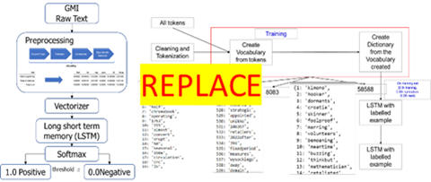**..**

**Few lines about the sentiment model and link to fig2**

In order to give more consistency to our sentiment analysis, we develop a novel method that integrated the concept of topic model with the pure sentiment information extracted from the comments in the GMI database described above. This is essentially done to track temporal dynamics of the topic wise sentiment. We use conventional topic modelling algorithms (ex: BERTopic[3]) and calculate a topic probability for each comment. As the demand forecasting is occurring on a monthly basis, we aggregate said topic probability and calculate a monthly score.

Let *N* be the number of documents (comments) in the GMI database and let *K* be the number of topics decided by the user. They are indexed by *i* and *k*, respectively. We define *r*(*i*) as the sentiment score computed by an the sentiment classification model mentioned above. Let *α*(*i, k*) be the probability of topic *k* in document *i*, where and for all *i*, *k*. We define a topic mood score per topic that reflects the macro level sentiment corresponding to a topic based on the whole corpus Each document *i* is classified to k for which *α*(*i, k*) is maximum. Within that topic the topic mood score is defined as:

$β\left(k\right)=\frac{µ(+, k)}{µ\left(+, k\right)+ µ\left(0, k\right)+ µ(-, k)}$ Eq.(1)

where $µ\left(+, k\right), µ\left(0, k\right) and µ(-, k)$ are number of positive, neutral and negative comments for topic k with maximum $α\left(i, k\right)$ among all k in {1, K}. Finally, the Topic wise sentiment score for each i in GMI, denoted as S(i) is computed as:

$S\left(i\right)=r(i)\sum_{k=1}^{K}{ α\left(i, k\right) β\left(k\right)}$ Eq.(2)

This is one of the novel contributions of this paper. Now, in order to aggregate this on a monthly basis we took the median S(i) for all the comments from month *t*. This reflects the temporal dynamics of the linear combination of topic wise sentiment and per document topic content and eventually aggregated over months

3.2.2 Evaluation

For our experimental evaluation we use the GMI dataset that contains a total of 785 comments out of which 392 are positively rated and 393 are negative. Among the total available comments, 80% are used for training and the remaining 20% are used for evaluation. Our model calculates the topic-wise sentiment score of a given sales person comment and classifies it as a positive sentiment or negative sentiment.

Results are summarized in Table1.

Table 1: Sentiment Analysis Results on GMI data

|  |  |  |  |  |
| --- | --- | --- | --- | --- |
|  | Precision | Recall | F1Score | Support |
| neg | 0.76 | 0.59 | 0.66 | 80 |
| pos | 0.66 | 0.81 | 0.72 | 78 |
| accuracy |  |  | **0.70** | 158 |
| w.avg | 0.71 | 0.70 | 0.69 | 158 |

**Fig. 2: Sentiment analysis model with custom dictionary**

3.3 Explaining the forecast

We implement the sentiment analysis model mentioned in (3.2) in our forecasts system and use this new information to strengthen its explainability. In this article we use forecast for Panasonic products in the automotive market as a test case and explain our method. Here, we leverage the feature importance calculation method based on SHapley Additive exPlanations (SHAP) [4] which is a fairly well-developed method for feature importance analysis.

3.3.1 Case Study: Automotive market

The case study is performed with respect to PCB relay which is a product used in the automotive market. This product is selected as it has been recently predicted that the automotive market is going through a dramatic transformation. As per the current practices we are using automotive market indexes such as world-wide production data for forecasting the sales. These features are macroscopic in nature in the sense that typically they reflect the dynamics of an entire industry sector and thereby are unlikely to change drastically over a small to moderate period. Whereas the market intelligence data internally available to the company is more relevant to specific products, business divisions and geographical locations. The main objective of the direction of research presented in this paper is to leverage that kind of internal dataset (mostly textual) to explain the forecast to facilitate large scale adoption among different functions in the company

We collected the GMI data from August 2021 to May 2022 and used a 3 months time shift to make the forecast of the sales of product mentioned above. We compute and evaluate the forecast generated for the month of July 2022. We produced the forecast under two different feature sets, i) conventional automotive market indexes, ii) features generated from GMI database. For the features generated from GMI database use the number of comments with Panasonic-specific sentiment score on a scale of 1 to 5 as labelled by the sales manager. Lastly, we created 16 features through topic models (4 topics) following the method developed in (3.2) and computed the forecast with all these above-mentioned features.

3.3.3 Evaluation

The primary objective of this paper is to develop a framework that provides explainability of the AI forecast. In order to evaluate the effectiveness of the framework developed we compare it with the conventional case where the forecast is generated through relevant macroeconomic indices.

**Fig. 5: Forecast Result.**

**A decrease in sales is predicted for July2022**

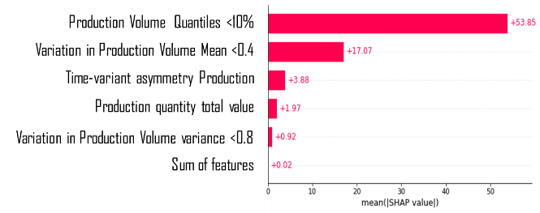

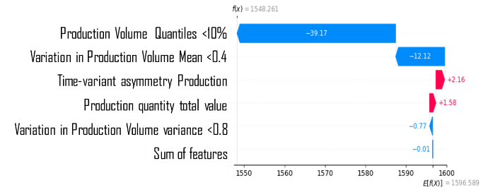

**Fig. 3: Feature importance analysis of the forecast produced by traditional features**

**(Upper: Global features; Lower: Local features)**

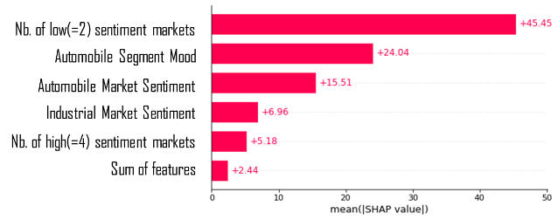

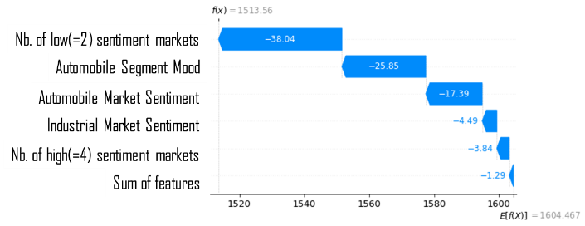

**Fig. 4: Feature importance analysis of the forecast produced by textual features.**

**(Upper: Global features; Lower: Local features)**

The traditional features used to forecast the sales of PCB relay are mainly the features generated from the automotive global market indexes such as production figures at different regions. We use the tool called TSFresh[5] to generate the statistical characteristic from these timeseries on automotive market index production volume at different regions. We replace this set of features by features obtained from GMI by applying NLP tools described in Section (3.2). It is found that the difference in forecast generated by two different sets of features is only 3.17%. The forecast generated by traditional features and textual features are reasonably close to each other meaning former can be explained by the later with no compromise in error.

However, the feature importance analysis through textual features is much more explainable and interpretable by business users with varying degrees of domain, product and industry knowledge.

[Fig.5] presents the forecast generated by our model using textual features. It is observed that a decrease in sales is being predicted for the month of July when compared to the last few months, and this can be very well explained using our proposed method when using textual features.

First and foremost, the traditional features are macroscopic, whereas the numerical features are very complex statistical functions of microscopic factors. As a reason it is practically impossible to explain the forecast using only the traditional features. Moreover, they are often ambiguous and contrary to general wisdom. On the other hand, the textual features are more microscopic and contain information specific to the Panasonic business as well as to relevant market segments.

In our example, two complex functions of different quantiles and a reversed time asymmetry statistics of the automotive market index timeseries turns out to be three top features in the traditional forecasting method [Fig.3]. On the other hand, in our proposed method, the number of negative(=2 out of 5) sentiment markets, Automobile Segment Mood and Automobile Market Sentiment turns out to be the most influencing features. The first feature is the number of comments where the calculated score equals to 2, which is intuitively a negatively correlated feature with reference to sales. ‘Automobile Segment Mood’ is the automotive sentiment calculated with reference to the overall market aggregated monthly. More precisely, this is S(i) in [Eq.(2)] for the comments (i) where the topic automotive is predominant for each month and since we do this topic wise segmentation it gives additional insights. This is nonetheless very in line with the nature of the forecast target product. The third most important features is the r(i) as described in [Eq.(2)] for the comments where is the automotive topic is predominant. It is to be noted that we created the features for all the topics including Semiconductor, Automotive, Industrial and others out of which only the ones related to automotive resulted in higher SHAP score than others. Nevertheless, in future works we plan to explore hierarchical topic modeling that would further aggregate and disaggregate the topics to avoid unmeasured overlap.

The global feature importance analysis ([Fig.3] Upper & [Fig.4] Upper) explains the model over the entire training dataset whereas the local importance analysis ([Fig.3]lower & [Fig.4] lower) explains the forecast for a particular month. We observe that the top 5 features for globally and locally important feature are same for both traditional and textual features respectively.

The top important feature is Number of comments with low score (Nb. low(=2) sentiment markets) of which the sales should be a decreasing function. As shown in the local feature importance figure the average of the forecast across the training set is 1604.5 and the number of low sentiment score decreases the forecast by 38 units. This is because the average value of this feature is 6 and for the month of May this is 9 which is much larger than the average value. Similarly for the second most important feature, namely, Automobile Segment Mood takes the average value of 0.12, whereas for May it takes a value of 0.08. The sales is an increasing function of this feature and thereby the lower than average value of this feature decreases the forecast by 26 units. The above provides a much clear and better explainability of AI forecast to the user, which is the main objective of this paper.

4 Conclusion

We have developed a demand forecasting model for short to mid-term planning and it has been implemented into multiple sales department's monthly process. Furthermore, in this paper we introduced a novel method that provides a better understanding and explanations on why each forecasting was made.

We presented a method based on a popular and well explored technique based on (SHAP). Our high-level objective is to help users make informed decisions and avoid errors that could result in significant losses. Such explanations reinforce our AI models, increase confidence in the system, and help identify errors and performance problems. We have also presented this concept to internal sales department and have received highly rated feedback.

The major contribution of this paper is the development of an alternative mechanism for explaining demand forecast through internal customer insight or field data, mostly textual, that are more explainable than the traditional statistical level features. Secondly, it studies a product used in automotive industry and demonstrates the effectiveness of the proposed method in terms of explainability as compared to the one evaluated with the traditional features.

In future works we plan to explore higher level of explanation based on textual data such as the creation of causal chains and economic knowledge graphs which are specific to the Panasonic industry business .

References

1. Miura K., & Co. (2020). Hierarchical Forecasting AI Technology for Global Device Demand, Panasonic Symposium2020
2. Hochreiter, S., & Schmidhuber, Jurgen. (1997). Long short-term memory. Neural Computation, 9(8)
3. BertTopic
4. Scott Lundberg. ,& Co. (2017). A Unified Approach to Interpreting Model Predictions, NIPS2017.
5. Christ, M., Braun, N., Neuffer, J. and Kempa-Liehr A.W. (2018). Time Series FeatuRe Extraction on basis of Scalable Hypothesis tests (tsfresh – A Python package). Neurocomputing 307 (2018) 72-77,