Daanish Husain

Steve Lai

Anjani Mallampati

Paul Diaz

CS 187: Software Quality Engineering Team 09

Assignment #4

1. Data Flow Graph

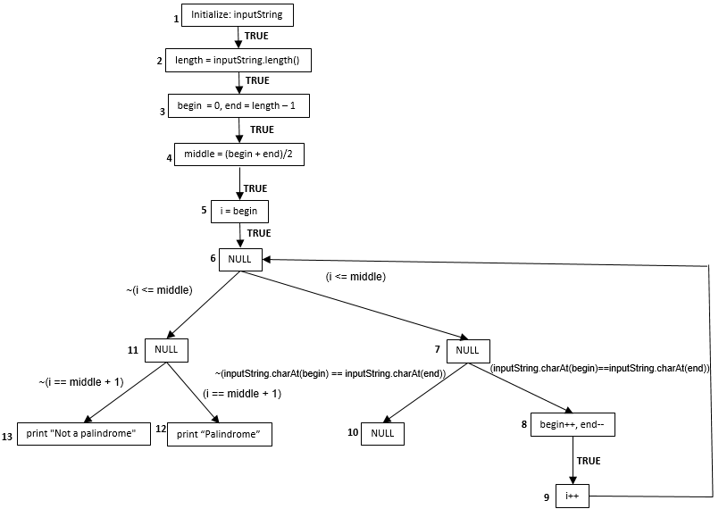

2. Independent paths:

Path 1: 1 - 2 - 3 - 4 - 5 - 6 - 7 - 10 - 11 - 12

Path 2: 1 - 2 - 3 - 4 - 5 - 6 - 7 - 8 - 9 - 12

Path 3: 1 - 2 - 3 - 4 - 5 - 6 - 11 - 13

3. Simple Path or Loop-free Path

Path 1: Loop-free path

Path 2: Loop-free path

Path 3: Loop-free path

4.

|  |  |  |  |
| --- | --- | --- | --- |
| Statements | Def | P-Use | C-Use |
| Statement 1 | inputString |  |  |
| Statement 2 | length |  | inputString |
| Statement 3 | i, begin, end, middle |  |  |
| Statement 4 | begin |  |  |
| Statement 5 | end |  | length |
| Statement 6 | middle |  | begin, end |
| Statement 7 | i | i, middle | begin |
| Statement 8 |  | inputString, begin, end |  |
| Statement 9 |  |  | begin |
| Statement 10 |  |  | end |
| Statement 11 |  |  |  |
| Statement 12 |  | i, middle |  |
| Statement 13 |  |  |  |
| Statement 14 |  |  |  |

5.

**Begin**: Initialized at line 3, Defined at line 4, C-use at line 6, C-use at line 7

**Middle**: Initialized at line 3, Defined at line 6, P-use at line 7, C-use at line 12

**End**: Initialized at line 3, Defined at line 5, C-use at line 6,