Daanish Husain

Steve Lai

Anjani Mallampati

Paul Diaz

CMPE 187 Team 09

Assignment #6

Generating Test Cases with FSM’s

**States**

|  |  |
| --- | --- |
| **State** | **State Description** |
| 1. Idle | Not moving, waiting for elevator request |
| 2. Moving Up | Travelling upwards |
| 3. Moving Down | Travelling downwards |
| 4. Waiting (doors opened) | Waiting to continue tasks with opened doors |
| 5. Waiting (doors closed) | Waiting to continue tasks with closed doors |
| 6. Hold | Holding the elevator: then door opens again |
| 7. Emergency Stop | Halts the elevator from moving |
| 8. Maintenance Needed | Not working, waiting for fix |

**State Transitions**

|  |  |  |  |
| --- | --- | --- | --- |
| **Current State** | **Next State** | **Input** | **Output** |
| Idle | Moving Up | Call Button pressed | Moved Up |
| Idle | Moving Down | Call Button pressed | Moved Down |
| Moving Up | Waiting (doors opened) | Floor Button pressed with specified floor (going up) | Arrived at target floor |
| Moving Down | Waiting (doors opened) | Floor Button pressed with specified floor (going down) | Arrived at target floor |
| Waiting (doors opened) | Waiting (doors closed) | No buttons pressed | Doors close |
| Waiting (doors closed) | Idle | NA | NA |

**FSM Diagram**

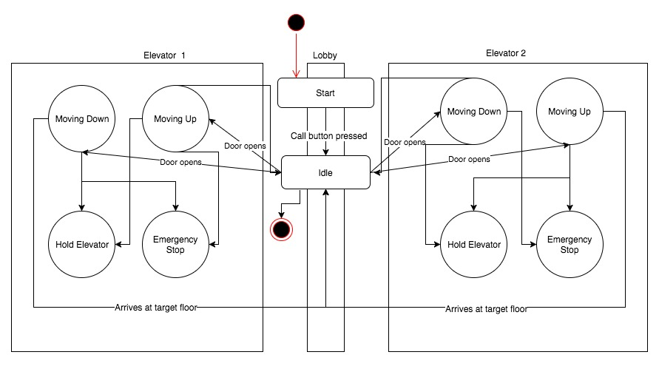

**Test Sequences**

1. Pressed call button UP at first floor going up.

Elevator !Emergency_Stop

START(TIMER1, d1)

Elevator MOVING_UP? PASS

CANCEL(TIMER1)

Elevator !Emergency_Stop continue

ANY ?OTHERWISE FAIL

CANCEL(TIMER1)

Elevator !Emergency_Stop continue

?TIMER FAIL

CANCEL(TIMER1)

Elevator !Emergency_Stop continue

1. Pressed call button UP at second floor going to fifth floor. Call button is pressed from third floor.

Elevator !Emergency_Stop

START(TIMER1, d1)

Elevator MOVING_UP?

REQUEST_3rd_UP ?updateIT PASS

CANCEL(TIMER1)

Elevator STOPS_AT_3rd PASS

Elevator ?MOVING_UP PASS

CANCEL(TIMER1)

IDLE? Elevator ONHOLD

ANY ?OTHERWISE

CANCEL(TIMER1)

IDLE? Elevator ONHOLD

?TIMER1

CANCEL(TIMER1)

IDLE? Elevator ONHOLD

ANY ?OTHERWISE FAIL

CANCEL(TIMER1)

Elevator !Emergency_Stop continue

?TIMER FAIL

CANCEL(TIMER1)

Elevator !Emergency_Stop continue

1. Elevator moving up but Emergency Stop activated

Elevator MOVING_UP

START(TIMER1, d1)

Elevator MOVING_UP? PASS

ACTIVATED ?Emergency_Stop PASS

Elevator ONHOLD

CANCEL(TIMER1)

IDLE? Elevator ONHOLD

ANY ?OTHERWISE

CANCEL(TIMER1)

IDLE? Elevator ONHOLD

?TIMER1

CANCEL(TIMER1)

IDLE? Elevator ONHOLD

ANY ?OTHERWISE FAIL

CANCEL(TIMER1)

Elevator !Emergency_Stop continue

?TIMER FAIL

CANCEL(TIMER1)

Elevator !Emergency_Stop continue

1. Elevator opens at second floor to go up, a rider pressed HOLD button

Elevator MOVING_UP

START(TIMER1, d1)

Elevator MOVING_TO_UP? PASS

Elevator !ARRIVES PASS

HOLD_BUTTON ?PRESSED PASS

Elevator ONHOLD

CANCEL(TIMER1)

IDLE? Elevator ONHOLD

ANY ?OTHERWISE

CANCEL(TIMER1)

IDLE? Elevator ONHOLD

?TIMER1

CANCEL(TIMER1)

IDLE? Elevator ONHOLD

ANY ?OTHERWISE FAIL

CANCEL(TIMER1)

Elevator !Emergency_Stop continue

?TIMER FAIL

CANCEL(TIMER1)

Elevator !Emergency_Stop continue

1. Elevator 1 was requested on first floor: Emergency stop was activated on its way. Elevator 2 takes the request.

Elevator1 MOVING_DOWN

START(TIMER1, d1)

Elevator1 MOVING_UP? PASS

ACTIVATED ?Emergency_Stop PASS

Elevator1 ONHOLD PASS

CANCEL(TIMER1)

IDLE? Elevator ONHOLD

ANY ?OTHERWISE

CANCEL(TIMER1)

IDLE? Elevator ONHOLD

?TIMER1

CANCEL(TIMER1)

IDLE? Elevator ONHOLD

Elevator2 MOVING_DOWN? PASS

CANCEL(TIMER1)

Elevator2 !Emergency_Stop continue

ANY ?OTHERWISE FAIL

CANCEL(TIMER1)

Elevator2 !Emergency_Stop continue

?TIMER FAIL

CANCEL(TIMER1)

Elevator2 !Emergency_Stop continue

ANY ?OTHERWISE FAIL

CANCEL(TIMER1)

Elevator1 !Emergency_Stop continue

?TIMER FAIL

CANCEL(TIMER1)

Elevator1 !Emergency_Stop continue

**Legend for Test Sequences**

|  |  |
| --- | --- |
| **Legend** | **Meaning** |
| Elevator,Elevator1, Elevator2 | <Any elevator, elevator 1, elevator 2> |
| MOVING_UP | Elevator is going up |
| MOVING_DOWN | Elevator is going down |
| Emergency_Stop | Emergency stop is activated |
| REQUEST_3rd_UP | A rider requested an elevator at 3rd floor |
| updateIT | Updates system after another rider requested an elevator |
| STOPS_AT_3rd | Elevator stops at 3rd floor |
| IDLE | Elevator waits for riders to come and out |
| ONHOLD | Elevator is on hold because of emergency stop |
| ACTIVATED | A button is activated (mostly Emergency Stop) |
| ARRIVES | Elevator arrives at destination |
| HOLD_BUTTON | Hold button is activated |

**Transition Tour**

1. Idle → [Call button pressed] Waiting (doors opened) → [Floor button pressed] Moving Up → [Arrived at target floor] Idle
2. Idle → [Call button pressed] Waiting (doors opened) → [Floor button pressed] Moving Down →[Emergency Stop called] Elevator halts
3. Idle → [Call button pressed] → Moving Up → Waiting (doors opened) → Hold → [Floor button pressed] Moving up → [Arrived at target floor] Idle
4. Idle → [Call button pressed] → Moving Down → Waiting (doors opened) → [Floor button pressed] Moving Down → [Emergency Stop called] Elevator halts
5. Idle → [Call button pressed] → Moving Down → Waiting(doors opened) → Emergency Stop called] Elevator halts → Maintenance needed