Daanish Husain

Steve Lai

Anjani Mallampati

Paul Diaz

CMPE 187 Team 09

Assignment #7: Testing Without Specifications

**SoundCloud**

SoundCloud is an audio distribution platform, available on Android and iOS, that allows users to listen to original sounds as well as, upload and share their original audio creations. There are two mobile apps associated with SoundCloud: SoundCloud and SoundCloud Pulse. For the purpose of this assignment, the focus will be SoundCloud.

**Main Features**

For the purpose of this assignment, five of the main features offered by SoundCloud will be evaluated and tested.

1. The first main feature on SoundCloud is **Create an Accoun**t. This if the first step that is required for interested users who are not signed up with SoundCloud.
2. Another feature available to users is **Search**. Search allows users to search through the database and find tracks, artists, other users, albums, and playlists.
3. Additionally, SoundCloud offers users a **Repost Track** feature. Users are able to repost tracks, which posts it on their profile and their followers’ streams.
4. Next, **Follow** is another core feature. Users have the ability to follow other users, which would allow them to see any posted tracks on their stream.
5. Lastly, a feature called **Create a Playlist**, which is another core feature that allows users to group and organize their interests and findings. Users have the option of creating either public or private playlists and add tracks to or delete tracks from it.
6. **Test Case for *Create an Account***
   1. **Input Values:**

In order to register to SoundCloud, a potential user must provide a unique and valid email address and password that consists of at least six characters — alphanumeric characters with at least one uppercase letter.

* 1. **Steps and Expected Output:**

To Create an Account, the first step is to select the button “Create Account.” Then, the user is redirected to a page that gives the user multiple options to create an account, such as Sign up with Facebook, Sign up with Google+, or enter email/password. After selecting an option, for example, entering email and password, press the button “Next.” Then, the user is prompted to enter their age, which is needed to check that the user meets the minimum age restriction, and gender, which is optional. Then, press the button “Done.” Next, the user is shown a notification box that reads, “By tapping ‘Continue’ you agree to the Terms of Use Cookie Policy and Privacy Policy of SoundCloud.” After pressing the button “Continue,” the account is created.

|  |  |  |  |  |
| --- | --- | --- | --- | --- |
| **Create Account** | **Input** | **Expected Output** | **Actual Output** | **Pass/Fail** |
| 1 | Valid and unique email, password | Account created | Accept Terms of Use | Pass |
| 2 | Valid and unique email, password | Account created | Denied Terms of Use | Fail |
| 3 | Sign up with Facebook | Account created | Accept Terms of Use via Facebook | Pass |
| 4 | Sign up with Google+ | Account created | Accept Terms of Use via Google+ | Pass |
| 5 | Using app without signing in | No account created | Accept Terms of Use | Fail |

**Note:** A non-registered user can use the app without signing in; however, this user is only able to search and listen to music; the user is not able to follow other users, create playlists or collections, likes users’ posts, and reposts music, albums, or collections.

* 1. **State Transition Diagram for *Create an Account***

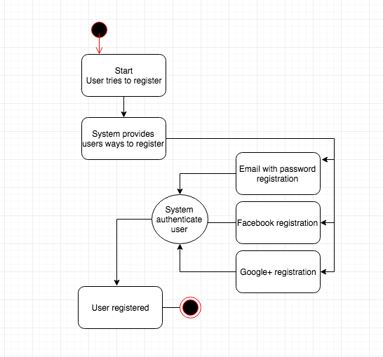

* 1. **Screenshots/GUI Transitions**

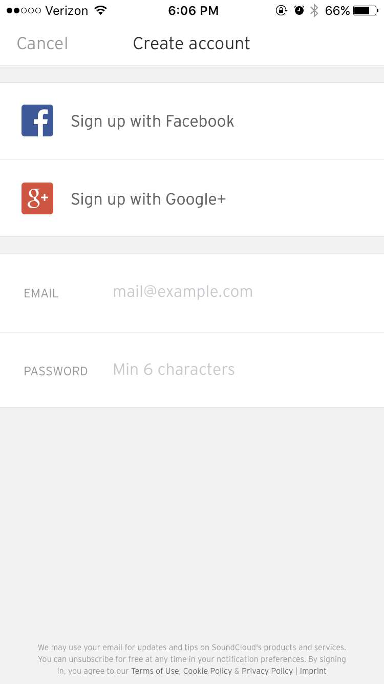 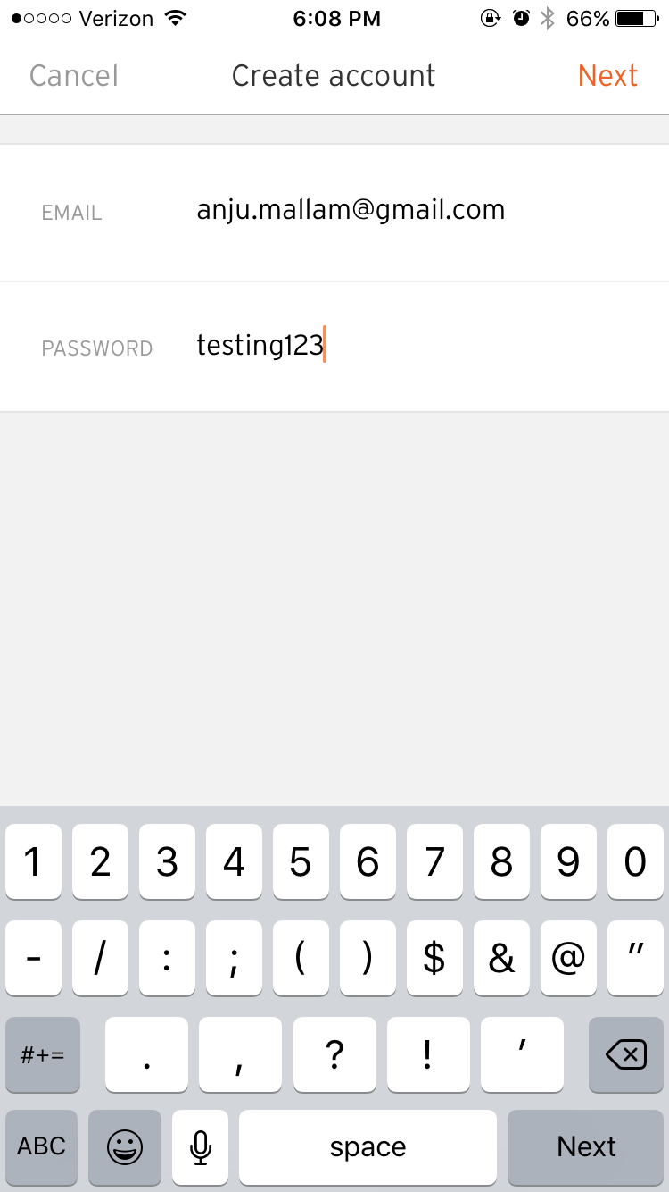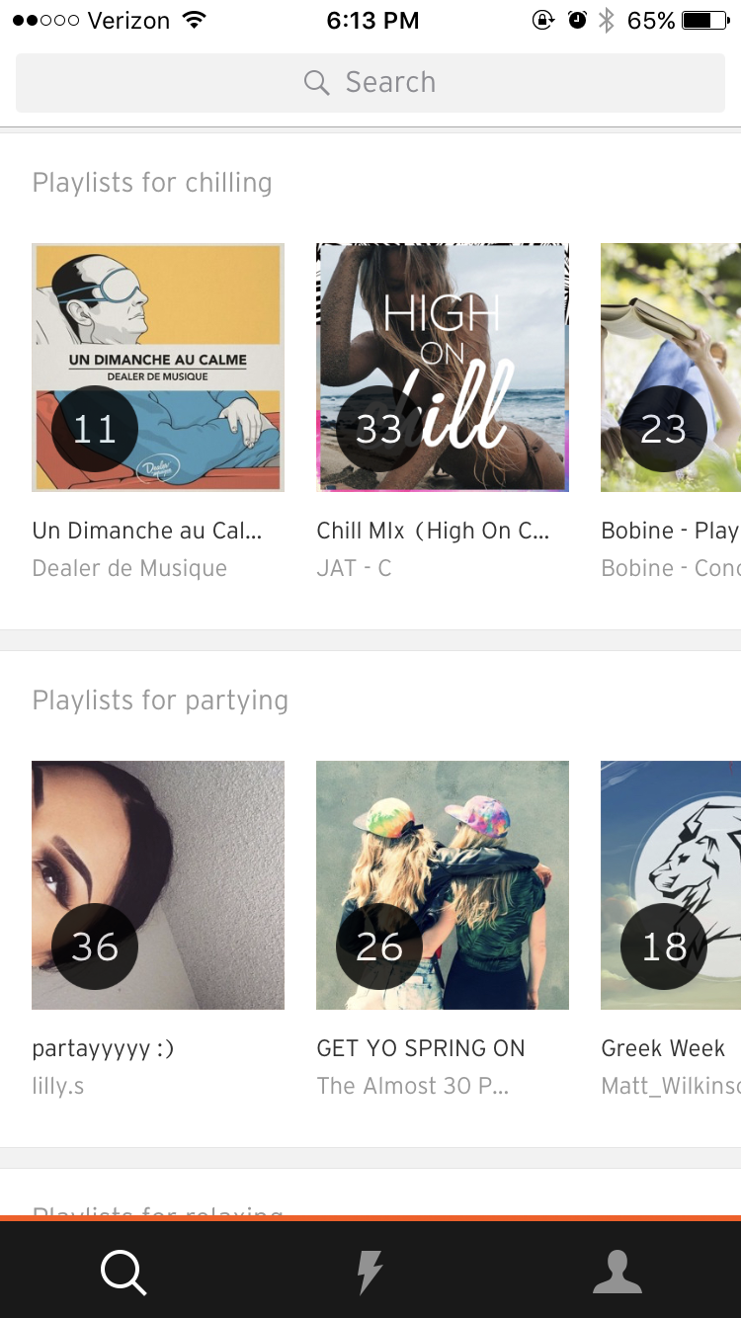 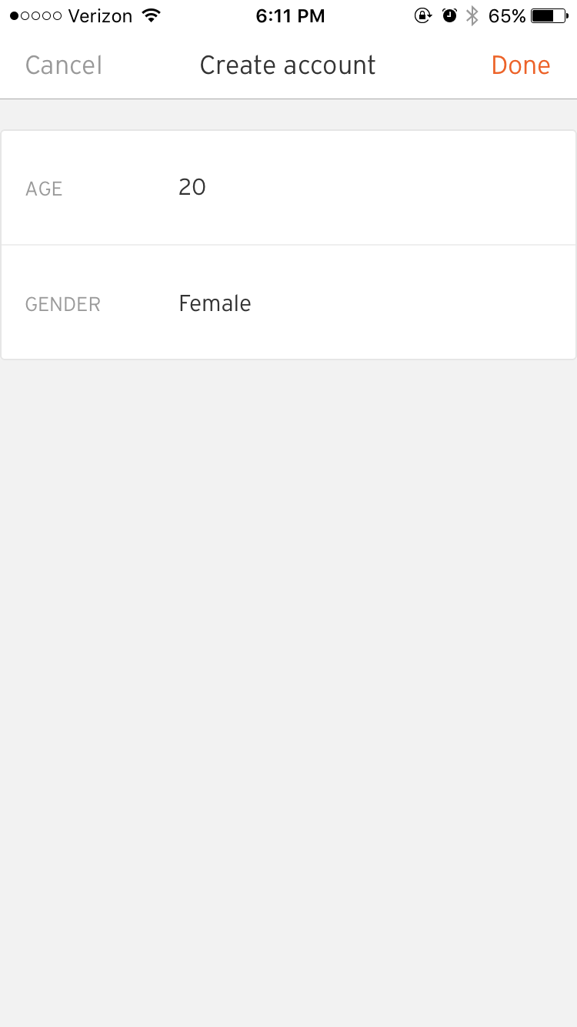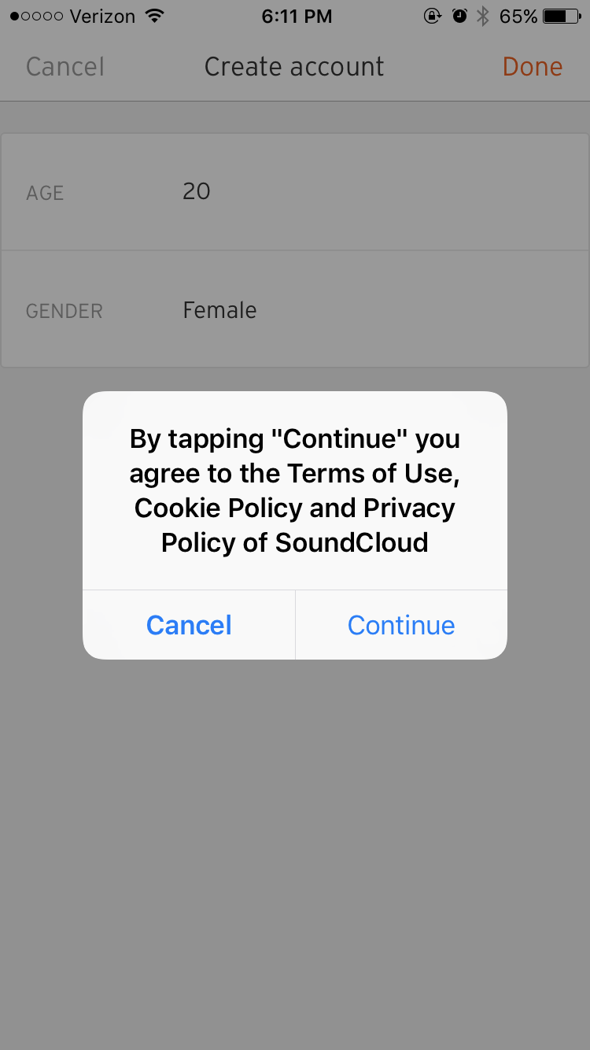

Figures 1-5. The sequential steps to creating an account using an email address.

1. **Test Case for *Search***
   1. **Input Values:**

The input boundary value for search ranges from song/track title, artist, album, other users/follower names. The search engine provides some suggestions, in the form of autofill, as the user types in the search keywords.

* 1. **Steps and Expected Output:**

At the top of the screen, there is a search bar. As the user types their search keywords, or the input value, they are given autofill recommendations. Once the user is finished entering their search, they press the button “Search.” Then, they are redirected to a page that shows all the tracks, people, albums, and playlists that contain their search.

|  |  |  |  |  |
| --- | --- | --- | --- | --- |
| **Search** | **Input** | **Expected Output** | **Actual Output** | **Pass/Fail** |
| 1 | “Hello” Search by track/song title | Tracks, people, albums, playlists that contain the word “Hello” | Tracks, people, albums, playlists that contain the word “Hello” | Pass |
| 2 | Search by album | Lists all albums that match the input query | Lists all albums that match the input query | Pass |
| 3 | Search by artist | Lists all artists that match the given input | Lists all artists that matched the given input as well as users that have the artist’s name as part of username | Fail |
| 4 | Search by users/followers | Lists all users and followers that match the given input query | Lists all users and followers that match the given input query | Pass |
| 5 | Search by playlist | List all playlists that match the given input query | List all playlists that match the given input query | Pass |

* 1. **State Transition Diagram for *Search***

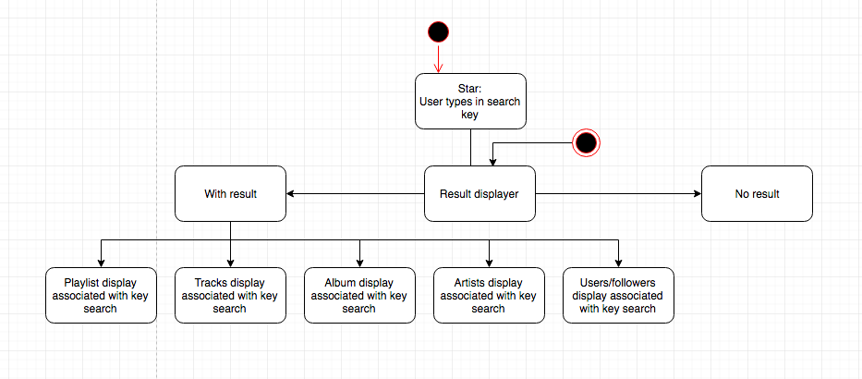

* 1. **Screenshots/GUI Transitions**

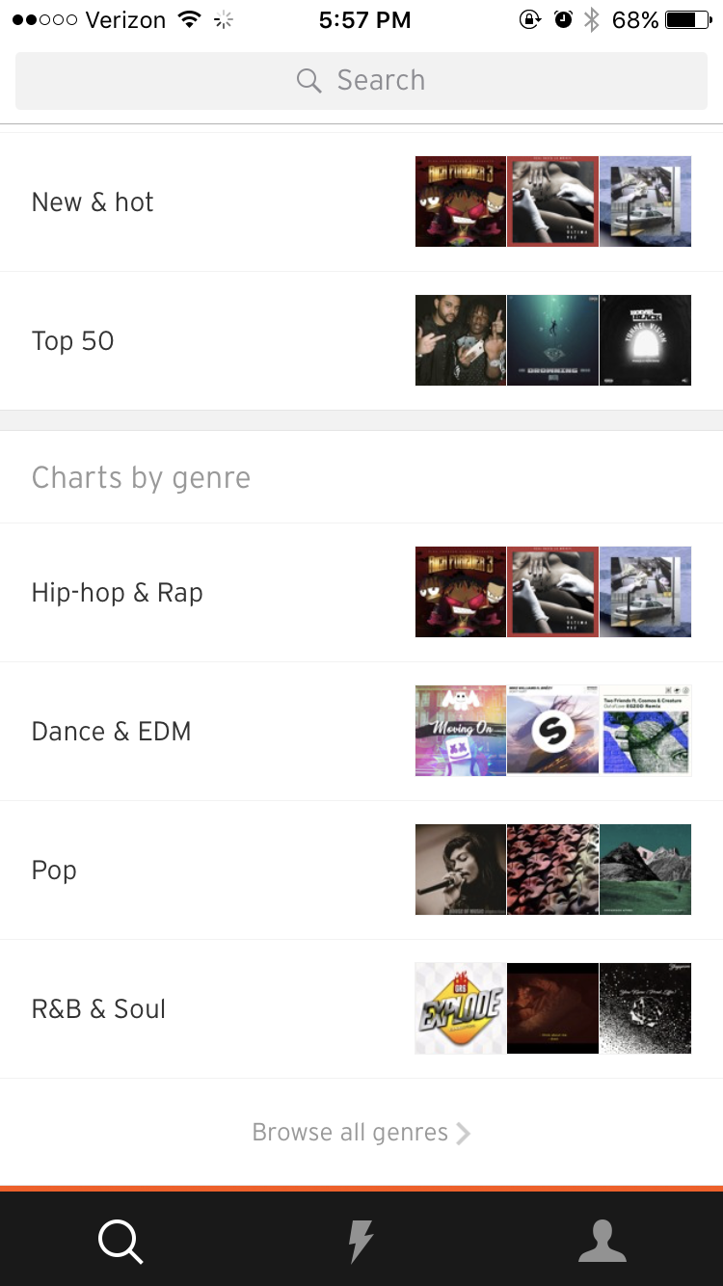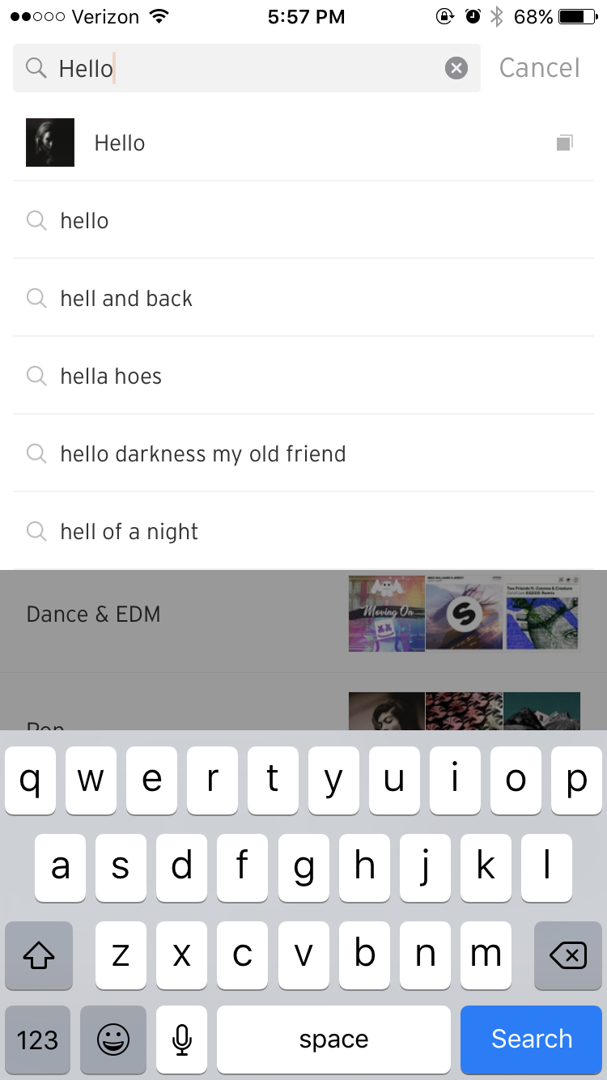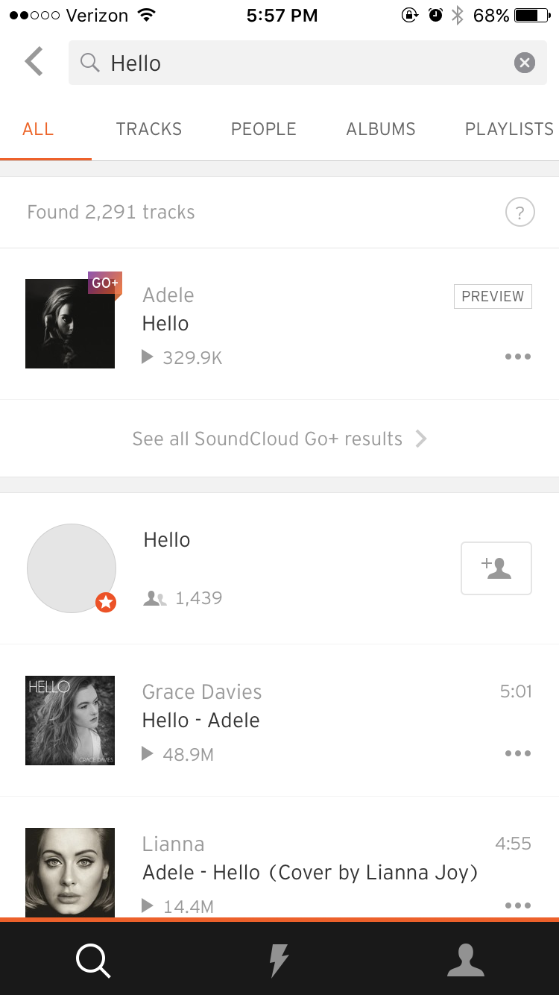

Figures 6-9. The steps to search for “Hello.” Demonstrates test case 1 for Search.

1. **Test Case for *Repost Track***
   1. **Input Values:**

A user must be registered to repost a track. The input boundary for this feature is the music/track that the user wants to repost. Repost is done one music/track at a time.

* 1. **Steps and Expected Output:**

There are two ways to Repost a track. The first way is to go to a specific track and select it. At the bottom, press the button “...” which will provide additional options. Of the options, select “Repost on SoundCloud” and the track will be posted on the user’s profile and on the user’s followers’ stream. The second way to Repost a track is to go to the user’s stream and select the box with the Repost symbol at the bottom of each track.

|  |  |  |  |  |
| --- | --- | --- | --- | --- |
| **Repost** | **Input** | **Expected Output** | **Actual Output** | **Pass/Fail** |
| 1 | Tap repost button on another user's song that is saved to a personal playlist | Selected song is posted to personal stream for all followers to see | Selected song is posted to personal stream for all followers to see | Pass |
| 2 | Tap repost on another user's song while viewing their profile | Selected song is posted to personal stream for all followers to see | Selected song is posted to personal stream for all followers to see | Pass |
| 3 | Tap the "…" button and then select the repost option while viewing specific track | Selected song is posted to personal stream for all followers to see | Selected song is posted to personal stream for all followers to see | Pass |
| 4 | Tap the repost option on the featured song in the personal stream | Selected song is posted to personal stream for all followers to see | Selected song is posted to personal stream for all followers to see | Pass |
| 5 | Tap the repost option after it has already been selected | The song should be removed from personal stream and not visible to followers | The song should be removed from personal stream and not visible to followers | Pass |

* 1. **State Transition Diagram for *Repost Track***

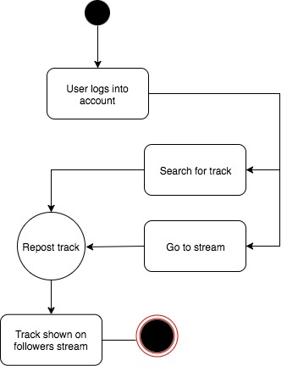

* 1. **Screenshots/GUI Transition**

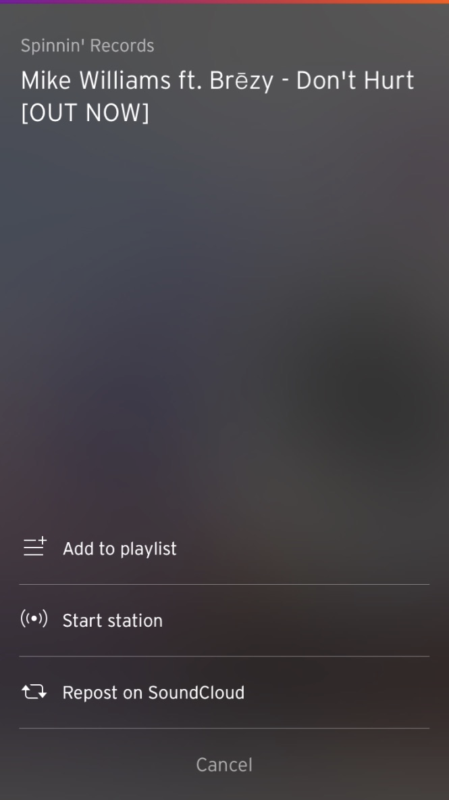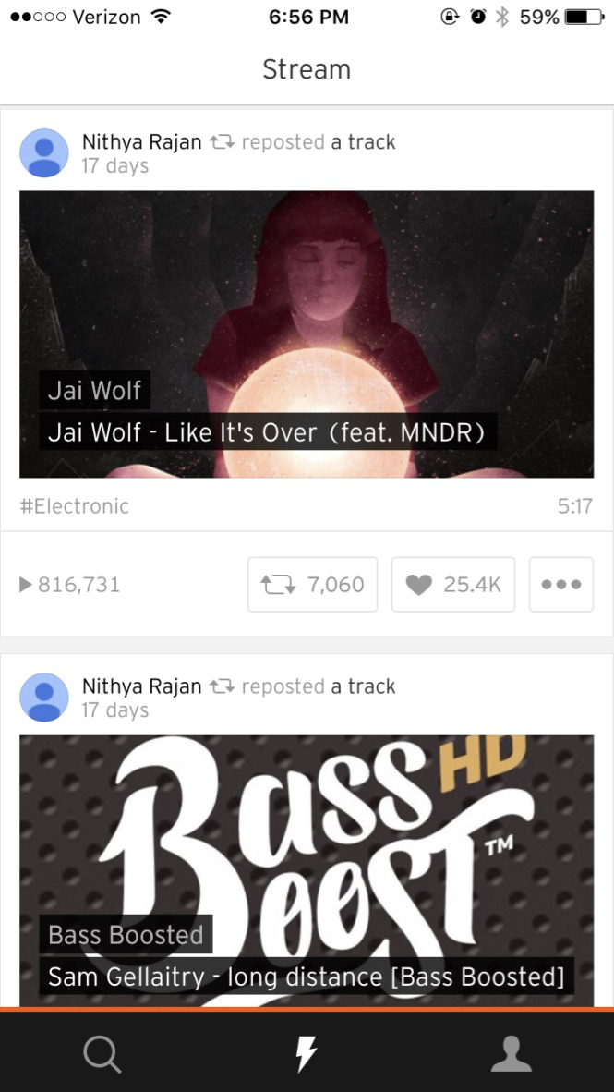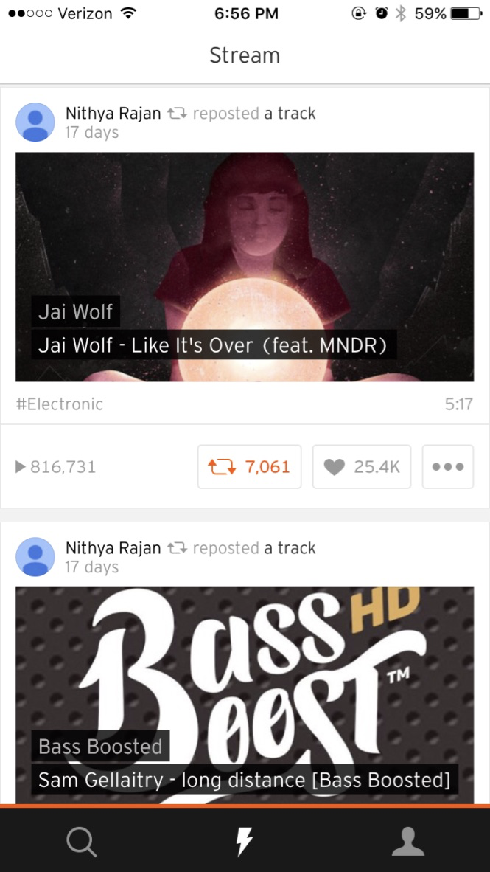

Figures 10-12. The Repost feature is shown.

1. **Test Case for *Follow a User/Artist***
   1. **Input Values:**

The only input boundary value needed to follow another user/artist is that the user must first be logged in before being able to select the Follow option. There is no limit as to how many users a user can follow.

* 1. **Steps and Expected Output:**

There are several ways on how to follow a user/artist. The first way is to navigate to a user’s profile and tap the Follow button. Next, the second way is to go to your stream and follow a user from the list of suggested users. Lastly, the third way is a user can follow another user/artist from the search results page. After tapping the Follow button, users and artists that the said user have followed appear on his/her profile page. The stream suggests artists, songs, and genre of music related to what the user has followed. Also whenever a user/artist that is being followed makes an update, those updates appear on the personal stream.

|  |  |  |  |  |
| --- | --- | --- | --- | --- |
| **Follow** | **Input** | **Expected Output** | **Actual Output** | **Pass/Fail** |
| 1 | Tap the Follow button after navigating to a user's profile | The followed user's updates now appear in personal stream | The followed users update's now appear in personal stream | Pass |
| 2 | Tap the Follow button of a suggested user in personal stream | The followed user's updates now appear in personal stream | The followed user's updates now appear in personal stream | Pass |
| 3 | Tap to Follow button after searching for that artist | The followed user's updates now appear in personal stream | The followed user's updates now appear in personal stream | Pass |
| 4 | Tap the Follow button after clicking on a song from a suggested playlist | The followed users tracks will now appear in personal stream | The followed user’s posted and reposted tracks now appear in personal stream | Pass |
| 5 | Tap the Follow button after unfollowing a certain user | The followed user’s tracks will now appear in personal stream, also a message saying the user has been followed before | The followed users posted and reposted tracks now appear again in personal stream | Pass |

* 1. **State Transition Diagram for *Follow a User/Artist***

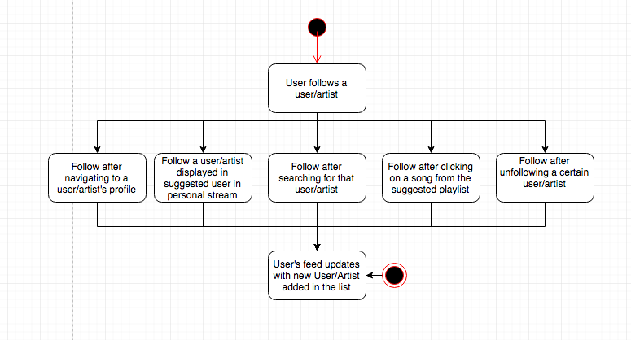

* 1. **Screenshots/GUI Transition**

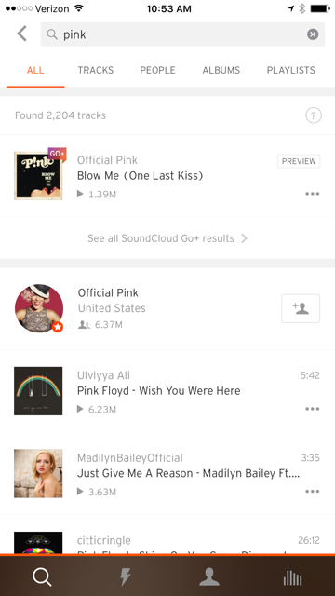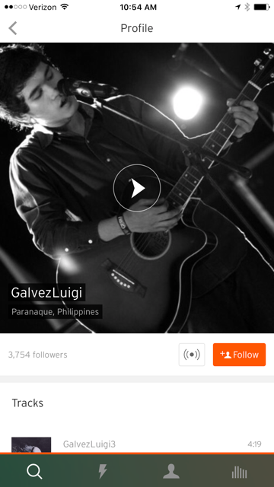

Figures 13-14. The Follow feature is shown on two different screens.

**Note:** The image on the left side shows a user icon with a + sign with it. A user can tap this to follow this artist searched. The image on the left side shows a user icon with + sign and Follow text contained in orange button. A user can tap this to follow this artist/user.

1. **Test Case for *Create Playlist***
   1. **Input Values:**

The input boundary for Create playlist ranges from a one character playlist name, to as many characters as possible for the title. There is no limit for how many characters the playlist name can be.

* 1. **Steps and Expected Output:**

To Create a Playlist, the first step is to tap the “...” on a track. The result will be a list of options. Whether the user has existing playlists or not, one of the options will be “Add to a Playlist.” After selected “Add to a Playlist,” the user will be taken to a page where there will be a list of existing playlists or nothing. There is a “+” at the stop, which indicates “Create a Playlist.” After selecting the “+” the user can enter a name for the playlist and press the button “Done” to finish creating a playlist. For a new playlist to be created, there has to be at least one track inserted in the playlist. If the user tries to create a playlist without adding a track, it would fail to create.

|  |  |  |  |  |
| --- | --- | --- | --- | --- |
| **Create Playlist** | **Input** | **Expected Output** | **Actual Output** | **Pass/Fail** |
| 1 | Select a track and then add to a new Playlist “New” using the “+” button | Create new playlist “New” | Create the new playlist “New” | Pass |
| 2 | Select a track that already exists in the playlist and add to that playlist. | Multiples of the same track will not be added to the playlist. | Multiple of the same tracks are not added to the playlist | Pass |
| 3 | Select a track and add to an existing playlist. | Selected track will be added to the existing playlist. | Selected track added to the existing playlist. | Pass |
| 4 | Add selected track to multiple playlists. | Selected track can be added to multiple playlists. | Selected track added to multiple playlists. | Pass |
| 5 | Create playlist without selecting track. | Cannot create playlist without selecting a track. | Does not create a playlist without selecting a track. | Pass |

* 1. **State Transition Diagram for *Create Playlist***

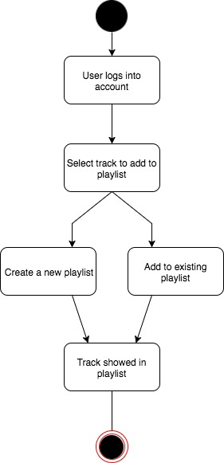

* 1. **Screenshots and GUI transition**

