Module Advanced algorithms

8th November 2018

**Project planning**

**Team members**

|  |  |  |
| --- | --- | --- |
| **Name** | **Role** | **Tasks** |
| Louise Harding | Project Leader | Deployment instructions  Branch and bound algorithm  GUI |
| Mohammad Poul Doust | Developer | Genetic algorithm  Branch and bound version adding and removing edges |
| Robin Khatri | Developer | Brute force algorithm  Ant Colony algorithm  Report finalization |
| Mohamed Nassar | Developer | Problem generator  Greedy algorithm  Minimum spanning tree |
| Laetitia Couge | Developer | Randomized algorithm  Dynamic programming algorithm  GUI |

**Gantt chart**

The planning has been designed considering 10 hours/week of work per resource.

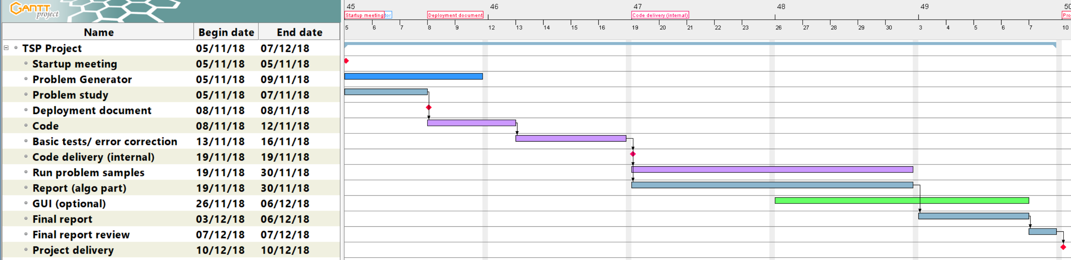

**Resource assignment**

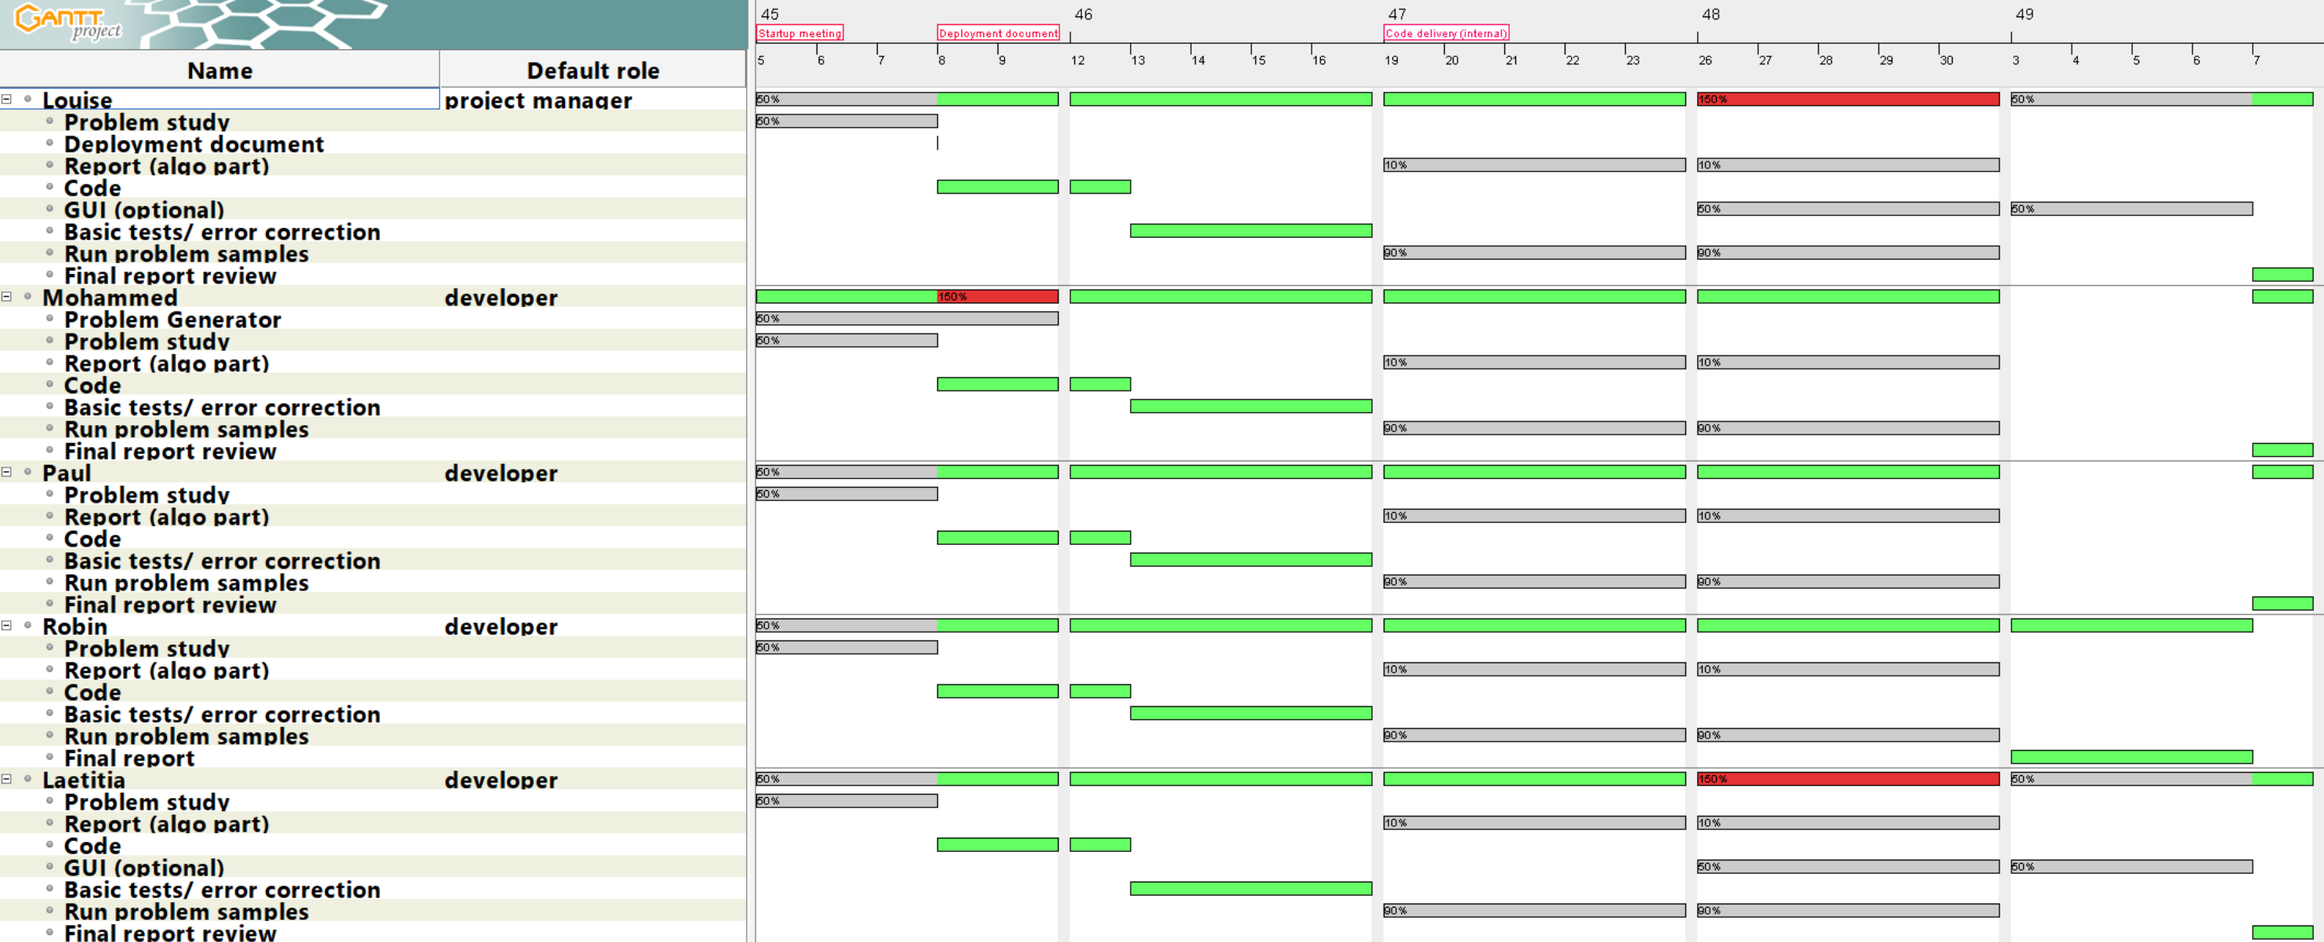

The GUI development remains optional as some resources might be overloaded.

**Testing**

We will choose a small selection of data sets from a standard library to benchmark the algorithms. Each developer will be required to test his/her code and their codes will be tested by at least one other team member. We will do a short investigation to see if we can find an appropriate automated testing option. For the purposes of time comparison we will use the same computer.