Procedure of installing MySQL Replica Status Script on Centos 7 and Zabbix Server & Agent version 3.0.32-1. The script will be used on the Slave Node where MySQL Replication is running!

1. Installing the corresponding zabbix-sender version compatible with your version of linux

[root@slave ~]# wget <https://repo.zabbix.com/zabbix/3.0/rhel/7/x86_64/zabbix-sender-3.0.32-1.el7.x86_64.rpm>

[root@slave ~]# rpm -ivh zabbix-sender-3.0.32-1.el7.x86_64.rpm

2. Get the script from :

<https://github.com/pauldualsim/zabbix/blob/main/mysql-replica-status-check.sh>

save it to the desired folder and change the values inside the script with your information

( ex. Your Zabbix-server IP, hostname of agent where running the script, key , mysql login info )

3. Give executable permissions

[root@slave ~]# chmod +x mysql-replica-status-check.sh

4. Setup the script to run at a desired time, for example every 24 hours, by using the command “crontab -e”

[root@slave ~]# crontab -e

* */24 * * * /root/ mysql-replica-status-check.sh

5. Make sure to reload the crond service using :

[root@slave ~]# systemctl reload crond

6. Go to Zabbix-server, login to the web interface and do the necessary steps required by the script to send information to the server

a) Go to Configuration-> Hosts and click on the desired HOSTNAME (that you are using inside the script) then click on Items and Create Item on the Top Right corner:

You need to add info in the first 4 rows:

- Name : example -> Replica Status

- Type : Zabbix trapper is required here

- Key : example -> replica.status

- Type of information : select -> Numeric(float)

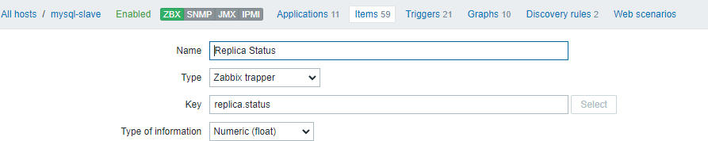

Make sure Enabled is marked and press on Update.

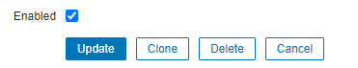

b) Press on Triggers, then click on Create Trigger on the Top Right corner:

- Name: example -> replica-status-check

- Expression: -> click Add on the right, a new window will open with options:

- on the Item option click on Select and search for the name your entered on the previous step when you created an Item, used example was -> Replica Status

- on the Function option select -> last() – Last (most recent) T value

- press on Insert

- Severity: -> select Warning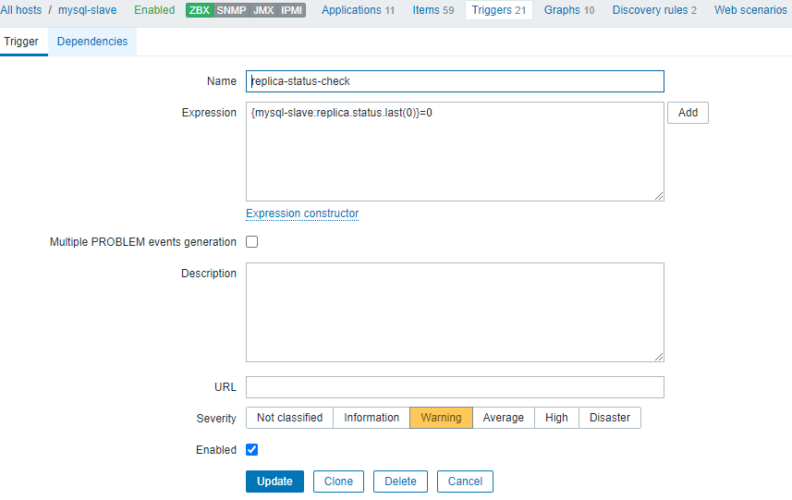

Make sure Enabled is marked and click on Update !



The configuration is done !

7. Test the script to see that alert is working by manually changing the ITEM_VALUE

Example: /usr/bin/zabbix_sender -z 192.168.200.7 -s mysql-slave -k replica.status -o 0

/usr/bin/zabbix_sender -z 192.168.200.7 -s mysql-slave -k replica.status -o 1

Done.