# A Novel Framework for Multi-Objective Optimization and Robust Plan Selection Using Graph Theory

## Paul Dubois, Nikos Paragios, Paul-Henry Cournède, Gizem Temiz, Rafael Marini-Silva, Norbert Bus, Pascal Fenoglietto

### Submitted for ESTRO 2024 (Glasgow, UK)

#### Purpose/Objective

Optimizing dose distribution in radiation therapy planning for complex prescriptions is a multifaceted challenge with critical implications for patient treatment and toxicity management. This challenge arises from several key factors:

***Lack of Standardization:*** Radiation therapy requires balancing multiple objectives without a universally agreed prioritization of constraints, making it difficult to define an optimal plan.

***Complex Mathematical Aspects:*** Non-convex multi-objective optimization in radiation therapy planning involves intricate interactions, non-convex functions, fragmented Pareto fronts, and a vast solution space, complicating global optimization.

***Expert Bias:*** The subjectivity in treatment planning is influenced by the preferences and expertise of radiation oncologists and medical physicists, leading to variability in clinical practice.

These challenges emphasize the need for a standardized, evidence-based approach. Incorporating advanced technologies, data-driven decision support, and interdisciplinary collaboration can help strike a balance between tumor control and minimizing toxicity, ensuring the best outcomes for each patient while reducing unnecessary risks.

#### Material and Methods

This study introduces an innovative framework aimed at addressing persistent challenges in multi-objective optimization for radiotherapy planning. This framework is underpinned by two key principles, each representing a substantial departure from conventional approaches:

The first principle reimagines the treatment planning process by acknowledging the dynamic and inherently uncertain nature of clinical scenarios. To address this, we introduce the concept of generating multiple treatment plans with statistical perturbations applied to the importance of multi-objective constraints. By deliberately introducing randomized variations in constraint weights, a wide spectrum of potential treatment plans is explored. These perturbations enable a comprehensive exploration of trade-offs between competing clinical objectives, empowering the formulation of adaptable and remarkably robust strategies to handle unexpected scenarios.

The second principle leverages advanced graph-theory techniques for population clustering [4]. After generating perturbed treatment plans, the study proposes an unsupervised approach to group them into distinct clusters based on similarities in trade-offs observed in dose distributions. This clustering process greatly reduces the number of solutions offered to doctors. They can then choose the most suitable approach out of the few clusters, without being overwhelmed by over 30 plans to judge individually. The proposed framework is summarized in figure 1.

The study utilizes the TG119 dataset [2], optimizing over 30 plans with an in-house optimization engine based on Collapsed Cone Convolution (CCC) [6]. A fully connected graph represents optimized doses, with edge weights indicating the inverse distance between plans. Spatial separation between treatment plans is quantified through a custom metric using Dose-Volume Histograms (DVHs) of Organs at Risk (OaRs) and Planning Target Volumes (PTVs). The L1 distance between these functional representations is computed, and the Louvain method efficiently clusters the optimized doses graph, determining the correct number of clusters based on modularity optimization.

#### Results

We managed to successfully cluster the 30 plans into 5 clusters. The variability of a set of doses is measured using the mean standard deviation of 100 points on the DVHs. We observed that the intra-variability inside clusters (7.3, 4.51, 0.95, 2.17, 7.92; average 4.57) is much lower than inter-variability between clusters (14.16). It's worth noting that the intra-variability of the clusters is also lower than the variability observed across all doses (15.54). These findings underscore the meaningful and informative nature of the clusters. The visual evaluation of the DVHs of the plans also shows the clinical meaning of the clustering found (fig. 2).

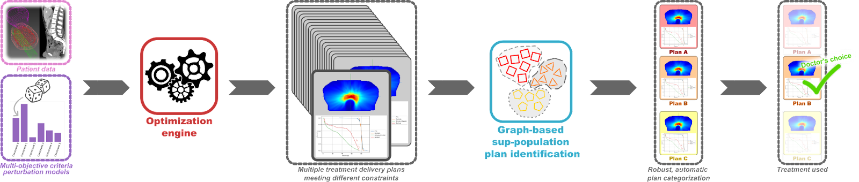

Figure 1: New dose optimization process proposed (graphical abstract).

#### Conclusion

Finding the balance between target volume coverage and adhering to normal tissue constraints in the optimization of radiotherapy plans is undeniably a complex task. However, our study presents a promising leap forward by introducing a compelling proof of concept for a robust plan selection approach. This innovative approach leverages multiple plans and their consistency in terms of DVH distribution metrics to automate the optimization process, reducing the potential influence of expert biases and local practices as well as improving treatment outcomes. Moreover, it holds the promise of substantial time savings for dosimetrists and medical physicists. As we look ahead, our research is poised to expand this method into real-world scenarios, incorporating plan perturbation models informed by real-world examples to create a more accurate representation of the clinical reality. The ultimate aim is to empower clinicians with the ability to explore a multitude of optimization possibilities without the need for labor-intensive manual intervention, streamlining the selection of the optimal treatment dose. Furthermore, the versatility of this approach extends to the realm of fully automated on-the-fly re-optimization, using the most current patient data to ensure the closest match to the ideal treatment plan.