Load Sharing on a UNIX NOW

Paul Egan - lumpy@cs.ucc.ie

June 1998

Abstract
Load sharing on a network of workstations allows users to utilise the full potential of the computing resources scattered around a system and may provide substantial performance improvements to applications. This project examines the merits of a simple load sharing system that does not require operating system or application modifications, uses existing protocols and has a low administrative overhead.

Introduction
With recent advances in computing technologies, networks of workstations, NOW’s, are poised to become the primary computing infrastructure for science and parallel applications [ACP95]. Distributed computing has been gaining importance as a preferred model of computing compared to centralised computing. It has been widely observed that usage’s of computing resources in a distributed environment is usually bursty over time and uneven among hosts. A user of a workstation may not use the machine all the time, but may need more than it can provide while actively working. Some hosts may be heavily loaded, while others remain idle. Along with the dramatic decrease in hardware costs, resource demands of applications have been increasing steadily, and new, resource-intensive applications are being introduced rapidly.
Load sharing is the process of redistributing the system workload among the workstations to improve performance and accessibility of remote resources. Intuitively, avoiding the situation of load imbalances and exploiting powerful hosts may lead to better job response times and resource utilisation. Numerous studies on load sharing have confirmed such an intuition [ELZ86,Z88,LLM88].
This report is organised as follows: The next section introduces the main concepts and strategies in load sharing systems with examples of existing systems. Section 3 describes the nature of workloads on UNIX systems and how this impacts load sharing. Section 4 briefly summarises some relevant remote facilities in UNIX. Section 5 describes the system implemented for this project and section 6 analyses the effect of the system.

Load Sharing Systems
Intuitively the load on a computer is directly related to the processes running on it. Therefor load distribution is attained with the distribution of the processes. Process distribution can be achieved by using preemptive or non-preemptive strategies. Preemptive strategies are carried out by moving an active process from one machine to another. On the other hand, non-preemptive load distribution is referred to as remote execution, where a process is assigned to a machine before starting execution and that process resides on the same machine until it terminates. If the cost of the remote execution of a process is high relative to its lifetime, as it usually is, then a priori information about the processes lifetime and resource utilisation is commonly used. This is often implemented as a list of process names that are eligible for remote execution. In contrast, preemptive strategies do not require such a priori information since the current lifetime and resource utilisation can be used to determine eligibility. Preemptive migration has the draw-back that the entire state of the process, including all code and data, must be transferred to the target host, whereas remote execution simply requires a remote procedure call. In general preemptive strategies lead to better load distribution since they can make better use of the current state of the system and are not restricted to the choice of process to be migrated. For in depth comparison of the two strategies see [KL88,ELZ88,HBD96].
The two most important decisions to be made in any load sharing strategy are which process to migrate and to where - referred to the migration and location policies respectively. Clearly the objective of the location policy is to select the host with the lowest load. The issue is the determination of the load. Indices that are often used include CPU utilisation, memory usage & rate context switches. However previous work has shown that the use of the CPU run queue length is both simple and effective, particularly if it is exponentially smoothed [K91,FZ87]. Generally the process selected for migration is one which is long running and resource intensive. For preemptive migration these aspects can be measured dynamically however they must be determined manually for remote execution.
Most existing distributed systems provide some form of process migration, however few do so for the purposes of load sharing. The known systems that use pre-emptive process migration for load sharing are: Demos/MP [PM83], MOSIX [BSW93], RHODOS [GGI91], Condor [LLM88] and V [TLC85]. Those that use remote execution include: Locus [T91], NEST [AE87] and Utopia [ZWZD93]. Of these only MOSIX, Condor, NEST and Utopia are UNIX based. MOSIX’s preemptive migration uses the run queue length as its load index and selects the process with the longest lifetime. Transparency is achieved by the creation of a deputy process on the source host to which location dependant system calls are re-routed. MOSIX has been found to be one of the most efficient load sharing systems implemented to date, however it requires extensive operating system kernel changes. NEST also achieves full transparency but again at the cost of kernel modifications. Condor does not require any operating system modifications, however all participating processes must be linked against a special library. Utopia is the only system that does not require changes to the operating system or application involved and has gone on to commercial success as LSF. For more information on existing load sharing systems see [N94,JM89].

UNIX processes
The effectiveness of load sharing, either by remote execution or preemptive migration, depends strongly on the nature of the workload, including the distribution of process lifetimes and the arrival process. The general shape of the distribution of process lifetimes in an UNIX environment is well known [LO86, HBD96]: there are many short jobs and a few long jobs. The variance of the distribution is greater than that of an exponential distribution. Specifically it tends to be of the form: the probability of a process’ lifetime exceeding T seconds is rT^{k} where k ≈ -1 ( r normalises the distribution ). Also it is noted that these few long jobs utilise the majority of the available resources. These resource hogs are usually easily identifiable, e.g. compilers, document processors, leading to the possibility of efficient implementations of remote execution load sharing systems based on eligibility lists.
Unlike those in the majority of systems in which preemptive process migration has been implemented, UNIX processes have a large kernel level state. This high dependency on the source host makes migration of a process extremely difficult and is usually solved by leaving a shadow process on the source host. Many system calls, particularly I/O, made by the application must be passed back to the shadow process. This system involves a high communication overhead and does not completely alleviate the load on the source.

Remote Facilities in UNIX
UNIX provides many services for working within a distributed environment. The two most relevant remote facilities to this project are the rcmd and rwho protocols.
The rcmd protocol uses an RPC method to execute a command on a remote host. The RPC server, rshd, listens for a service request on a well known port. The service request includes the local and remote user id, the source hostname and the command to be executed. If none of these are valid or the request does not come from a privileged port then service is denied. If the request is validated then the command is executed with two socket streams connecting it to the client. The first socket is used for standard I/O, while the second is used for error and signal handling. On the client side the rcmd() function is used to initiate a request and will return the two socket streams for communication with the remote process. Since the request must come from a privileged port, the caller of the rcmd() function must have effective root privileges. The standard UNIX command rsh provides a wrapper for rcmd and can be used from the command line. Rcmd is often used in a NOW environment where each workstation has the same users, perhaps distributed with NIS. In order to maintain transparency when the remote process is to access files, a distributed file system with a uniform file name space is necessary. This is often the case in a NOW environment. The rcmd protocol does have its weaknesses: the I/O redirection does not work with all programs and the signal handling is not comprehensive. Also, because of the stringent security, an rcmd request can take in the order of 1 to 3 seconds to complete.
The rwho protocol is used to disseminate information about each workstation in a NOW. A process called rwhod runs on each workstation in the NOW and operates as both a producer and consumer of status information. As a producer of information it periodically ( c.a. every 3 minutes. ) queries the state of the local system and constructs status messages which are broadcast on the network. As a consumer of information, it listens for other rwhod servers’ status messages, validating them, then recording them in a collection of files. While the rwho messages contain much information about the users on each workstation, of interest in the load sharing context is the load average and number of users. The load average gives the 5 minute exponentially smoothed CPU queue length. The collection of files produced by rwhod can be accessed by any other process to determine the state of the NOW. Standard examples are rwho and ruptime. Also of note is that the status of the local workstation is stored, providing a platform independent method of determining the local load.

Design & Implementation
Variable | Use
lsOn | Turns on & off load sharing
lsHWM | Specifies the threshold to determine is the local host is over-loaded.
lsLWM | The Low Water Mark - Any remote host selected must have a load lower than this.
lsRExec | The program to use for the remote execution of a command.
lsCmds | The list of commands that are suitable for migration.
lsDebug | Turns on & off debug output.
Figure 2
The objective of this project was to implement and study a load sharing system that did not require modifications to existing systems. As a result many of the design decisions were without choice, e.g. it is not possible to implement a preemptive migration scheme without changes to the applications or operating systems involved. For these reasons the system was implemented entirely at the user level. The shell was taken to be the most suitable location to add load sharing functionality as it is there that most processes are initiated. As described in the previous section the rcmd protocol requires the use of a privileged port, therefore a separate program was needed to perform the remote execution. The load sharing system is divided into two parts. The first is the application to remotely execute a command. The second is a shell which on reading a command decides whether the command is to be executed remotely and if so, calls the first with the name of the most suitable workstation and the command to be executed.
The program that performs the remote execution was implemented by extending the functionality of rsh. Indeed rsh could have been used unmodified with certain programs. Rsh however does not provide the degree of transparency needed for load sharing purposes and so support for the maintenance of the working environment, such as the current directory, was added. The signal handling mechanisms were also extended.
main()
{
while (1){
read(command);
checkCommand(command);
execute(command);
}
}

checkCommand(commandRead)
{
if ( !value(lsOn) || (lsCmds)==NULL )
return;

for (each command in lsCmds)
if ( match(command,commandRead)&& currentLoad()>value(lsHWM) &&
(target=bestHost())!=NULL )
commandRead = value(lsRExec) + target + commandRead;
}

bestHost()
{
bestHost.name = NULL;
bestHost.load = value(lsLWM);

while ( nextHost=getHostInfo() )
if ( nextHost.load<bestHost.load ||( nextHost.load==bestHost.load
&& nextHost.numUsers<bestHost.numUsers ) )
bestHost = nextHost;

return bestHost.name;
}
Figure 1
The second and main part of the system was the shell. Rather than implementing a new shell specialised for load sharing, it was decided to augment an existing popular shell with load sharing facilities. The shell chosen was tcsh. The control flow of the load sharing code is very simple. The command is first matched against a list of commands suitable for load sharing. This list is maintained as a shell variable. If the load on the local workstation is high then the workstation with the lowest number of users and lowest load, that is below a certain threshold, in the NOW is selected. If a suitable workstation is selected then the command is executed on that workstation using the program described above. If the command is not on the list, the load on the local workstation is low or a suitable remote workstation is not found, then the command is executed as normal. Figure 1 gives an outline of the code to be added to a shell. Control of the system is performed with the use of shell variables. Figure 2 shows the variables available and their uses. The use of the threshold, lsLWM, insures that the system is stable when the load is high on all workstations.
Simply replacing a users shell with this modified shell is all that is needed to harness the performance gains of load sharing. Installation and control of the system can be performed on a per user basis so that users who do not wish to have their working habits affected are not impacted and a system administrator need not be involved.
The simple implementation of this load sharing system relies on a few assumptions. Firstly each user is required to be recognised by each workstation. Clearly the rwho and rcmd servers must also be enabled. For file access, a distributed file system must also be in place. These requirements are not overly stringent since they are met in most NOW environments.

Performance
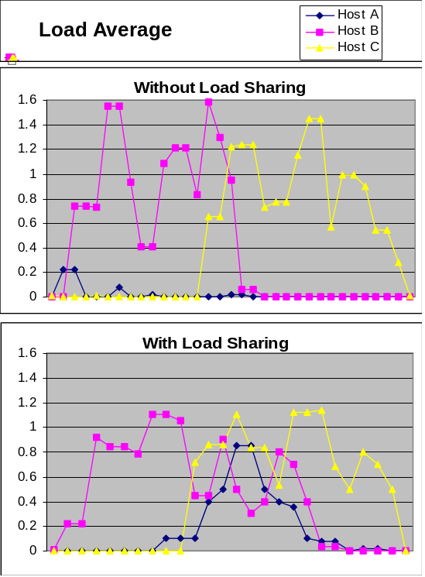
Figure 3
In order to examine the efficiency and performance of the load sharing system a trace driven simulation was developed. This was in the form a script which introduced processes to a NOW with arrival and life-time distributions that modelled standard UNIX process activity. The simulation was run on a network of three workstations with and without the load sharing system.
Figure 3 shows the load on the three workstations with and without load sharing. It is clear that the load is being distributed thus improving the performance of the system. To analytically measure the benefits to processes of the load sharing system the metric of mean slowdown was used. Slowdown is taken to be the ratio of wall clock execution time to CPU time ( thus it is always greater than one ). The mean slowdown is the average slowdown of all processes in the system. For the purposes of this analysis, interactive and I/O bound processes were ignored as the slowdown of these processes are not load dependant. Figure 4 shows the mean slowdown for the three workstations with and without load sharing.
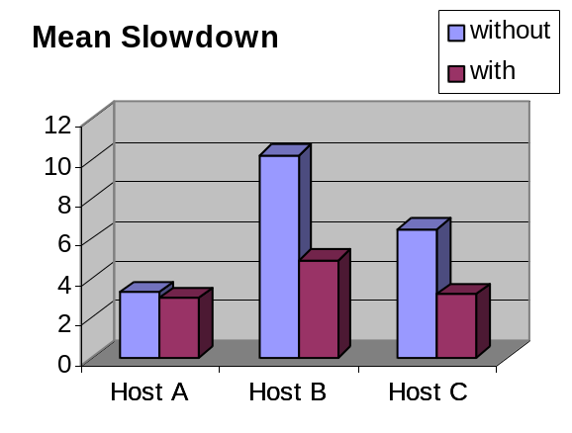
Figure 4
The results show a considerable decrease in the mean slowdown, particularly on the highly loaded workstation. For the user this means that processes are completing quicker.

Conclusion
The system described above is not the most robust or innovative of existing load sharing systems. Its simple load sharing algorithm may not lead to the selection of the most suitable remote workstation and requires a priori knowledge of process resource utilisation. However it is the simple implementation that leads to a low administrative overhead and easy integration with existing systems. With no operating system or application changes necessary and without the need for extra server processes running on the NOW, integration is hardly a consideration. The system can also be used on a per user basis. Most importantly of all however is that, despite the system’s simplicity, the performance benefits are considerable. The more effective use of the resources in a UNIX NOW with load sharing lead to a substantial decrease in the mean slowdown of processes.
References
[ACP95] | T. Anderson, D. Culler & D. Paterson. A Case for NOW. IEEE Micro, 15(1):64-64, February 1995.
[AE87] | R. Agrawal & A. Ezzet. Location independent remote execution in NEST. IEEE Transactions on Software Engineering, 13(8):905-912, August 1987.
[BSW93] | A. Barak, G. Shai & R. Wheeler. The MOSIX Distributed Operating System: Load Balancing for UNIX. Lecture Notes in Computer Science, Vol. 672, Springer Verlag, Berlin, 1993.
[ELZ86] | D. Eager, E. Lazowska & J. Zahorjan. Adaptive Load Sharing in Homogeneous Distributed Systems. IEEE Transactions on Software Engineering, 12(5):662-675, May 1986.
[ELZ88] | D. Eager, E. Lazowska & J. Zahorjan. The Limited Performance Benefits of Migrating Active Processes for Load Sharing. SIGMETRICS 662-675, May 1988.
[FZ87] | D. Ferrari and S. Zhou. An Empirical Investigation of Load Indices for Load Balancing Applications. Technical Report UCB/CSD 87/353, 1987.
[GGI91] | G. Gerrity, A. Goscinski, J. Indulska, W. Toomey & W. Zhu. RHODOS - A Testbed for Studying Design Issues in Distributed Operating Systems. Towards Network Globalization (SICON 91): 2nd International Conference on Networks, 268-274, September 1991.
[HBD96] | M. Harchol-Baltor & A. Downey. Exploiting Process Lifetime Distributions for Dynamic Load Balancing. Proceedings of ACM SIGMETRICS, May 1996.
[JM89] | C. Jacqmot & E. Milgrom, Unix and Load Balancing: a Survey, Proc. of EUUG Spring Conference, 1-13, April 1989.
[KL88] | P. Krueger & M. Livny. A comparison of preemptive and non-preemptive load distributing. 8th International Conference on Distributed Computing Systems, 123-130, June 1988.
[K91] | T. Kunz. The Influence of Different Workload Descriptions on a Heuristic Load Balancing Scheme. IEEE transactions on Software Engineering, 17(7):725-730, July 1991.
[LO86] | W. Leland & T. Ott. Load Balancing Heuristics and Process Behaviour. Proceedings of ACM SIGMETRICS, Vol. 14 54-69, 1986.
[LLM88] | M. Litzkow, M. Livny & M. Mutka. Condor - A Hunter of Idle Workstations. Proceedings of the 8th International Conference on Distributed Computing Systems, 104-111, June 1998.
[N94] | M. Nuttall, A brief survey of systems providing process or object migration, ACM SIGOPS Operating System Review, 28(4):64-80, Oct. 1994.
[PM83] | M. Powell & B. Miller. Process Migrations in Demos/MP. ACM-SIGOPS 6th ACM Symposium on Operating Systems Principles, 110-119, November 1983.
[T91] | G. Thiel. Locus Operating System, A Transparent System. Computer Communications, 14(6):336-346, 1991.
[TLC85] | M. Teimer, K. Lantz & D. Cheriton. Preemptable Remote Execution Facilities for the V-System. ACM SIGOPS 10th ACM Symposium on Operating System Principles, 2-12, December 1990.
[ZWZD93] | S. Zhou, J. Wang, X. Zheng & P. Delisle. Utopia: A Load Sharing Facility for Large, Heterogeneous Distributed Computer Systems. Software - Practice and Experience, 23(2):1305-1336, December 1993.
[Z88] | S. Zhou. A Trace-driven Simulation Study of Dynamic Load Balancing. IEEE Transactions on Software Engineering, 14(9):1327-1341, November 1988.

