Question 1

When the noise variance increases, the two clusters tend to mix. When the noise variance is lower than 0.25, the two clusters are often separable. Therefore, the average error is 0 : the algorithm converges. But when the noise variance becomes greater than 0.5, the two clusters becomes inseparable.

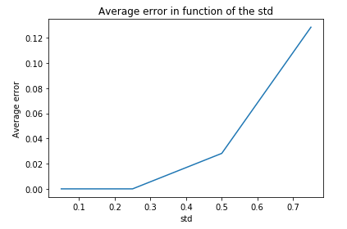
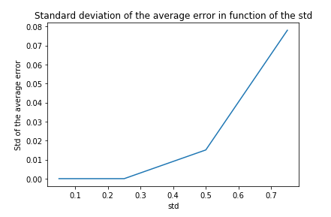

The greater is this noise variance, the greater will be the average error because more points will be considered to be part of the other cluster after the perceptron.
The standard deviation of the average error also increases because the situation is more complex and thus the boundary of the perceptron will change a lot from a situation to another.

Question 2

In question 2, we fix the standard deviation of the two clusters but we allow each point to change label with a certain probability p. When we increase this probability, it’s logical that there will be more errors after perceptron in so far as there are more and more points that are not where “they should be”.

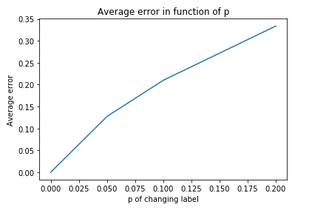
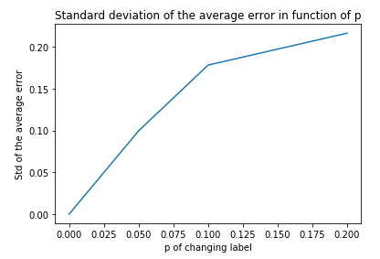

As in question 1, the standard deviation also increases because the initial situation varies more when p is great.

The points that changes label in question 2 could be compared to noise in our data. We can see that perceptron is not very robust to noise. It behavior can change a lot with noise.

