Paul Guillermo Arias

Unit 1 | Assignment – KickStart My Chart

**Question 1: What are three conclusions we can make about Kickstarter campaigns?**

1. A super category of creative arts are the most likely to be funded projects on Kickstarter.

Looking at the 9 parent categories, we can see that the biggest category of Kickstarter projects are theater, music and film & video. Technology comes in a close second. IT also appears from the stacked bar charts that they also have the highest percentages of “success” rates.

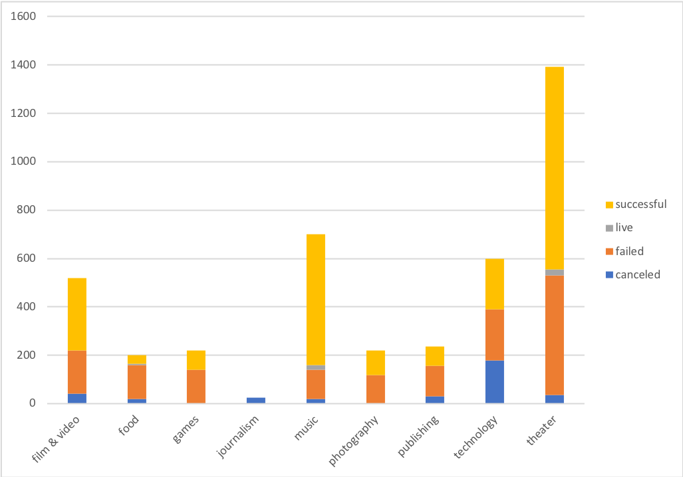

1. The least funded parent category is journalism, has highest (exclusively) cancellation rate.

It isn’t possible to determine a causation for the failure of the journalism projects from this dataset, however, it is perhaps enough for a person who is thinking in participating in some kind of Kickstarter to project to stay away from projects in this category.

1. Small projects tend to have the highest success rates.

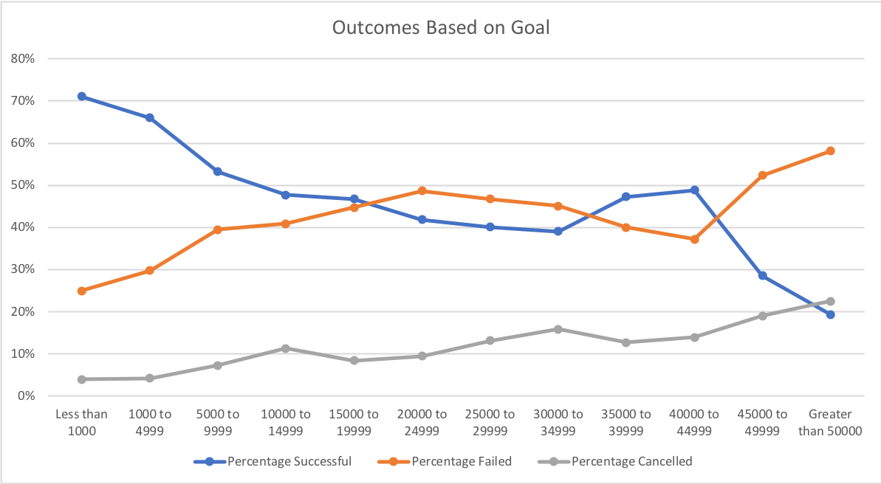

The percentage of successful projects ten to be highest when the funds requested are rather small. There is also some kind of phenomenon of higher degree of success when the project range is between $40000-$45000. It is possible that this range of project goal tends to attract people that will work on it full time, but that would need to be hypothesis to be tested with more relevant data.

**Question 2: What are some of the limitations of this dataset?**

The dataset does not seem to contain any information about the personnel of the project (how many people on the project team, expertise, etc.) It makes it harder to judge the possible competencies of the projects, or to determine if there is a distinction between success and failure rates.

**Question 3: What are some other possible tables/graphs that we could create?**

It is possible to report the overall percentage of success, failure and cancellation rates among each category, in order to get quantitative data on how these projects do. This can be done by reporting the value of the counts as % of the rows.

The projects that are highlighted by “Staff Picks” seem to have a much higher likelihood of succeeding, and this can be added as a filter to the chart with a line graph that shows success, failure and cancellation rates.