QUAKELAB INVESTIGATION

Earthquake Engineering
  - Structural basics through experimentation — then an open design challenge
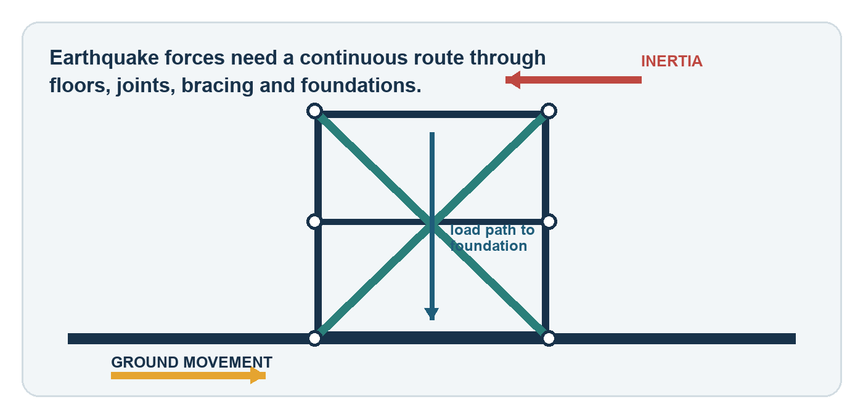
Student | Class | Teacher | Date

Driving question
How can evidence about forces, shape, materials, mass and vibration help us design safer buildings?

Year 9 Science & Engineering • 5–7 lessons • Individual task
START HERE

Your engineering mission
  - You will build knowledge in four controlled investigations before applying it to your own solution.

Learning intentions
- Explain how earthquake shaking creates forces in a structure.
- Investigate how bracing, materials, mass position and frequency affect structural response.
- Collect sensor data, identify patterns, and make evidence-based claims.
- Research earthquake-resistant design principles and judge the credibility of sources.
- Design, test and improve a solution within realistic constraints.

Success criteria
I can… | Evidence to include
conduct a fair test | one independent variable; other settings controlled
use measurements | units, sensor position, maximum response and cost
explain cause and effect | Claim–Evidence–Reasoning (CER), not just ‘it worked’
improve a design | labelled versions and a justified change
use research responsibly | credible sources, notes in my own words, links recorded

Important model limitation
QuakeLab is a simplified classroom model. A ‘survived’ result is not proof that a real building is safe or code-compliant. Real engineers use site data, standards, detailed analysis, testing and professional judgement.

Simulation survival checks
The app reports ‘survived’ only when all four simplified limits are met:
Roof sway | Storey drift | Failed members | Height retained
≤ 160 mm | ≤ 80 mm | ≤ 25% | ≥ 65%

RESEARCH PRIMER

What happens during an earthquake?
  - Read, annotate the image, then answer using scientific language.
Ground motion travels as seismic waves. Buildings resist rapid movement because of inertia, creating changing horizontal forces. Damage depends on the motion’s amplitude, frequency and duration, plus distance, depth, local geology, foundations, structural form and construction quality.
Australian context
Australia is not on a major plate boundary, but damaging earthquakes do occur. The 1989 Newcastle earthquake caused deaths and major damage. Earthquake hazard information is used in mitigation and building-code decisions.

R1. Distinguish earthquake magnitude from shaking intensity at a particular place.
________________________________________________________________________________
________________________________________________________________________________
R2. Use the diagram to explain why a continuous load path from roof to foundation matters.
________________________________________________________________________________
________________________________________________________________________________
R3. Name two site factors and two building factors that could change the amount of damage.
________________________________________________________________________________
________________________________________________________________________________
STRUCTURAL BASICS

Five ideas engineers combine
  - A safer design balances performance, cost, materials, use and constructability.
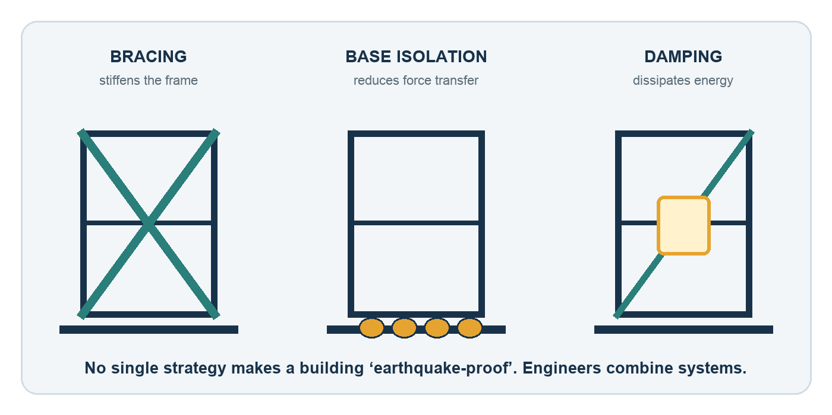
Principle | Meaning | Possible strategy
Load path | Forces travel through connected parts to the ground. | Strong joints; tied floors/walls; secure foundations
Strength + stiffness | Strength resists failure; stiffness limits shape change and drift. | Braced frames; shear walls; adequate members
Ductility | A system deforms and carries load instead of failing suddenly. | Detailed steel/reinforcement; ductile connections
Energy control | Reduce transferred energy or dissipate it. | Base isolation; dampers; material damping
Regularity + mass | Balanced load paths and sensible mass placement reduce twisting and demand. | Symmetry; avoid weak storeys; lighter upper levels

R4. Why is ‘earthquake-resistant’ more accurate than ‘earthquake-proof’?
________________________________________________________________________________
________________________________________________________________________________
R5. Explain the difference between strength, stiffness and ductility. Why might maximising only stiffness be a poor strategy?
________________________________________________________________________________
________________________________________________________________________________
________________________________________________________________________________
BEFORE TESTING

QuakeLab investigation routine
  - Use the same routine for every trial so your data can be compared.
Step | Action | Quality check
1 | Build from Floor Joints. Join joints with Beams and/or Braces. | Is there a continuous path to the shake table?
2 | Choose materials. Attach payload in 100 kg intervals. | Record material, mass and total cost.
3 | Place up to four Sensors on joints or along members. | Record exactly where S1–S4 are located.
4 | Set amplitude, frequency, duration and damping. | Change only the planned independent variable.
5 | Start test. Observe motion and failures; inspect response graph. | Record maximum values with units.
6 | Retest or modify after the test. Save evidence if required. | Label each version; do not overwrite observations.

Sensor meaning
A sensor reports signed horizontal movement (Δx) at its attachment point relative to the shake table. Positive and negative show direction. For comparison, use the maximum absolute value: the largest distance from zero.

Fair-test record
Independent variable | Dependent variable(s) | Controlled variables
what I change | what I measure | what I keep the same

Q0. Why should you reset or use the same starting structure before comparing trials?
________________________________________________________________________________
________________________________________________________________________________
INVESTIGATION 1

Frames and triangulation
  - How does diagonal bracing change lateral movement?
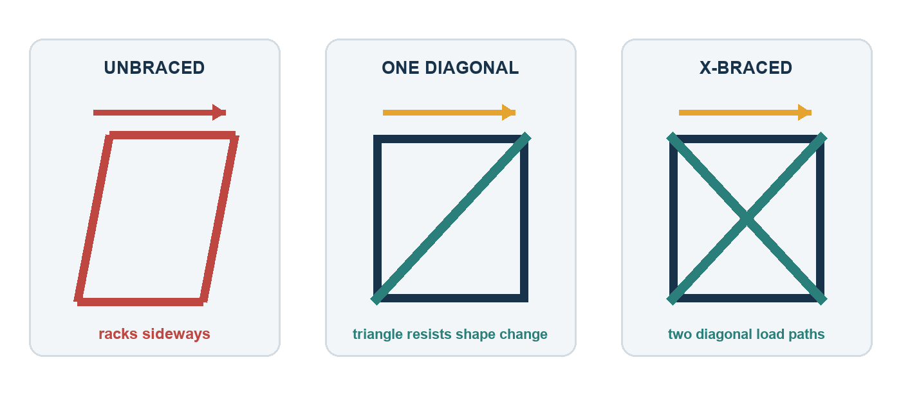
Controlled test
Build the same two-storey rectangular frame three times: A unbraced, B one diagonal per storey, C X-braced. Use Timber throughout, a 500 kg roof payload, amplitude 30 mm, frequency 1.50 Hz, duration 8 s, damping 8%. Place S1 on the roof and S2 on the first floor.

Prediction: Which design will have the lowest roof response? Why?
________________________________________________________________________________
Design | Cost ($) | Max |S1| roof (mm) | Max |S2| floor (mm) | Max drift (mm) | Failures | Survived?
A Unbraced
B Diagonal
C X-braced

Q1. Make a claim about triangulation. Support it with two numerical results.
________________________________________________________________________________
________________________________________________________________________________
Q2. What trade-off appears when more bracing is added? Consider cost, material and access/openings.
________________________________________________________________________________
INVESTIGATION 2

Materials: performance and cost
  - Does the most expensive material always give the best engineering solution?
Controlled test
Use your X-braced design from Investigation 1. Repeat the identical shake with every structural member changed to one material at a time. Keep geometry, sensors, 500 kg payload and shake settings unchanged.

Material | App cost / m | Strength | Stiffness | Weight | Damping
Timber | $10 | medium | medium | low | medium
Steel | $30 | high | high | high | low
Reinforced | $22 | high | high | medium | medium
Lightweight | $7 | low | low | low | medium–high

Material | Total cost ($) | Max |S1| (mm) | Max drift (mm) | Failures | Survived?
Timber
Steel
Reinforced
Lightweight

Q3. Which material gave the lowest movement? Which gave the best performance for cost? Use data.
________________________________________________________________________________
________________________________________________________________________________
________________________________________________________________________________
Q4. Explain why material selection is a multi-criteria decision rather than a simple ‘strongest wins’ choice.
________________________________________________________________________________
________________________________________________________________________________
INVESTIGATION 3

Mass and where it is placed
  - How does payload position affect movement and structural demand?
Controlled test
Use one unchanged, two-storey X-braced design. Use Timber and the Investigation 1 shake settings. Compare 2000 kg at the first floor, 2000 kg at the roof, and 1000 kg at each level. Sensors remain at roof (S1) and first floor (S2).

Trial | Mass arrangement | Max |S1| roof (mm) | Max |S2| floor (mm) | Max drift (mm) | Failures | Survived?
A | 2000 kg low
B | 2000 kg high
C | 1000 + 1000 kg

Q5. Which mass arrangement produced the greatest roof response or drift? Quote measurements.
________________________________________________________________________________
________________________________________________________________________________
Q6. Use inertia and centre of mass to explain the pattern. Why can heavy upper levels be challenging?
________________________________________________________________________________
________________________________________________________________________________
________________________________________________________________________________
Q7. Was total mass controlled in all three trials? Was mass position controlled? Identify the independent variable.
________________________________________________________________________________
________________________________________________________________________________
INVESTIGATION 4

Frequency, natural period and resonance
  - When can repeated shaking build a large response?
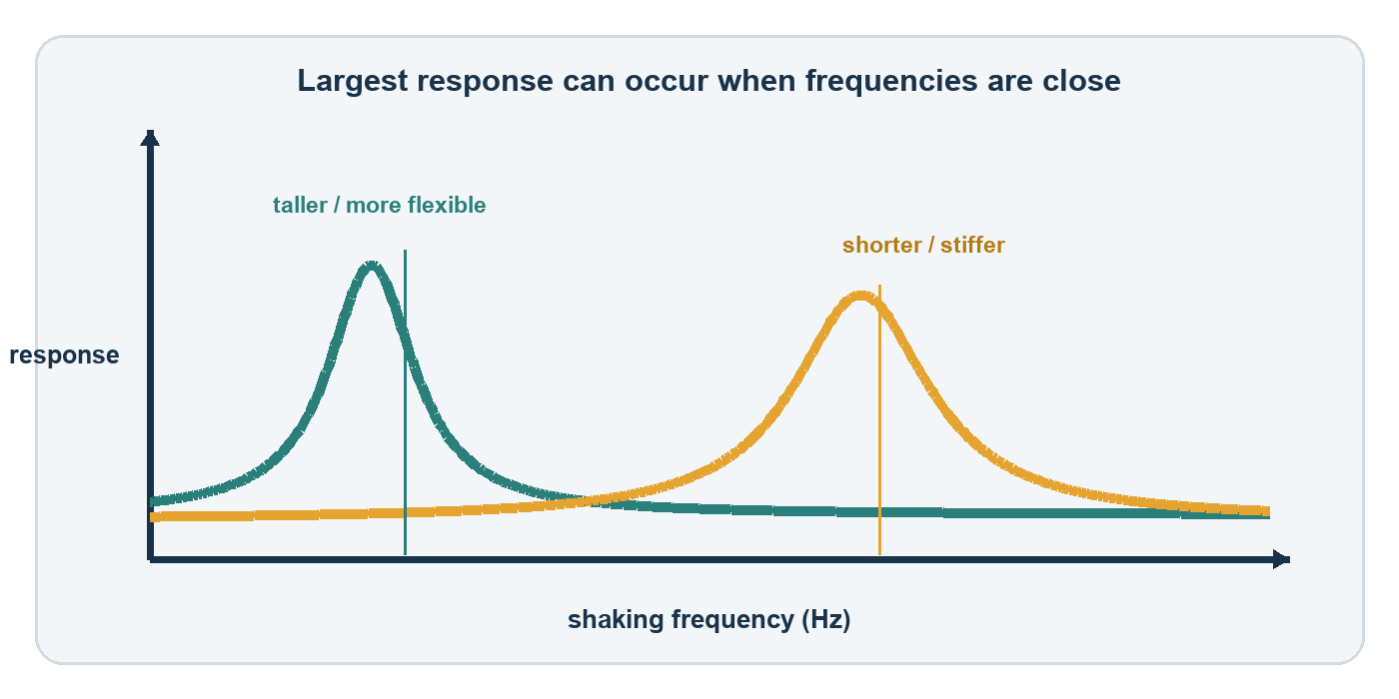
Every structure has natural modes of vibration. When forcing frequency is near a natural frequency, repeated pushes can add efficiently and response may grow. This is resonance. Height, stiffness, mass and damping all influence the response.
Frequency sweep
Use one unchanged design. Set amplitude 10 mm, duration 8 s and damping 8%. Test the listed frequencies. Record the app’s calculated peak acceleration and the maximum absolute roof-sensor response.

Frequency (Hz) | 0.50 | 1.00 | 1.50 | 2.00 | 3.00 | 4.00
Peak acceleration (g)
Max |S1| (mm)

Q8. At which frequency was the response largest? Does this suggest a possible resonant region?
________________________________________________________________________________
Q9. Why is constant amplitude not a perfectly fair resonance test? Hint: compare peak acceleration as frequency rises.
________________________________________________________________________________
________________________________________________________________________________
Q10. Predict how added damping would change the height and width of a resonance peak. Test one frequency if time permits.
________________________________________________________________________________
OPEN-ENDED DESIGN TASK

Resilient Community Hub Challenge
  - Design a three-level community building that protects occupants while meeting constraints.
Scenario
Your town needs a compact community hub that may shelter people after an earthquake. The building needs useful floor space, must carry emergency supplies, and must be affordable. You will independently propose, test and justify a structural concept.

Non-negotiable constraints
Requirement | Constraint
Form | Three occupied levels, fixed to the shake table with Floor Joints
Payload | 2000 kg total, placed in 100 kg intervals; justify its distribution
Materials | Use at least two app materials; total app cost ≤ $750
Complexity | Maximum 24 structural members (beams + braces)
Measurement | Use four sensors: base/low, middle, upper and roof locations
Research | Use at least two earthquake-resistant principles and cite sources
Final test | 60 mm amplitude • 2.00 Hz • 15 s • 8% damping
Performance | App survival + zero member failures + max roof |Δx| ≤ 120 mm

Engineering process
1 DEFINE → 2 IMAGINE → 3 PLAN → 4 BUILD → 5 TEST → 6 ANALYSE → 7 IMPROVE → 8 COMMUNICATE
Open-ended means
There is no single correct structure. A strong solution is one you can defend with measurements, structural reasoning, research, trade-offs and honest discussion of limitations.

CHALLENGE PLANNING

Concept sketch and design reasoning
  - Sketch clearly enough that your teacher or another student could reproduce your idea.
Front/elevation sketch — label floor joints, beams, braces, materials, masses and S1–S4 | Key dimensions / notes

Decision | My choice | Reason / research link
Structural form and load path
Bracing / lateral system
Materials
Mass distribution
Sensor locations

C1. Predict the part or storey most likely to experience the greatest movement or failure. Why?
________________________________________________________________________________
CHALLENGE TESTING

Test, analyse and improve
  - Use a lower-risk diagnostic test before the final hazard test.
Diagnostic test
Suggested settings: 30 mm amplitude, 1.50 Hz, 8 s, 8% damping. Observe load paths and sensor differences. Change one major feature at a time so you can explain the effect.

Version | Change made | Cost ($) | Max |S1| | Max |S2| | Max |S3| | Max |S4| | Drift | Failures
V1 | baseline
V2
V3

C2. Which change had the strongest evidence of improvement? Quote before-and-after data.
________________________________________________________________________________
________________________________________________________________________________
________________________________________________________________________________
C3. Did any change improve one measure but worsen another? Explain the trade-off.
________________________________________________________________________________
________________________________________________________________________________
________________________________________________________________________________

Final hazard test
Cost | Roof max |Δx| | Max drift | Failed members | Height retained / app result | Challenge met?

Attach or paste graph/screenshot evidence here if your teacher requests it.
COMMUNICATE

Engineering evidence report
  - Answer in complete sentences. Use precise measurements and acknowledge limitations.
E1 — Claim. How well did your final design meet the brief? State a clear overall judgement.
________________________________________________________________________________
________________________________________________________________________________
________________________________________________________________________________
E2 — Evidence. Give at least three relevant results, with units, including sensor response, drift/failure and cost.
________________________________________________________________________________
________________________________________________________________________________
________________________________________________________________________________
________________________________________________________________________________
E3 — Reasoning. Explain how two structural features caused the measured response. Use terms such as load path, stiffness, ductility, damping, inertia, triangulation or resonance correctly.
________________________________________________________________________________
________________________________________________________________________________
________________________________________________________________________________
________________________________________________________________________________
________________________________________________________________________________
E4 — Research connection. How does one credible real-world source support or challenge a choice you made? Cite it.
________________________________________________________________________________
________________________________________________________________________________
________________________________________________________________________________
E5 — Limitations. Identify two limitations of the simulator or your method. How could a real engineer obtain stronger evidence?
________________________________________________________________________________
________________________________________________________________________________
________________________________________________________________________________
________________________________________________________________________________
E6 — Next iteration. If given one more design cycle, what specific change would you test and what result would you expect?
________________________________________________________________________________
________________________________________________________________________________
________________________________________________________________________________
ASSESSMENT

Student checklist and rubric
  - Use this before submitting your workbook and design evidence.
Criterion | High achievement | Sound achievement | Developing | Marks
Investigation method | Fair tests; variables and sensor positions clear; data complete with units | Mostly controlled tests; usable data | Variables unclear or data incomplete | /4
Structural understanding | Accurate, connected explanation of forces and ≥3 principles | Explains main principles with minor gaps | Mostly describes results without mechanism | /4
Data analysis | Patterns, anomalies and trade-offs supported by quantitative evidence | Uses relevant data to support conclusions | Limited or unsupported conclusions | /4
Research literacy | Two credible sources evaluated, paraphrased and cited; limitations recognised | Relevant sources cited and mostly explained | Sources weak, copied or not connected | /4
Design process | Constraints met; purposeful iterations; final decision strongly justified | Design tested and improved; most constraints met | Little iteration or weak justification | /4

TOTAL: ____ / 20

Submission checklist
☐ All four investigations include predictions, measurements and answers.
☐ My cited research is in my own words and URLs are recorded.
☐ My challenge design is labelled and meets the constraints, or exceptions are explained.
☐ I included evidence from more than one design version.
☐ My final report uses numerical evidence and discusses limitations.
My strongest design decision | My most useful next improvement

RESEARCH SOURCES

Trusted starting points
  - Use these to begin; your teacher may approve additional sources. Accessed 27 August 2026.
Geoscience Australia — Earthquakes
Australian earthquake processes, magnitude and intensity, local factors, impacts and case examples.
Geoscience Australia — National Seismic Hazard Assessment
How national earthquake-hazard information supports risk reduction and building-code decisions.
Geoscience Australia — Resilience to the shake
Australian work on the vulnerability and strengthening of older masonry buildings, including Adelaide context.
FEMA / NEHRP — Earthquake-Resistant Design Concepts (FEMA P-749)
Accessible technical explanations of strength, stiffness, ductility, bracing, isolation and energy dissipation.
U.S. Geological Survey — What are the Effects of Earthquakes?
How amplitude, frequency, duration, distance and local ground conditions influence shaking and damage.
U.S. Geological Survey — How Seismic Waves Affect Different Size Buildings
Why different building sizes respond differently to wave frequencies.
EarthScope Consortium (IRIS) — Building resonance
Natural period, forcing frequency and resonance explained through building response.
Source use
Do not copy sentences. Read, close the source, write the idea in your own words, reopen it to check accuracy, then record the organisation, title and URL.

