Phipps_ms156

PGD

28/04/2020

This is the analysis for Bodie’s mice

# Questions

Mother focused

1. Is the MB of mothers different at the time of mating?
2. Is the MB of mothers different at the time of birth?
3. Is the MB of mothers different at the time the pups are sacrificed?
4. Is the MB of mothers different over time (gestation, birth, and pup sacrifice)?

Pup focused

1. Is the MB of pups different at the time of PVM infection (PND7)?
2. Is the MB of pups different in the early post natal period (PND3)?
3. Is the MB of pups different over time (PND3-7)?

Cross fostering focussed

1. What is the effect of cross fostering on the MB of pups at PND17?

First we got the data in

# Data input and subsetting  
  
# Get environmental metadata  
  
env <- read.table('../../Data/env_with_metadata.csv', header=TRUE, sep=',', row.names=1)  
  
# Get OTU table  
  
otu.tmp <- read.table('../../Data/otu_with_tax_1600.csv', header=TRUE, sep=',', row.names=1)  
otu <- t(otu.tmp[,-76]/1600) # transpose and divide by 1600 to get relative abundances  
  
taxonomy <- otu.tmp[,76] # Make a list of OTUs with the respective taxonomy  
taxonomy <- as.data.frame(taxonomy)  
row.names(taxonomy) <- row.names(otu.tmp)  
  
row.names(otu) == row.names(env)

## [1] TRUE TRUE TRUE TRUE TRUE TRUE TRUE TRUE TRUE TRUE TRUE TRUE TRUE TRUE TRUE  
## [16] TRUE TRUE TRUE TRUE TRUE TRUE TRUE TRUE TRUE TRUE TRUE TRUE TRUE TRUE TRUE  
## [31] TRUE TRUE TRUE TRUE TRUE TRUE TRUE TRUE TRUE TRUE TRUE TRUE TRUE TRUE TRUE  
## [46] TRUE TRUE TRUE TRUE TRUE TRUE TRUE TRUE TRUE TRUE TRUE TRUE TRUE TRUE TRUE  
## [61] TRUE TRUE TRUE TRUE TRUE TRUE TRUE TRUE TRUE TRUE TRUE TRUE TRUE TRUE TRUE

# Subset to questions  
  
env1 <- env[env$Q1 == 1,]  
env2 <- env[env$Q2 == 1,]  
env3 <- env[env$Q3 == 1,]  
env4 <- env[env$Q4 == 1,]  
env5 <- env[env$Q5 == 1,]  
env6 <- env[env$Q6 == 1,]  
env7 <- env[env$Q7 == 1,]  
env8 <- env[env$Q8 == 1,]  
  
otu1 <- otu[env$Q1 == 1,]  
otu2 <- otu[env$Q2 == 1,]  
otu3 <- otu[env$Q3 == 1,]  
otu4 <- otu[env$Q4 == 1,]  
otu5 <- otu[env$Q5 == 1,]  
otu6 <- otu[env$Q6 == 1,]  
otu7 <- otu[env$Q7 == 1,]  
otu8 <- otu[env$Q8 == 1,]

# Load libraries and source custom functions

source("../Functions/Functions.R")

## Loading required package: permute

## Loading required package: lattice

## This is vegan 2.5-6

library(sciplot)

Then we looked at Alpha diversity

### Alpha diversity  
  
library(vegan)  
library(sciplot)  
  
# Q1  
anova(lm(Chao1 ~ factor(Diet), data=env1))

## Analysis of Variance Table  
##   
## Response: Chao1  
## Df Sum Sq Mean Sq F value Pr(>F)  
## factor(Diet) 1 235.8 235.83 0.3612 0.5612  
## Residuals 10 6529.6 652.96

anova(lm(Sobs ~ factor(Diet), data=env1))

## Analysis of Variance Table  
##   
## Response: Sobs  
## Df Sum Sq Mean Sq F value Pr(>F)  
## factor(Diet) 1 102.08 102.083 1.7946 0.21  
## Residuals 10 568.83 56.883

#anova(lm(Simp ~ factor(Diet), data=env1))  
anova(lm(Shan ~ factor(Diet), data=env1))

## Analysis of Variance Table  
##   
## Response: Shan  
## Df Sum Sq Mean Sq F value Pr(>F)  
## factor(Diet) 1 0.01174 0.011735 0.0622 0.8081  
## Residuals 10 1.88706 0.188706

anova(lm(PD ~ factor(Diet), data=env1))

## Analysis of Variance Table  
##   
## Response: PD  
## Df Sum Sq Mean Sq F value Pr(>F)  
## factor(Diet) 1 0.01943 0.019429 0.1098 0.7472  
## Residuals 10 1.76872 0.176872

# Q2  
anova(lm(Chao1 ~ factor(Diet), data=env2))

## Analysis of Variance Table  
##   
## Response: Chao1  
## Df Sum Sq Mean Sq F value Pr(>F)  
## factor(Diet) 1 845.7 845.72 1.8631 0.2145  
## Residuals 7 3177.6 453.94

anova(lm(Sobs ~ factor(Diet), data=env2))

## Analysis of Variance Table  
##   
## Response: Sobs  
## Df Sum Sq Mean Sq F value Pr(>F)   
## factor(Diet) 1 120.05 120.050 5.0639 0.05917 .  
## Residuals 7 165.95 23.707   
## ---  
## Signif. codes: 0 '***' 0.001 '**' 0.01 '*' 0.05 '.' 0.1 ' ' 1

#anova(lm(Simp ~ factor(Diet), data=env2))  
anova(lm(Shan ~ factor(Diet), data=env2))

## Analysis of Variance Table  
##   
## Response: Shan  
## Df Sum Sq Mean Sq F value Pr(>F)   
## factor(Diet) 1 0.10090 0.100899 3.7127 0.09537 .  
## Residuals 7 0.19024 0.027177   
## ---  
## Signif. codes: 0 '***' 0.001 '**' 0.01 '*' 0.05 '.' 0.1 ' ' 1

anova(lm(PD ~ factor(Diet), data=env2))

## Analysis of Variance Table  
##   
## Response: PD  
## Df Sum Sq Mean Sq F value Pr(>F)   
## factor(Diet) 1 1.24383 1.24383 19.591 0.003058 **  
## Residuals 7 0.44443 0.06349   
## ---  
## Signif. codes: 0 '***' 0.001 '**' 0.01 '*' 0.05 '.' 0.1 ' ' 1

# Q3  
anova(lm(Chao1 ~ factor(Diet), data=env3))

## Analysis of Variance Table  
##   
## Response: Chao1  
## Df Sum Sq Mean Sq F value Pr(>F)  
## factor(Diet) 1 270.23 270.23 0.4463 0.5407  
## Residuals 4 2422.01 605.50

anova(lm(Sobs ~ factor(Diet), data=env3))

## Analysis of Variance Table  
##   
## Response: Sobs  
## Df Sum Sq Mean Sq F value Pr(>F)  
## factor(Diet) 1 28.17 28.167 0.1779 0.6949  
## Residuals 4 633.33 158.333

#anova(lm(Simp ~ factor(Diet), data=env3))  
anova(lm(Shan ~ factor(Diet), data=env3))

## Analysis of Variance Table  
##   
## Response: Shan  
## Df Sum Sq Mean Sq F value Pr(>F)  
## factor(Diet) 1 0.99081 0.99081 1.6819 0.2644  
## Residuals 4 2.35641 0.58910

anova(lm(PD ~ factor(Diet), data=env3))

## Analysis of Variance Table  
##   
## Response: PD  
## Df Sum Sq Mean Sq F value Pr(>F)  
## factor(Diet) 1 0.24618 0.24618 0.3562 0.5828  
## Residuals 4 2.76439 0.69110

# Q4  
anova(lm(Chao1 ~ factor(Diet) * factor(Time), data=env4))

## Analysis of Variance Table  
##   
## Response: Chao1  
## Df Sum Sq Mean Sq F value Pr(>F)  
## factor(Diet) 1 192.2 192.25 0.3328 0.5701  
## factor(Time) 2 491.1 245.54 0.4251 0.6592  
## factor(Diet):factor(Time) 2 1149.4 574.69 0.9950 0.3865  
## Residuals 21 12129.1 577.58

anova(lm(Sobs ~ factor(Diet) * factor(Time), data=env4))

## Analysis of Variance Table  
##   
## Response: Sobs  
## Df Sum Sq Mean Sq F value Pr(>F)  
## factor(Diet) 1 3.49 3.492 0.0536 0.8191  
## factor(Time) 2 263.95 131.976 2.0258 0.1569  
## factor(Diet):factor(Time) 2 246.07 123.034 1.8885 0.1761  
## Residuals 21 1368.12 65.148

#anova(lm(Simp ~ factor(Diet) * factor(Time), data=env4))  
anova(lm(Shan ~ factor(Diet) * factor(Time), data=env4))

## Analysis of Variance Table  
##   
## Response: Shan  
## Df Sum Sq Mean Sq F value Pr(>F)   
## factor(Diet) 1 0.6150 0.61503 2.9131 0.1026   
## factor(Time) 2 1.2873 0.64365 3.0486 0.0688 .  
## factor(Diet):factor(Time) 2 0.5775 0.28876 1.3677 0.2765   
## Residuals 21 4.4337 0.21113   
## ---  
## Signif. codes: 0 '***' 0.001 '**' 0.01 '*' 0.05 '.' 0.1 ' ' 1

anova(lm(PD ~ factor(Diet) * factor(Time), data=env4))

## Analysis of Variance Table  
##   
## Response: PD  
## Df Sum Sq Mean Sq F value Pr(>F)   
## factor(Diet) 1 0.8936 0.89358 3.7700 0.06572 .  
## factor(Time) 2 0.4026 0.20131 0.8493 0.44188   
## factor(Diet):factor(Time) 2 0.5710 0.28550 1.2045 0.31973   
## Residuals 21 4.9775 0.23703   
## ---  
## Signif. codes: 0 '***' 0.001 '**' 0.01 '*' 0.05 '.' 0.1 ' ' 1

# Q5  
anova(lm(Chao1 ~ factor(Diet), data=env5))

## Analysis of Variance Table  
##   
## Response: Chao1  
## Df Sum Sq Mean Sq F value Pr(>F)  
## factor(Diet) 1 20.88 20.884 0.0832 0.7779  
## Residuals 12 3011.93 250.994

anova(lm(Sobs ~ factor(Diet), data=env5))

## Analysis of Variance Table  
##   
## Response: Sobs  
## Df Sum Sq Mean Sq F value Pr(>F)   
## factor(Diet) 1 176.09 176.095 14.59 0.002441 **  
## Residuals 12 144.83 12.069   
## ---  
## Signif. codes: 0 '***' 0.001 '**' 0.01 '*' 0.05 '.' 0.1 ' ' 1

#anova(lm(Simp ~ factor(Diet), data=env5))  
anova(lm(Shan ~ factor(Diet), data=env5))

## Analysis of Variance Table  
##   
## Response: Shan  
## Df Sum Sq Mean Sq F value Pr(>F)   
## factor(Diet) 1 1.8641 1.86410 13.386 0.003274 **  
## Residuals 12 1.6710 0.13925   
## ---  
## Signif. codes: 0 '***' 0.001 '**' 0.01 '*' 0.05 '.' 0.1 ' ' 1

anova(lm(PD ~ factor(Diet), data=env5))

## Analysis of Variance Table  
##   
## Response: PD  
## Df Sum Sq Mean Sq F value Pr(>F)   
## factor(Diet) 1 0.45893 0.45893 7.3981 0.01861 *  
## Residuals 12 0.74441 0.06203   
## ---  
## Signif. codes: 0 '***' 0.001 '**' 0.01 '*' 0.05 '.' 0.1 ' ' 1

# Q6  
anova(lm(Chao1 ~ factor(Diet), data=env6))

## Analysis of Variance Table  
##   
## Response: Chao1  
## Df Sum Sq Mean Sq F value Pr(>F)   
## factor(Diet) 1 7493.6 7493.6 42.32 0.0001108 ***  
## Residuals 9 1593.6 177.1   
## ---  
## Signif. codes: 0 '***' 0.001 '**' 0.01 '*' 0.05 '.' 0.1 ' ' 1

anova(lm(Sobs ~ factor(Diet), data=env6))

## Analysis of Variance Table  
##   
## Response: Sobs  
## Df Sum Sq Mean Sq F value Pr(>F)   
## factor(Diet) 1 1820.08 1820.08 21.759 0.001178 **  
## Residuals 9 752.83 83.65   
## ---  
## Signif. codes: 0 '***' 0.001 '**' 0.01 '*' 0.05 '.' 0.1 ' ' 1

#anova(lm(Simp ~ factor(Diet), data=env6))  
anova(lm(Shan ~ factor(Diet), data=env6))

## Analysis of Variance Table  
##   
## Response: Shan  
## Df Sum Sq Mean Sq F value Pr(>F)   
## factor(Diet) 1 4.7836 4.7836 16.264 0.00296 **  
## Residuals 9 2.6472 0.2941   
## ---  
## Signif. codes: 0 '***' 0.001 '**' 0.01 '*' 0.05 '.' 0.1 ' ' 1

anova(lm(PD ~ factor(Diet), data=env6))

## Analysis of Variance Table  
##   
## Response: PD  
## Df Sum Sq Mean Sq F value Pr(>F)   
## factor(Diet) 1 4.6973 4.6973 21.724 0.001184 **  
## Residuals 9 1.9461 0.2162   
## ---  
## Signif. codes: 0 '***' 0.001 '**' 0.01 '*' 0.05 '.' 0.1 ' ' 1

# Q7  
anova(lm(Chao1 ~ factor(Diet) * factor(Time), data=env7))

## Analysis of Variance Table  
##   
## Response: Chao1  
## Df Sum Sq Mean Sq F value Pr(>F)   
## factor(Diet) 1 5456.8 5456.8 24.881 6.164e-05 ***  
## factor(Time) 1 11291.7 11291.7 51.487 4.499e-07 ***  
## factor(Diet):factor(Time) 1 3789.9 3789.9 17.281 0.0004464 ***  
## Residuals 21 4605.6 219.3   
## ---  
## Signif. codes: 0 '***' 0.001 '**' 0.01 '*' 0.05 '.' 0.1 ' ' 1

anova(lm(Sobs ~ factor(Diet) * factor(Time), data=env7))

## Analysis of Variance Table  
##   
## Response: Sobs  
## Df Sum Sq Mean Sq F value Pr(>F)   
## factor(Diet) 1 2544.2 2544.2 59.520 1.466e-07 ***  
## factor(Time) 1 10322.8 10322.8 241.492 5.429e-13 ***  
## factor(Diet):factor(Time) 1 529.3 529.3 12.382 0.00204 **   
## Residuals 21 897.7 42.7   
## ---  
## Signif. codes: 0 '***' 0.001 '**' 0.01 '*' 0.05 '.' 0.1 ' ' 1

#anova(lm(Simp ~ factor(Diet) * factor(Time), data=env7))  
anova(lm(Shan ~ factor(Diet) * factor(Time), data=env7))

## Analysis of Variance Table  
##   
## Response: Shan  
## Df Sum Sq Mean Sq F value Pr(>F)   
## factor(Diet) 1 0.0129 0.0129 0.0627 0.8046   
## factor(Time) 1 7.7856 7.7856 37.8620 4.184e-06 ***  
## factor(Diet):factor(Time) 1 6.4569 6.4569 31.4005 1.463e-05 ***  
## Residuals 21 4.3182 0.2056   
## ---  
## Signif. codes: 0 '***' 0.001 '**' 0.01 '*' 0.05 '.' 0.1 ' ' 1

anova(lm(PD ~ factor(Diet) * factor(Time), data=env7))

## Analysis of Variance Table  
##   
## Response: PD  
## Df Sum Sq Mean Sq F value Pr(>F)   
## factor(Diet) 1 7.243 7.243 56.537 2.193e-07 ***  
## factor(Time) 1 38.971 38.971 304.180 5.687e-14 ***  
## factor(Diet):factor(Time) 1 1.361 1.361 10.622 0.003751 **   
## Residuals 21 2.691 0.128   
## ---  
## Signif. codes: 0 '***' 0.001 '**' 0.01 '*' 0.05 '.' 0.1 ' ' 1

# Q8  
anova(lm(Chao1 ~ factor(Cross.foster), data=env8))

## Analysis of Variance Table  
##   
## Response: Chao1  
## Df Sum Sq Mean Sq F value Pr(>F)   
## factor(Cross.foster) 3 4262.0 1420.66 6.3324 0.003692 **  
## Residuals 19 4262.6 224.35   
## ---  
## Signif. codes: 0 '***' 0.001 '**' 0.01 '*' 0.05 '.' 0.1 ' ' 1

anova(lm(Sobs ~ factor(Cross.foster), data=env8))

## Analysis of Variance Table  
##   
## Response: Sobs  
## Df Sum Sq Mean Sq F value Pr(>F)   
## factor(Cross.foster) 3 2695.25 898.42 17.856 9.336e-06 ***  
## Residuals 19 955.97 50.31   
## ---  
## Signif. codes: 0 '***' 0.001 '**' 0.01 '*' 0.05 '.' 0.1 ' ' 1

#anova(lm(Simp ~ factor(Cross.foster), data=env8))  
anova(lm(Shan ~ factor(Cross.foster), data=env8))

## Analysis of Variance Table  
##   
## Response: Shan  
## Df Sum Sq Mean Sq F value Pr(>F)   
## factor(Cross.foster) 3 3.7722 1.2574 4.0746 0.02158 *  
## Residuals 19 5.8634 0.3086   
## ---  
## Signif. codes: 0 '***' 0.001 '**' 0.01 '*' 0.05 '.' 0.1 ' ' 1

anova(lm(PD ~ factor(Cross.foster), data=env8))

## Analysis of Variance Table  
##   
## Response: PD  
## Df Sum Sq Mean Sq F value Pr(>F)   
## factor(Cross.foster) 3 8.4761 2.82536 18.782 6.571e-06 ***  
## Residuals 19 2.8581 0.15043   
## ---  
## Signif. codes: 0 '***' 0.001 '**' 0.01 '*' 0.05 '.' 0.1 ' ' 1

#Tukey's Honest Significant Difference Post hoc's  
  
# Q4  
TukeyHSD(aov(Chao1 ~ factor(Diet) * factor(Time), data=env4))

## Tukey multiple comparisons of means  
## 95% family-wise confidence level  
##   
## Fit: aov(formula = Chao1 ~ factor(Diet) * factor(Time), data = env4)  
##   
## $`factor(Diet)`  
## diff lwr upr p adj  
## HFD-CFD -5.34041 -24.59056 13.90974 0.5701204  
##   
## $`factor(Time)`  
## diff lwr upr p adj  
## PND17-E0 -10.468097 -40.75634 19.82015 0.6639090  
## PupDOB-E0 -6.450435 -33.16216 20.26129 0.8169882  
## PupDOB-PND17 4.017662 -27.90895 35.94428 0.9461917  
##   
## $`factor(Diet):factor(Time)`  
## diff lwr upr p adj  
## HFD:E0-CFD:E0 8.8662473 -34.54272 52.27522 0.9865649  
## CFD:PND17-CFD:E0 0.6761374 -52.48878 53.84105 1.0000000  
## HFD:PND17-CFD:E0 -12.7460848 -65.91100 40.41883 0.9728861  
## CFD:PupDOB-CFD:E0 6.9497485 -38.57797 52.47746 0.9964734  
## HFD:PupDOB-CFD:E0 -12.5585848 -61.09129 35.97412 0.9625431  
## CFD:PND17-HFD:E0 -8.1901099 -61.35503 44.97481 0.9963188  
## HFD:PND17-HFD:E0 -21.6123321 -74.77725 31.55258 0.7964993  
## CFD:PupDOB-HFD:E0 -1.9164988 -47.44421 43.61122 0.9999935  
## HFD:PupDOB-HFD:E0 -21.4248321 -69.95754 27.10787 0.7373738  
## HFD:PND17-CFD:PND17 -13.4222222 -74.81178 47.96733 0.9818293  
## CFD:PupDOB-CFD:PND17 6.2736111 -48.63488 61.18210 0.9991139  
## HFD:PupDOB-CFD:PND17 -13.2347222 -70.65939 44.18995 0.9771270  
## CFD:PupDOB-HFD:PND17 19.6958333 -35.21266 74.60432 0.8667303  
## HFD:PupDOB-HFD:PND17 0.1875000 -57.23717 57.61217 1.0000000  
## HFD:PupDOB-CFD:PupDOB -19.5083333 -69.94500 30.92833 0.8271615

TukeyHSD(aov(Sobs ~ factor(Diet) * factor(Time), data=env4))

## Tukey multiple comparisons of means  
## 95% family-wise confidence level  
##   
## Fit: aov(formula = Sobs ~ factor(Diet) * factor(Time), data = env4)  
##   
## $`factor(Diet)`  
## diff lwr upr p adj  
## HFD-CFD -0.7197802 -7.184963 5.745402 0.8191464  
##   
## $`factor(Time)`  
## diff lwr upr p adj  
## PND17-E0 -7.916667 -18.089003 2.255670 0.1466303  
## PupDOB-E0 -4.123321 -13.094479 4.847837 0.4901337  
## PupDOB-PND17 3.793346 -6.929239 14.515930 0.6513267  
##   
## $`factor(Diet):factor(Time)`  
## diff lwr upr p adj  
## HFD:E0-CFD:E0 5.833333 -8.745611 20.412278 0.8066781  
## CFD:PND17-CFD:E0 -2.833333 -20.688821 15.022154 0.9957713  
## HFD:PND17-CFD:E0 -7.166667 -25.022154 10.688821 0.8047056  
## CFD:PupDOB-CFD:E0 2.100000 -13.190526 17.390526 0.9978597  
## HFD:PupDOB-CFD:E0 -5.250000 -21.549756 11.049756 0.9102132  
## CFD:PND17-HFD:E0 -8.666667 -26.522154 9.188821 0.6568617  
## HFD:PND17-HFD:E0 -13.000000 -30.855488 4.855488 0.2464275  
## CFD:PupDOB-HFD:E0 -3.733333 -19.023860 11.557193 0.9706879  
## HFD:PupDOB-HFD:E0 -11.083333 -27.383089 5.216422 0.3117795  
## HFD:PND17-CFD:PND17 -4.333333 -24.951075 16.284408 0.9847390  
## CFD:PupDOB-CFD:PND17 4.933333 -13.507735 23.374402 0.9569938  
## HFD:PupDOB-CFD:PND17 -2.416667 -21.702798 16.869464 0.9986185  
## CFD:PupDOB-HFD:PND17 9.266667 -9.174402 27.707735 0.6244257  
## HFD:PupDOB-HFD:PND17 1.916667 -17.369464 21.202798 0.9995495  
## HFD:PupDOB-CFD:PupDOB -7.350000 -24.289203 9.589203 0.7505976

#anova(lm(Simp ~ factor(Diet) * factor(Time), data=env4))  
TukeyHSD(aov(Shan ~ factor(Diet) * factor(Time), data=env4))

## Tukey multiple comparisons of means  
## 95% family-wise confidence level  
##   
## Fit: aov(formula = Shan ~ factor(Diet) * factor(Time), data = env4)  
##   
## $`factor(Diet)`  
## diff lwr upr p adj  
## HFD-CFD 0.3020614 -0.06598533 0.6701081 0.1026105  
##   
## $`factor(Time)`  
## diff lwr upr p adj  
## PND17-E0 0.1270165 -0.4520693 0.70610224 0.8461457  
## PupDOB-E0 -0.4084775 -0.9191832 0.10222811 0.1329960  
## PupDOB-PND17 -0.5354940 -1.1459040 0.07491599 0.0924401  
##   
## $`factor(Diet):factor(Time)`  
## diff lwr upr p adj  
## HFD:E0-CFD:E0 0.06254369 -0.7673993 0.89248666 0.9998838  
## CFD:PND17-CFD:E0 -0.24807906 -1.2645475 0.76838934 0.9707391  
## HFD:PND17-CFD:E0 0.56465570 -0.4518127 1.58112410 0.5236529  
## CFD:PupDOB-CFD:E0 -0.48869056 -1.3591421 0.38176098 0.5125686  
## HFD:PupDOB-CFD:E0 -0.27560727 -1.2035117 0.65229718 0.9343758  
## CFD:PND17-HFD:E0 -0.31062274 -1.3270911 0.70584565 0.9266347  
## HFD:PND17-HFD:E0 0.50211201 -0.5143564 1.51858041 0.6406158  
## CFD:PupDOB-HFD:E0 -0.55123424 -1.4216858 0.31921729 0.3849043  
## HFD:PupDOB-HFD:E0 -0.33815096 -1.2660554 0.58975349 0.8590871  
## HFD:PND17-CFD:PND17 0.81273476 -0.3609818 1.98645136 0.2938247  
## CFD:PupDOB-CFD:PND17 -0.24061150 -1.2904155 0.80919255 0.9776708  
## HFD:PupDOB-CFD:PND17 -0.02752821 -1.1254396 1.07038314 0.9999995  
## CFD:PupDOB-HFD:PND17 -1.05334626 -2.1031503 -0.00354221 0.0489159  
## HFD:PupDOB-HFD:PND17 -0.84026297 -1.9381743 0.25764838 0.2030137  
## HFD:PupDOB-CFD:PupDOB 0.21308329 -0.7512233 1.17738988 0.9809632

TukeyHSD(aov(PD ~ factor(Diet) * factor(Time), data=env4))

## Tukey multiple comparisons of means  
## 95% family-wise confidence level  
##   
## Fit: aov(formula = PD ~ factor(Diet) * factor(Time), data = env4)  
##   
## $`factor(Diet)`  
## diff lwr upr p adj  
## HFD-CFD -0.364093 -0.754059 0.02587302 0.0657174  
##   
## $`factor(Time)`  
## diff lwr upr p adj  
## PND17-E0 -0.21206883 -0.8256425 0.4015048 0.6638888  
## PupDOB-E0 -0.26309411 -0.8042152 0.2780270 0.4517748  
## PupDOB-PND17 -0.05102528 -0.6977887 0.5957381 0.9784584  
##   
## $`factor(Diet):factor(Time)`  
## diff lwr upr p adj  
## HFD:E0-CFD:E0 -0.08047644 -0.9598473 0.7988944 0.9996987  
## CFD:PND17-CFD:E0 -0.04975044 -1.1267553 1.0272544 0.9999897  
## HFD:PND17-CFD:E0 -0.45486366 -1.5318685 0.6221412 0.7704028  
## CFD:PupDOB-CFD:E0 0.04940496 -0.8728869 0.9716968 0.9999785  
## HFD:PupDOB-CFD:E0 -0.69874233 -1.6819088 0.2844241 0.2688071  
## CFD:PND17-HFD:E0 0.03072600 -1.0462789 1.1077309 0.9999991  
## HFD:PND17-HFD:E0 -0.37438722 -1.4513921 0.7026177 0.8808991  
## CFD:PupDOB-HFD:E0 0.12988140 -0.7924105 1.0521733 0.9975894  
## HFD:PupDOB-HFD:E0 -0.61826589 -1.6014323 0.3649006 0.3922839  
## HFD:PND17-CFD:PND17 -0.40511322 -1.6487313 0.8385049 0.9062970  
## CFD:PupDOB-CFD:PND17 0.09915540 -1.0131705 1.2114813 0.9997350  
## HFD:PupDOB-CFD:PND17 -0.64899189 -1.8122901 0.5143063 0.5191816  
## CFD:PupDOB-HFD:PND17 0.50426862 -0.6080572 1.6165945 0.7161090  
## HFD:PupDOB-HFD:PND17 -0.24387867 -1.4071769 0.9194196 0.9849095  
## HFD:PupDOB-CFD:PupDOB -0.74814729 -1.7698838 0.2735893 0.2412647

# Q7  
TukeyHSD(aov(Chao1 ~ factor(Diet) * factor(Time), data=env7))

## Tukey multiple comparisons of means  
## 95% family-wise confidence level  
##   
## Fit: aov(formula = Chao1 ~ factor(Diet) * factor(Time), data = env7)  
##   
## $`factor(Diet)`  
## diff lwr upr p adj  
## HFD-CFD -29.57164 -41.90048 -17.24281 6.16e-05  
##   
## $`factor(Time)`  
## diff lwr upr p adj  
## PND7-PND3 -42.52465 -54.93329 -30.11601 5e-07  
##   
## $`factor(Diet):factor(Time)`  
## diff lwr upr p adj  
## HFD:PND3-CFD:PND3 -52.418218 -77.41336 -27.42307 0.0000466  
## CFD:PND7-CFD:PND3 -68.397222 -92.22916 -44.56529 0.0000005  
## HFD:PND7-CFD:PND3 -70.865278 -93.15801 -48.57254 0.0000001  
## CFD:PND7-HFD:PND3 -15.979004 -40.97415 9.01614 0.3093994  
## HFD:PND7-HFD:PND3 -18.447060 -41.97921 5.08509 0.1600444  
## HFD:PND7-CFD:PND7 -2.468056 -24.76079 19.82468 0.9895077

TukeyHSD(aov(Sobs ~ factor(Diet) * factor(Time), data=env7))

## Tukey multiple comparisons of means  
## 95% family-wise confidence level  
##   
## Fit: aov(formula = Sobs ~ factor(Diet) * factor(Time), data = env7)  
##   
## $`factor(Diet)`  
## diff lwr upr p adj  
## HFD-CFD -20.19231 -25.63531 -14.74931 1e-07  
##   
## $`factor(Time)`  
## diff lwr upr p adj  
## PND7-PND3 -40.65934 -46.13757 -35.18111 0  
##   
## $`factor(Diet):factor(Time)`  
## diff lwr upr p adj  
## HFD:PND3-CFD:PND3 -25.833333 -36.86832 -14.798348 0.0000103  
## CFD:PND7-CFD:PND3 -50.666667 -61.18811 -40.145221 0.0000000  
## HFD:PND7-CFD:PND3 -57.833333 -67.67524 -47.991422 0.0000000  
## CFD:PND7-HFD:PND3 -24.833333 -35.86832 -13.798348 0.0000179  
## HFD:PND7-HFD:PND3 -32.000000 -42.38910 -21.610904 0.0000001  
## HFD:PND7-CFD:PND7 -7.166667 -17.00858 2.675245 0.2091153

#anova(lm(Simp ~ factor(Diet) * factor(Time), data=env7))  
TukeyHSD(aov(Shan ~ factor(Diet) * factor(Time), data=env7))

## Tukey multiple comparisons of means  
## 95% family-wise confidence level  
##   
## Fit: aov(formula = Shan ~ factor(Diet) * factor(Time), data = env7)  
##   
## $`factor(Diet)`  
## diff lwr upr p adj  
## HFD-CFD 0.04547071 -0.332044 0.4229854 0.8046472  
##   
## $`factor(Time)`  
## diff lwr upr p adj  
## PND7-PND3 -1.116622 -1.49658 -0.7366639 4.6e-06  
##   
## $`factor(Diet):factor(Time)`  
## diff lwr upr p adj  
## HFD:PND3-CFD:PND3 1.3243855 0.5590226 2.0897484 0.0004912  
## CFD:PND7-CFD:PND3 -0.0879670 -0.8177119 0.6417779 0.9865569  
## HFD:PND7-CFD:PND3 -0.8253242 -1.5079380 -0.1427104 0.0141925  
## CFD:PND7-HFD:PND3 -1.4123525 -2.1777154 -0.6469896 0.0002330  
## HFD:PND7-HFD:PND3 -2.1497097 -2.8702751 -1.4291444 0.0000003  
## HFD:PND7-CFD:PND7 -0.7373572 -1.4199711 -0.0547434 0.0312116

TukeyHSD(aov(PD ~ factor(Diet) * factor(Time), data=env7))

## Tukey multiple comparisons of means  
## 95% family-wise confidence level  
##   
## Fit: aov(formula = PD ~ factor(Diet) * factor(Time), data = env7)  
##   
## $`factor(Diet)`  
## diff lwr upr p adj  
## HFD-CFD -1.077407 -1.375394 -0.7794202 2e-07  
##   
## $`factor(Time)`  
## diff lwr upr p adj  
## PND7-PND3 -2.498234 -2.79815 -2.198318 0  
##   
## $`factor(Diet):factor(Time)`  
## diff lwr upr p adj  
## HFD:PND3-CFD:PND3 -1.3123864 -1.9165171 -0.7082557 0.0000291  
## CFD:PND7-CFD:PND3 -3.0116399 -3.5876559 -2.4356239 0.0000000  
## HFD:PND7-CFD:PND3 -3.3775026 -3.9163162 -2.8386890 0.0000000  
## CFD:PND7-HFD:PND3 -1.6992534 -2.3033841 -1.0951227 0.0000006  
## HFD:PND7-HFD:PND3 -2.0651162 -2.6338864 -1.4963459 0.0000000  
## HFD:PND7-CFD:PND7 -0.3658627 -0.9046764 0.1729509 0.2611681

# Q8  
TukeyHSD(aov(Chao1 ~ factor(Cross.foster), data=env8))

## Tukey multiple comparisons of means  
## 95% family-wise confidence level  
##   
## Fit: aov(formula = Chao1 ~ factor(Cross.foster), data = env8)  
##   
## $`factor(Cross.foster)`  
## diff lwr upr p adj  
## CFD2HFD-CFD -28.283424 -52.59935 -3.96750 0.0192473  
## HFD-CFD 6.700541 -17.61538 31.01646 0.8648205  
## HFD2CFD-CFD -1.552868 -27.05562 23.94989 0.9981509  
## HFD-CFD2HFD 34.983965 10.66804 59.29989 0.0035337  
## HFD2CFD-CFD2HFD 26.730556 1.22780 52.23331 0.0379482  
## HFD2CFD-HFD -8.253409 -33.75616 17.24935 0.7997812

TukeyHSD(aov(Sobs ~ factor(Cross.foster), data=env8))

## Tukey multiple comparisons of means  
## 95% family-wise confidence level  
##   
## Fit: aov(formula = Sobs ~ factor(Cross.foster), data = env8)  
##   
## $`factor(Cross.foster)`  
## diff lwr upr p adj  
## CFD2HFD-CFD -27.000000 -38.5153059 -15.4846941 0.0000145  
## HFD-CFD -3.333333 -14.8486393 8.1819726 0.8471265  
## HFD2CFD-CFD -15.033333 -27.1106881 -2.9559786 0.0117388  
## HFD-CFD2HFD 23.666667 12.1513607 35.1819726 0.0000787  
## HFD2CFD-CFD2HFD 11.966667 -0.1106881 24.0440214 0.0526604  
## HFD2CFD-HFD -11.700000 -23.7773548 0.3773548 0.0596096

#anova(lm(Simp ~ factor(Cross.foster), data=env8))  
TukeyHSD(aov(Shan ~ factor(Cross.foster), data=env8))

## Tukey multiple comparisons of means  
## 95% family-wise confidence level  
##   
## Fit: aov(formula = Shan ~ factor(Cross.foster), data = env8)  
##   
## $`factor(Cross.foster)`  
## diff lwr upr p adj  
## CFD2HFD-CFD -1.11248970 -2.0143248 -0.2106546 0.0125672  
## HFD-CFD -0.44685881 -1.3486939 0.4549763 0.5184765  
## HFD2CFD-CFD -0.46567735 -1.4115300 0.4801753 0.5237203  
## HFD-CFD2HFD 0.66563089 -0.2362042 1.5674660 0.1968165  
## HFD2CFD-CFD2HFD 0.64681235 -0.2990403 1.5926650 0.2519692  
## HFD2CFD-HFD -0.01881854 -0.9646712 0.9270341 0.9999348

TukeyHSD(aov(PD ~ factor(Cross.foster), data=env8))

## Tukey multiple comparisons of means  
## 95% family-wise confidence level  
##   
## Fit: aov(formula = PD ~ factor(Cross.foster), data = env8)  
##   
## $`factor(Cross.foster)`  
## diff lwr upr p adj  
## CFD2HFD-CFD -1.5079385 -2.13758136 -0.87829565 0.0000109  
## HFD-CFD -0.1542652 -0.78390805 0.47537766 0.9000508  
## HFD2CFD-CFD -0.7889453 -1.44932033 -0.12857034 0.0159163  
## HFD-CFD2HFD 1.3536733 0.72403045 1.98331617 0.0000449  
## HFD2CFD-CFD2HFD 0.7189932 0.05861817 1.37936817 0.0299458  
## HFD2CFD-HFD -0.6346801 -1.29505514 0.02569486 0.0622105

# Plots  
  
  
# Q1  
bargraph.CI(x.factor = factor(Diet), response = Chao1, data=env1, legend = TRUE)

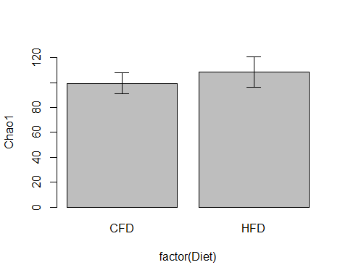

bargraph.CI(x.factor = factor(Diet), response = Sobs, data=env1, legend = TRUE)

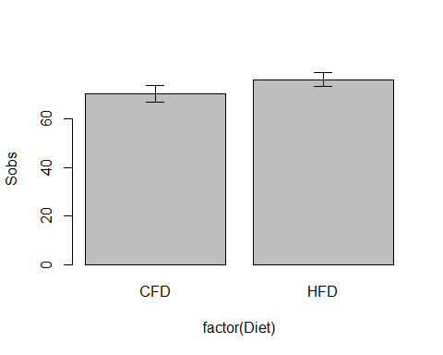

#bargraph.CI(x.factor = factor(Diet), response = Simp, data=env1, legend = TRUE)  
bargraph.CI(x.factor = factor(Diet), response = Shan, data=env1, legend = TRUE)

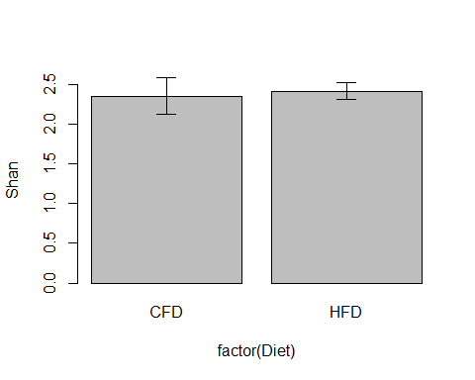

bargraph.CI(x.factor = factor(Diet), response = PD, data=env1, legend = TRUE)

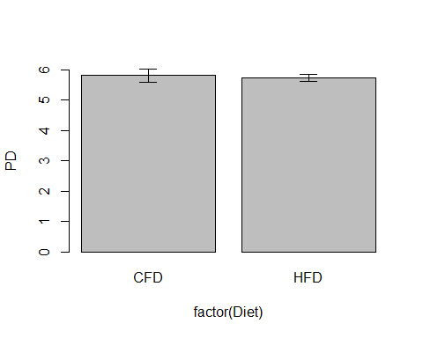

# Q2  
bargraph.CI(x.factor = factor(Diet), response = Chao1, data=env2, legend = TRUE)

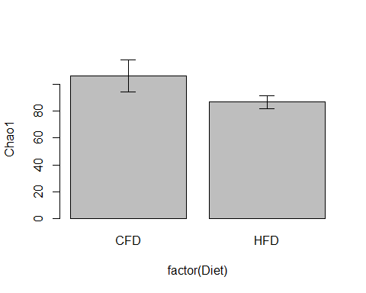

bargraph.CI(x.factor = factor(Diet), response = Sobs, data=env2, legend = TRUE)

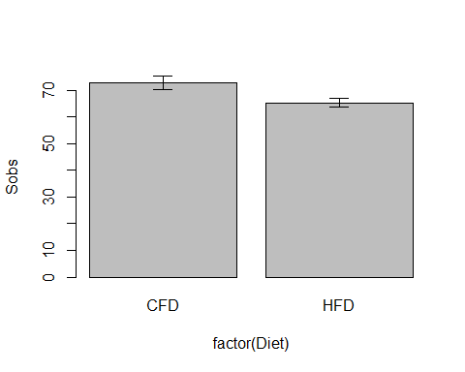

#bargraph.CI(x.factor = factor(Diet), response = Simp, data=env2, legend = TRUE)  
bargraph.CI(x.factor = factor(Diet), response = Shan, data=env2, legend = TRUE)

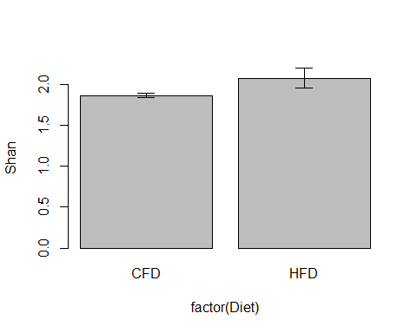

bargraph.CI(x.factor = factor(Diet), response = PD, data=env2, legend = TRUE)

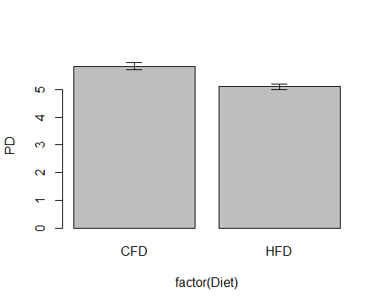

# Q3  
bargraph.CI(x.factor = factor(Diet), response = Chao1, data=env3, legend = TRUE)

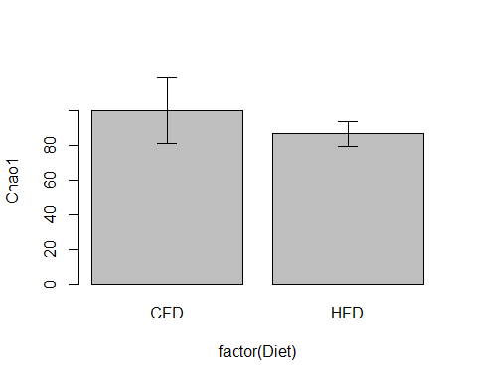

bargraph.CI(x.factor = factor(Diet), response = Sobs, data=env3, legend = TRUE)

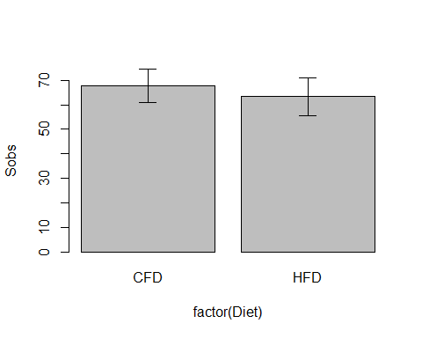

#bargraph.CI(x.factor = factor(Diet), response = Simp, data=env3, legend = TRUE)  
bargraph.CI(x.factor = factor(Diet), response = Shan, data=env3, legend = TRUE)

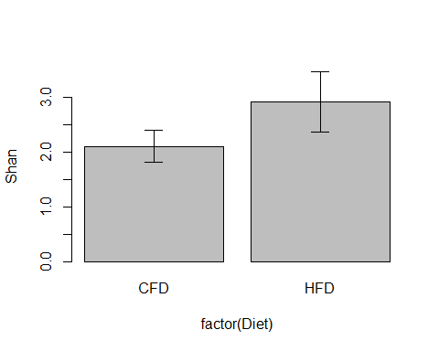

bargraph.CI(x.factor = factor(Diet), response = PD, data=env3, legend = TRUE)

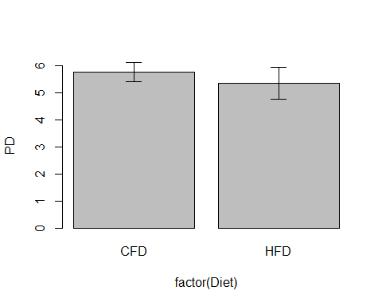

# Q4  
bargraph.CI(x.factor = factor(Diet), response = Chao1, group = Time, data=env4, legend = TRUE)

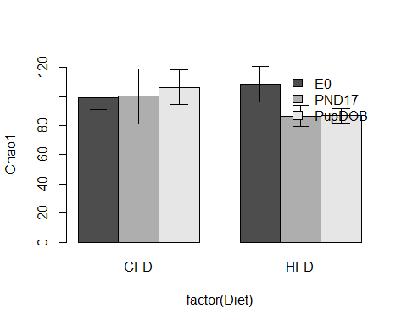

bargraph.CI(x.factor = factor(Diet), response = Sobs, group = Time, data=env4, legend = TRUE)

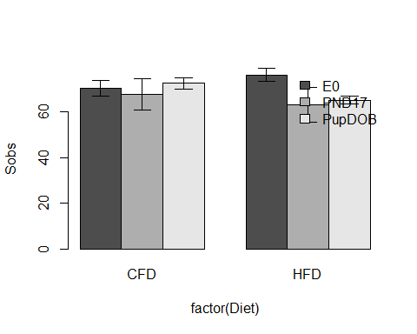

#bargraph.CI(x.factor = factor(Diet), response = Simp, group = Time, data=env4, legend = TRUE)  
bargraph.CI(x.factor = factor(Diet), response = Shan, group = Time, data=env4, legend = TRUE)

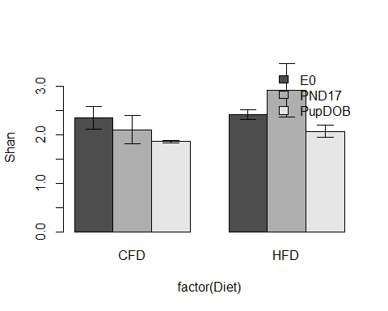

bargraph.CI(x.factor = factor(Diet), response = PD, group = Time, data=env4, legend = TRUE)

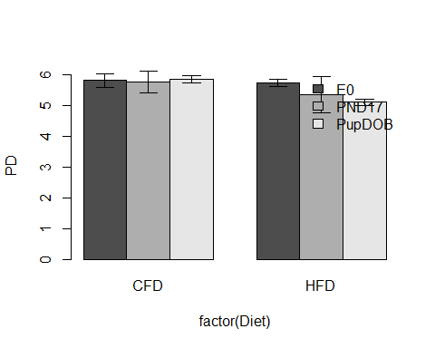

# Q5  
bargraph.CI(x.factor = factor(Diet), response = Chao1, data=env5, legend = TRUE)

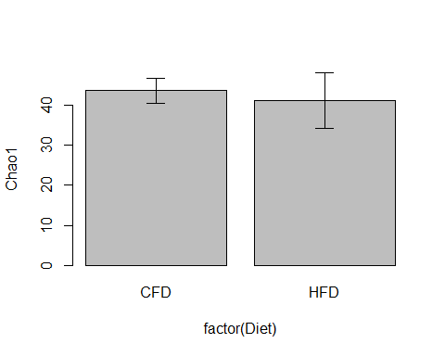

bargraph.CI(x.factor = factor(Diet), response = Sobs, data=env5, legend = TRUE)

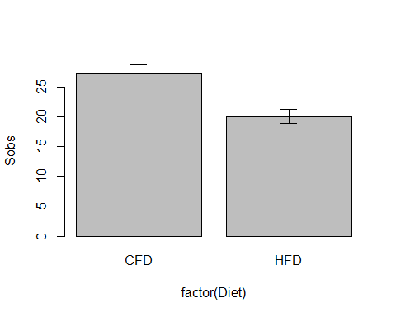

#bargraph.CI(x.factor = factor(Diet), response = Simp, data=env5, legend = TRUE)  
bargraph.CI(x.factor = factor(Diet), response = Shan, data=env5, legend = TRUE)

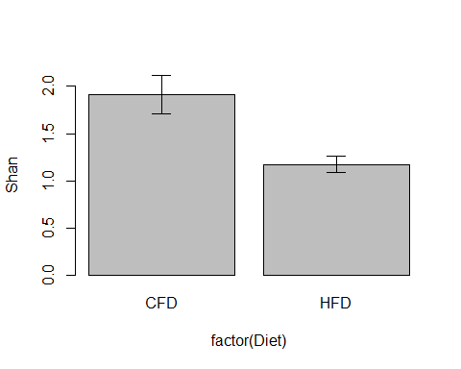

bargraph.CI(x.factor = factor(Diet), response = PD, data=env5, legend = TRUE)

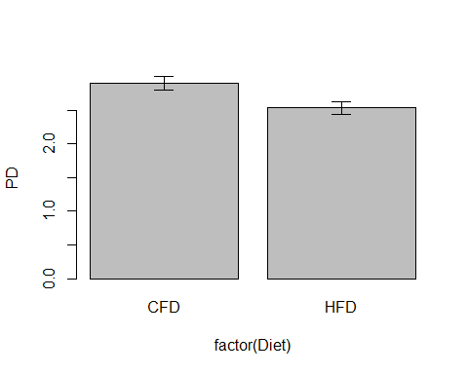

# Q6  
bargraph.CI(x.factor = factor(Diet), response = Chao1, data=env6, legend = TRUE)

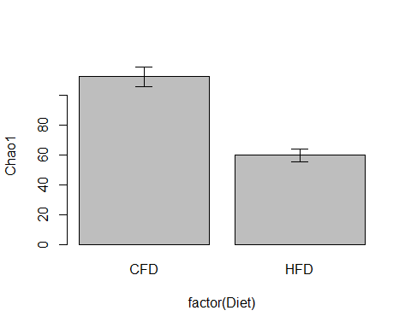

bargraph.CI(x.factor = factor(Diet), response = Sobs, data=env6, legend = TRUE)

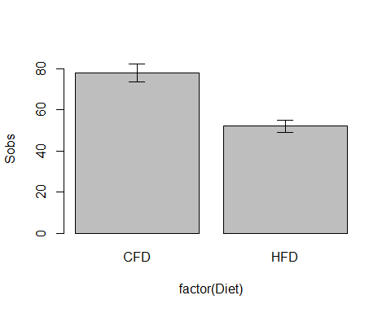

#bargraph.CI(x.factor = factor(Diet), response = Simp, data=env6, legend = TRUE)  
bargraph.CI(x.factor = factor(Diet), response = Shan, data=env6, legend = TRUE)

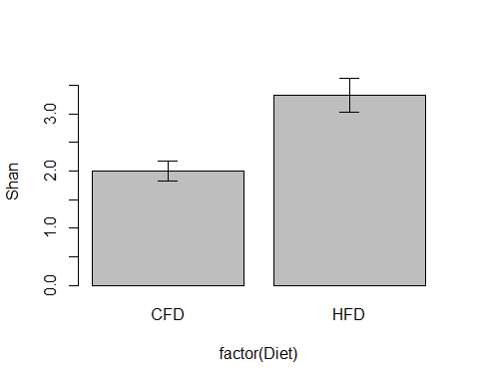

bargraph.CI(x.factor = factor(Diet), response = PD, data=env6, legend = TRUE)

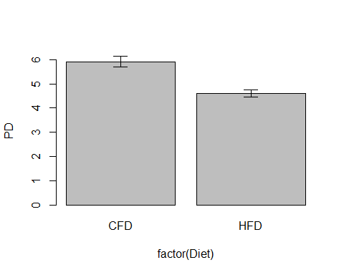

# Q7  
bargraph.CI(x.factor = factor(Diet), response = Chao1, group = Time, data=env7, legend = TRUE)

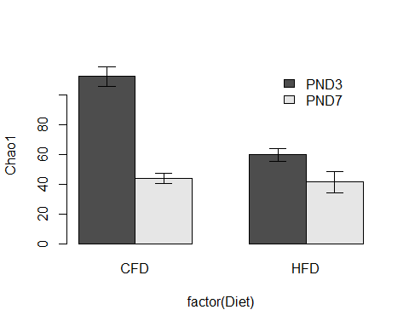

bargraph.CI(x.factor = factor(Diet), response = Sobs, group = Time, data=env7, legend = TRUE)

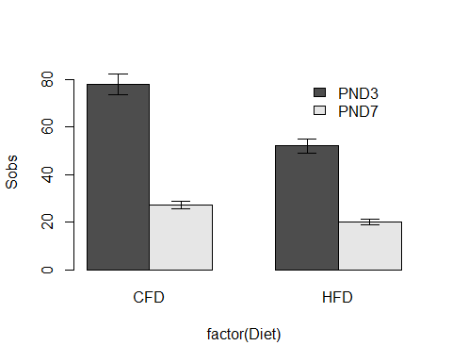

#bargraph.CI(x.factor = factor(Diet), response = Simp, group = Time, data=env7, legend = TRUE)  
bargraph.CI(x.factor = factor(Diet), response = Shan, group = Time, data=env7, legend = TRUE)

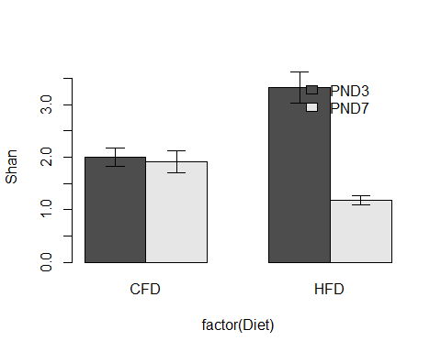

bargraph.CI(x.factor = factor(Diet), response = PD, group = Time, data=env7, legend = TRUE)

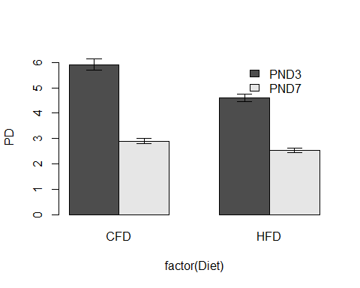

# Q8  
bargraph.CI(x.factor = factor(Cross.foster), response = Chao1, data=env8, legend = TRUE)

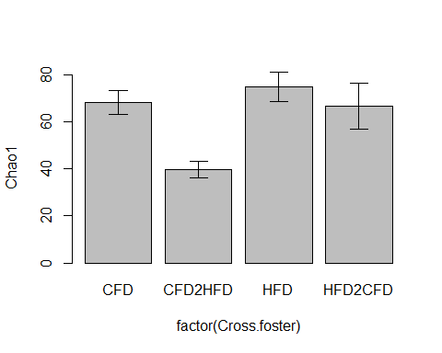

bargraph.CI(x.factor = factor(Cross.foster), response = Sobs, data=env8, legend = TRUE)

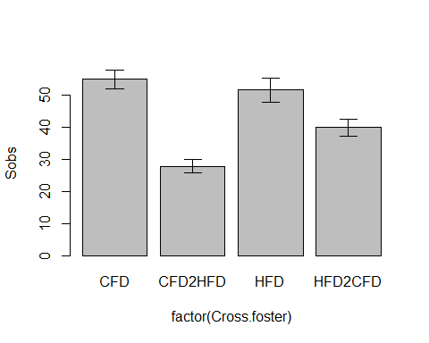

#bargraph.CI(x.factor = factor(Cross.foster), response = Simp, data=env8, legend = TRUE)  
bargraph.CI(x.factor = factor(Cross.foster), response = Shan, data=env8, legend = TRUE)

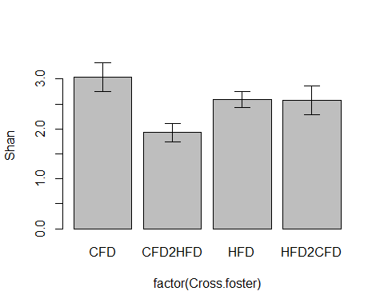

bargraph.CI(x.factor = factor(Cross.foster), response = PD, data=env8, legend = TRUE)

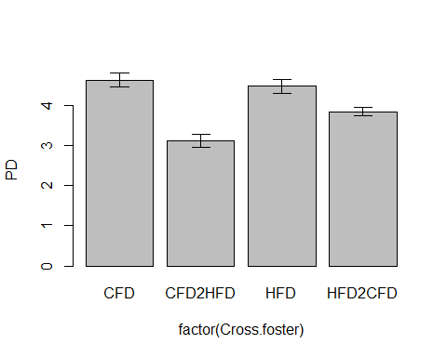

…and then beta diversity, which first needed some custom functions

# _____ _ _   
# | ___| _ _ __ ___| |_(_) ___ _ __ ___   
# | |_ | | | | '_ \ / __| __| |/ _ \| '_ \/ __|  
# | _|| |_| | | | | (__| |_| | (_) | | | \__ \  
# |_| \__,_|_| |_|\___|\__|_|\___/|_| |_|___/  
#  
# Paul Dennis   
  
## Axis percent   
# Returns the percentage varation on ordination axes  
  
axis.percent <- function(ordination){  
 round((100*eigenvals(ordination)[1:2]/ordination$tot.chi[[1]]),digits=2)  
}  
  
# END  
  
  
  
## pcoa  
# Makes a PCoA ordination object  
pcoa <- function(ord){  
 cmdscale(dist(ord,'euc'), k=(nrow(ord)-1), eig=TRUE)  
}  
  
## axis.percent.pcoa   
# Returns the percentage varation on ordination axes  
axis.percent.pcoa <- function(ordination){  
 round(as.vector(eigenvals(ordination)/sum(eigenvals(ordination)))[1:2]*100,digits=2)  
}  
  
## custom.plot.pcoa  
# Plots a PCoA ordination with group enrichment  
  
custom.plot.pcoa <- function(ord,group,title,plottype){  
 ordiplot(scores(ord, choices=c(1,2)), type=plottype,   
 xlab=paste("PCoA1 (",axis.percent.pcoa(  
 ord)[[1]],"%)",sep=""),  
 ylab=paste("PCoA2 (",axis.percent.pcoa(ord)[[2]],"%)",sep=""),  
 main=title)  
 ordiellipse(ord,group,  
 kind='sd')  
 #conf=0.95)  
 points(ord$points, pch=21, cex=3, bg=factor(group))   
 abline(h=0, lty=3)  
 abline(v=0, lty=3)  
 legend("topright",legend=unique(factor(group)),pch=19,col=unique(factor(group)))  
}

### Beta Diversity  
  
library(vegan)  
  
# Q1  
adonis(sqrt(otu1) ~ factor(Diet), data = env1, method='euc')

##   
## Call:  
## adonis(formula = sqrt(otu1) ~ factor(Diet), data = env1, method = "euc")   
##   
## Permutation: free  
## Number of permutations: 999  
##   
## Terms added sequentially (first to last)  
##   
## Df SumsOfSqs MeanSqs F.Model R2 Pr(>F)   
## factor(Diet) 1 0.29946 0.299464 4.3882 0.30499 0.006 **  
## Residuals 10 0.68243 0.068243 0.69501   
## Total 11 0.98189 1.00000   
## ---  
## Signif. codes: 0 '***' 0.001 '**' 0.01 '*' 0.05 '.' 0.1 ' ' 1

pcoa1 <- pcoa(sqrt(otu1))  
custom.plot.pcoa(pcoa1,group = factor(env1$Diet), plottype = "t", title = "Q1")

## species scores not available

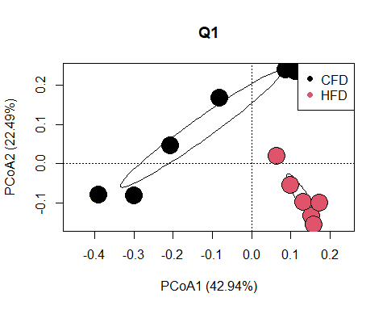

# Q2  
adonis(sqrt(otu2) ~ factor(Diet), data = env2, method='euc')

##   
## Call:  
## adonis(formula = sqrt(otu2) ~ factor(Diet), data = env2, method = "euc")   
##   
## Permutation: free  
## Number of permutations: 999  
##   
## Terms added sequentially (first to last)  
##   
## Df SumsOfSqs MeanSqs F.Model R2 Pr(>F)   
## factor(Diet) 1 0.26484 0.264840 8.4596 0.54721 0.013 *  
## Residuals 7 0.21914 0.031306 0.45279   
## Total 8 0.48398 1.00000   
## ---  
## Signif. codes: 0 '***' 0.001 '**' 0.01 '*' 0.05 '.' 0.1 ' ' 1

pcoa2 <- pcoa(sqrt(otu2))  
custom.plot.pcoa(pcoa2,group = factor(env2$Diet), plottype = "t", title = "Q2")

## species scores not available

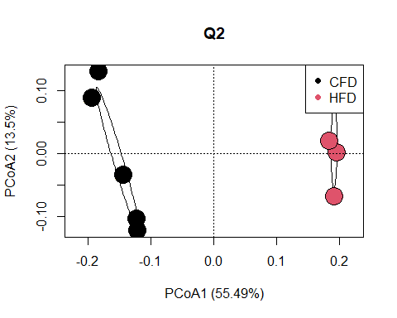

# Q3  
adonis(sqrt(otu3) ~ factor(Diet), data = env3, method='euc')

## 'nperm' >= set of all permutations: complete enumeration.

## Set of permutations < 'minperm'. Generating entire set.

##   
## Call:  
## adonis(formula = sqrt(otu3) ~ factor(Diet), data = env3, method = "euc")   
##   
## Permutation: free  
## Number of permutations: 719  
##   
## Terms added sequentially (first to last)  
##   
## Df SumsOfSqs MeanSqs F.Model R2 Pr(>F)  
## factor(Diet) 1 0.23140 0.231396 2.4156 0.37652 0.1  
## Residuals 4 0.38317 0.095791 0.62348   
## Total 5 0.61456 1.00000

pcoa3 <- pcoa(sqrt(otu3))  
custom.plot.pcoa(pcoa3,group = factor(env3$Diet), plottype = "t", title = "Q3")

## species scores not available

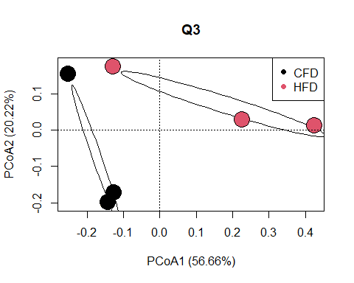

# Q4  
adonis(sqrt(otu4) ~ factor(Diet) * factor(Time), data = env4, method='euc')

##   
## Call:  
## adonis(formula = sqrt(otu4) ~ factor(Diet) * factor(Time), data = env4, method = "euc")   
##   
## Permutation: free  
## Number of permutations: 999  
##   
## Terms added sequentially (first to last)  
##   
## Df SumsOfSqs MeanSqs F.Model R2 Pr(>F)   
## factor(Diet) 1 0.50988 0.50988 8.3344 0.21028 0.001 ***  
## factor(Time) 2 0.33832 0.16916 2.7650 0.13953 0.002 **   
## factor(Diet):factor(Time) 2 0.29179 0.14590 2.3848 0.12034 0.003 **   
## Residuals 21 1.28474 0.06118 0.52985   
## Total 26 2.42473 1.00000   
## ---  
## Signif. codes: 0 '***' 0.001 '**' 0.01 '*' 0.05 '.' 0.1 ' ' 1

pcoa4 <- pcoa(sqrt(otu4))  
env4$Diet.Time = paste(env4$Diet,env4$Time, sep="." )  
custom.plot.pcoa(pcoa4,group = factor(env4$Diet.Time), plottype = "t", title = "Q4")

## species scores not available

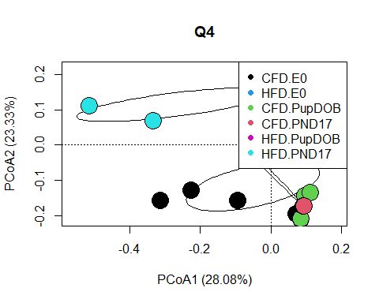

# Q5  
adonis(sqrt(otu5) ~ factor(Diet), data = env5, method='euc')

##   
## Call:  
## adonis(formula = sqrt(otu5) ~ factor(Diet), data = env5, method = "euc")   
##   
## Permutation: free  
## Number of permutations: 999  
##   
## Terms added sequentially (first to last)  
##   
## Df SumsOfSqs MeanSqs F.Model R2 Pr(>F)  
## factor(Diet) 1 0.25327 0.25327 1.2022 0.09106 0.308  
## Residuals 12 2.52796 0.21066 0.90894   
## Total 13 2.78123 1.00000

pcoa5 <- pcoa(sqrt(otu5))  
custom.plot.pcoa(pcoa5,group = factor(env5$Diet), plottype = "t", title = "Q5")

## species scores not available

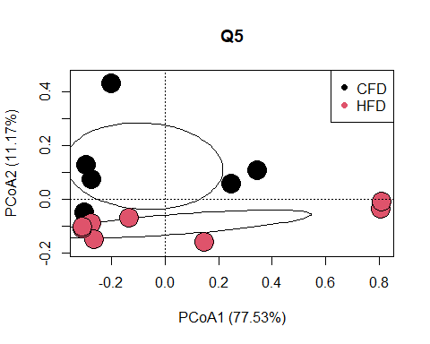

# Q6  
adonis(sqrt(otu6) ~ factor(Diet), data = env6, method='euc')

##   
## Call:  
## adonis(formula = sqrt(otu6) ~ factor(Diet), data = env6, method = "euc")   
##   
## Permutation: free  
## Number of permutations: 999  
##   
## Terms added sequentially (first to last)  
##   
## Df SumsOfSqs MeanSqs F.Model R2 Pr(>F)   
## factor(Diet) 1 3.0493 3.04929 16.424 0.64601 0.001 ***  
## Residuals 9 1.6709 0.18566 0.35399   
## Total 10 4.7202 1.00000   
## ---  
## Signif. codes: 0 '***' 0.001 '**' 0.01 '*' 0.05 '.' 0.1 ' ' 1

pcoa6 <- pcoa(sqrt(otu6))  
custom.plot.pcoa(pcoa6,group = factor(env6$Diet), plottype = "t", title = "Q6")

## species scores not available

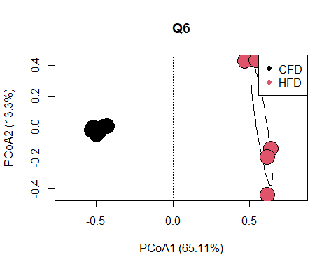

# Q7  
adonis(sqrt(otu7) ~ factor(Diet) * factor(Time), data = env7, method='euc')

##   
## Call:  
## adonis(formula = sqrt(otu7) ~ factor(Diet) * factor(Time), data = env7, method = "euc")   
##   
## Permutation: free  
## Number of permutations: 999  
##   
## Terms added sequentially (first to last)  
##   
## Df SumsOfSqs MeanSqs F.Model R2 Pr(>F)   
## factor(Diet) 1 1.7060 1.7060 8.5320 0.14352 0.001 ***  
## factor(Time) 1 4.2041 4.2041 21.0259 0.35368 0.001 ***  
## factor(Diet):factor(Time) 1 1.7777 1.7777 8.8909 0.14956 0.001 ***  
## Residuals 21 4.1989 0.1999 0.35324   
## Total 24 11.8866 1.00000   
## ---  
## Signif. codes: 0 '***' 0.001 '**' 0.01 '*' 0.05 '.' 0.1 ' ' 1

pcoa7 <- pcoa(sqrt(otu7))  
env7$Diet.Time = paste(env7$Diet,env7$Time, sep="." )  
custom.plot.pcoa(pcoa7,group = factor(env7$Diet.Time), plottype = "t", title = "7")

## species scores not available

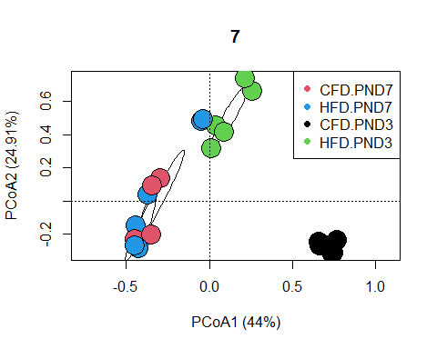

# Q8  
adonis(sqrt(otu8) ~ factor(Cross.foster), data = env8, method='euc')

##   
## Call:  
## adonis(formula = sqrt(otu8) ~ factor(Cross.foster), data = env8, method = "euc")   
##   
## Permutation: free  
## Number of permutations: 999  
##   
## Terms added sequentially (first to last)  
##   
## Df SumsOfSqs MeanSqs F.Model R2 Pr(>F)   
## factor(Cross.foster) 3 2.9908 0.99694 2.9842 0.32028 0.001 ***  
## Residuals 19 6.3473 0.33407 0.67972   
## Total 22 9.3381 1.00000   
## ---  
## Signif. codes: 0 '***' 0.001 '**' 0.01 '*' 0.05 '.' 0.1 ' ' 1

pcoa8 <- pcoa(sqrt(otu8))  
custom.plot.pcoa(pcoa8,group = factor(env8$Cross.foster), plottype = "t", title = "Q8")

## species scores not available

