|  |  |
| --- | --- |
| **Chapter** | **Page** |
| **Chapter 1: Introduction** |  |
| 1. Introduction | 3 |
| 1.1. Objective | 3 |
| 1.2. Home | 3 |
| 1.3. Register | 4 |
| 1.4. Login | 4 |
| 1.5. Find Route | 4 |
| 1.6. Contact Us | 5 |
| 1.5. Summary | 5 |
| **Chapter 2: System Analysis** |  |
| 2.1 Introduction | 5 |
| 2.2. Existing System Analysis | 6 |
| 2.3. Description | 6 |
| 2.4. System Objective | 6 |
| 2.5. E-R Diagram | 7 |
| **Chapter 3: Proposed System** |  |
| Introduction | 7 |
| 3.1. Schedule | 8 |
| 3.2. Implementation and result | 8 |
| 3.3. System Requirements | 9 |
| 3.4. Database | 9 |
| 3.5. Summary | 10 |
| **Chapter 4: Conclusion** |  |
| 4.1. Introduction | 9 |
| 4.2. Future Work | 10 |
|  |  |
|  |  |
|  |  |
| **Reference** | 11 |
| **List of Figure** | 11 |

**Chapter 1**

**Introduction:**

This is an integrated service that provides all information about the metro rail and its routes for the public. The proposed system is a web-based application which provides information regarding timings, routes, fair.

This system manages public feedback about services through it’s message management system. With this system user can register themselves, login system, search routes with specific day and view fair price of tickets.

There is also an admin module where admin can add stations, trains, routes and also update the fairs. The admin is a panel consisting of a group of authorized persons.

It has a home page, register page, login page, find route page and contact us page.

**1.1 OBJECTIVE**

The objectives of the project are as follows:

* Users can register complaints through the site.
* User login page where users can recharge tickets online.
* Users can view metro timetable.

**1.2. Home page**

This is the main page of the system. Here user can see all header, logo and go for registration page.

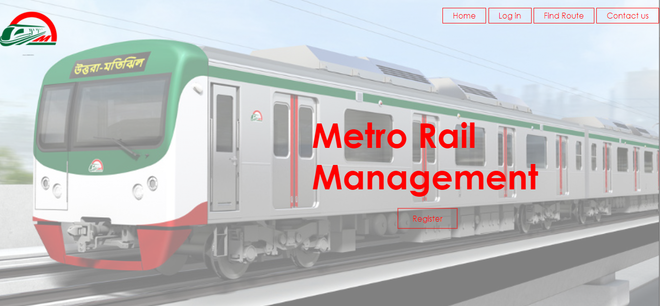

Figure:1 Home

**1.3. Register page**

This is for registration. Here user can register themselves.

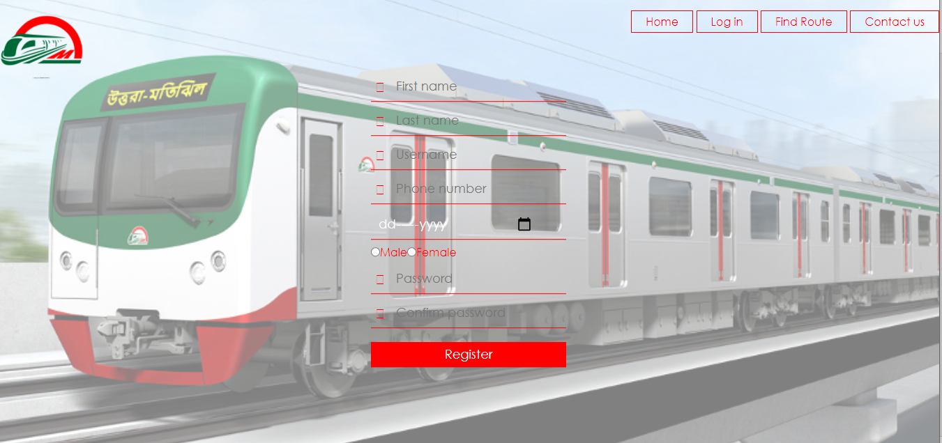

Figure:2 Register

**1.4. Login page**

After registration is complete user can go for login page. In this page user login the system.

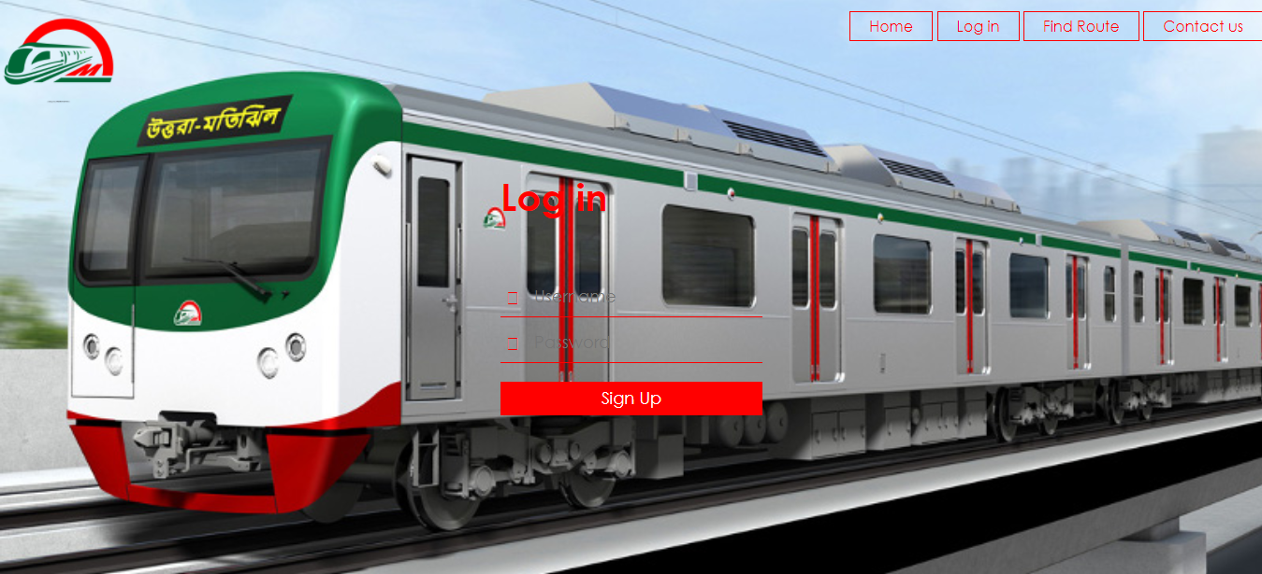

Figure:3 Login

**1.5. Find route page**

This page for search route. After search route with source area, destination area and date, user can view rail name, rail depature time and ticket fair price.

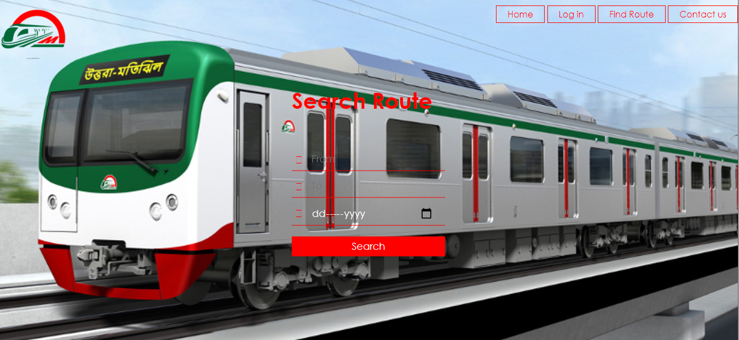

Figure:4 Find Route

1.6. **Contact us page**

In this page user can give feedback and contact with system manager with the contact information.

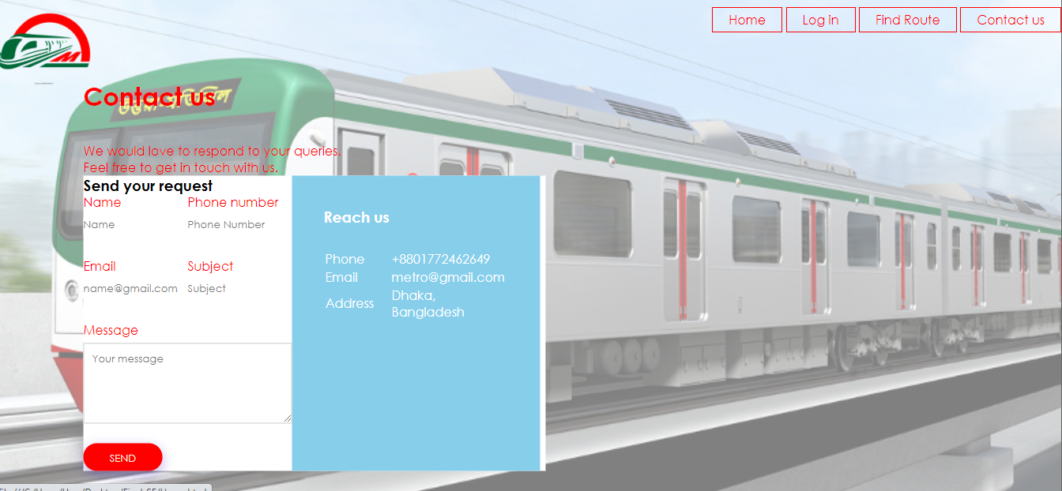

Figure:5 Contact Us

**1.7. Summary**

To see rail fair ticket price is very hard and time killing job. With our system user can easily find metro train time table and view fair price of ticket. This system can save users valuable time.

**Chapter 2**

**SYSTEM ANALYSIS**

**Introduction**

System analysis is the process of gathering and interpreting facts, diagnosing problems and using the information to recommend improvements on the system. System analysis is a problem-solving activity that requires intensive communication between the system users and system developers. System analysis or study is an important phase of any system development process. The system is viewed as a whole, the inputs are identified and the system is subjected to close study to identify the problem areas. The solutions are given as a proposal. The proposal is reviewed on user request and suitable changes are made. This loop ends as soon as the user is satisfied with the proposal.

**2.1 EXISTING SYSTEM**

* Information cannot be collected, processed and communicated more quickly and efficiently.
* Current working systems doesn’t ensure that right information reaches the right person at the right time.

2.3.1. DESCRIPTION

**System Description:**

Metro rail management system is an online system which helps the user to view route and ticket fair online. It also have a complaint management system in which users can register their complaints online. By visiting the site the users can get metro time table. Other than that by entering the source station and destination station the users can get all sorts of information about trains arriving and departing from the stations, it’s fair details.

**Problem Statement:**

The problem occurred before having online system includes:

* File lost When online system is not implemented the complaints are reported in files. The files are always lost due to some human errors.
* Time consuming When there is no computerized system then for recharge purposes the users need to travel to the stations and also sometimes even need to stand in large queues for recharge purposes.
* Most updations are unnoticeable. When online systems is not implemented any changes in fair, timings etc when updated ,the details of these things are only available at the stations.

**2.3.2 SYSTEM OBJECTIVES**

* Improvement in Control and performance
* The system is developed to cope up with current issues and problems of the metro rail.
* The system helps to make a complaint online, display metro timetable, fairs.
* Save time User is able to recharge online, see details of metro time table, fairs and even the user can complaint online there by saving his valuable time.
* Easy to Use A person with just an internet connection and a pc can do things such as complaint, recharge and view metro details very easily.

**2.4. ER diagram**

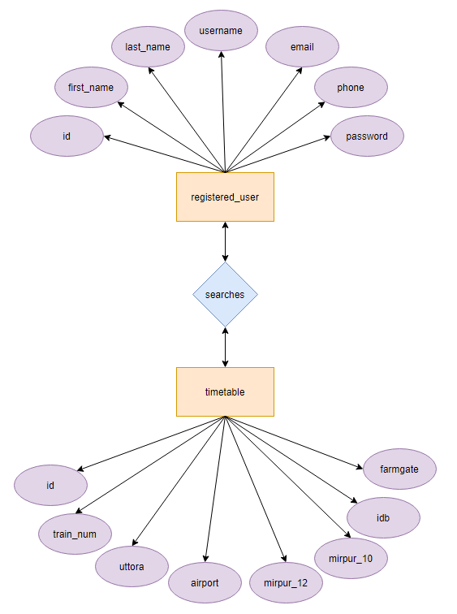

Figure:6 ER diagram

**Chapter 3**

**PROPOSED SYSTEM**

**Introduction**

The proposed system is designed to eliminate the disadvantages of the existing system. The proposed system “Metro Rail Management System” is mentioned for tracing the problems in the existing system.

* Increased efficiency and reliability. Easier Access.
* Easy to use Provide accurate information to the user for taking necessary decisions.
* Accuracy - The information will be correct, accurate and unambiguous.
* Efficiency - Information can be collected, processed and communicated more quickly and efficiently.
* Systems ensure that right information reaches the right person at the right time.
* Reliability - Since systems are free from boredom and tiredness, they work constantly on data to produce more reliable outputs.
* Accessibility, Usability and Understandability The options used can be easily accessed, used and realized.

3.1 Schedule

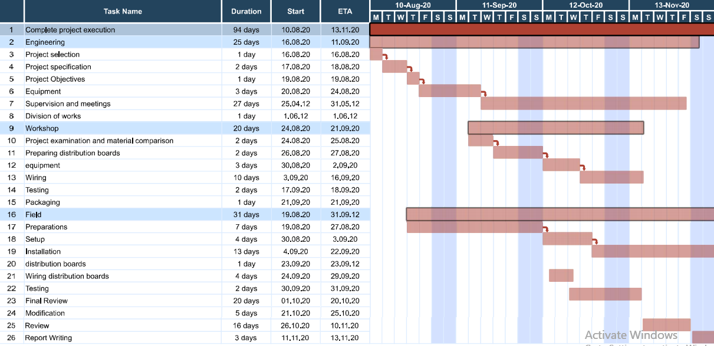

Figure7: Grant chart

3.2 Implementation And result

**3.2.1 System Setup**

1. Package: Operating System (Any)
2. Software: Android Studio, XAMPP, MySQL, MySQL connector, Application: Web browser (Any)
3. Hard Disk: 120GB (minimum)
4. RAM: 2GB (minimum)
5. Processor: Duel-core or above
6. Language use: HTML, CSS, PHP, SQL

**3.2.2 Results and discussion**

It’s an online management system. It's a giant arrangement to show all the information about metro rail. Our project online metro rail management system is developed so that users can view the knowledge of the metro rail. Some information are may be unnotiable therefore the system can find the specified information with the specified information easily from the large database by using the search feature within the webpage. This technique provides a dynamic database. And keep users personal information secure.

**3.2.3 Existing System Analysis**

* In the current system, user often go for station to station collect information about the rail.
* In the existing system, a high cost of user time is required for searching and storing information about rail.
* However, the users feel weak and light-headed for several hours following the procedure.

3.4 Database

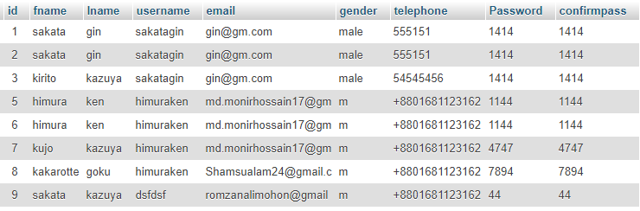

Figure 8: Registration

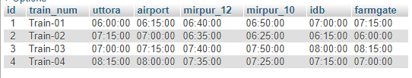

Figure 9: From to

**3.3 Summary**

This application is providing each entity the power to approach to find all information about metro rail so that it'll become much easier. We believed that our system will reduce the rail information finding problem.

**Chapter 4**

**Conclusion**

**Introduction:**

This is an integrated service that provides all information about the metro rail and its routes for the public. The proposed system is a web-based application which provides information regarding timings, routes, fair.

To see rail fair ticket price is very hard and time killing job. With our system user can easily find metro train time table and view fair price of ticket. This system can save users valuable time.

This application is providing each entity the power to approach to find all information about metro rail so that it'll become much easier. We believed that our system will reduce the rail information finding problem.

**4.1 Future work**

The Main future scope of our proposed model about online metro rail system is to try it in the real world that means we have to implement it with better results. We will try to improve the security of user identification make it more secure. We will use online geographical platform to view user and donor location. We will add this in our future work. We will also try to improve to add online payment system.

**Reference**

[1]. Nevon Projects. “Local Train Ticketing Project” Jun-19, 2015. Available: url: <https://www.youtube.com/watch?v=LxCfVoUevaI>

[2]. AJMAL RAHMAN, AKHIL G SANJAY, P R. “METRO RAIL MANAGEMENT ONLINE” MARCH 2014. Availabe: url: [www.github.com/](http://www.github.com/)

[3]. AnkitJishan. “Metro Rail Project” Oct-1,2019. Available: url: <https://github.com/AnkitJishan/Metro-System-Database-Project/>

[4]. freeCodeCamp. “HTML Full Course-Build a Website Tutorial” Sep-18, 2018. Available: url: <https://www.youtube.com/watch?v=pQN-pnXPaVg/>

[5]. freeCodeCamp. “CSS Tutorial – Zero to Hero” Oct-16, 2019. Available: url: <https://www.youtube.com/watch?v=1Rs2ND1ryYc/>

[6]. freeCodeCamp. “PHP Programming Tuitorial” Jun-21, 2018. Available: url: <https://www.youtube.com/watch?v=OK_JCtrrv-c/>

[7]. Kenneth E. Kendall, Julie E. Kendall, “Systems Analysis and Design”, Ninth Edition.

**List of Figure**

|  |  |
| --- | --- |
| Figure 1 Home | 3 |
| Figure 2 Registration | 4 |
| Figure 3 Login | 4 |
| Figure 4 Find Route | 5 |
| Figure 5 Contact us | 5 |
| Figure 6 E-R Diagram | 7 |
| Figure 7 Grant Chart | 8 |
| Figure 8 Registration table | 9 |
| Figure 9 From To table | 10 |