Empowering Animatronics with Micro:bit

Paul H Dietz
University of Toronto
Toronto, ON, Canada
Paul.Dietz@utoronto.ca
Catherine M. Dietz
The Animatronics Workshop
Seattle, WA, USA
cathy@animatronicsworkshop.com
Abstract—The Animatronics Workshop has long worked with schools and other institutions to empower kids to create their own robotic shows. To increase the accessibility of these programs, we are working to leverage the Micro:bit platform. Our emphasis is on storytelling, with the tech playing a critical, but supporting role. We will be creating accessories for the Micro:bit that make it easy for kids to create shows featuring their own talking robotic characters, each with synchronized motion and sound.

Introduction
Animatronics is the art and science of robotic storytelling. It is a staple of theme park attractions, where robotic characters appear alive, performing shows for delighted audiences. Animatronics has traditionally been the domain of highly specialized artists and engineers working with significant resources. So it is perhaps a bit audacious that our shows are conceived and constructed by children [1-6].
Back in 2006, we started the Animatronics Workshop [6] in Hopkinton, Massachusetts as a Saturday morning club for middle school students (grades 6-8) to build complete, theme park-style animatronic shows in a tabletop format. We were inspired by school robotics clubs, and hoped a theater/storytelling model would attract kids who would not normally be interested in conventional robotics programs
Our early efforts were focused on making fun, interesting shows purely for entertainment. Trinity Valley School (TVS) in Fort Worth, TX was an early adopter, and began experimenting with adding animatronics to their curriculum. For example, they created a high school senior elective in animatronics that was jointly offered by the English and Computer Science departments. Students studied character development and how to craft a compelling story, as well as how to physically build and control a robotic character.
Eventually, TVS decided to use animatronics as a way to teach 7th grade history. Students were paired up, and asked to create an animatronic show of an impossible dinner conversation between two historical figures from different places and different time periods. Over the course of a year, the students carefully studied their selected characters, imagining what they would talk about. They created the robots and elaborate sets. Drama teachers were brought in to help the students learn voice performance and stage directing. They even added a sewing component so the kids could do costuming.
The TVS animatronics history projects were a remarkable success. The students displayed real passion for their characters, studying them intently. At the end of the year, the school would invite the parents for a festival to see all the shows. The kids learned a diverse set of skills, and created compelling experiences. But perhaps most importantly, the school was able to show that this was an effective way to inspire students to learn history.
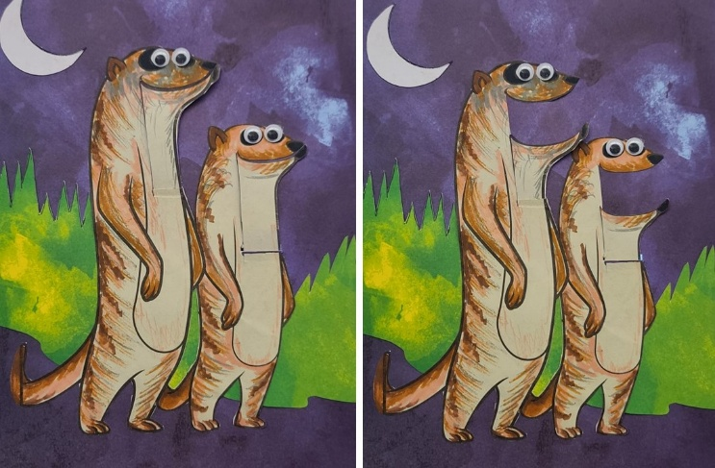
An example of a two-character, paper animatronic show. In this show, we learn fun facts about Meerkats.
TVS is a well-funded, private school with deep resources. We made a number of attempts to reproduce the TVS model in typical inner city public schools, but these were not successful. Teachers needed to have a rare mix of skills to be able to guide kids through crafting motorized aluminum skeletons for the hand puppets and also managing the professional animatronics control software. It was all just too much. We needed a major rethink of the program if we were to have broad adoption.
Over the last several years, we have created a new series on animatronics activities based on papercraft that are both inexpensive and easy for teachers to adopt. These activities spiral up in complexity over the years, allowing ever more sophisticated shows to be created by the kids. We have successfully piloted these programs in Canadian schools, starting with kids as young as 4 years old [1]. We have run teacher training programs in very large school districts in Toronto and Vancouver and found teachers anxious to incorporate these activities in language and history classes – places where you might be very surprised to see kids building robots. Our goal was to add animatronics to the standard list of project-based learning experiences that any teacher could utilize, along side such traditional projects as book reports, posters and videos. Along the way, kids master technical skills and get to exercise them creatively.
Seeing the broad adoption of Micro:bit, we decided to explore if we could bring our animatronics experiences to that platform. In the following sections we will describe important pieces of our current paper animatronics programs, and then discuss how we hope to bring these to Micro:bit.

Paper Animatronics 2025
As of 2025, we have created a growing collection of electronic and mechanical hardware that lets kids create animatronic shows of increasing complexity.

Level 1: Puppetry
Our introductory animatronics experience begins with crafting paper characters driven by servo motors so that they can move and appear to speak as commanded by the puppeteer.
In tests, we found that kids often had a difficult time utilizing our micro servos in paper designs. Servos rotate, but most kids wanted their servos to move something back and forth, such as a mouth opening and closing.
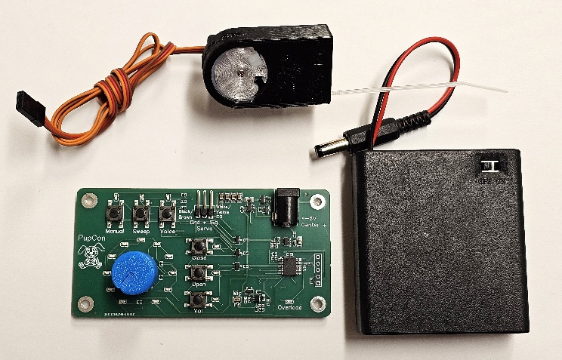
Basic puppetry kit including the PupCon controller, a 4xAA battery pack and a Zip Servo.
To solve this problem, we created the Zip Servo. These are simple, 3D-printed linear actuators that use a micro servo to wind and unwind a nylon zip tie. They move about 3cm and can lift about 1kg – more than sufficient for moving bits of paper. They are also fast enough to create convincing mouth movements. The zip tie has enough stiffness to hold paper bits without additional support, but also enough flexibility to be feed through a hole and along curved paths. We use two-sided Nano tape to easily attach them to paper or cardboard, and then regular tape to attach something to the zip tie.
While there are existing servo testers that let you control the servo with a knob, we found we needed something a bit more specialized. Our PupCon controller lets you control the position of the servo with a knob. But it also lets you specify the ideal mouth open and close position and maps the knob onto this range. And most importantly, it has a voice activated mode, where the loudness of your voice controls the position of the servo to automatically create convincing mouth movements.
With a Zip Servo, a PupCon and a battery pack, a kid can create a talking paper character in minutes. They can puppet the character manually using the knob, or they can control it with their voice. We have successfully piloted this experience with kids as young as 4, who needed some help with scissors, but were otherwise very successful at bringing characters of their own creation to life. It’s also worth noting that this same experience also works well as an introduction to animatronics for all ages.

Level 2: Scripted Shows
Our next level, which works well with kids about 9 and up, involves creating a scripted, prerecorded show. The kids create and write a script for a two-character show. They then record themselves voicing the two parts using Audacity, GarageBand or another audio editor, creating a stereo audio file with one character on the left channel and one on the right. They then connect our Audio2Servo board to the audio output of their computer which automatically drives two servos to create believable mouth movements for the two characters. TheAudio2Servo board has an audio out jack which you can connect to powered speakers to hear the voices while playing.
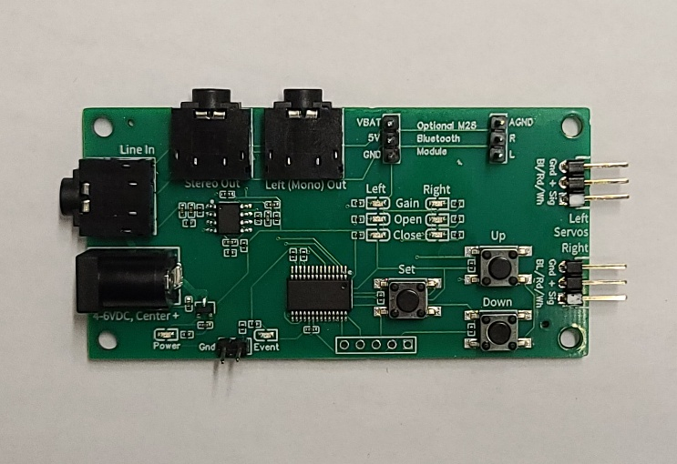
The Audio2Servo controller board drives the mouth servos of two animatronic characters based on a stereo audio signal.

. Level 3: Synced Events
At the next level we add the ability to write code which causes other things to happen (move servos, turn on lights, etc.) in sync with the rest of the show. Because simple programming skills are required, this usually works best for kids that are 12 and up.
In the early days of animatronics, multitrack tape decks were used to control a show. Some tracks were used for audio, but others were control tracks with signals that cause actuators to move at the right times in sync with the audio. Inspired by this history, the Audio2Servo board allows you to use the right audio channel as a control track. The board has a logic output that goes high anytime it hears noise on the right channel. This signal can then be connected to a microcontroller, typically an Arduino UNO, which runs a simple program which takes specific actions with each noise trigger. For example, the first beep on the right channel might be programmed to have a servo move an arm. A second beep might light an LED. And so on. In this way, very sophisticated shows can be created. To make this all easier, we designed mini shields that allow simple attachment of 6 additional servo to the UNO, and 6 LEDs on long cables for easy placement.

Paper Animatronics with Micro:bit
Here we consider the opportunities and challenges of creating versions of these animatronics experiences utilizing the Micro:bit platform.

Level 1: Puppetry
The Micro:bit is fully capable of creating the appropriate pulses for controlling servos. It also has an on-board microphone that can be used to implement a voice-activated mouth servo signal similar to PupCon. It lacks a control knob, but does have an accelerometer that can be used to measure pan and tilt of the board – a simple way of generating two channels of analog control.
What is lacking is a way of connecting and powering servos. Fortunately, there are off-the-shelf solutions such as the Kitronik Simple Servo Control Board which allows the connection of up to three micro servos. The board holds 3xAA batteries which can power both the servos and the Micro:bit itself, creating an all-in-one solution.
Another great feature of the Micro:bit is its radio capabilities. It is very easy to use one Micro:bit to run the servos, and a separate remote Micro:bit to act as a wireless remote control, sending commands to the first one. Using MakeCode, a student can quickly create a remote control that transmits a voice and a pan and a tilt signal to the other Micro:bit. Similarly, it is a few blocks of code to receive this data and drive three servos accordingly. The pan-tilt interface is certainly different from the knob, but it’s hard to say if it is better or worse. It certainly feels more like controlling a marionette. It is unquestionably an upgrade to be able to puppet with 3 servos at once rather than just 1.

Level 2: Scripted Shows
Emulating the functionality of the Audio2Servo board with a Micro:bit requires a more specialized interface. We propose to make a Micro:bit accessory that will accomplish this.
Our solution uses an on-board MP3 player module (a DF Player Mini – a commonly available module) to provide the audio via a micro SD card. The Micro:bit controls the playing of the audio files on the card. In addition, the audio signals are routed out to drive a speaker and also to ADC inputs on the Micro:bit. This allows the Micro:bit to listen for the audio levels on the left and right channels, and drive to servos accordingly. This board will need to provide power to the audio system, the servos and the Micro:bit.
In addition to its use in animatronics, we imagine this board would be generally popular for its ability to play high quality, long MP3 files under programmatic control of the Micro:bit.

. Level 3: Synced Events
Because it is already listening to the right audio track, the MP3 player board described can also be used to sync other devices using control signals on the right audio track. However, the board will need additional interfaces to drive more servos, LEDs and other output devices. These can easily be added to the design.

. Enhancements
Thanks to the radio capabilities of the Micro:bit, further animatronics capabilities can be implemented using the proposed hardware while taking advantage of the Micro:bit’s radio features. One could easily imagine supporting an entire class making a single animatronic show with a large number of characters. Each student makes one or two characters, and records their lines, which can then be triggered individually by a master show coordinator using the radio.

Responsible innovation
We strongly believe that the most important skills we can teach the current generation of kids are:
- The ability to create across traditional disciplines
- The ability to effectively use new technologies
- The confidence to build significant projects
- The empathy to know what will be compelling to others
Our paper animatronics activities exercise all of these skills.

Conclusion
We have described our previous work empowering kids to create their own animatronics shows. By using the Micro:bit platform, we hope to extend the reach of this work.

About the Authors
The authors have 20 years of experience working with kids to create animatronic shows. Both have advanced degrees in Electrical Engineering from Carnegie Mellon University and have extensive experience in product design, crafting and making in general.

Acknowledgements
Our work has been supported by many organizations over the years, including recent grants from Meta and Adobe.
As always, we particularly thank our partners at Trinity Valley School who have adopted animatronics wholeheartedly and provided much of the inspiration for what it has become.

References
- S. Kushner, J. Kanji, P. H. Dietz and D. Wigdor, "Papertronic Puppets: Teaching STEM and Storytelling Through Creative Construction," 2024 IEEE Frontiers in Education Conference (FIE), Washington, DC, USA, 2024, pp. 1-9, doi: 10.1109/FIE61694.2024.10892876. https://doi.org/10.1109/FIE61694.2024.10892876
- Elementary Paper Animatronics. In ACM SIGGRAPH 2023 Labs (SIGGRAPH '23). Association for Computing Machinery, New York, NY, USA, Article 4, 1–2. https://doi.org/10.1145/3588029.3599744
- Paul H. Dietz and Jennifer (Ginger) Alford. 2019. LEDs as sensors. In ACM SIGGRAPH 2019 Studio (SIGGRAPH '19). Association for Computing Machinery, New York, NY, USA, Article 10, 1–2. DOI: https://doi.org/10.1145/3306306.3328752
- Paul Dietz, M. K. Haley, Roger Malina, Ramesh Raskar, and Jennifer (Ginger) Alford. 2014. Cultivating creative thinking: stories from the field. In ACM SIGGRAPH 2014 Panels (SIGGRAPH '14). Association for Computing Machinery, New York, NY, USA, Article 7, 1. DOI: https://doi.org/10.1145/2614208.2615540
- Jennifer Ginger Alford, Lucas Jacob, and Paul Dietz. 2013. Animatronics Workshop: A Theater + Engineering Collaboration at a High School. IEEE Comput. Graph. Appl. 33, 6 (November 2013), 9–13. DOI: https://doi.org/10.1109/MCG.2013.86
- Paul H. Dietz and Catherine Dietz. 2007. The animatronics workshop. In ACM SIGGRAPH 2007 educators program (SIGGRAPH '07). Association for Computing Machinery, New York, NY, USA, 36–es. DOI: https://doi.org/10.1145/1282040.1282078

