*The motor alignment and waterproofing of this boat were more annoying than anticipated. This file documents our troubleshooting process for these two aspects of the boat.*

**Alignment**

Motor alignment is crucial in allowing the motors to consistently spin. If the motor shafts are misaligned in their bushings, they will be finnicky and often not spin properly, causing motor burnout. However, it is also important that the motors are not constrained too tightly, as the viscous bearing effect allows the shaft to align itself as it rotates. So, the mounts must be solidly attached to the boat, but must allow for some movement of the motors.

Initially, one 3D-printed motor mount was used to mount both motors, as shown below (dimensions are in inches):

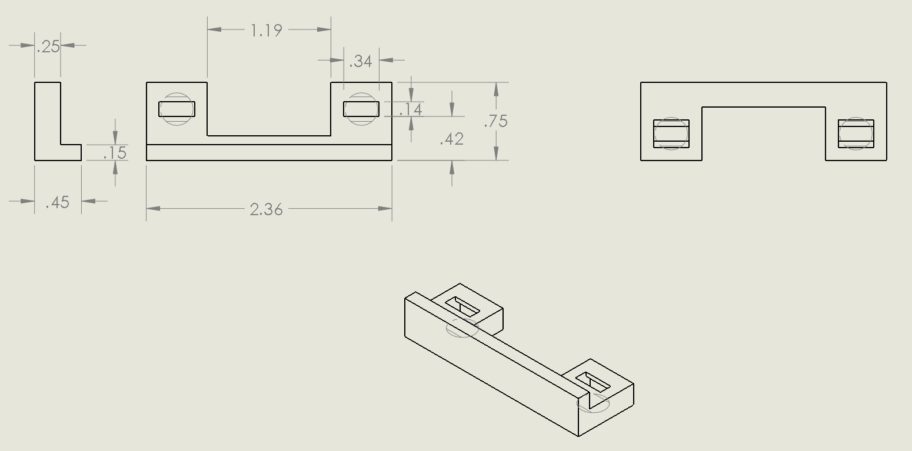

However, this mount proved to be problematic. Physically linking the two motors made it much more difficult to align both, as when one was aligned, the other was not. To fix this, we took the same mount design and simply 3D-printed the end parts: one for each motor. Each motor was then aligned separately, and its respective mount was glued to the boat hull.

**Waterproofing**

Waterproofing the boat was intertwined with shaft alignment because of the viscous bearing effect. Grease was used inside the bearings as a twofold measure: waterproofing the bearings and greasing the motor shaft. However, if the grease is too viscous, the motors cannot spin, and also cannot self-align through the viscous bearing effect.

Lucas Oil Marine Grease was found to be too viscous, so Vaseline was used instead. During waterproofing testing, we found that the bushing hugged the shaft too tightly, allowing any slight misalignment to prevent the motor from spinning. To fix this, we bore out the inside of the bushing, increasing the inner diameter by ~0.003”. More Vaseline was added to compensate for the larger hole.