Problem 1 (Weiss 9.1):
A, B, C, t
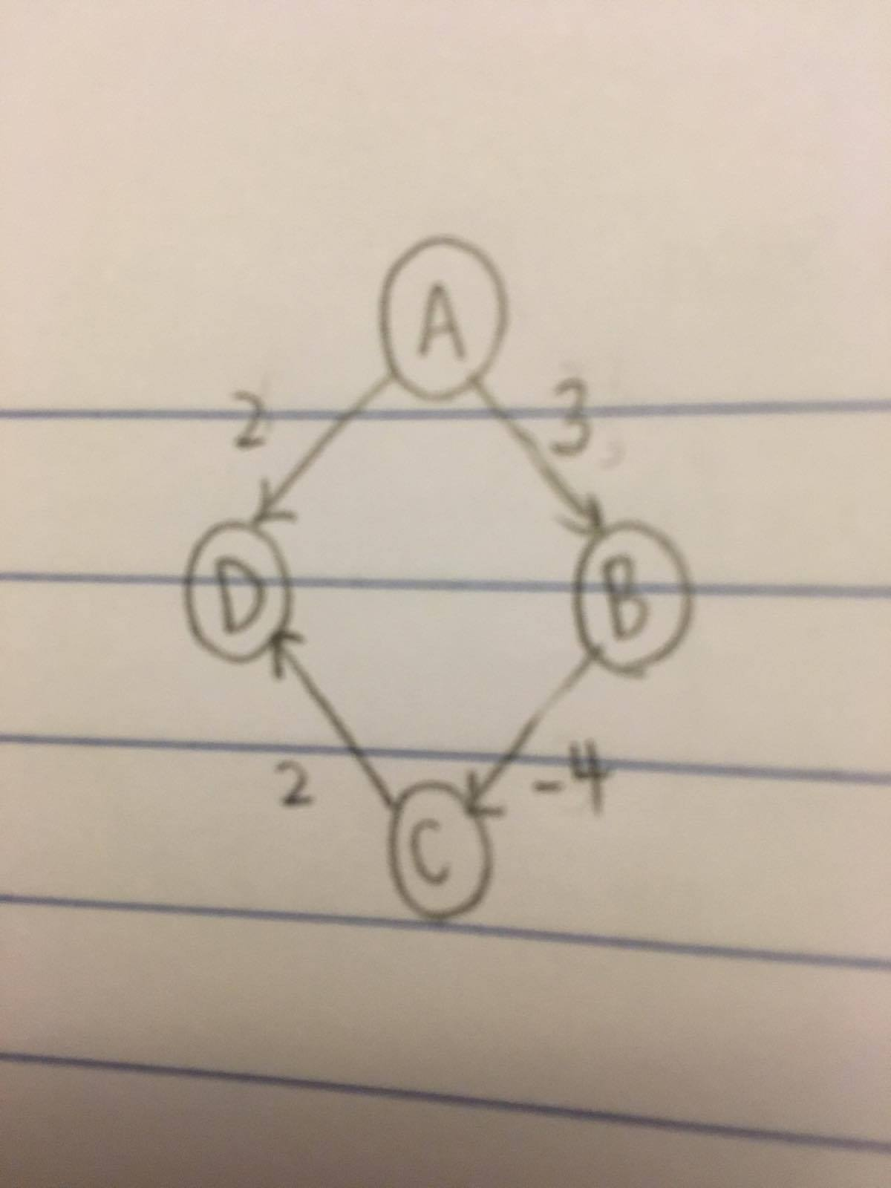
Problem 2 (Weiss 9.7a):

Dijkstra’s would choose to go from A to D, with a weight of 2, and would set the value of A-D as 2. However, the actual shortest path is A-B-C-D, which results in a weight of 1. Dijkstra’s would not catch this when recalculating the shortest path. Of the 2 vertices coming out of A, the 2-edge is the greedier option than the 3-edge.

