Product Design
Team StackOverflowGooglers

Revision Number | Revision Date | Summary of Changes | Author(s)
1.0 | 09/21/2015 | Filling out the whole thing | Doug Gawne, Paul Hulbert, Lucas Smith

Architectural Model
This diagram represents the major subsystems of the product. Initially focus on the domain layer and its components before decomposing the user interface component. Note that a common interface allows both the GUI and a Command Line Interface to access the domain model in the same manner without regard to the type of presentation technique.
Presentation Layer
Healthcare.net, HTML, CSS
Human Testing,
Unit Testing
Trello, SVN, Gliffy, Python3.4
Domain Layer
SQLite
Django 1.8

Components and Functions
Home Page | - Patient login link  - Doctor login link  - Nurse login link  - Admin login link
Patient Login | - Patient login form  - Patient register link
Admin Login | - Superuser functionality
Doctor Login | - Doctor login form
Nurse Login | - Nurse login form
Doctor/patient create appointment | - Cancel link  - details form
Doctor/patient view calendar | - logout link  - create appointment link  - edit patient details link
Nurse view calendar | - logout link  - shows all appointments over a week  - edit appointment link
Patient edit patient details | - cancel link  - details form
Doctor/patient/nurse edit appointment | - cancel button for doctor/patient  - detail form
Admin view logs | - Superuser can view models with logs contained

Class Diagram(s)
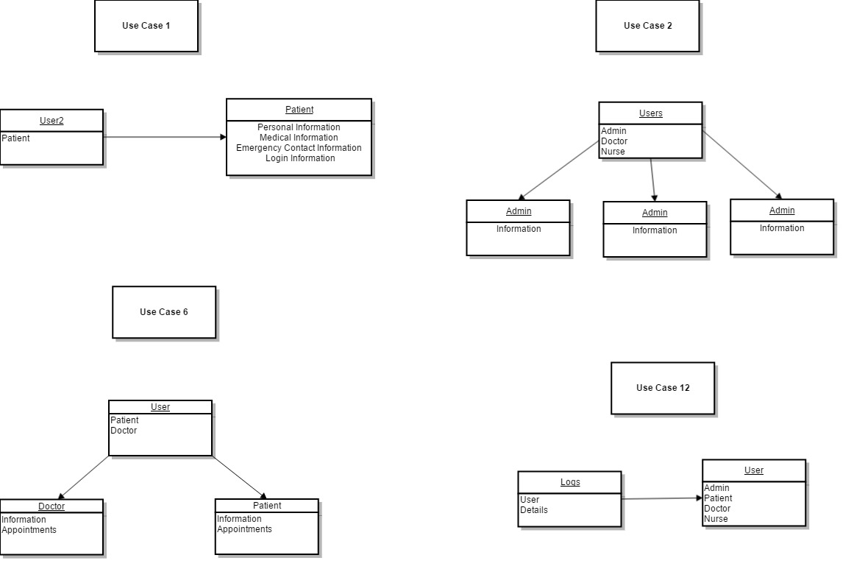
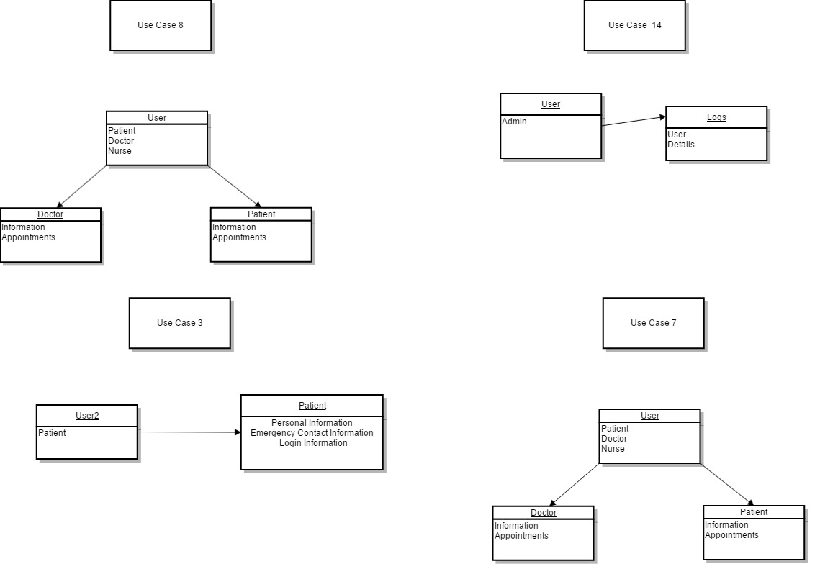

Sequence Diagram(s)

Use Case 1
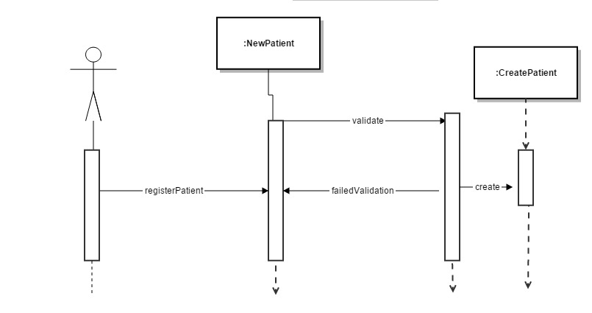
Use Case 2
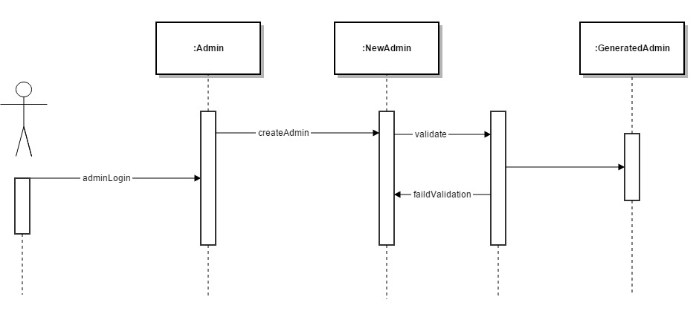
Use Case 6
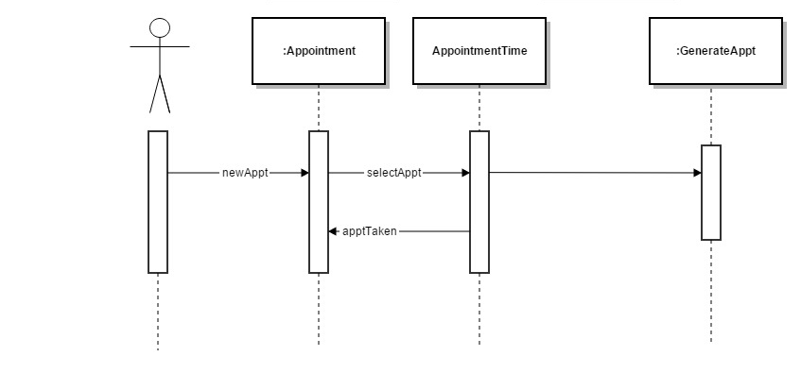
Use Case 12
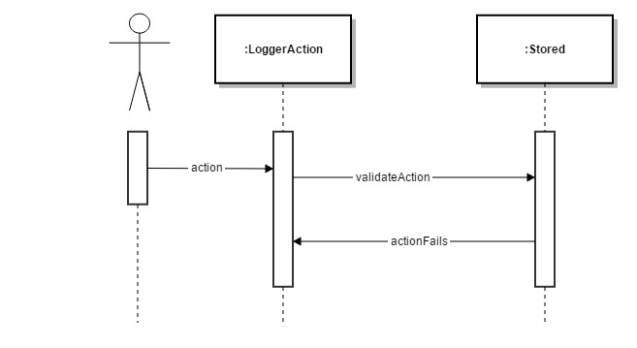
Use Case 3
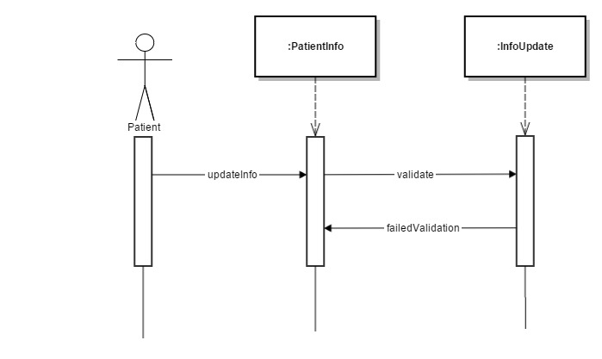
Use Case 7
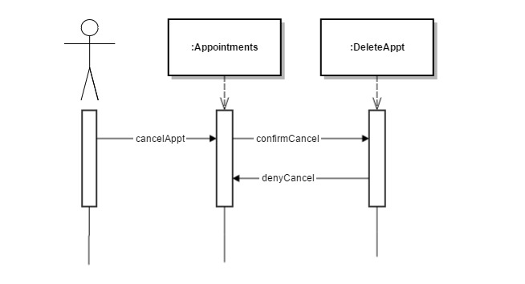
Use Case 8
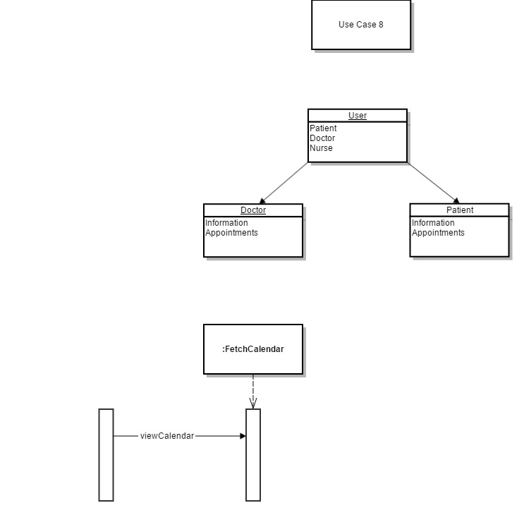
Use Case 14
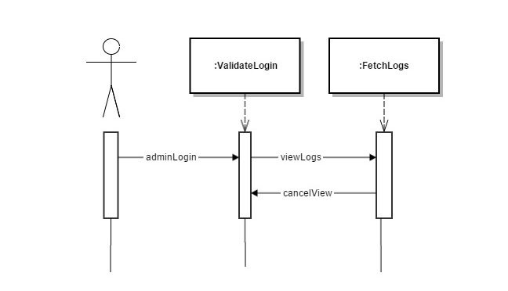

Design Rationale
We chose to use only one app for this project. We could not find any benefit aside from namespace collisions that would result from making multiple apps.

This meant we had to figure out a different way to prevent namespace collisions. What we chose to do was create an individual .py file for each view, and import them into the main views.py file. This also let us be able to work on views simultaneously without risk of merge conflicts.

We chose to use the Django superuser as the admin, because it gives us everything we need, custom built. Perhaps we will edit the templates later to make it work better, but for now it works well.

We also broke the work into front end, back end (views), and models. This lets us break into smaller groups to do the different parts.
Django has a built-in login view, but we chose to make our own because it allows us to better control it and prevent someone from re-logging in.

