Title

Authors

**Keywords:**

# Abstract

Abstract here

# Introduction

Introduction

## New topic

Topic

## Topic 2

Topic

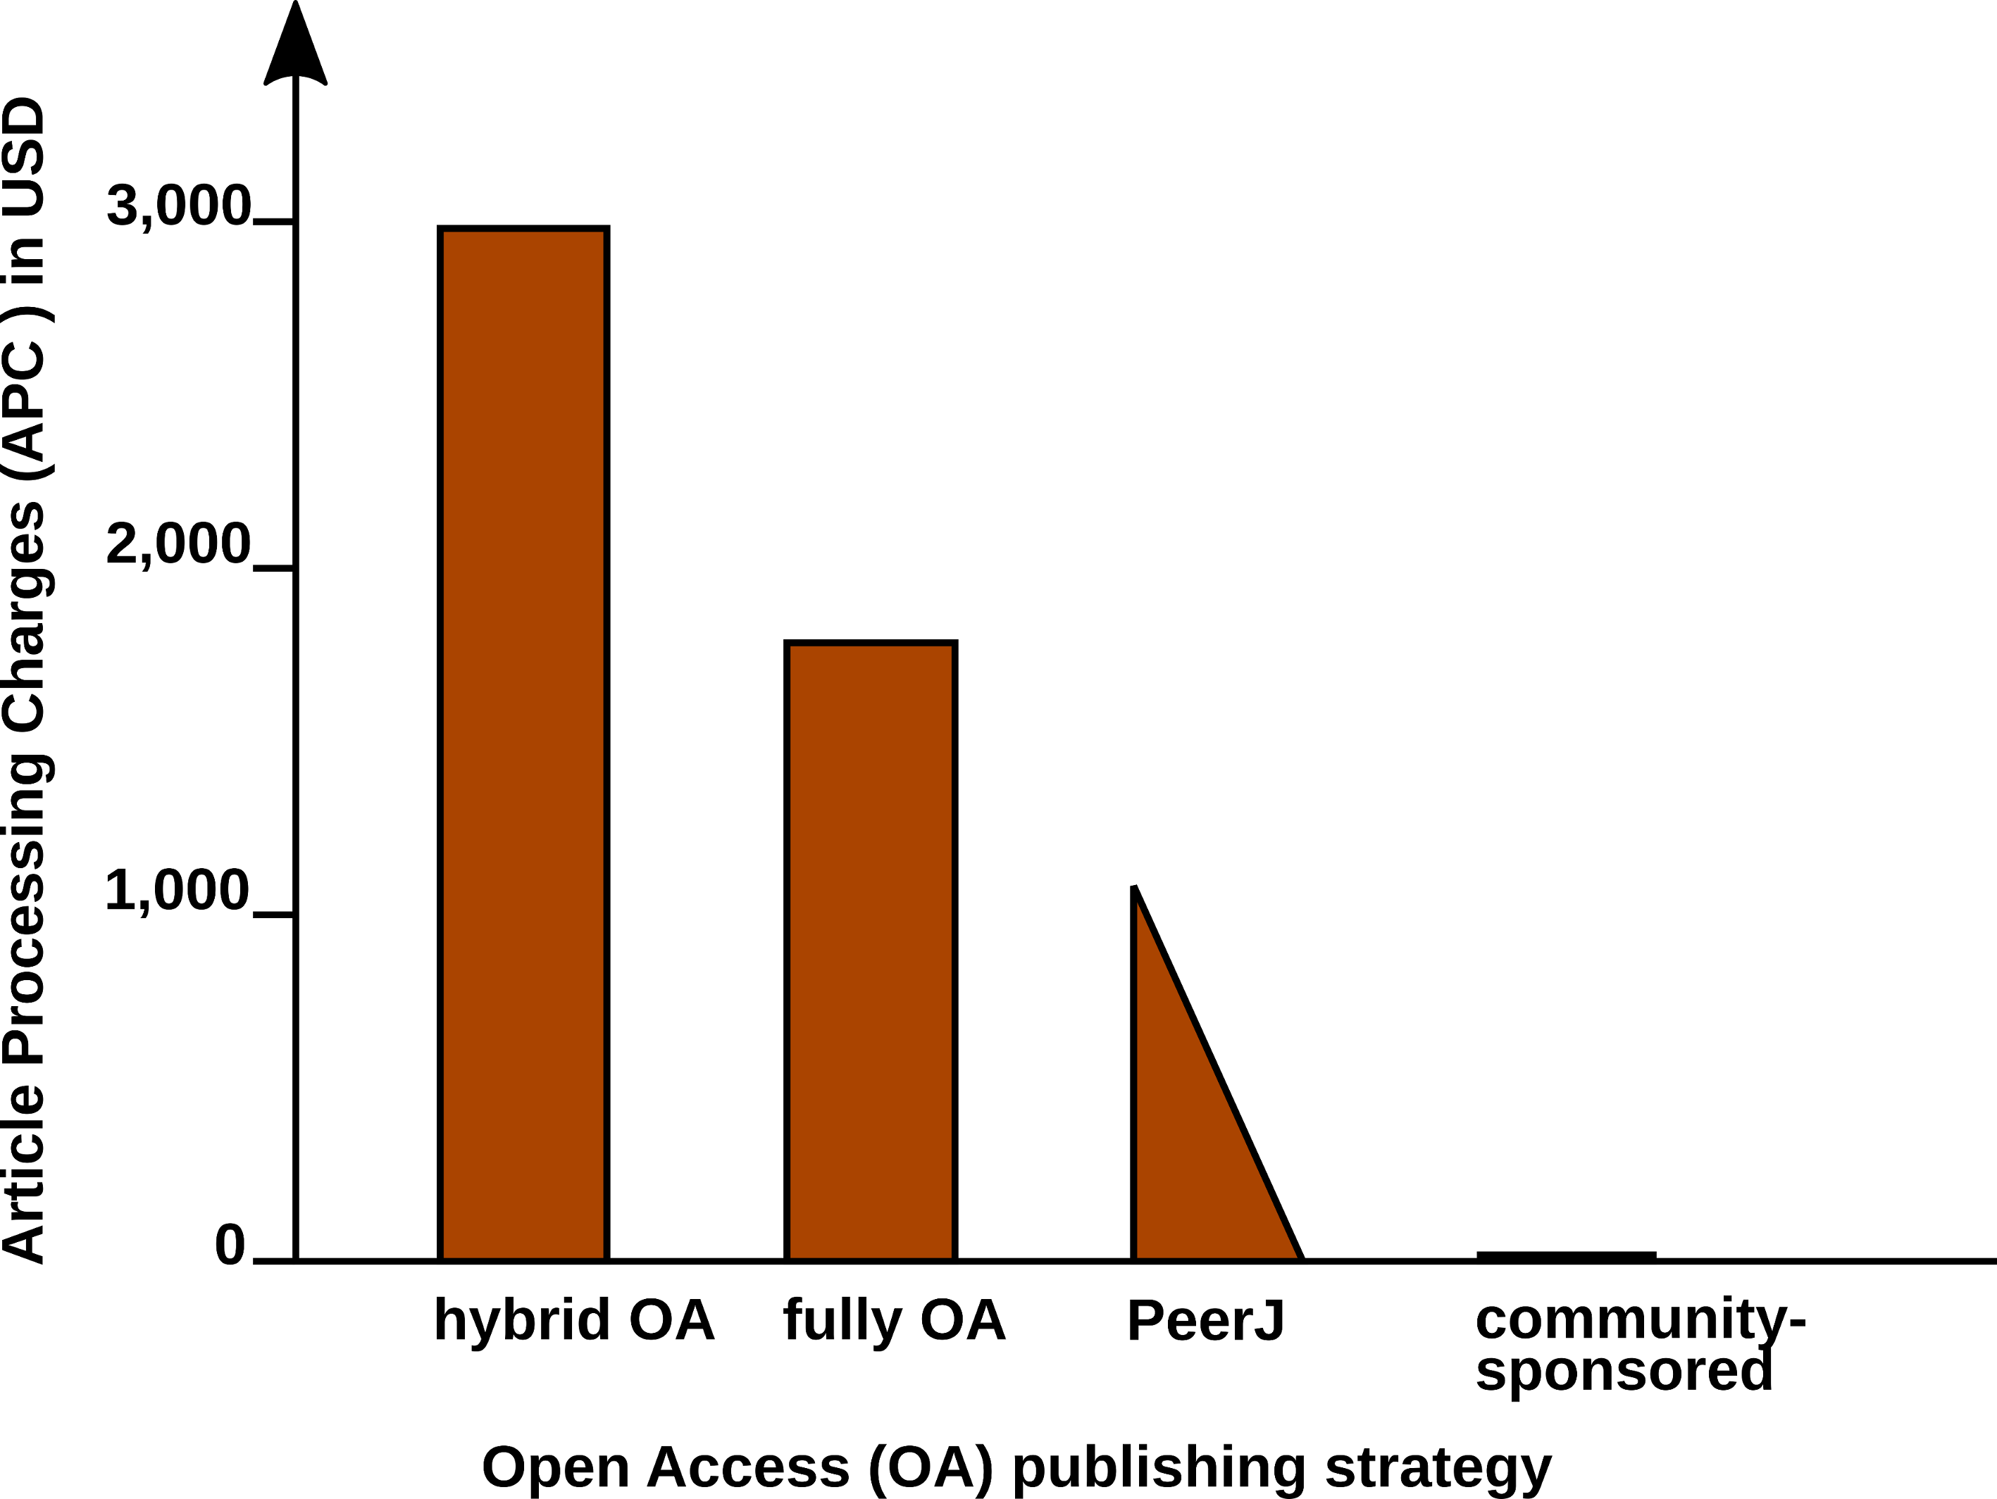

Article Processing Charge (APCs) that authors have to pay for with different Open Access (OA) publishing models. Data from (Solomon and Björk 2016) and journal web-pages.

Figure

# Conclusions

Conclusion

# Acknowledgments

Acnowledge

# Bibliography