Hand gesture recognition application for patient recovery

LICENSE THESIS

 | Graduate: | Paul IANCU
 | Supervisor: | S. l. dr. ing. Razvan ITU

2015

DEAN, |  |  | HEAD OF DEPARTMENT,
Prof. dr. eng. Liviu MICLEA |  | Prof. dr. eng. Rodica POTOLEA

Graduate: Paul IANCU

Hand gesture recognition application for patient recovery

- Project proposal: Short description of the license thesis and initial data

- Project contents: Presentation page, advisor's evaluation, Table of contents, Introduction, Project objectives, Bibliography research, Analysis and theoretical foundation, Detailed design and implementation, Testing and validation, User’s manual, Conclusions, Bibliography.

- Place of documentation: Technical University of Cluj-Napoca, Computer Science Department

- Consultants: S. l. dr. ing. Razvan ITU

- Date of issue of the proposal: November 1, 2014

- Date of delivery: June 18th, 2015 (the date when the document is submitted)

Graduate: | ____________________________
Supervisor: | ____________________________

Declaraţie pe proprie răspundere privind
autenticitatea lucrării de licenţă

Subsemnatul(a)________________________________________________________________________________________________________________________, legitimat(ă) cu _______________ seria _______ nr. ___________________________
CNP _______________________________________________, autorul lucrării ____________________________________________________________________________________________________________________________________________________________________________________________elaborată în vederea susţinerii examenului de finalizare a studiilor de licență la Facultatea de Automatică și Calculatoare, Specializarea ________________________________________ din cadrul Universităţii Tehnice din Cluj-Napoca, sesiunea _________________ a anului universitar __________, declar pe proprie răspundere, că această lucrare este rezultatul propriei activităţi intelectuale, pe baza cercetărilor mele şi pe baza informaţiilor obţinute din surse care au fost citate, în textul lucrării, şi în bibliografie.
Declar, că această lucrare nu conţine porţiuni plagiate, iar sursele bibliografice au fost folosite cu respectarea legislaţiei române şi a convenţiilor internaţionale privind drepturile de autor.
Declar, de asemenea, că această lucrare nu a mai fost prezentată în faţa unei alte comisii de examen de licenţă.
In cazul constatării ulterioare a unor declaraţii false, voi suporta sancţiunile administrative, respectiv, anularea examenului de licenţă.

Data  _____________________ |  | Nume, Prenume  _______________________________
 |  | Semnătura

De citit înainte (această pagină se va elimina din versiunea finală):

- Cele trei pagini anterioare (foaie de capăt, foaie sumar, declaraţie) se vor lista pe foi separate (nu faţă-verso), fiind incluse în lucrarea listată. Foaia de sumar (a doua) necesită semnătura absolventului, respectiv a coordonatorului. Pe declaraţie se trece data când se predă lucrarea la secretarii de comisie.
- Pe foaia de capăt, se va trece corect titulatura cadrului didactic îndrumător, în engleză (consultaţi pagina de unde aţi descărcat acest document pentru lista cadrelor didactice cu titulaturile lor).
- Documentul curent a fost creat în MS Office 2007. Dacă folosiţi alte versiuni e posibil sa fie mici diferenţe de formatare, care se corectează (textul conţine descrieri privind fonturi, dimensiuni etc.).
- Cuprinsul începe pe pagina nouă, impară (dacă se face listare faţă-verso), prima pagina din capitolul Introducere tot aşa, fiind numerotată cu 1. Pentru actualizarea cuprinsului, click dreapta pe cuprins (zona cuprinsului va apare cu gri), Update field->Update entire table.
- Vizualizaţi (recomandabil şi în timpul editării) acest document după ce activaţi vizualizarea simbolurilor ascunse de formatare (apăsaţi simbolul π din Home/Paragraph).
- Fiecare capitol începe pe pagină nouă, datorită simbolului ascuns Section Break (Next Page) care este deja introdus la capitolul precedent. Dacă ştergeţi din greşeală simbolul, se reintroduce (Page Layout -> Breaks).
- Folosiţi stilurile predefinite (Headings, Figure, Table, Normal, etc.)
- Marginile la pagini nu se modifică (Office 2003 default).
- Respectaţi restul instrucţiunilor din fiecare capitol.

Table of Contents

Chapter 1. Introduction (Heading 1 style) 1
1.1. Project context (Heading 2 style) 1
1.1.1. (Heading 3 style) 1
Chapter 2. Project Objectives 3
Chapter 3. Bibliographic Research 4
Chapter 4. Analysis and Theoretical Foundation 5
Chapter 5. Detailed Design and Implementation 6
Chapter 6. Testing and Validation 7
Chapter 7. User’s manual 8
Chapter 8. Conclusions 9
Bibliography 10
Appendix 1 (only if needed) 11

Introduction (Heading 1 style)
The title of each chapter is formatted using Heading 1 style, numbering with one digit (Chapter x. Chapter Name ), font Times New Roman, size 14 points, Bold.
This chapter will present:
- Project context,
- Specification of the precise domain of the license thesis,
- Use about 5% of the paper.

Project context (Heading 2 style)
The font used for the text in this document is Times New Roman, size 12 points, as defined in the Normal style, Line spacing equal to 1.0 (Paragraph, Line spacing) and Justify.
The first line for each paragraph must be indented (implicit in Normal Style), and no additional space is inserted between successive paragraphs.

(Heading 3 style)
Each table used in this document is labeled as Table x.y, where x represents the chapter number, and y shows the table number within the current chapter. Leave a blank line between and after each table, relative to the adjacent paragraphs.

Table 1.1 (References, Insert caption->Table)
Times new roman ( 12) | Xxxx | xxxx | xxxx

Each figure used in the document must be cited within the text (ex: in figure x.y the system components are presented... ) and labeled. The labeling must be as Figure x.y where x represents the chapter number, and y shows the number of the figure within the current chapter. Use (References, Insert caption->Figure).

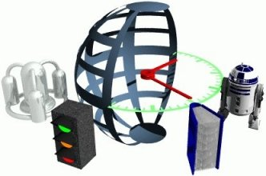
Figure 1.1 Description (References, Insert caption->Figure)
Each chapter must start on a new page.

Project Objectives
The project theme must be described in this chapter (as a research/design proposal, clearly formulated, with clear objectives 2-3 pages, and some explanatory figures).
Should represent about 10% of the paper.

Bibliographic Research
Bibliographic research has as an objective the establishment of the references for the project, within the project domain/thematic. While writing this chapter (in general the whole document), the author will consider the knowledge accumulated from several dedicated disciplines in the second semester, 4th year (Project Elaboration Methodology, etc.), and other disciplines that are relevant to the project theme.
Represents about 15% of the paper.
References will be included in the Bibliography section. The reference format must be IEEE, or similar. The introduction of new references in the Bibliography section, and their citation within the document text can be done manually (by obeying the format), but it is less recommended, or by using the tools mentioned in the last paragraphs of this chapter.
In the Bibliography section, there are examples of references to conferences or workshops articles [1], journal articles [2], and books [3]. References to applications or online resources (web pages) must include at least a short relevant description in addition to the link [4], and other information is available (authors, year, etc.). References that contain only the link to the online resource will be placed in the page footer.
Each reference must be cited within the document text, see example below (depending on the project theme, the presentation of a method/application can vary).
In paper [1] the authors present a detection system for moving obstacles based on stereovision and ego motion estimation. The method is … discus the algorithms, data structures, functionality, specific aspects related to the project theme, etc…. Discussion: pros and cons.
In chapter 4 of [3], the similar-to-my-project-theme algorithm is presented, with the following features…
Software and other tools managing bibliography for MS Word 2003, and usage instructions can be found at:
How to use JabRef (BibTeX) with Microsoft Word 2003
Bibtex4Word
BibWord makes it easier to create and manipulate Microsoft Word citation and bibliography styles
For MS Word 2007 and MS Word 2010, the integrated bibliography management system should be used, References, Citations & Bibliography. More information can be found in the online documentation of MS Office.

Analysis and Theoretical Foundation

Functional and non-functional requirements
The proposed application must have the following functionalities: hand recognition, hand localization, gesture classification, visual display of the status of the game.
The environment in which the application is assumed to be used is a static room (a room with no other moving objects in the background other than the user).
- The application will be used by the patient with hand motor control problems.
- The application will be available for usage on all widely available OSes (Windows, MacOS, Linux).
- The application requires a web-camera to be equipped with the system.

Functional requirements
The purpose of this application is to provide an interactive way for the user to exercise his/her hand motor control. The system should detect the user’s hand, classify the hand gesture and check if it matches the desired gesture, which the user was asked to replicate. If the hand gesture made by the user matches the given one, the system will ask the user to replicate another gesture. If the hand gesture made by the user does not match the given one, the system will display to the user the differences between the made gesture and the chosen one.

Non functional requirements
The application must be robust. The application must give accurate results in most lighting conditions. The application must give good results for any web-camera which has a resolution of at least 720p and captures images at a frame rate of at least 30 FPS.
The application must be accurate. The algorithm for hand gesture classification must have a high accuracy score. The methods used for hand detection and hand tracking must also be very precise.
The application must be efficient. The application must provide back to the user a response in real-time. A minimum frame rate of 15 FPS must be achieved.
The application must have a high score of usability. The application must be intuitive to the user, and must not require instructions outside of the ones given by the application.
The application must have a high score of availability. The application must run on any PC which has installed a widely available OS (Windows, MacOS, Linux).

Use cases
The use cases for the proposed application are presented in the diagram below.
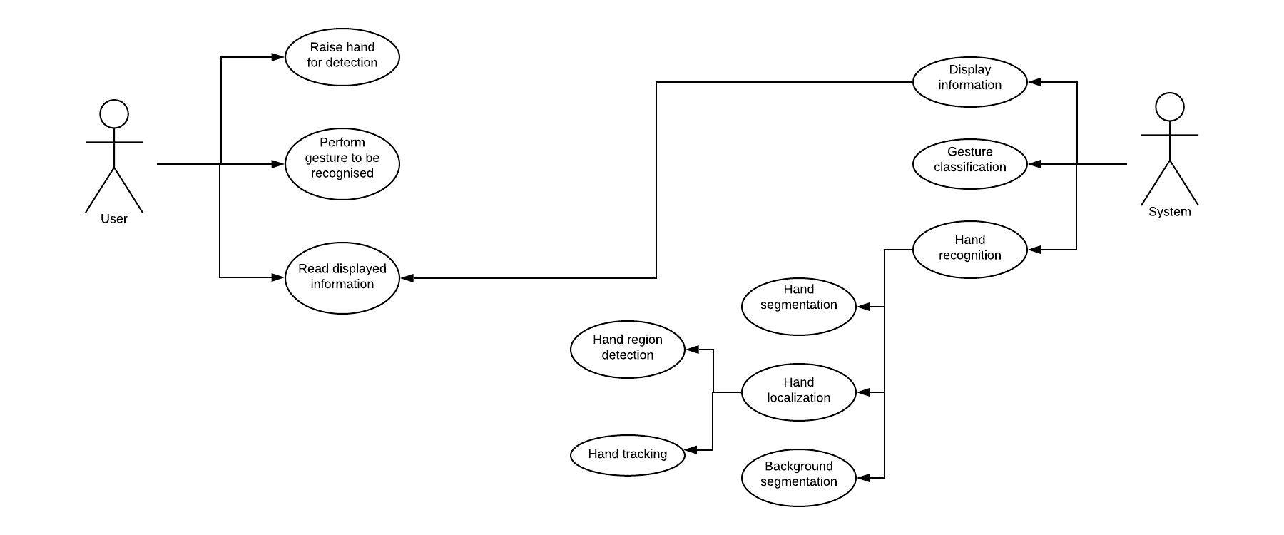
Figure 4.1 Use cases of the application

High-level system overview
The main steps of the systems are the following: background subtraction, hand detection, hand tracking, hand segmentaion, high-level feature extraction, hand gesture classification.
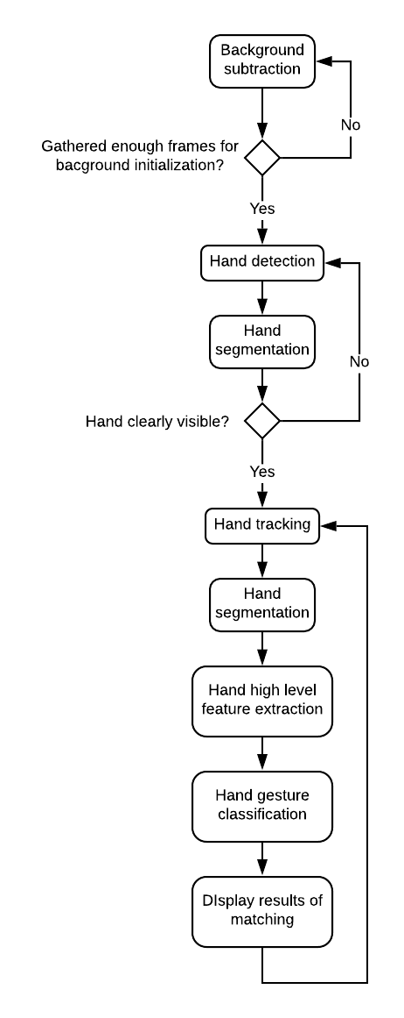
Figure 4.2 High level system overview

Background subtraction
The method used for background subtraction is the following. A certain number of frames for background initialization is chosen. These first frames are used to calculate the average frame. Each frame is represented by a two dimensional matrix where a cell is a tuple of three values between 0 – 255, which represent a color value in RGB space. To calculate the average frame, we sum all the gathered frames (the frames are added element wise), then we divide each element of the summed matrix by the number of collected frames. The resulted frame is converted into a grayscale image (a two dimensional matrix with values between 0 - 255), then a Gaussian blur is applied over the grayscale image. To subtract the foreground, we convert the frame to a grayscale image, apply a Gaussin blur, subtract the current frame from the obtained background frame (element wise), apply a threshold over the obtained frame (in order to filter out the insignificant differences), apply a closing operation over the frame (in order to fill in the small gaps).

Hand detection
For hand detection, a YOLOv3 model was trained on a dataset. In order to feed a frame obtained from the web-camera to the network, some pre-processing steps must be done in order to comply to the network architecture. The first pre-processing step is to scale the values from the matrix in order to be in the interval [0, 1] (instead of [0, 255]). The second step is to resize the image to 416x416. Finally, the last step is to reverse the order of the values inside the cell. After the forward pass is performed, the output of the network is a vector which has the following structure: the first four elements are the center x, center y, width and height of the object bounding box (these dimension are in the interval [0,1], they are relative to the dimensions of the original image), the fifth element is the confidence that the bounding box contains an object, the rest of the elements represent the confidences for each class. The bounding boxes which have a confidence below the a chosen threshold are filtered out. Over the remaining bounding boxes, we apply a method called non maxima supression in order to eliminate bonding boxes which overlap.

Hand tracking
After it is sure that the region of the hand was clearly detected, in order to try to improve efficiency, an object tracking algorithm will be run on the subsequent frames, instead of running the detection method (which is more slow than the object tracking algorithm) on the rest of the frames. The chosen object tracking algorithm is CSRT (Discriminative Correlation Filter with Channel and Spatial Reliability). There are many object tracking algorithms, but from experimenting with the available methods, this approach was found to be the solution that provides good enough accuracy with exceptable efficiency.

Hand segmentation
In order to obtain a grayscale image which represents the silhouette of the hand (zero values represent the background, non zero values represent the hand region), a method based on the backprojection algorithm is applied. First, the ROI (Region of Interest) from the original frame is extracted into a separate two dimensional matrix. After this step, we convert the extracted image from the RGB color space into the HSV color space. The next step is to extract the ROI from the foreground mask. The histogram for the Hue and Saturation channels is calculated for the image in the HSV color space, but only taking into account the pixels where the foreground mask has a non zero value. This histogram will be saved when it is certain that the hand is clearly detected. For the subsequent frames, the bounding box given by the object tracking algorithm is used to extract the ROI, the ROI is converted to the HSV color space. For each pixel in the recently obtained image, we calculate where that pixel would be placed in the Hue-Saturation histogram, then that location will be looked up in our previously saved histogram. The value of the histogram in the given location will be placed in a new image, called the backprojection, at the same coordinates as the pixel in the original ROI. The backprojection image can be interpreted in the following way: the value of a pixel in the backprojection of an image is the probability that this pixel belongs to the region over which the original histogram was calculated. The next step is to apply a filter over the backprojection, in order to smooth the image. A thresholding operation is applied, in order to keep only the relevant pixels. After this step, a closing operation is applied in order to close the small gaps that might have resulted from the previous step and from imperfections in the webcamera. In the final step, the connected components in the image are found, and only the connected component with the largest area (number of pixels which it contains) is kept in the final image.

High level feature extraction
In order to extract high level features from the hand’s silhouette image (such as the palm center, wrist points, hand orientation, fingers’ state and fingertips) a series of operations have to be performed.

Localization of the palm point
The palm point in this context is defined as the point which can be considered the center of the palm. In order to find this point, we must first obtain the distance transform of the hand’s silhouette. The distance transform is an operation which is applied over a binary image, and outputs a matrix where each element represents the distance from the pixel at these coordinates to the nearest boundary point of the object in the original image. The palm point can be found by locating the element with the maximum value in the distance transform. This flow of steps is exemplified in Figure 4.3.

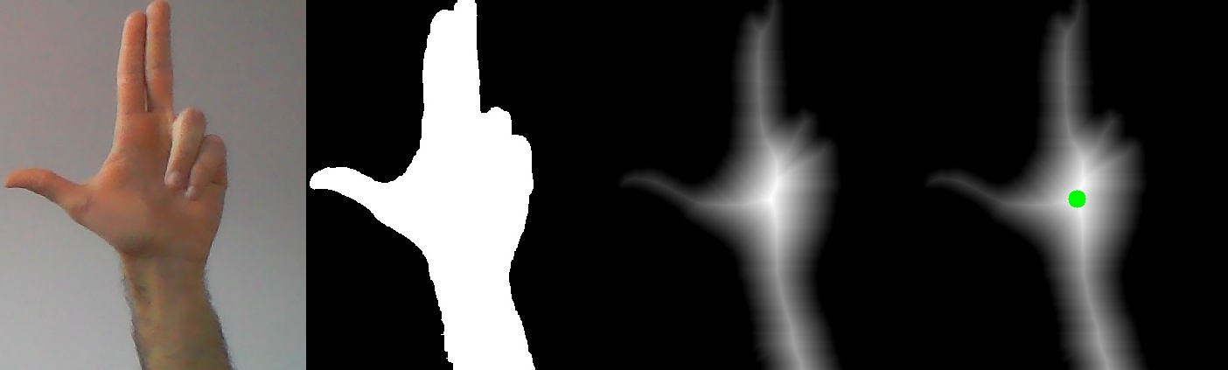
Figure 4.3 From left to right a) original image captured from webcam b) hand’s silhouette after segmentation c) distance transform d) distance transform with palm point marked

Determination of the palm region
The palm region is the portion from the image in which most of the palm is found. It can be approximated by a circle centered at the palm point and having a specific radius, called the radius of the palm. In order to find the radius of the palm, the contour of the silhouette is determined. The next step is to calculate the distances from the palm point to each point on the previously obtained contour. The minimum such calculated distance is then multiplied with 1.2. An illustration of the palm region is shown in Figure 4.4.

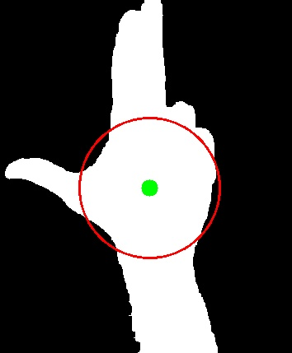
Figure 4.4 Palm region

Determination of the palm mask points
The palm mask points represent the vertices of the polygon which enclose only the palm portion of the image. To obtained these points, we must first determine the sample points. The sample points are found by sampling points on the circle previously defined as the palm region, taking a sample for each angle in the interval [0, 360] with 1 degree increment. After obtaining the sample points, for each sample point we find the point on the contour which is the closest. In Figure 4.5, an illustration of the palm mask points can be found. The blue lines in this figure are from the sample points to the palm mask points.
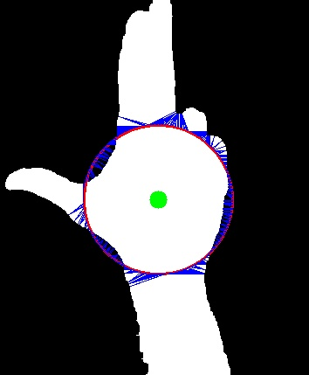
Figure 4.5 Palm mask points

Wrist points localization, hand orientation and arm segmentation
The wrist points can be seen as the points which determine the line of the wrist. The wrist points can be obtained by finding the pair of consecutive elements in the palm mask points list which has the maximum distance between them. The wrist points are used for two purposes: hand orientation calculation and arm segmentation. The hand orientation is the perpendicular direction over the wrist line. The image hand is rotated such that the wrist line will become a horizontal line. This step makes the algorithm of high level feature extraction invariant to the orientation of the hand in the original image. After this step, the region of the image which is below the wrist line is cropped of, in order to eliminate the arm from the image (which will not contain any useful information from this step onwards). In Figure 4.6, in the left region, the wrsit points are represented by the light blue circles and the wrist line is marked by the yellow line. In the right region of the the result after rotation by the hand orientation and arm segmentation is presented.
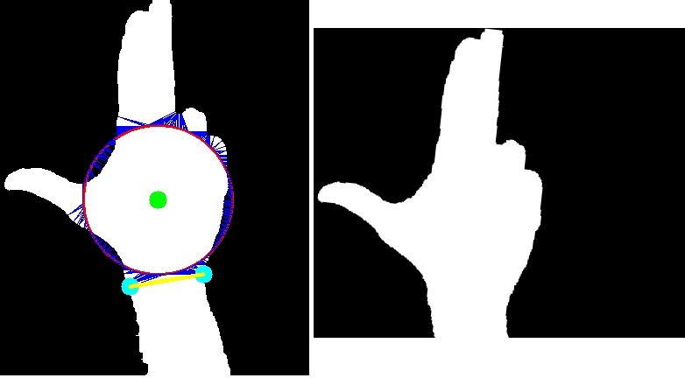
Figure 4.6 From left to right a) wrist points and wrist line b) hand rotation and arm segmentation

Finger segmentation
In this step an image in which only the lifted fingers are presented will be obtained. First, the palm mask points have to be rotated by the angle given by the hand orientation. Next, in order to obtain the palm mask (binary image where only pixels in the region of the palm have non zero values), the closed polygon given by the palm mask points is filled. The palm mask is used by subtracting it from the image obtained at 4.8.4.
This process is illustrated in Figure 4.7.
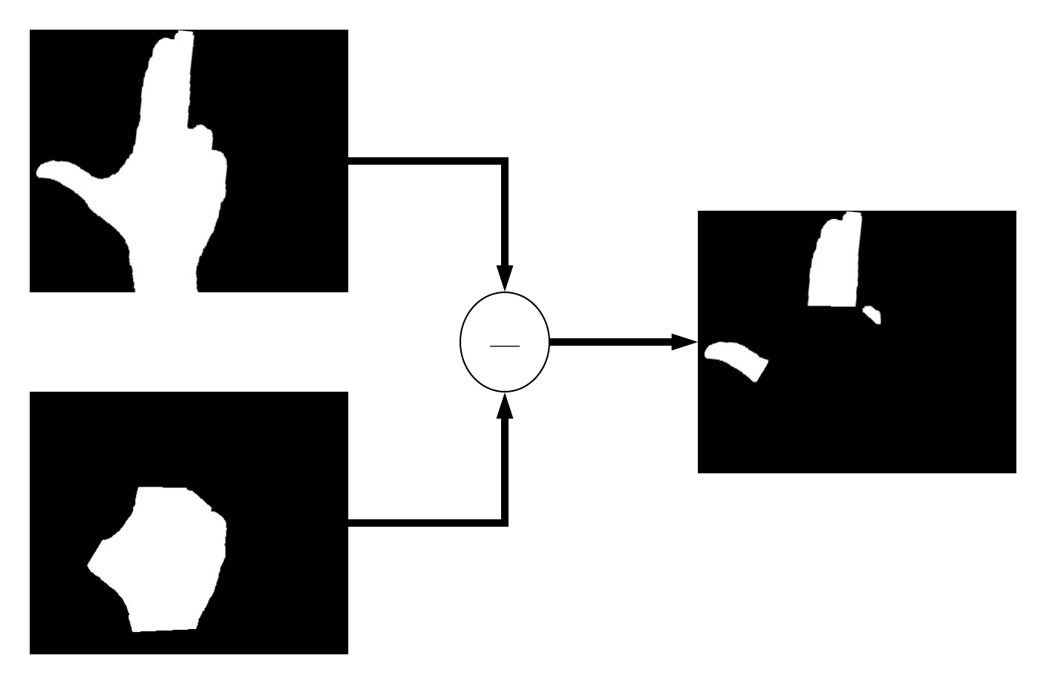
Figure 4.7 Finger segmentation

Fingers’ lines determination
The connected components from the image in the previous step are found. For each connected component, the minumum area rectangle is determined. The average area of these rectangles is calculated. The connected components whose minimum rectangle have an area smaller than the average , which was previously found, divided by 2.5 are filtered out. This filtering is neccessary in order to eliminate the components that do not represent a finger and which escaped the finger segmentation step (these components are usually the knuckles). If the area of a mimum rectangle is at least 1.5 times greater than the expected area, that rectangle will be divided by into multiple smaller rectangles. From the obtained minimum area rectangles, the finger line is found. The finger line is defined by the middle point of the minimum area rectangle and its projection on the bottom side of the rectangle. In Figure 4.8, this process is illustrated.

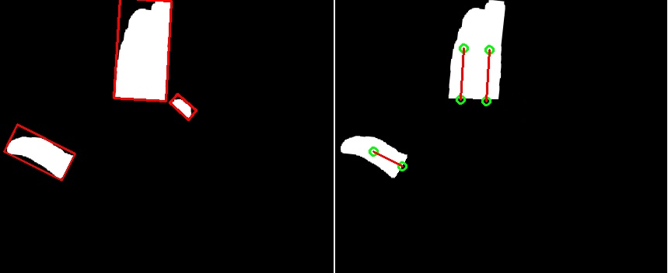

Figure 4.8 From left to right a) minimum area rectangles b) fingers’ lines

Thumb detection, palm line determination
In order to determine if the thumb is present in the image, for each finger line obtained in the previous step, the angle between the finger line and the wrist line is calculated. If there is exists such an angle which is smaller than 35 degrees, then the thumb is detected in the image, else the thumb is not detected in the image. The palm line is a horizontal line used to classify the remaining fingers. It is found by searching for the horizontal line in the palm mask which has the greates number of non zero values. The search is done from top to bottom. If the thumb is present in the image, the search will be done only up to the bottom of the thumb’s base. If the thumbs is not present in the image, the search is done on all the image.

Fingers classification
The thumb finger was classified (if it is present or not) in the previous step. In order to classify the remaining fingers (the remaining finger lines), the palm line will be used. The palm line will be divided into four equal regions. From left to right, the first region will be associated with the index finger, the second region will be associated with the middle finger, the third region will be associated with the ring finger and the fourth region will be associated with the little finger. For each finger line, the bottom point will be projected onto the palm line. The finger line will be classified with the finger associated with the region onto which the projection fell on. In Figure 4.9, the result of this classification is shown.

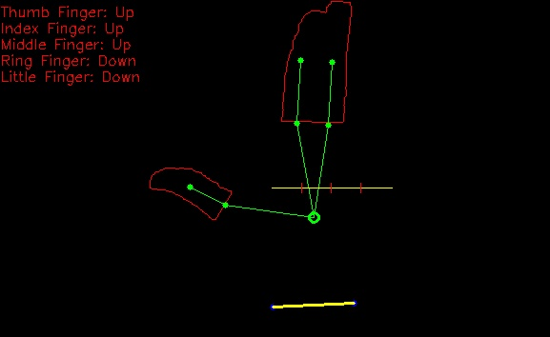
Figure 4.9 Final results

Detailed Design and Implementation

High-level system architecture
The architecture of the system is composed of multiple layers and components. The high-level overview is presented in Figure 5.1.
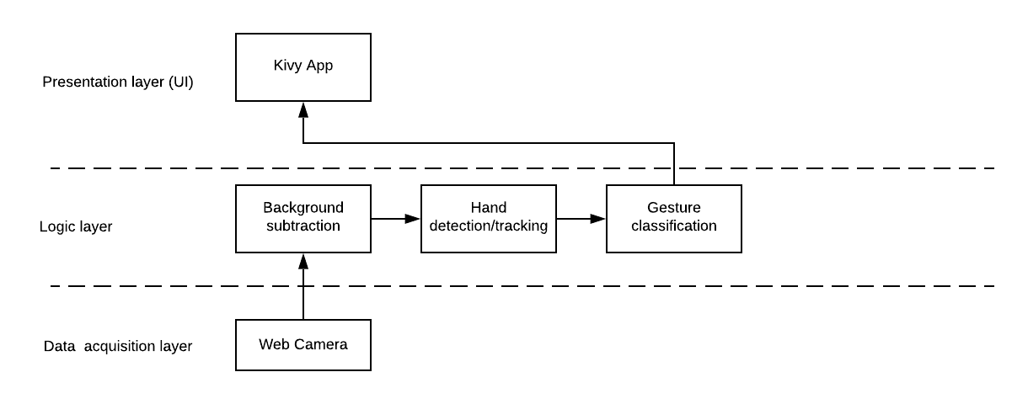
Figure 5.1 High-level system architecture

Programming and development tools
The project was developed in the Python programming language using the JetBrain’s PyCharm IDE.

Python
Python is a general-purpose programming language, first released in 1991 and developed by Guido van Rossum. The main features of the Python programming language are the following: dynamically typed, which means that the type of a variable does not have to be specified at declaration and that a variable can hold values of different types; garbage collected: which means that the programmer does not have to manually manage allocated memory, the garbage collector will automatically free unused memory; multi-paradigm: unlike other modern programming languages (e.g.: C, Java, C#, etc.), Python does not force the programmer into a specific paradigm, instead, it provides syntax and semantics for all modern paradigms (procedural, object oriented, functional) and lets the developer choose his preferred paradigm or a combination (as is usually the case) of them. The main disadvantage of Python is its slowness, which is caused by the fact that it is an interpreted language and a garbage collected one. However, this disadvantage can be somewhat mitigated by using various tools and libraries.

JetBrain’s PyCharm
JetBrain’s PyCharm is a popular IDE (Integrated Development Environment) used for developing Python applications.

OpenCV Library

OpenCV is a library developed in C++, which aims to provide efficient implementations of commonly used algorithms and methods frequently encountered in computer vision. It has bindings for the Python programming language, making it suitable for prototyping applications.

NumPy
NumPy is a scientific computing library that provides efficient implementations of vectors/matrices data structures and linear algebra operations and functions for the Python programming language. Python code written using NumPy can become very efficient, however the code must be rewritten in order to make use of vector and matrices operations. NumPy ndarrays (homogenous matrix data structure) is the main object used by OpenCV to represent images, filter kernels, feature points, etc. One of the main disadvantages of NumPy is that it can not be used to optimize code written using traditional for loops.

Numba
Numba is a package for the Python programming language that provides a JIT (Just In Time) compiler which can compile source code written in Python (and which optionally uses NumPy structures and functions) into optimized machine code. Numba also offers features for parallelizing code using either SIMD operations, CPU cores or GPU cores. Numba is mainly used in order to circumvent one of the main limitations of the Numpy library, which is that code written using traditional for loops is very slow. However, some modifications of the original source code may be necessary in order for the JIT compiler to optimize the code.

Darknet
Darknet is a framework for building and training neural networks written in C and CUDA, which supports computation on both CPUs and GPUs.

Kivy
Kivy is a framework used to develop GUIs (Graphical User Interfaces) for the Python programming language. Kivy can run on many of the most available platforms including Windows, Linux, MacOS X, Android, iOS and Raspery Pi. Kivy’s widgets and screen are rendered using OpenGL ES 2, making it very fast and responsive.

SciPy
SciPy is a library used for scientific and technical computing designed for the Python programming language.

Implementation details
In this section, more details will ben given regarding the project structure, how and where the tools and technologies listed in the previous section were used, some details regarding the optimization of the project.

Class diagram
The class diagram which represents the structure of the project is shown in Figure 5.1.
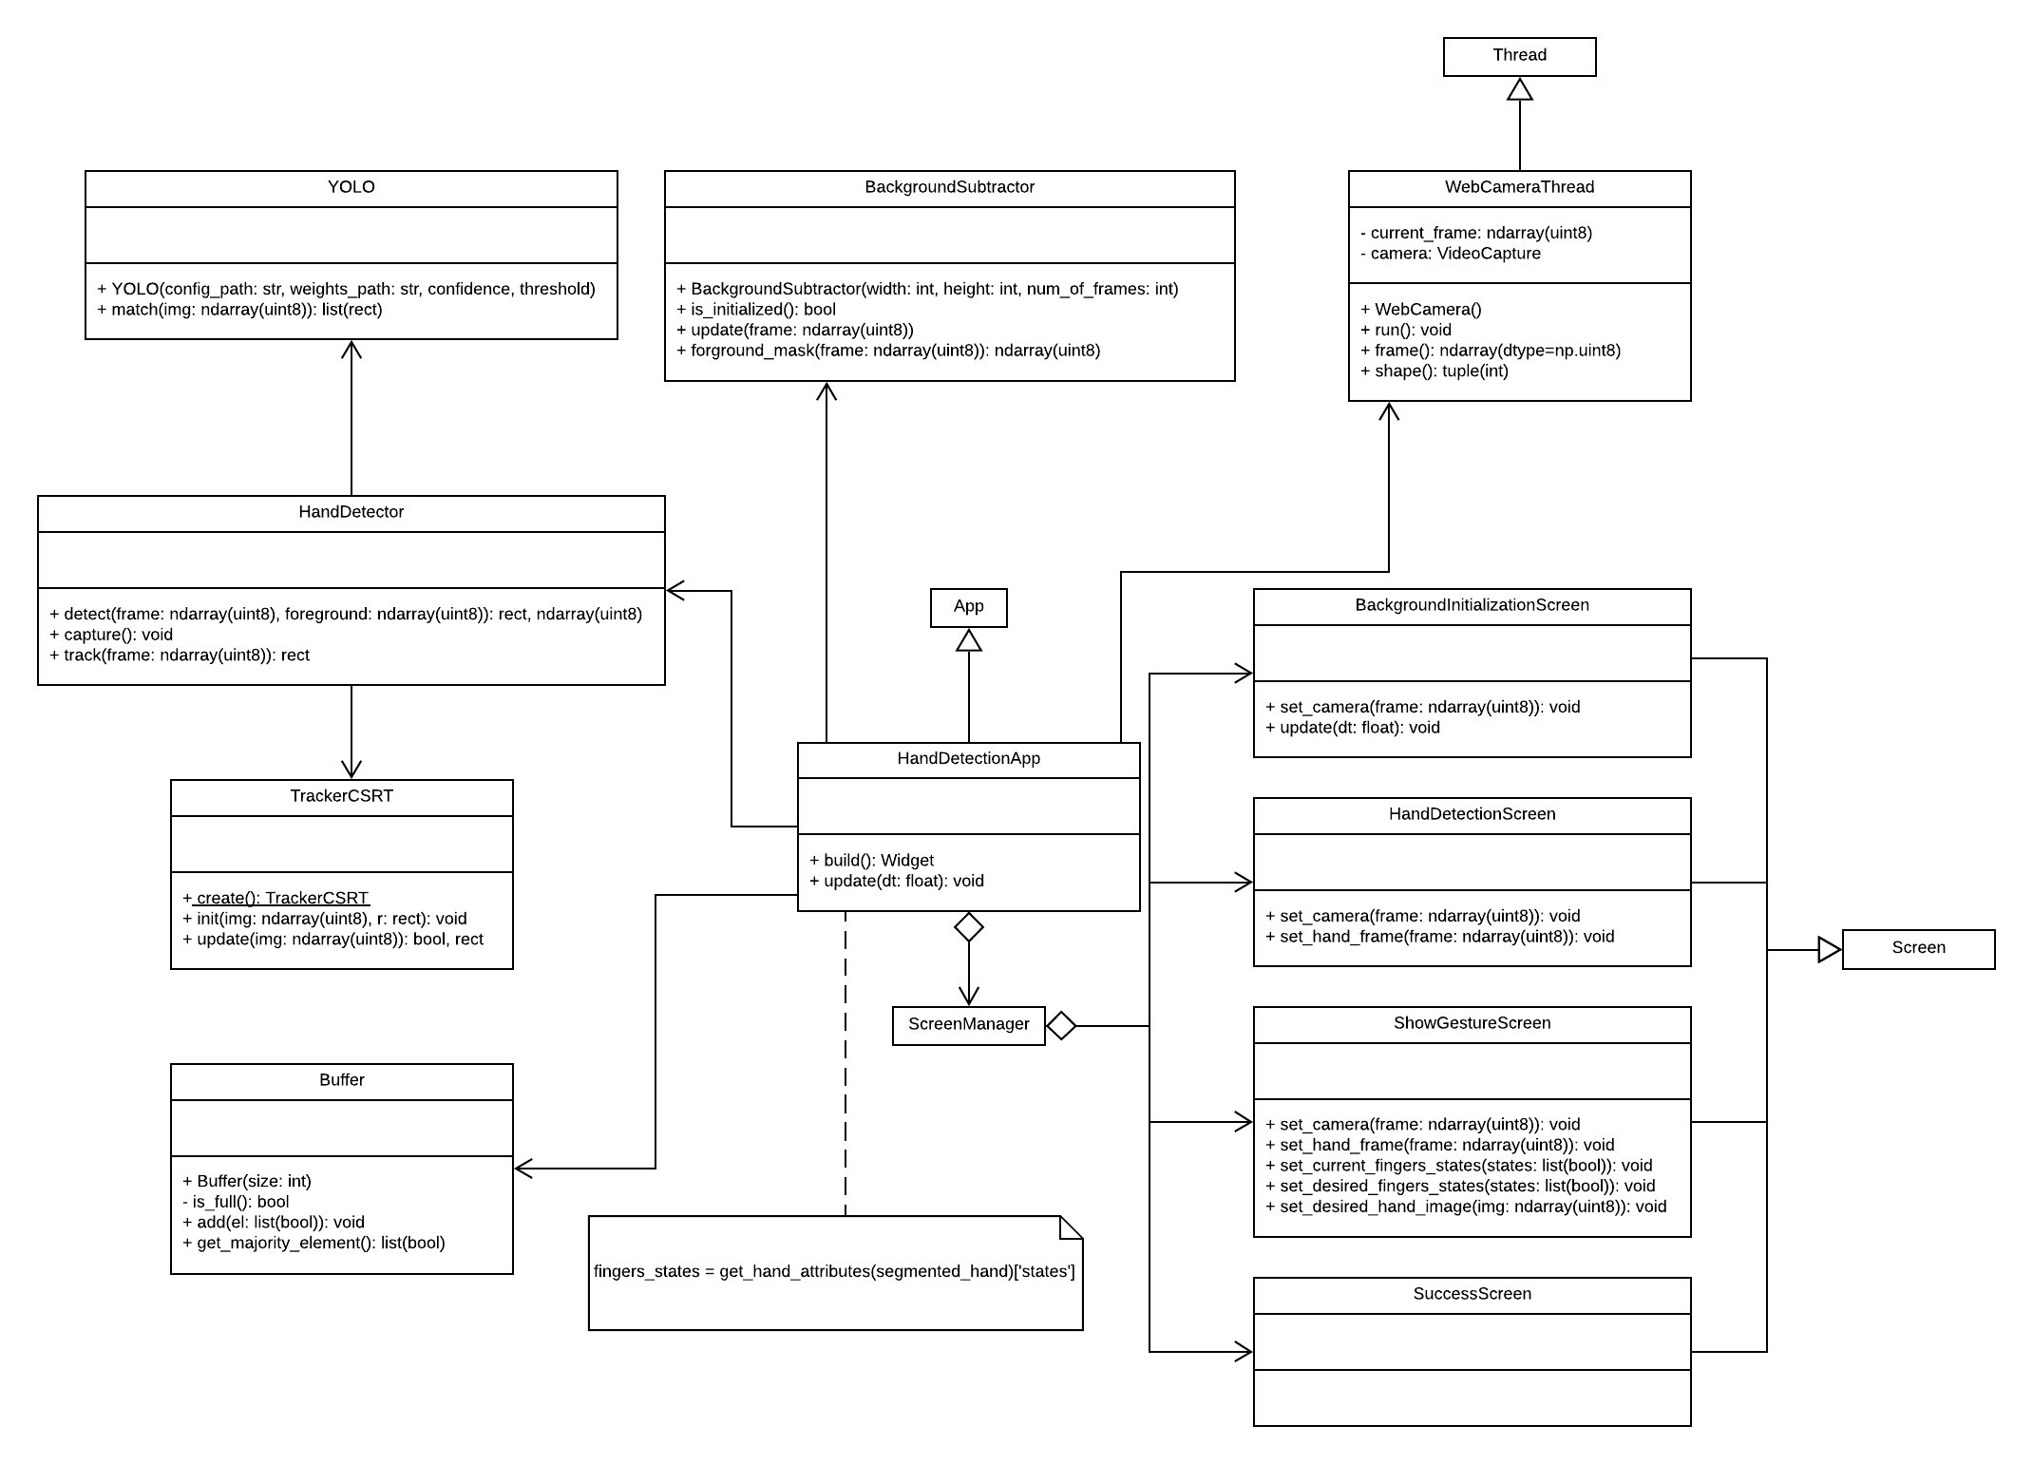

Figure 5.1

WebCameraThread Class
The WebCameraThread class is used in order to read frames from the web camera. It inherits from the Thread class of the Python’s threading module in order to implement a daemon thread (a thread that runs in the background). In order to define the job which is to be run in the background, the run method of the Thread class must be overriden. The main job of this thread is to continuously read data from the web camera and save the last captured frame. This class also provides a method for getting the last captured frame from the web camera. This approach is used because reading data from the web-camera is a very time consuming I/O task. The time it takes for the data acquisition step can be used in order to process the previous frames. When using this approach, it is possible that some frames will be dropped (will not be processed by the logic level), because the last frame might take much longer to process than reading the next frame. However, the information that is lost is not much and is not very relevant (can be easily interpolated without significant loss of accuracy). Although Python does not allow multiple threads to run in parallel due to its GIL (Global Interpreter Lock), this is a problem only for multiple CPU bound threads, not for I/O bound threads (as the web camera thread). The frames from the web camera are acquired by instantiating an object of the VideoCapture class, from the OpenCV module, and using the object’s read method, which returns a boolean value for the status of the operation (true for success, false otherwise) and the frame represented as a Numpy ndarray.

BackgroundSubtractor Class
The BackgroundSubtractor class implements the logic required for background subtraction. The constructor of this class takes as parameters the size of the subsequent frames (width and height) and the number of frames required for initializing the background. The is_initailized() method returns a boolean value which determines if the background initialisation is finished. The update() method takes as an argument the current frame and uses it to update the current background model. The foreground_mask() method is used to obtain a binary image in which the pixel having a non-zero value represent the foreground, it takes as a parameter the current extracted frame.

Testing and Validation
About 5% of the paper.

User’s manual
In the installation description section your should detail the hardware and software resources needed for installing and running the application, and a step by step description of how your application can be deployed/installed. An administrator should be able to perform the installation/deployment based on your instructions.
In the user manual section you describe how to use the application from the point of view of a user with no inside technical information; this should be adorned with screen shots and a stepwise explanation of the interaction. Based on user's manual, a person should be able to use your product.

Conclusions
About. 5% of the whole.
In this chapter you present:
- A summary of your contributions/achievements,
- A critical analysis of the results achieved,
- A description of the possibilities of improvements/further development.

Bibliography

[1] A. Bak, S. Bouchafa, and D. Aubert, "Detection of independently moving objects through stereo vision and ego-motion extraction," in IEEE Intelligent Vehicles Symposium (IV), San Diego, USA, 2010, pp. 863-870.
[2] A. Chambolle and T. Pock, "A First-Order Primal-Dual Algorithm for Convex Problems with Applications to Imaging," Journal of Mathematical Imaging and Vision, vol. 40, pp. 120-145, 2011.
[3] R. C. Gonzalez and R. E. Woods, Digital Image Processing. Second Edition.: Addison-Wesley Longman Publishing Co., Inc., 2001.
[4] Ajax Tutorial, http://www.tutorialspoint.com/ajax/.

Appendix 1 (only if needed)
…
Relevant code sections
…
Other relevant info (proofs etc.)
…
Published papers (if any)
etc.

