

School of Electrical and Electronic Engineering

**EEEN 40010**

**Control Theory**

|  |  |
| --- | --- |
| Student Name: | Paul Doherty |
| Student Number: | 10387129 |
| Date: | 4/11/2013 |
| Laboratory Title: | Frequency Domain Methods |

# Objective

To investigate the design of controllers by frequency domain methods when frequency response data only is available concerning the plant.

# Problem1

## The type and relative degree of the plant

The type and relative degree of the plant were determined by analysing the low and high frequency asymptotes of the magnitude plot respectively of the frequency domain data given.

By analysing the low frequency asymptote of the magnitude response of the plant it is found that the plant is of type 0.

By analysing the high frequency asymptote of the magnitude response of the plant it is found that the plant has a relative degree of 2. This was deduced by seeing that the plant magnitude has a roll-off of $40dB/decade$ at high frequencies, namely $100<ω<1000(rad/sec)$. This can be seen in figure 1. The relative degree of the plant tells us that the system contains at least two poles.

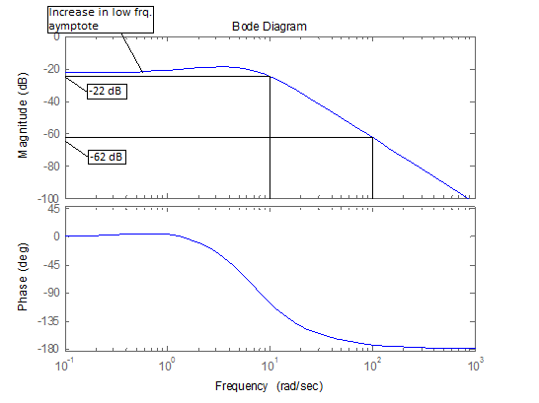

Figure :Increase in low frq. asymptote and high frq. asymptote 40 dB/decade roll-off shown

From examining the low frequency asymptote of the magnitude response it can be seen that there is a slight increase and so I think there is a zero present in the systems transfer function (figure 1). From these conditions it can be deduced that the system transfer function contains 1 zero and 3 poles.

## Gain and Phase Margins

The gain and phase margins of the plant were found by analysing the gain and phase crossover frequencies.

The phase crossover frequency, $ω_{pc}$, is defined as $Arg\left(G\left(jω_{pc}\right)\right)=-180$, i.e.where the phase shift is equal to $-180 degrees$. The phase crossover frequency tells us the gain margin of the plant. If there is no such frequency that the phase response of the system actually crosses $-180 degrees$ then the gain margin is $∞$. In the frequency domain information given it can be seen that the never actually crosses or even reaches $-180 degrees$ and so the gain margin of this plant is infinity $∞$.

The gain crossover frequency, $ω_{gc}$, is defined as $20\log_{10}\left(\left|G\left(jω_{gc}\right)\right|\right)=0 dB$. From the gain crossover frequency the phase margin can be found as $PM= -180$ + $ω_{gc}$. As can be seen from the frequency information given a gain crossover does not occur and so the phase marg. in of his plant is at $∞$.

## Steady State percentage Error

A system of type 0 cannot track any of the three references with zero error but it can track a step input with finite error. The steady state percentage error of the plant to a step input when it is places in a negative feedback loop is calculated as follows:

$\frac{r_{0}}{1+G_{o}(0)}$ = $\frac{r_{o}}{1+K_{p}}$

$$K_{p}=\lim_{s→0}{G_{o}(s)}$$

From the given Bode plot $G_{0}\left(0\right)=-21 dB$.

$$20\log_{10}\left(K_{p}\right)=-21 dB$$

$$K_{p}=0.089$$

$$\frac{1}{1+0.089}=0.92$$

Plant has a steady state error of: $92\%$

## Controller Design

The desired damping ratio of the controller can be found from the desired percentage overshoot. $PO\%= 100e^{\left(\frac{-πξ}{\sqrt{1- ξ^{2}}}\right)}$. Solving for $ξ$ the desired damping ratio of the system is $ξ=0.456$. Therefore the desired phase margin of the system is $PM=100ξ=45.6°$. Bring this up to $50°$ to improve specification. The desired $2\%$ settling time is $2$ sec and so the gain crossover frequency, $ω_{gc}$ can be found. $\frac{4}{ξω_{n}}≤2 sec$. Therefore $ω_{n}=4.39 (rad/sec)$ using these values the gain crossover frequency can be found:

$$ω_{gc}=ω_{n}\sqrt{\sqrt{1+4ξ}-2ξ^{2}}$$

$$ω_{gc}=3.58 (rad/sec)$$

$$ω_{gc}≅3.6 (rad/sec)$$

By using the gain crossover frequency of the desired system we can find the gain and phase margins of this desired plant by using the Bode plot given. This can be seen in figure 1.

The gain margin at $3.6 rad/sec$ is $-18 dB$

The phase margin at $3.6 rad/sec$ is $-37°$

For gain crossover to occur at $3.6 rad/sec$ the gain of controller needs to be $18 dB$. For a phase margin of $50°$ the phase of controller needs to be:

$$phase magin=phase of plant+phase of controller+180°$$

$$50°=-37°+phase of controller+180°$$

$$phase of controller=-93°$$

Using a PI controller we have:

$$G_{c}\left(j3.6\right)=\frac{k\left(3.6j+z\right)}{3.6j}$$

A phase of $3.6j+z>50°$, $50°=0.87 rad/sec$, is required.

$$\tan^{-1}\left(\frac{3.6}{z}\right)>0.87 rad/sec$$

$$z<3.02$$

Try $z=2.75$.

$$20\log_{10}\left(\left|\frac{k\left(3.6j+2.75\right)}{3.6j}\right|\right)=18 dB$$

$$20\log_{10}\left(k\right)+20\log_{10}\left(\left|\frac{\left(3.6j+2.75\right)}{3.6j}\right|\right)=18 dB$$

$$20\log_{10}\left(k\right)=16 dB$$

$$k=6.3$$

Thus my controller to meet the design specification is:

$$G_{c}\left(j3.6\right)=\frac{6.3\left(3.6j+2.75\right)}{3.6j}$$

$$G_{c}\left(s\right)=\frac{6.3\left(s+2.75\right)}{s}$$

# Problem 2

For an electrically driven tool axis we adopt the following model:

$$\frac{A}{s^{q}}\left(\frac{ω_{n1}^{2}}{s^{2}+2ξ_{1}ω_{n1}s+ω_{n1}^{2}}\right)\left(\frac{ω_{n2}^{2}}{s^{2}+2ξ_{2}ω_{n2}s+ω_{n2}^{2}}\right)e^{-sL}$$

## Finding unknowns

The damping ratios were found by the given equation that the resonant peak of a canonical second order system with damping ratio $ξ$ is given by:

$$\frac{1}{2ξ\sqrt{1-ξ^{2}}}$$

By using the resonant frequencies given in the problem and finding the corresponding magnitude between their peaks and their expected magnitude we can solve for $ξ_{1}$ and $ξ_{2}$. These values were found by ana sing the magnitude response as shown in figure2**:**

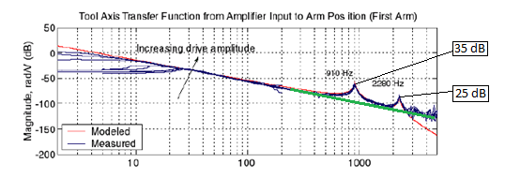

Figure : difference between resonant peak magnitude and expected magnitude, expected magnitude shown by thick line

$$\frac{1}{2ξ_{1}\sqrt{1-ξ_{1}^{2}}}=35 dB$$

Solving for $ξ$ gives $ξ_{1}=±1$

$ξ_{1}=±-0.008$

Since a stable system cannot have a negative or a damping ratio of 1, it is clear that the damping ratio of the system is $ξ_{1}=0.008$.

Employing the same method for $ξ_{2}$ it is found that: $ξ_{2}=±1$

$ξ_{2}=±0.02$

$ξ_{2}$ will be taken to be $ξ_{2}=0.02$

The values for $ω_{n1}$ and $ω_{n2}$ are chosen to be the resonant peaks of the system are $5717.7 dB$ and $14325.7 dB$ respectively.

By analysing the low frequency asymptote of the magnitude response data the type of the system $q$ can be found. It can be seen from figure 2 the low frequency ($10Hz-100Hz$) asymptote of the system has an approximate roll-off of $40 dB/decade$. It can be seen that I took the lower frequency point from a measurement that was close to the modelled data.

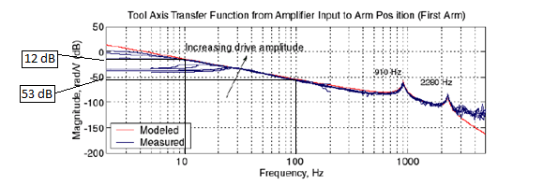

Figure : Magnitude roll-off of low frequency asymptote used for finding the system type

The gain $A$ of the system was found as follows:

$$\left|\frac{A}{s^{2}}\right|×\left|\frac{ω_{n1}^{2}}{ω_{n1}^{2}}\right|×\left|\frac{ω_{n2}^{2}}{ω_{n2}^{2}}\right|$$

$$\left|\frac{A}{s^{2}}\right|=Gain(s)$$

$$\left|\frac{A}{ω^{2}}\right|=Gain(jω)$$

$$\left|\frac{A}{ω^{2}}\right|=1$$

$$A=ω^{2}$$

$$A={\left(2π×4.5\right)}^{2}$$

$$A≅800$$

The latency $L$ was worked out as follows using the correct form of the phase at high frequencies:

$$-\left(n-m\right)90°-ωL\left(\frac{180°}{π}\right)$$

Samples of the phase were recorded at two different frequencies, namely, $440 rad/sec$ and $5026 rad/sec$. This can be seen from figure 3 below.

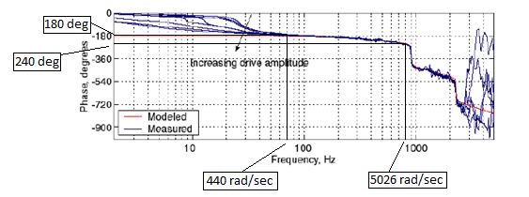

Figure : Points used for finding the latency of the plant

The phase at $440 rad/sec$ is approximately $180°$ and the phase at $5026 rad/sec$ is approximately $230°$. Comparing these phases at the given angular frequency, the above equation is used to calculate the latency.

$$-180°+230°≅5026L\left(\frac{180°}{π}\right)-440L\left(\frac{180°}{π}\right)$$

$$L≅2×{10}^{-4}sec$$

Subbing these values into the transfer function given gives a plant transfer function of:

$$\frac{A}{s^{2}}\left(\frac{{\left(5717.7\right)}^{2}}{(s^{2}+2\left(0.008\right)\left(5717.7\right)s+{\left(5717.7\right)}^{2}}\right)\left(\frac{{\left(14325.7\right)}^{2}}{(s^{2}+2\left(0.02\right)\left(14325.7\right)s+{\left(14325.7\right)}^{2}}\right)e^{-s2×{10}^{-4}}$$

Employing only a P controller, it is seen that the resulting closed-loop is in fact unstable for any positive gain. Below **figure 4** shows the closed-loop step response of the system when a P controller of gain of $k=2$ and $k=0.9$ is employed:

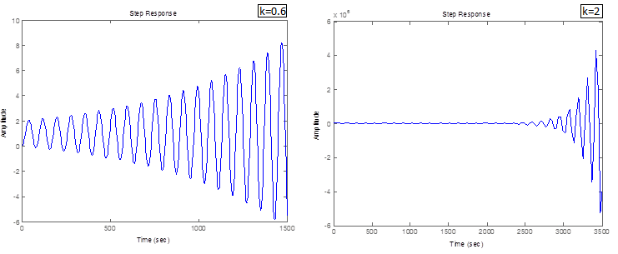

Figure : Comparing positive gains of plus minus 1, greater than 0

## Controller design

The objective is to design a controller which results in the system tracking a step and ramp inputs with zero error, having an overshoot not exceeding 70% and having a 2% settling time of less than 0.5 sec.

The first part of the design specification is already met by the plant of the system as it is a type 2 system and thus has zero steady state error to a step and ramp input and has a finite error to a parabola input.

In order to find the gain crossover frequency, $ω_{gc}$, and the phase margin of the desired system the damping ratio must first be found from the desired percentage overshoot requirement.

This is done as before with the equation:

$$PO\%= 100e^{\left(\frac{-πξ}{\sqrt{1- ξ^{2}}}\right)}$$

Solving this the damping ratio, $ξ$, it is found that a damping ratio is needed of:

$$ξ≥0.11$$

#

Take $ξ=0.15$

From this the phase margin requirement is found as follows:

$$PM≥100 ξ$$

$$PM≥15°$$

Take it to be $PM=20°$

From the $2\%$ settling time the natural frequency and the pole placement of the controller can be determined. The delay of the system must be considered here. Since there is a latency of $2×{10}^{-4} sec$, the settling time needs to take this into account and so

$$\frac{4}{σ}=\frac{4}{ξω_{n}}≤0.5-2×{10}^{-4} sec$$

Since it such a small delay it can be taken into account by pushing the controller poles further into the left half plane and increasing the

$$σ=8$$

$$ω_{n}=53.4 rad/sec$$

No poles of the controller are to lye to the right of $σ=8$. The gain crossover frequency $ω_{gc}$, can now be found:

$$ω_{gc}≥ω_{n}\sqrt{\sqrt{1+4ξ}-2ξ^{2}}$$

This gives a gain crossover frequency of:

$$ω_{gc}≥57.8 rad/sec$$

We will take a gain crossover of $$ω_{gc}=60 rad/sec$$

The magnitude plot gives that plant gain at $60 rad/sec$ is $-44 dB$

The phase plot gives that plant phase at $60 rad/sec$ is $-170°$. This can be seen from the below figure:

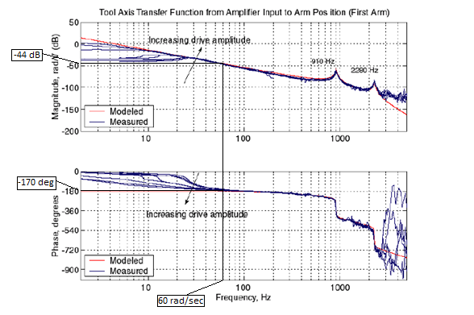

Figure : Finding magnitude and phase of plant at gain crossover frequency

Thus the controller needs a gain of $44 dB$ at $60 rad/sec$ and a phase of exceeding $-10°$

$$phase magin=phase of plant+phase of controller+180°$$

$$20°=-170°+phase of controller+180°$$

$$phase of controller=-10°$$

Lets take a phase of $-5°=0.87 rad/sec$.

I am going to use a lead controller to meet the specification. The lead controller increases the gain crossover frequency and increases the phase margin at desired frequency. This will improve the speed and overshoot of the response. A lead controller has the form of:

$$G_{lead}\left(s\right)=\frac{1+ατs}{1+τs}$$

Peak phase:

$$\sin\left(φ\right)=\frac{1-α}{1+α}$$

$$α=\frac{1+sin⁡(20°)}{1-sin⁡(20°)}$$

This gives $α=2.04$

Now $τ$ can be worked out using the frequency of peak phase:

$$ω_{gc}=\frac{1}{τ\sqrt{α}}$$

This gives:

$$τ=0.012$$

Thus the lead controller is:

$$G_{c}\left(s\right)=\frac{1+(2.04)(0.012)s}{1+(0.012)s}$$

Applying this lead controller to the plant in a unity negative feedback loop the following step response is acquired:



Figure : Step response of lead controller with plant

This step response looks good as it just about achieves the required percentage overshoot and no steady state error, however it is not quite fast enough. The speed can increased by employing a P controller in series with the lead. Only a small gain greater than 1 is required. By experimenting with different gain values it found that a P controller with gain $k$ suitably meets the specification as can be seen from the below graph:



Figure : Step response of lead and P controller with plant

It can be seen from this step response that all the specifications are met. The final transfer function of the lead with P controller is as follows:

$$G_{c}\left(s\right)=\frac{1.63\left(1+0.024s\right)}{1+0.012s}$$

## Simulink

The actual step response of the system can be found on Simulink

