# S1. Applicability Assessment Plan

# Step 1: Aim of the Computational Modeling

*Define how the computational model will be used. Note that this can include the question of interest and context of use.*

# Step 2: Two Elements of the Context of Use: R-COU and M-COU

Define the two domains describing the context of use for the model and real world. Create figure S1.

## R-COU: *Define the context of use domain for the real world.*

## M-COU: *Define the context of use domain for the computational model.*

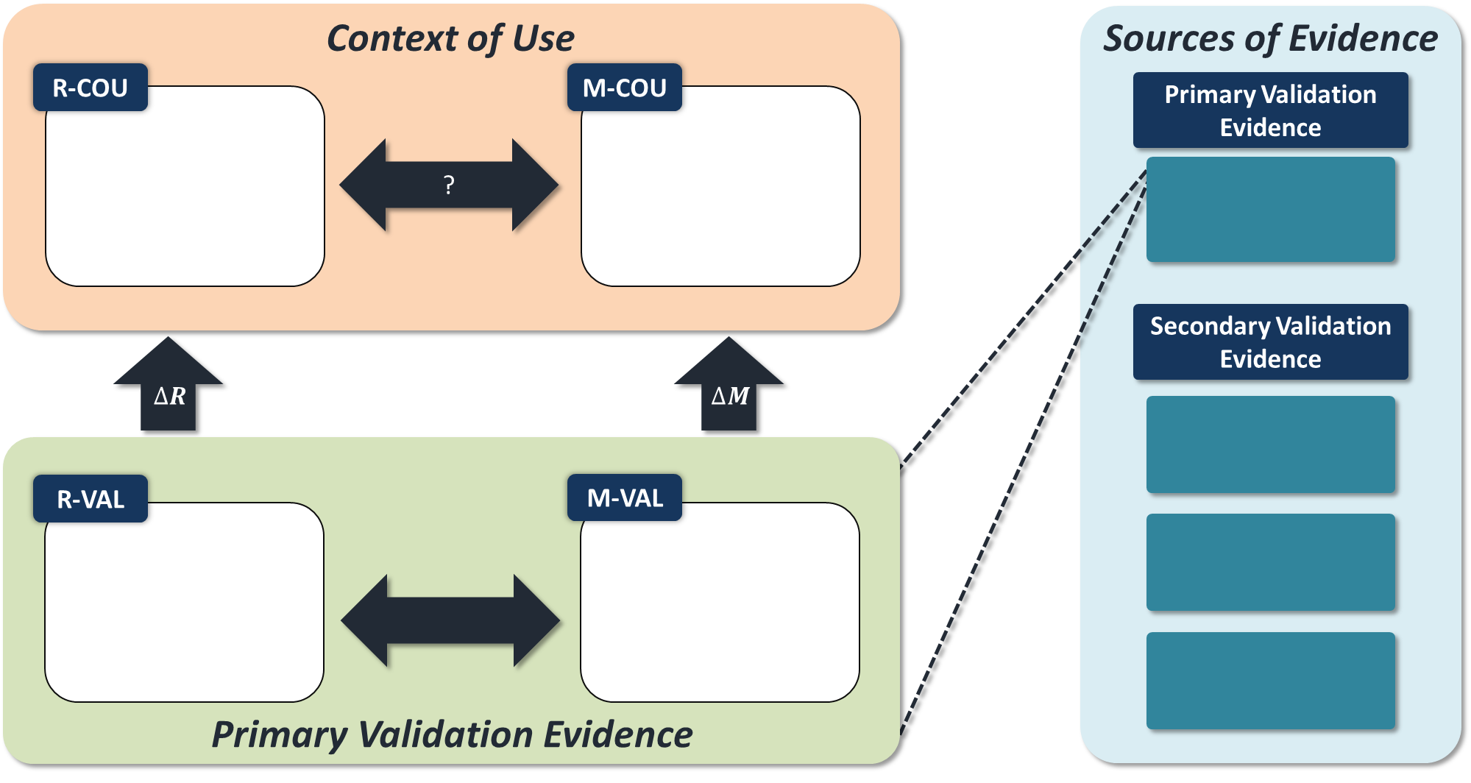

Figure S1: Applicability analysis domain diagram includes: Context of Use domain, Validation Domain, and sources of evidence. Create in Step 2 and complete by Step 4.

# Step 3: Sources of Validation Evidence

Update Figure S1 with complete validation evidence sources.

## Primary Validation Evidence: *Define source of evidence.*

## Supplemental Validation Evidence: *Define sources of evidence.*

# Step 4: Two elements of the Primary Validation Evidence, R-VAL and M-VAL

Define the two domains describing the validation for the model and the experiments. Update figure S1.

## R-VAL: *Define the validation domain for the validation experiments.*

## M-VAL: *Define* the validation domain for the computational model.

# Step 5. Aspects of the Computational Model that are the Same in M-COU and M-VAL

Generate a list of similarities between M-COU and M-VAL

# Step 6: Aspects of the Computational Model that are Different between M-VAL and M-COU (ΔM)

*Generate a list of differences between M-VAL and M-COU.*

# Step 7: Relevant Differences between R-VAL and R-COU (ΔR)

Generate a list of relevant differences between R-VAL and R-COU.

# Step 8: Is it Appropriate to use the Model Aspects Listed in Step 4 to Make Predictions about R-COU?

Complete attachment Applicability Analysis Tables spreadsheet under tab Step 8.

# Step 9: Do the Modifications to the Computational Model Result in Credible Predictions for the COU?

Complete attachment Applicability Analysis Tables spreadsheet under tab Step 9.

# Step 10: Rationale for Credibility if Different QOI’s are Used in Different Settings.

Complete attachment Applicability Analysis Tables spreadsheet under tab Step 10.

# Step 11: Consider the Overall Computational Model M-COU, in the Context of Differences Between R-VAL and R-COU

Complete attachment Applicability Analysis Tables spreadsheet under tab Step 11.

# Step 12: Discuss the overall applicability of the computational model for the COU

Complete attachment Applicability Analysis Tables spreadsheet under tab Step 12.