# Applicability Assessment Plan - Template

The applicability assessment plan is a living document that is intended for planning purposes to aid the user in completing a final applicability assessment. The following is a template that outlines the entire applicability assessment plan based on the applicability analysis framework [1].

# Step 1: Describe the Aim of the Computational Modeling.

*Briefly describe the aim of the computational modeling, including the question of interest or the decision to be made based on model predictions.*

# Step 2: Describe the Reality and Model Elements of the COU.

*The context of use is broken down into two domains: R-COU, M-COU. See Figure S1 for additional details*.

## R-COU: *Define the context of use domain for the real world.*

## M-COU: *Define the context of use domain for the computational model.*

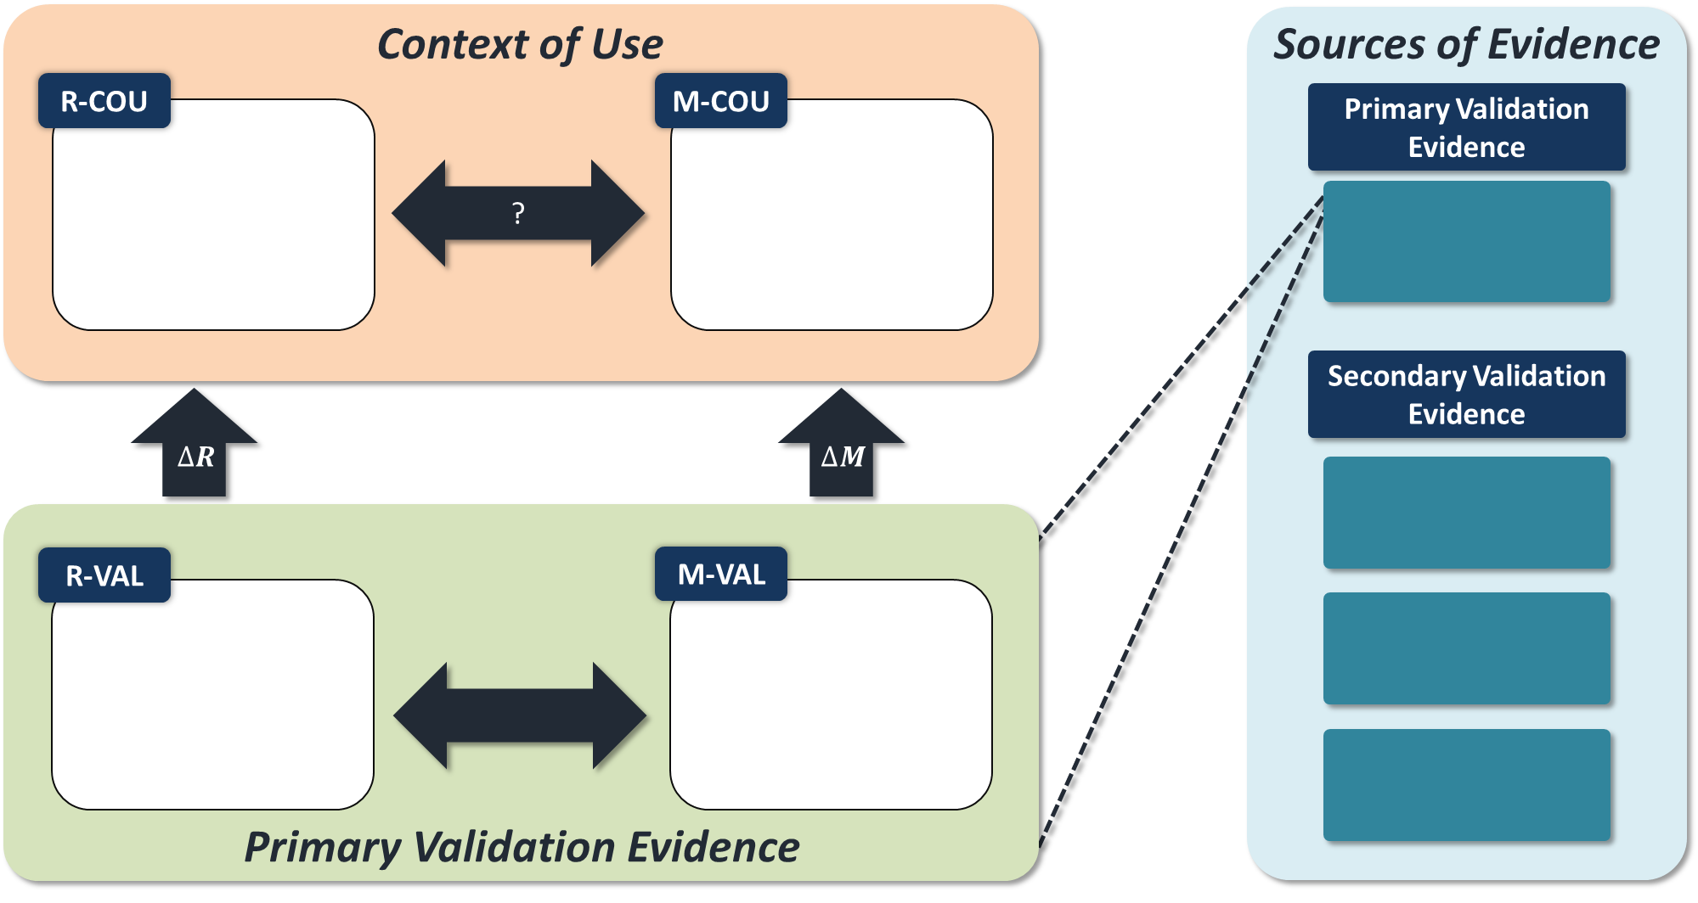

Figure S1. Applicability analysis specifications that include the context of use, primary validation evidence, and sources of evidence. Create in Step 2 and complete by Step 4.

# Step 3: Describe the Sources of Validation Evidence.

*Describe the different types of validation results available and other sources of evidence that could be used to support trustworthiness of the predictions from the computational model. See Figure S1 for additional details.*

## Primary Validation Evidence: *Define source of evidence.*

## Supplemental Validation Evidence: *Define sources of evidence.*

# Step 4: Describe the Reality and Model Elements of the Primary Validation Evidence.

*The primary validation evidence is broken down into two domains: R-VAL, M-VAL. See Figure S1 for additional details.*

## R-VAL: *Define the validation domain for the validation experiments.*

## M-VAL: *Define* the validation domain for the computational model.

# Step 5. Describe the Aspects of the Computational Model that are Identical in M-VAL and M-COU.

*See Table S1.*

Table S1 - Model features that are identical in M-VAL and M-COU.

|  |  |
| --- | --- |
| **Label** | **Description** |
| M1 |  |
| M2 |  |
| M3 |  |

# Step 6: Describe the Aspects of the Computational Model That Are Different between M-VAL and M-COU

*See Table S2.*

Table S2 - Model features that are different in M-VAL and M-COU.

|  |  |  |  |
| --- | --- | --- | --- |
| **Label** | **Description** | **M-VAL** | **M-COU** |
| DM1 |  |  |  |
| DM2 |  |  |  |
| DM3 |  |  |  |

# Step 7: Describe the Relevant Differences between R-VAL and R-COU.

*See Table S3.*

Table S3 - Differences between R-VAL and R-COU.

|  |  |  |  |
| --- | --- | --- | --- |
| **Label** | **Description** | **R-VAL** | **R-COU** |
| DR1 |  |  |  |
| DR2 |  |  |  |
| DR3 |  |  |  |

# Step 8: Is It Appropriate to Use the Model Aspects Listed in Step 5 to Make Predictions About R-COU? Assume That These Model Aspects Are Appropriate for R-VAL (or Refer to the Validation Results) and Then Consider Each of the Differences in DR (Listed in Step 7).

*For planning purposes, generate questions that require rationale, evidence, or discussion to address the question above. See Table S4 for specific questions raised. Each entry in the table is a question or area of concern that was raised, by considering whether it is appropriate to use the model aspect in COLUMN given the difference in ROW.*

Table S4 - Helper table for Step 8.

|  |  |  |  |
| --- | --- | --- | --- |
|  | **M1** | **M2** | **M3** |
| **DR1** |  |  |  |
| **DR2** |  |  |  |
| **DR3** |  |  |  |

# Step 9: Do the Modifications to the Computational Model (Listed in Step 6) Result in Trustworthy Predictions for the COU?

*For planning purposes, generate questions that require rationale, evidence, or discussion to address the question above. See Table S5 for specific questions raised regarding credibility.*

Table S5 - Questions raised based on the differences in the computational model.

|  |  |  |
| --- | --- | --- |
| **Label** | **Description** | **Questions Regarding Credibility** |
| DM1 |  |  |
| DM2 |  |  |
| DM3 |  |  |

# Step 10: Provide Rationale for Trustworthiness If the COU QOIs Differ From Validation QOIs.

*For planning purposes, define all the QOI’s. See Table S6 for the validation and COU QOI’s.*

Table S6 - Specification of QOI’s for both the validation and COU domains.

|  |  |
| --- | --- |
| **Validation** | **COU** |
|  |  |
|  |  |

# Step 11: Consider the Overall Computational Model M-COU, in the Context of Differences Between R-VAL and R-COU

*For planning purposes, generate additional questions. See Table S7 for additional questions.*

Table S7 - Questions raised about the overall computational model.

|  |  |  |
| --- | --- | --- |
| **Label** | **Description** | **Additional Questions Regarding M-COU** |
| DR1 |  |  |
| DR2 |  |  |
| DR3 |  |  |

# Step 12: Assess the Overall Applicability of the Computational Model for the COU

*For planning purposes, generate a complete list of questions that require rationale, evidence, or discussion for complete applicability assessment. See Table S8 for a list of all the questions derived in previous steps.*

Table S8 - Questions raised with associated source.

|  |  |
| --- | --- |
| **Source** | **Question Raised** |
| Step 8, M1 |  |
| Step 8, M3 |  |
| Step 9, DM1 |  |

# Citation

[1] Pathmanathan, P., Gray, R. A., Romero, V. J., & Morrison, T. M. (2017). Applicability analysis of validation evidence for biomedical computational models. Journal of Verification, Validation and Uncertainty Quantification, 2(2), 021005.