

**Course: DSA-5005**

**Computing Structures**

**Fall 2024**

Paulina Castillo

paulina.castillo@ou.edu

1. The code file is attached to the homework. However, can be found in the following Git repository <https://github.com/paulinacastillov/computer_structures>
2. I used chat GPT 4 to help me with different features of my code. For example when I don’t understand an error or when I need ideas about how to implement something. Examples of the prompts and suggestions that I ask are the following:

I got an error over and over and I didn’t understand why, so I asked chat GPT

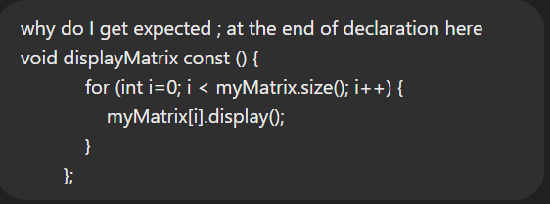

Based also in the class sparseRow I asked

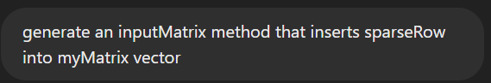

And Iased most errors that I couldn’t fix by myself



Sometimes it suggested something that I’ve already done before so my suggestions were explanations 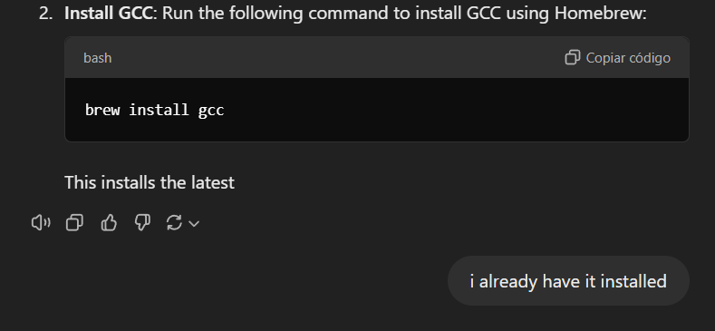

When I had the functions into my classes I started to try small examples and the trying to fix if there were some errors.

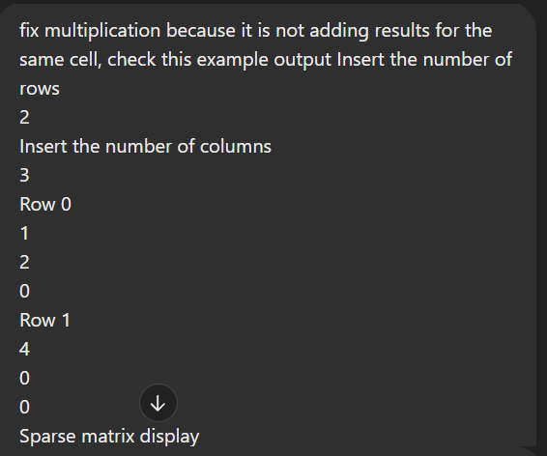

And with the code that I got I started to implement with the code that I already had. Sometimes Was useless because Chat GPT changed from a pointer to a variable and I need to change it manually (it was faster that explain what was grong and the check if the changes were ok or not).

An answer :  
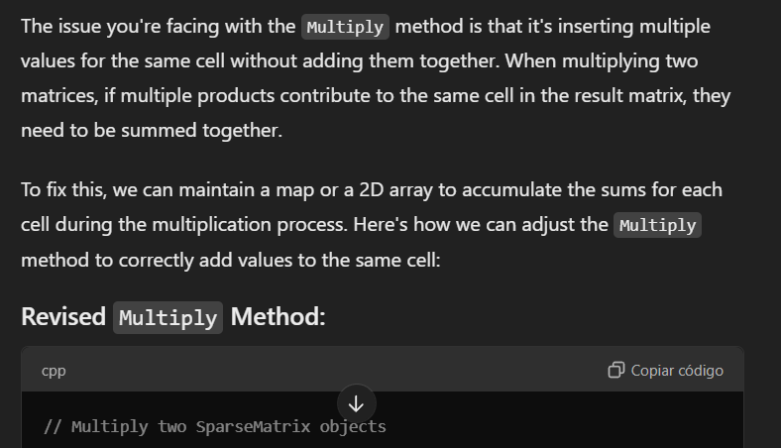

1. I create a main class just to avoid having to write manually each time two matrix

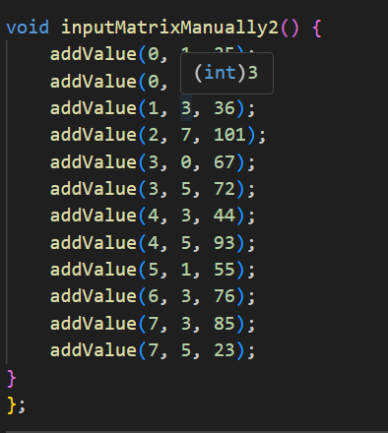 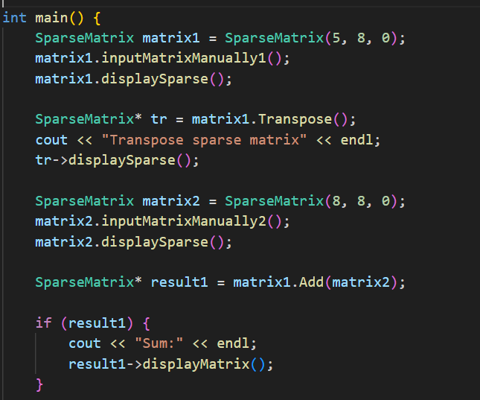

I checked that the output of my code had the same results as the output text file provided. After that, I just commented on the “fix” main(). In general, everything was fine except for the sum of matrices. I didn’t understand why so I asked chat GPT and he solved the part of the code that I have it. I don’t understand exactly what changed, The two codes looked alike, so probably was just tipping. I also used Chat GPT to create some matrices random and with Symbolab made the operations and compared them with my code.

