**Observations from Pyber data**

1. The urban cities have a higher number of rides (68%) and drivers (81%) than suburban and rural cities.

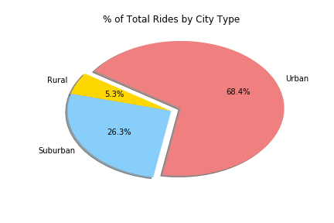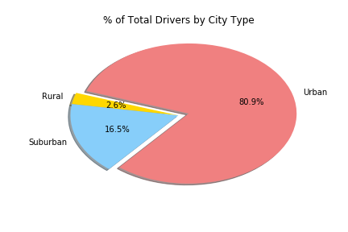

1. The average fare for rides in urban areas are cheaper as opposed to suburban and rural areas. This may be due to shorter driving distances and/or more availability of rides in urban areas.

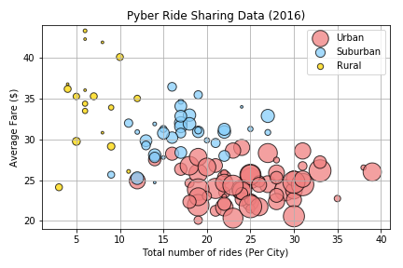

1. More people in urban areas prefer to use ride-sharing vehicles than people in suburban and rural areas.