**Observations**

**Max** **temperature**: The cities closer to the equator have the highest temperatures and they reduce as the latitude goes towards the poles.

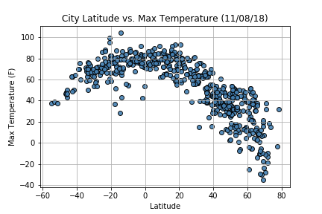

**Cloudiness**: Some cities close to the equator has a higher cloudiness %. The next region with a higher cloudiness % is between the 20°-40° region. There doesn’t seem to be any direct co-relation between the cloudiness percent and the latitude.

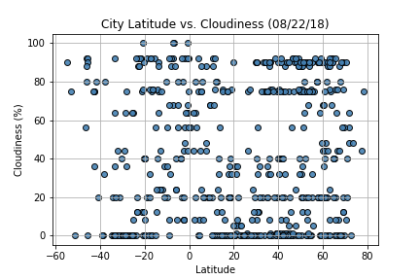

**Humidity**: The cities around the equator (-20° to 20°) has the highest humidity % and the cities between the 20° – 40° is also highly humid.

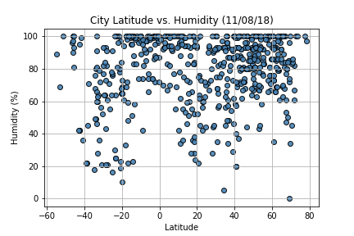

**Wind speed**: The wind speed remain relatively constant in a wide band (-40° - 60°) near the equator but it increases dramatically as the city’s latitude gets closer to the poles.

