**Assignment number:** YUCLAW-1

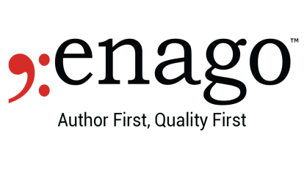

**Filename:** main_INQ-41566920_YUCLAW-1.docx.doc

**Primary Editor Name*:** Elliot

**“The authors would like to thank Enago (**[**www.enago.com**](chrome-extension://flock.co/client_base/apps/conversation/www.enago.com)**) for the English language review.”**

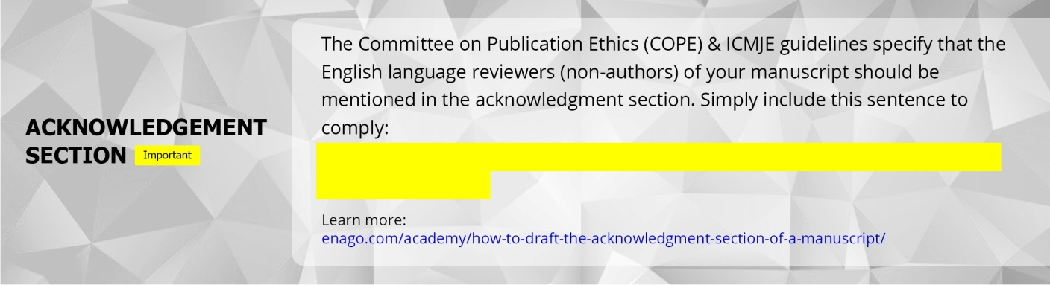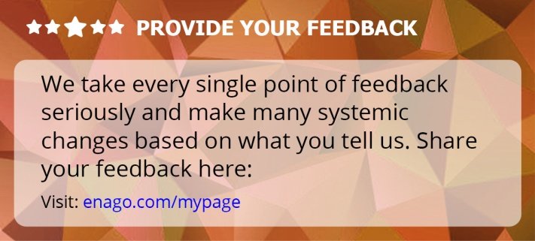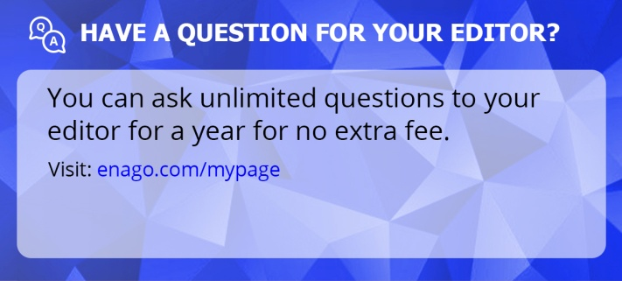

Dear Author:

Thank you for entrusting us with your manuscript and opting for our Copyediting service.

We have edited your assignment YUCLAW-1 for language and grammar, from the aspect of fluency, and would like to share our experience in editing your manuscript.

Overall, we have made moderate revisions to the manuscript in terms of language and grammar. We have also made some sentence reconstructions and word choice changes for accuracy and enhanced clarity. We hope that the revisions meet your expectations from our service.

Please be assured that we have edited the manuscript to the best of our ability and have clarified some of our changes through remarks. As a step toward finalization, we suggest that you resolve all remarks in the main file, as this is important for successful publication.

We have added tips on academic writing conventions specific to your manuscript in the edited file. We hope you find these tips helpful for future writing.

We wish you the very best for the successful publication of your manuscript and look forward to working with you again.

Sincerely,

Your Editor

Elliot

Notes

* Usually, abbreviations are spelled out at their first use in the abstract, in the table/figure captions, as well as in the text. Please check if the abbreviations in this manuscript need to be spelled out. If they are mentioned in the journal's list of accepted abbreviations, then they do not have to be spelled out.
* Please check the placement of all figures and tables in the document. Some figures have been displaced because of the use of Track Changes. Please adjust them accordingly after accepting the Track Changes.
* Please note that as this is a converted file, the equations/notations do not appear as typed. We have carefully edited the text around them, and remarks have been written for changes in equations, if any.

