Dart Programming Lab 1 outputs

PART 1 :

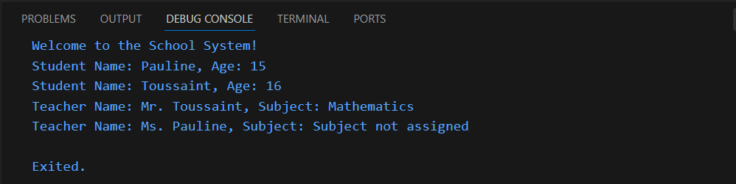

PART 2 :
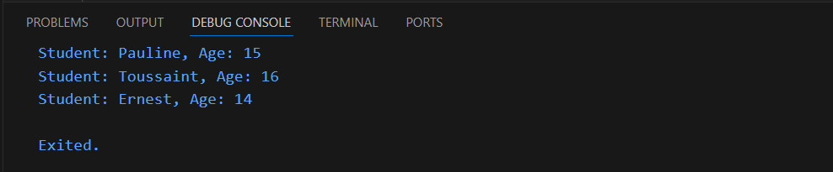

PART 3 : Inheritance
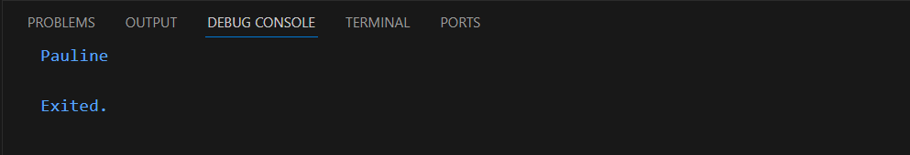

PART 4 : Interfaces
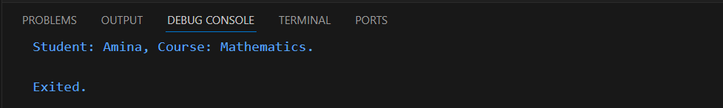

PART 5 : Mixins
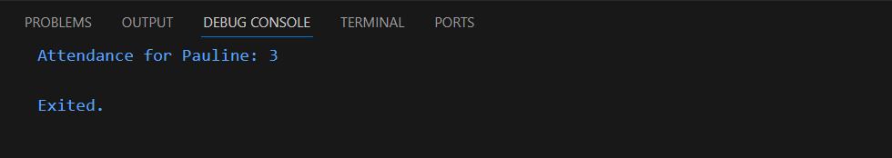

PART 6 : Collections
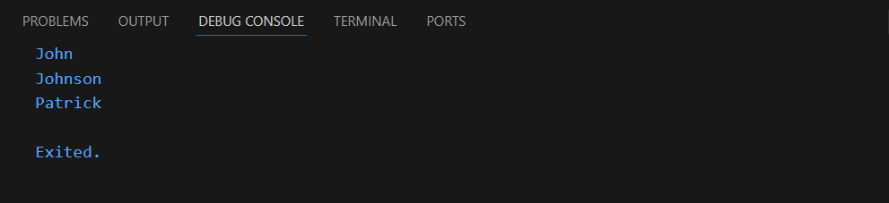

PART 7 : Anonymous and Arrow Functions
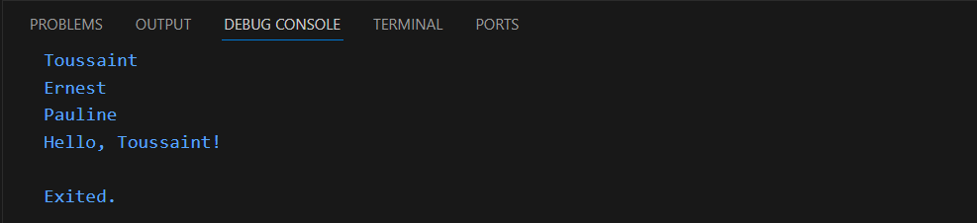

PART 8 : Asynchronous Programming
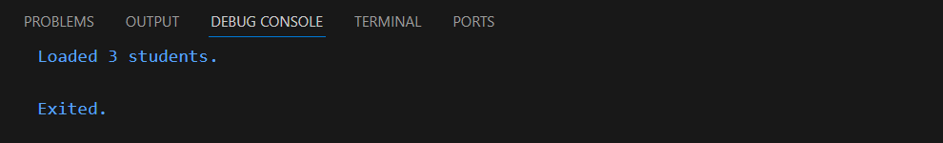

PART 9 : Integration Challenge
