LAB REPORT
Network Security & Password Analysis

Exercise 1 — Password Security

1. Why Common Passwords Are Insecure
Passwords like 123456, password, admin, qwerty are insecure because:
- They are short and predictable.
- They are commonly used worldwide.
- Attackers can guess them quickly using dictionary or brute force attacks.

2. Strong Password Examples
The following passwords comply with best practices (≥12 characters, mixed case, numbers, and special characters):
- Sec879@u!&ç4
- bU/Ki@1pad28
- w@r_t-f35zUh

Exercise 2 — Network Traffic Analysis (Wireshark)

HTTP Traffic
The Wireshark capture shows HTTP traffic between the local machine and external servers. HTTP transmits data in plain text, making all exchanged information visible to anyone intercepting the connection.
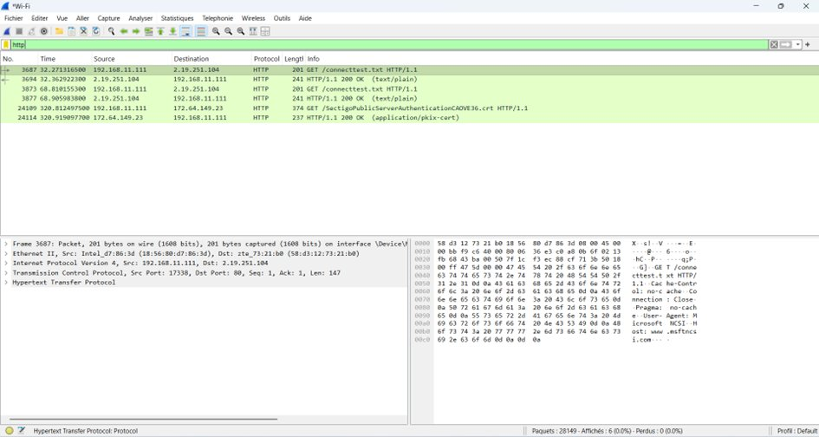
Figure 1 — Wireshark capture: HTTP traffic (unencrypted)

TLS Traffic
The Wireshark capture filtered by TLS shows the handshake process between the local computer and a remote server. The packets include Server Hello, Certificate, and Key Exchange messages. This demonstrates how HTTPS/TLS establishes a secure channel, ensuring that subsequent communication is encrypted and protected from interception.
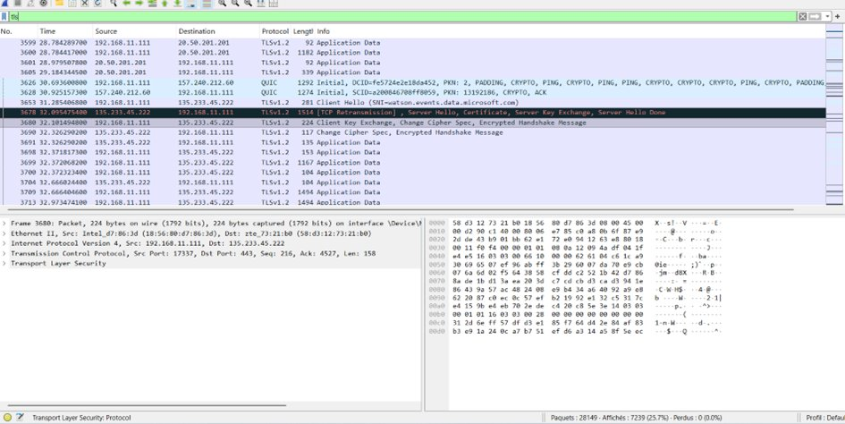
Figure 2 — Wireshark capture: TLS handshake (Server Hello, Certificate, Key Exchange)

DNS Traffic
DNS queries were captured, showing how domain names are resolved to IP addresses before any connection is established. Various domains such as whatsapp.net, microsoft.com, and gstatic.com were observed.
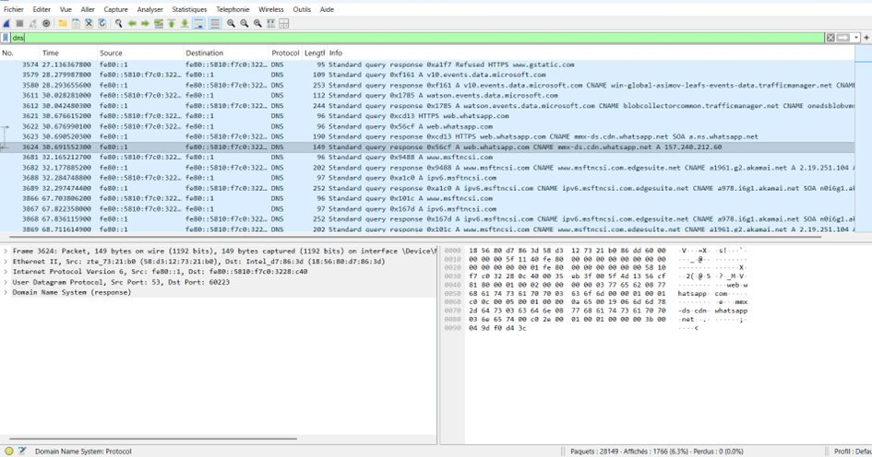
Figure 3 — Wireshark capture: DNS query responses

Analysis & Questions
1. Total packets captured:
During the experiment, Wireshark captured approximately 28,149 packets.
2. The three protocols observed:
- DNS — used to resolve domain names into IP addresses.
- HTTP — unencrypted web requests and responses.
- TLS/HTTPS — encrypted communication ensuring confidentiality.
3. Why encryption is important:
Encryption protects sensitive information such as passwords, personal data, and financial details from being intercepted. It also ensures data integrity and provides authentication of the websites you connect to.
4. Data exposed from unencrypted traffic:
- The websites visited (URLs and domains).
- Form data such as usernames, passwords, or search queries.
- Cookies and headers, which could be used for session hijacking.
- Downloaded files or resources in clear text.

Conclusion
This laboratory session demonstrated the importance of basic cybersecurity mechanisms. By capturing and analyzing network traffic with Wireshark, protocols such as DNS, HTTP, and TLS were identified and studied.
The exercises highlighted that:
- Weak passwords are easily exploitable.
- Unencrypted communications expose sensitive information.
- Attackers can intercept data when security is not applied.
In contrast, encryption through TLS/HTTPS ensures confidentiality, integrity, and protection of user privacy. Overall, the lab reinforced that strong authentication and secure communication are essential to safeguarding information in modern networks.

