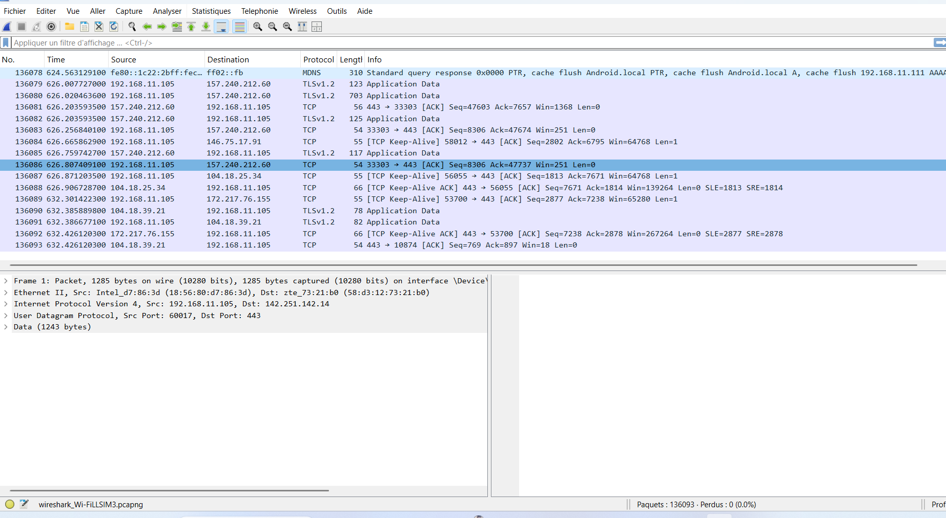



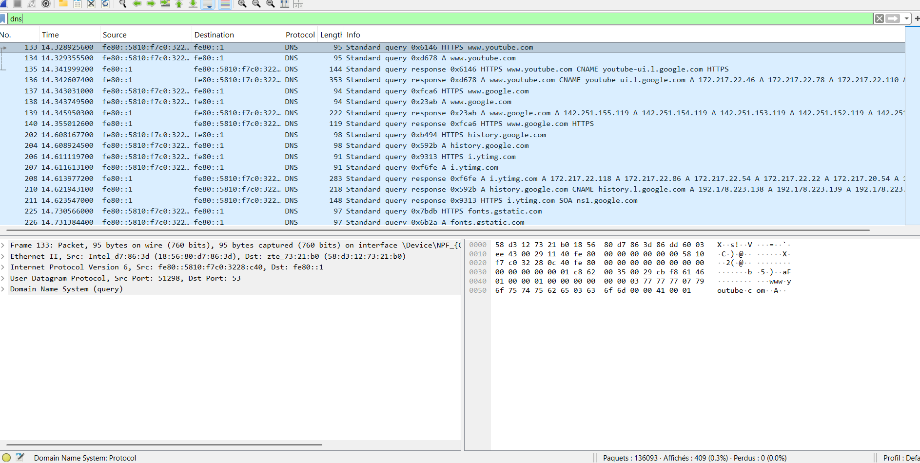

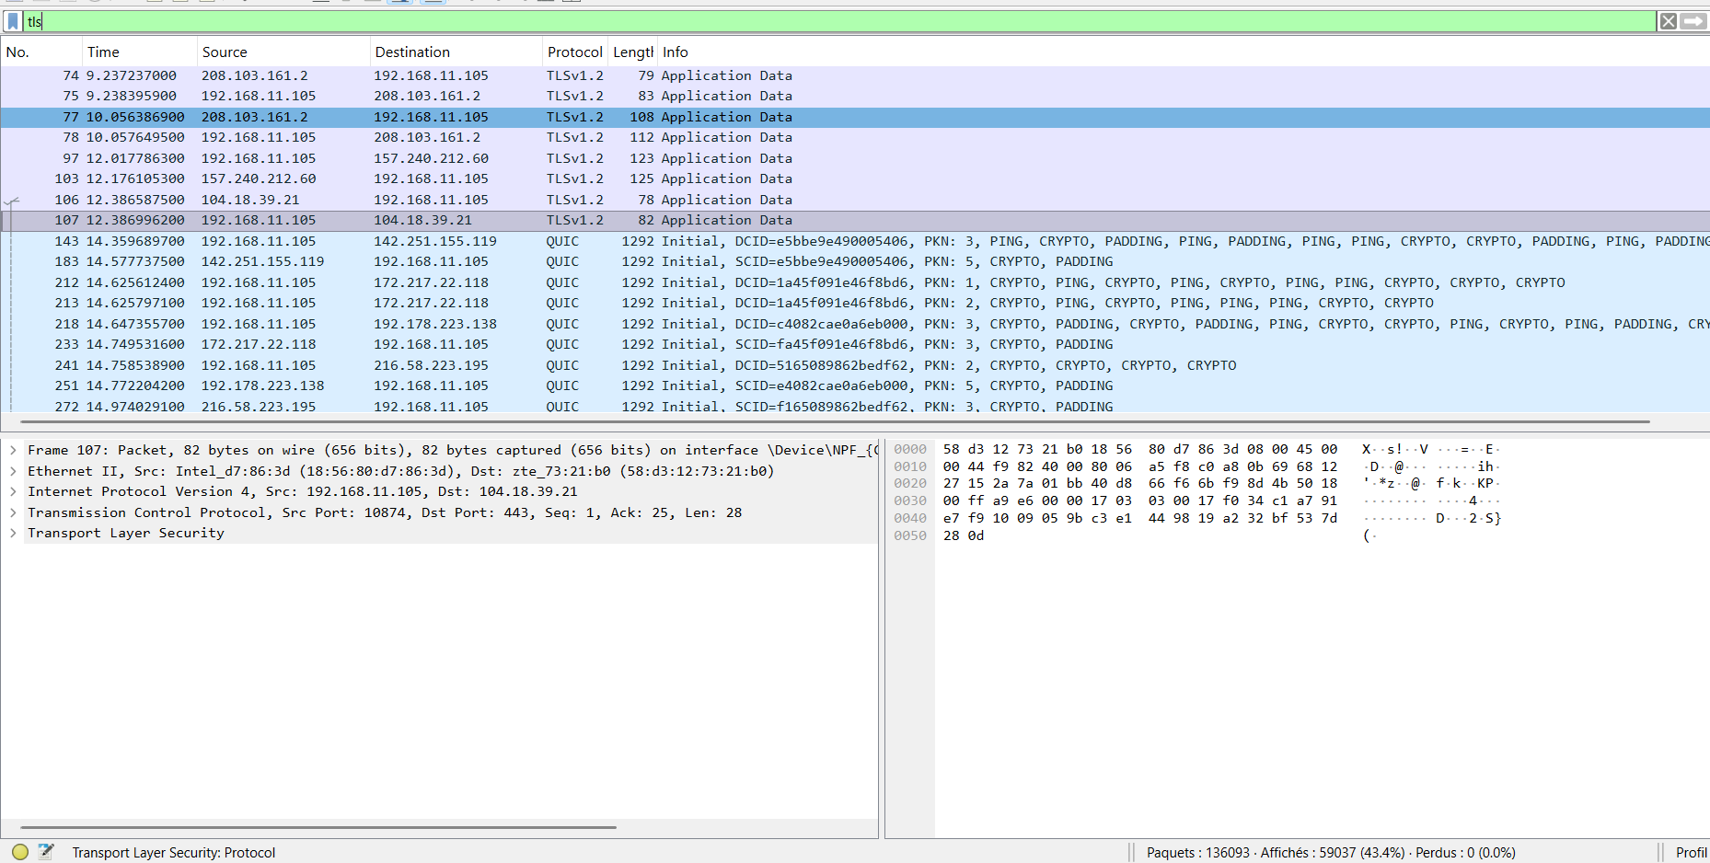
Results and Analysis
1. Approximately how many packets were captured?
During the experiment, about 136093 packets were captured in total. This large number reflects the variety of network activities taking place, including DNS queries, HTTP requests, and encrypted TLS/QUIC traffic.
2. List three protocols observed during the experiment.
The main protocols observed were:
- DNS for domain name resolution (e.g., queries for google.com and youtube.com).
- HTTP for unencrypted web traffic, visible in clear text (e.g., GET /connecttest.txt).
- TLS/HTTPS for encrypted communication, including the TLS handshake (Client Hello, Server Hello).
Additionally, TCP was seen establishing reliable connections, and QUIC appeared as a modern encrypted transport protocol.
3. Why is encryption important when browsing the internet?
Encryption is essential because it ensures confidentiality and integrity. Sensitive information such as passwords, personal data, and browsing activity cannot be read or altered by attackers when encrypted. Without encryption, traffic is exposed in clear text, leaving users vulnerable to interception, surveillance, and data manipulation.
4. What type of information could attackers obtain from unencrypted traffic?
From unencrypted traffic, attackers could easily obtain:
- Visited websites and URLs through DNS and HTTP requests.
- Login credentials or personal data transmitted in clear text.
- Files or messages sent without protection.
In short, attackers can reconstruct a user’s browsing activity and intercept sensitive information if encryption is not used.

