New Worcs manuscript

20 October, 2022

This manuscript uses the Workflow for Open Reproducible Code in Science (Van Lissa et al. 2020) to ensure reproducibility and transparency. All code are available at [git@github.com:paulinekiss/worcs-test.git](mailto:git@github.com:paulinekiss/worcs-test.git).

This is an example of a non-essential citation (@ Van Lissa et al. 2020). If you change the rendering function to worcs::cite_essential, it will be removed.

## GitHub Documents

This is an R Markdown format used for publishing markdown documents to GitHub. When you click the **Knit** button all R code chunks are run and a markdown file (.md) suitable for publishing to GitHub is generated.

## Including Code

You can include R code in the document as follows:

summary(cars)

## speed dist   
## Min. : 4.0 Min. : 2.00   
## 1st Qu.:12.0 1st Qu.: 26.00   
## Median :15.0 Median : 36.00   
## Mean :15.4 Mean : 42.98   
## 3rd Qu.:19.0 3rd Qu.: 56.00   
## Max. :25.0 Max. :120.00

## Including Plots

You can also embed plots, for example:

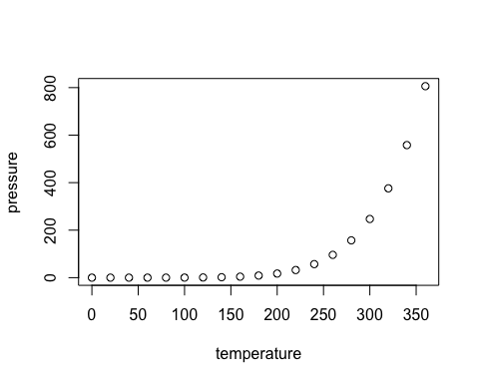

Note that the echo = FALSE parameter was added to the code chunk to prevent printing of the R code that generated the plot.

Van Lissa, Caspar J., Andreas M. Brandmaier, Loek Brinkman, Anna-Lena Lamprecht, Aaron Peikert, Marijn E. Struiksma, and Barbara Vreede. 2020. “WORCS: A Workflow for Open Reproducible Code in Science,” May. <https://doi.org/10.17605/OSF.IO/ZCVBS>.