Environment type
Develpment – solo 1 por projecto
Deployment – por default es prod
Deployments type:
General
Staging
Production
Al environment se le asigna un profile
Profile: Profiles contain the connection and credential information to connect to the data warehouse. See Profiles documentation for more information.
- Profile name
- Connection details
- Deployment credentials
  - Auth method (username and password, key pair)
  - Schema
  - Connection overrides
  - Account
  - Role (opt)
  - Database (opt)
  - Warehouse (opt)

Deployment credentials
Jobs:
3 tipos
- Deployments
- Continues integration
- Merge
Deployment:
Job name
Environment
Run source freshness (como primer paso) (opt)
Generar docs on run (opt)
Triggers
Schedule
Intervals
Specific hours
Chron shedule
Job completion (run when another job finishes)
Advanced settings
Target name
Run time out
Compare change against (env Select an environment to compare code changes against. Only modified models will build and these modified models will reference upstream, unchanged models from the comparison environment.)
Dbt versión
Threads

En entornos de Desarrollo (IDE)
Si marcas esta opción en tu entorno de Development, dbt cambia la "rama base" para todos los desarrolladores:
dbt Developer Hub +2
- Nueva Rama Base: En lugar de crear ramas nuevas desde main, dbt obligará a los desarrolladores a crear sus ramas de trabajo a partir de la rama qa.
- Bloqueo de Commits: La rama qa pasa a estar protegida dentro del IDE de dbt. Nadie puede hacer un "commit" directo a qa; dbt te pedirá obligatoriamente crear una rama nueva para guardar cambios.
- Pull Requests: Cuando un desarrollador termine su trabajo y quiera integrar cambios, el PR se abrirá por defecto hacia qa en lugar de hacia main

En el seteo de los Jobs, espacio es AND y coma es intersección
Chron
Minuto hora dia mes día de la semana
* * * * *
2,6
2-6
*/30 6-23 * * 1-5

POST https://cl537.us1.dbt.com/api/v2/accounts/70471823438819/jobs/70471823591177/run/

Headers
{ "Authorization": "Token <your-api-key>" }

Body
{
"cause": "Triggered via API",
}

Crear un CI job
This feature is only available for dbt repositories connected through dbt's native integration with GitHub, Gitlab, or Azure DevOps
Se recomienda crear un environment de Ci
Cdo hace el PR se crea un schema temporal en la base de datos
dbt_cloud_pr_<job_id>_<pr_id>
and can be found in the run details for the given run
dbt deletes the temporary schema from your data warehouse when you close or merge the pull request. If your project has schema customization using the generate_schema_name macro, dbt might not drop the temporary schema from your data warehouse

{% macro generate_schema_name(custom_schema_name, node) -%}
{%- set default_schema = target.schema -%}
{%- if custom_schema_name is none -%}
{{ default_schema }}
{%- else -%}
{{ default_schema }}_{{ custom_schema_name | trim }}
{%- endif -%}
{%- endmacro %}

Para hacer un Slim CI update
Dbt build –select state:modified+
Defer to a previous run (elegir sobre la cual comparar, de allí va a tomar los datos q va a copiar y no regenerar)

Differences between CI jobs and other deployment jobs
The dbt scheduler executes CI jobs differently from other deployment jobs in these important ways:
- Concurrent CI checks — CI runs triggered by the same dbt CI job execute concurrently (in parallel), when appropriate.
- Smart cancellation of stale builds — Automatically cancels stale, in-flight CI runs when there are new commits to the PR.
- Run slot treatment — CI runs don't consume a run slot.
- SQL linting — When enabled, automatically lints all SQL files in your project as a run step before your CI job builds.
Concurrent CI checks StarterEnterpriseEnterprise +
When you have teammates collaborating on the same dbt project creating pull requests on the same dbt repository, the same CI job will get triggered. Since each run builds into a dedicated, temporary schema that’s tied to the pull request, dbt can safely execute CI runs concurrently instead of sequentially (differing from what is done with deployment dbt jobs). Because no one needs to wait for one CI run to finish before another one can start, with concurrent CI checks, your whole team can test and integrate dbt code faster.
The following describes the conditions when CI checks are run concurrently and when they’re not:
- CI runs with different PR numbers execute concurrently.
- CI runs with the same PR number and different commit SHAs execute serially because they’re building into the same schema. dbt will run the latest commit and cancel any older, stale commits. For details, refer to Smart cancellation of stale builds.
- CI runs with the same PR number and same commit SHA, originating from different dbt projects will execute jobs concurrently. This can happen when two CI jobs are set up in different dbt projects that share the same dbt repository.
Smart cancellation of stale builds StarterEnterpriseEnterprise +
When you push a new commit to a PR, dbt enqueues a new CI run for the latest commit and cancels any CI run that is (now) stale and still in flight. This can happen when you’re pushing new commits while a CI build is still in process and not yet done. By cancelling runs in a safe and deliberate way, dbt helps improve productivity and reduce data platform spend on wasteful CI runs.
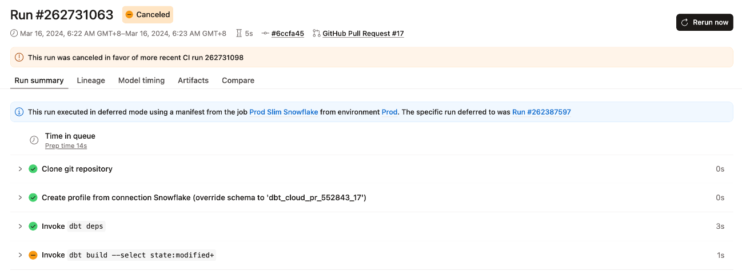Example of an automatically canceled run
Run slot treatment StarterEnterpriseEnterprise +
CI runs don't consume run slots. This guarantees a CI check will never block a production run.
SQL linting StarterEnterpriseEnterprise +
Available on dbt release tracks and dbt Starter or Enterprise-tier accounts.
When enabled for your CI job, dbt invokes SQLFluff which is a modular and configurable SQL linter that warns you of complex functions, syntax, formatting, and compilation errors. SQLFluff linting is not yet supported for dbt platform jobs that run on the dbt Fusion engine. For more information, see Fusion limitations.
By default, SQL linting lints all the changed SQL files in your project (compared to the last deferred production state). Note that snapshots can be defined in YAML and .sql files, but its SQL isn't lintable and can cause errors during linting. To prevent SQLFluff from linting snapshot files, add the snapshots directory to your .sqlfluffignore file (for example snapshots/). Refer to snapshot linting for more information.
If the linter runs into errors, you can specify whether dbt should stop running the job on error or continue running it on error. When failing jobs, it helps reduce compute costs by avoiding builds for pull requests that don't meet your SQL code quality CI check.
To configure SQLFluff linting:
You can optionally configure SQLFluff linting rules to override default linting behavior.
- Use SQLFluff Configuration Files to override the default linting behavior in dbt.
- Create a .sqlfluff configuration file in your project, add your linting rules to it, and dbt will use them when linting.
  - When configuring, you can use dbt as the templater (for example, templater = dbt)
  - If you’re using the Studio IDE, dbt CLI, or any other editor, refer to Customize linting for guidance on how to add the dbt-specific (or dbtonic) linting rules we use for own project.
- For complete details, refer to Custom Usage in the SQLFluff documentation.

Target es una variable de jinja, disponible en todo jinja macro y bloque de código
Target, cada desarrollador tiene seteado las target y también se puede ver en cada job
select *
from a_big_table

-- limit the amount of data queried in dev
{% if target.name != 'prod' %}
where created_at > date_trunc('month', current_date)
{% endif %}

Environmental variables

Concatena Targetname y custom schema si fue dado
Para generar el nombre del schema
Pero para prod, podemos necesitar algo distinto, en vez de prod_marketing, que solo genere el schema de prod
Se sobre escribe la macro que usa dbt generate_schema_name
{% macro generate_schema_name(custom_schema_name, node) -%}
{%- set default_schema = target.schema -%}
{%- if custom_schema_name is none -%}
{{ default_schema }}
{%- elseif {{target.name in [‘prod’] -%}
{{ custom_schema_name | trim }}
{%- else -%}
{{ default_schema }}_{{ custom_schema_name | trim }}
{%- endif -%}
{%- endmacro %}

Env variable.(dbt_xxx)

1 Personal (credenciales), job level (en el settings)
2 Development/deploy env (EN LA PAGINA DE ENV, están las variables de env por cada env)
3 Project default vars:
Si DB_SCHEMA no existe, usará 'analytics_dev'
my_schema: "{{ env_var('DB_SCHEMA', 'analytics_dev') }}"
4 Jinja function default {{ env_var(‘DBT_MY_ENV’, DEFAULT VALUE) }}

Environment variable's keys are uppercased and case sensitive. When referencing env_var('DBT_KEY') in your project's code, the key must match exactly the variable key on this page.

select *
from {{ env_var('DB_SOURCE_TABLE', 'raw_data_fallback') }}

- Tipos de datos: Los valores de las variables de entorno siempre se leen como strings. Si necesitas un número o un booleano, deberás usar filtros de Jinja para convertirlos (ej. | as_number o | as_bool).

Appropriate coverage
If you have not set a project level default value for every environment variable, it may be possible that dbt does not know how to interpret the value of an environment variable in all contexts. In such cases, dbt will throw a compilation error: "Env var required but not provided".
Changing environment variables mid-session in the Studio IDE
If you change the value of an environment variable mid-session while using the Studio IDE, you may have to refresh the Studio IDE for the change to take effect.

Environment variables prefixed with DBT_ENV_SECRET_ are protected with additional security controls
Secret keys are never written to logs or error messages and are obfuscated in dbt, so they are not exposed in the UI or artifacts, and are only available to dbt at runtime as needed.

dbt has a number of pre-defined variables built in. Variables are set automatically and cannot be changed. This means that the order of precedence for overriding environment variables doesn't apply to these pre-defined variables at the project, environment, or job level

DBT_CLOUD_GIT_BRANCH — Provides the development Git branch name in the Studio IDE.
- DBT_ENV — This key is reserved for the dbt application and will always resolve to 'prod'. For deployment runs only.
- DBT_CLOUD_ENVIRONMENT_NAME — The name of the dbt environment in which dbt is running.
- DBT_CLOUD_ENVIRONMENT_TYPE — The type of dbt environment in which dbt is running. The valid values are dev, staging, or prod. The value will be empty for General deployment environments, so use a default like {{ env_var('DBT_CLOUD_ENVIRONMENT_TYPE', '') }}.
- DBT_CLOUD_INVOCATION_CONTEXT — The context type in which dbt is invoked. The values are dev, staging, prod, or ci.
  - Additionally, use DBT_CLOUD_INVOCATION_CONTEXT in the generate_schema_name() macro to define explicit guidelines to use the default schema only (with the dbt_cloud_pr prefix) in CI job runs, even if those CI jobs run in the same environment as production jobs.
- DBT_CLOUD_PROJECT_ID — The ID of the dbt Project for this run
- DBT_CLOUD_JOB_ID — The ID of the dbt Job for this run
- DBT_CLOUD_RUN_ID — The ID of this particular run
- DBT_CLOUD_RUN_REASON_CATEGORY — The "category" of the trigger for this run (one of: scheduled, github_pull_request, gitlab_merge_request, azure_pull_request, other)
- DBT_CLOUD_RUN_REASON — The specific trigger for this run (for example, Scheduled, Kicked off by <email>, or a custom value set through the API)
- DBT_CLOUD_ENVIRONMENT_ID — The ID of the environment for this run
- DBT_CLOUD_ACCOUNT_ID — The ID of the dbt account for this run

- DBT_CLOUD_PR_ID — The Pull Request ID in the connected version control system
- DBT_CLOUD_GIT_SHA — The git commit SHA which is being run for this Pull Request build

