Link Github: <https://github.com/paulinyohanesta/PAULINYOHANESTAFERNANDA_1202150238_Modul3.git>

Hasil akhir Study Case Modul 3:

1. Splash Screen

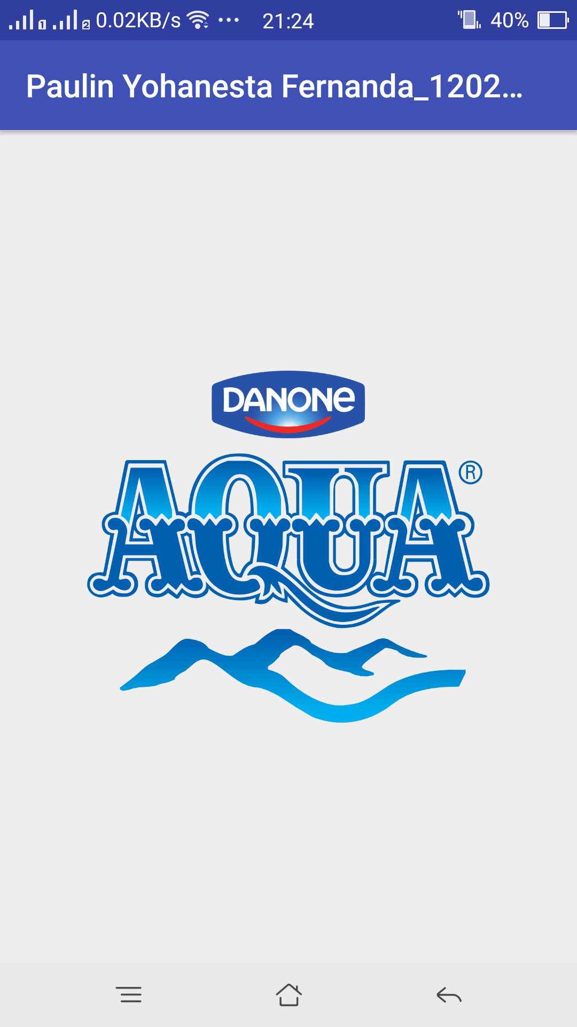

1. Halaman Login

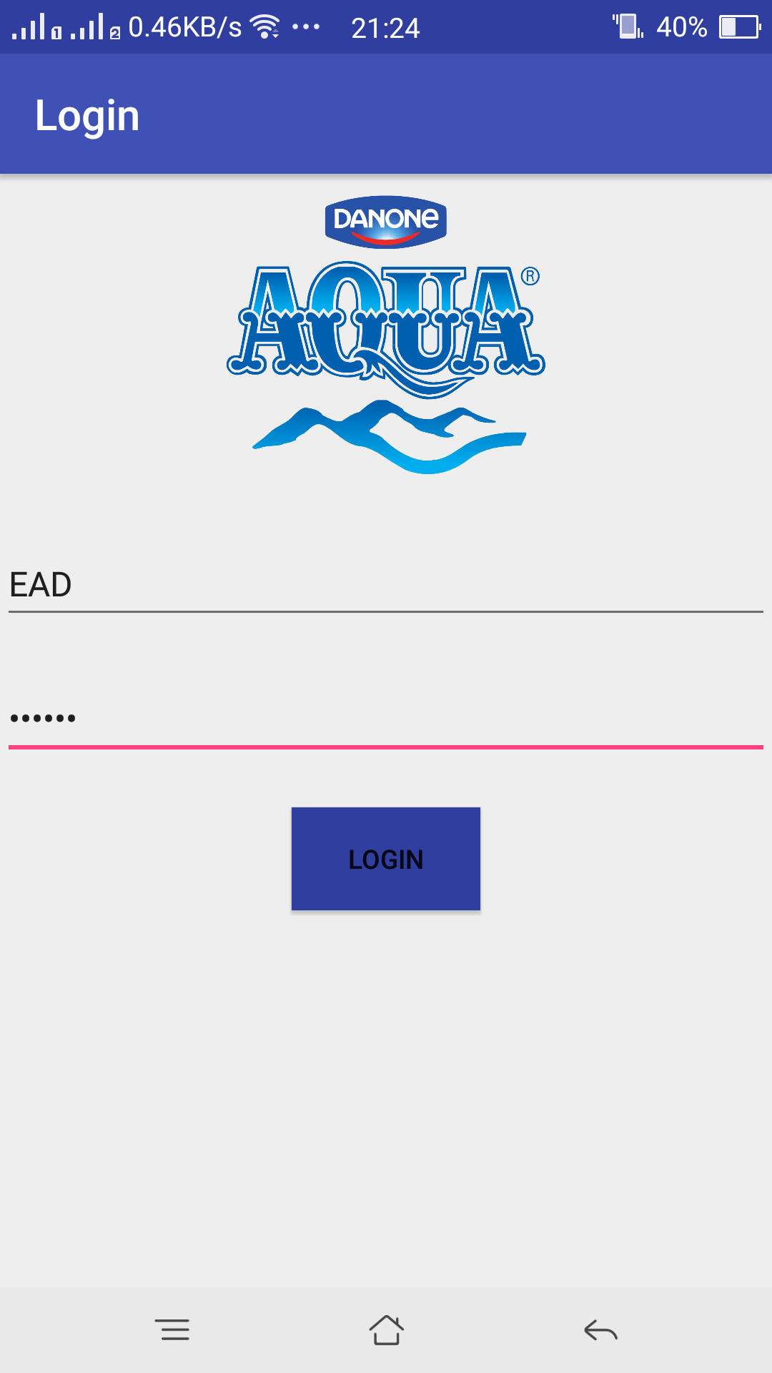

1. List Air Minum tampilan portrait

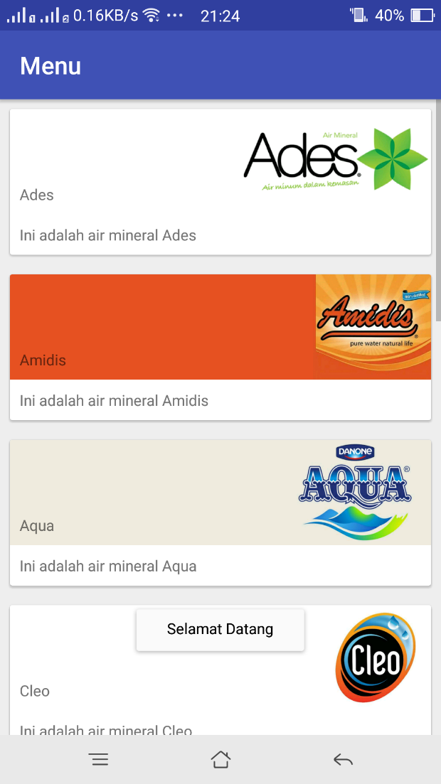

Tampilan landscape

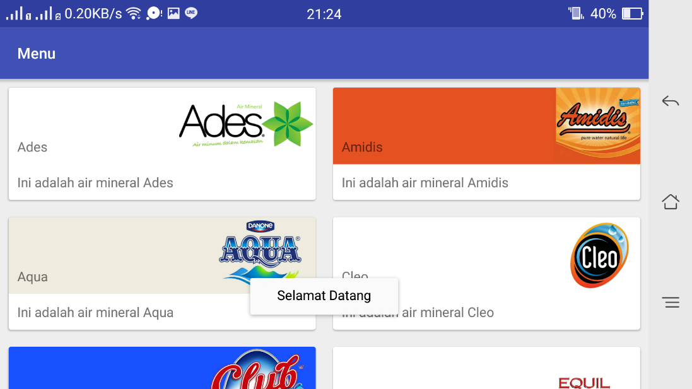

1. Detail dari setiap merk air minum

