

INVOICE N° 2022-06-02

Date: 07/07/2022

Client:

Details June 2022:

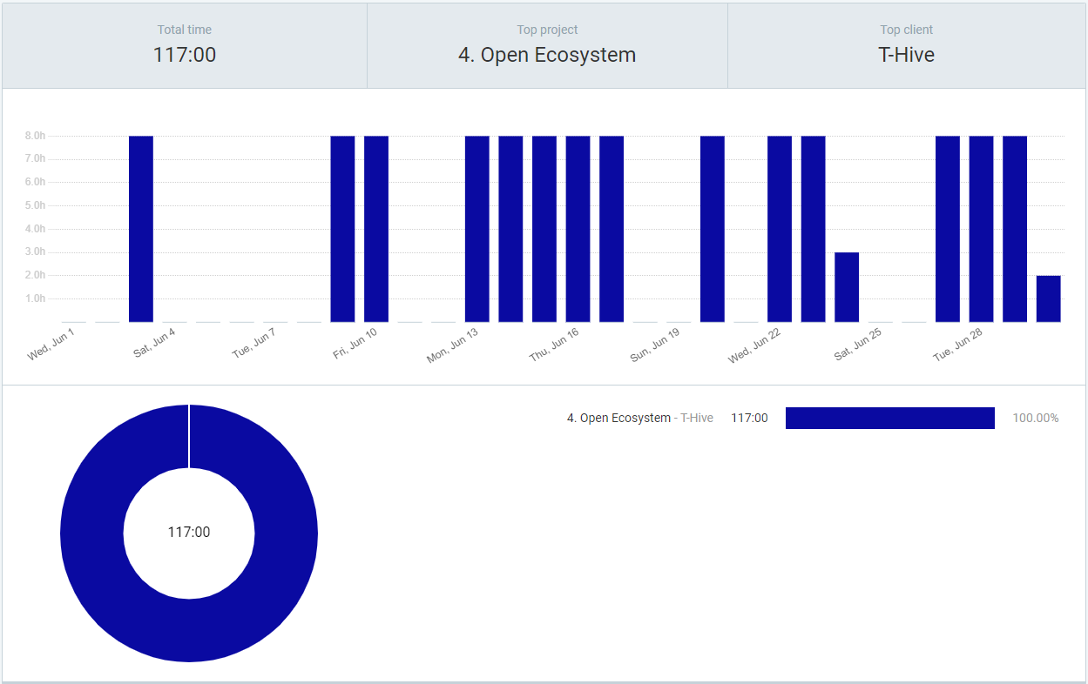

|  |  |  |
| --- | --- | --- |
| **Day** | **Hours** | **Description** |
| 3-Jun-2022 | 8 | Open Ecosystem |
| 9-Jun-2022 | 8 | Open Ecosystem |
| 10-Jun-2022 | 8 | Open Ecosystem |
| 13-Jun-2022 | 8 | Open Ecosystem |
| 14-Jun-2022 | 8 | Open Ecosystem |
| 15-Jun-2022 | 8 | Open Ecosystem |
| 16-Jun-2022 | 8 | Open Ecosystem |
| 17-Jun-2022 | 8 | Open Ecosystem |
| 20-Jun-2022 | 8 | Open Ecosystem |
| 22-Jun-2022 | 8 | Open Ecosystem |
| 23-Jun-2022 | 8 | Open Ecosystem |
| 24-Jun-2022 | 3 | Open Ecosystem |
| 26-Jun-2022 | 8 | Transport Paris-Louisville |
| 27-Jun-2022 | 8 | Open Ecosystem |
| 28-Jun-2022 | 8 | Open Ecosystem |
| 29-Jun-2022 | 8 | Open Ecosystem |
| 30-Jun-2022 | 2 | Open Ecosystem |
| 30-Jun-2022 | 8 | Transport Louisville-Bordeaux |

Declarations:

|  |  |
| --- | --- |
| **Amount** | **Description** |
| 14.00 | Visum (assuming 1 USD = 1 EUR) |
| 7.70 | Assurance annulation train |
| 89.00 | Train Bordeaux-Paris |
| 141.58 | Hotel Paris |
| 1471.85 | Ticket Paris-Louisville |
| 1,724.13 |  |

Agreement: 1 (standard) hour = 80 € ex. VAT

Hours worked: 117 hours

Hours travelled: 16 hours

Declarations: 1724.13 € (VAT is settled by T-Hive)

To pay: 117 * 80 + 16 * 80 / 2 + 1724.13 = 9,360.00 + 640.00 + 1,724.13 = **11,724.13 €** ex. VAT

To pay: **11,724.13 €** ex. VAT (VAT is settled by T-Hive)

The amount must be paid within 30 days after receipt of this invoice on this bank account:

NAME: SAS PAULISSOFT

BIC CODE: CCBPFRPPBDX

IBAN: FR76 1090 7000 9726 2211 2754 206