**TASK 1(Design Architecture)**

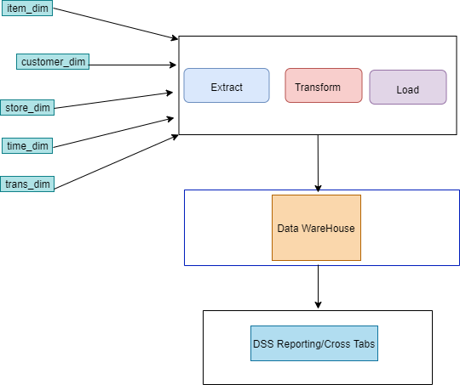

A Datawarehouse is a single data repository where records from various data sources in integrated for business purpose. The first step to generate data warehouse is the **“ETL”** which includes Extract, Transform , and Load. The steps are described below:

1)Extract: From the given csv file, 5 csv files were created according to the requirements.

2)Transform: Some preprocessing were required because some of the cells contained null values. The null / absent values were replaced with some default values in order to maintain consistency.

3) The main csv file was decomposed into 5 csv files and those were loaded into 5 different data tables. These are **fact_table,trans_dim,customer_dim,item_dim,time_dim,store_dim**.

**TASK 2(Design Architecture)**

Here there is a “**fact_table**” and 5 other dimension tables. The 5 dimension tables each has one primary key. The total 5 primary keys are used as foreign keys in the “**fact_table**”. Apart from these 5 fields, the “fact_table” has 4 additional fields.

The data of the superstore database will be collected to the DW using **source driven method.**

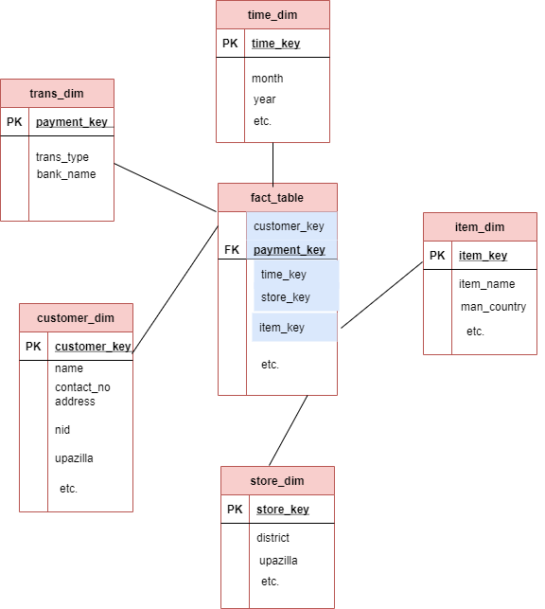

**TASK 3(Implementation of Star Schema)**

The start schema was implemented in PostgreSQL using Pgadmin using the following queries:

1)Fact Table Creation:

CREATE TABLE Public."fact_table"(

payment_key varchar(1000),

coustomer_key varchar(1000) ,

time_key varchar(1000) ,

item_key varchar(1000),

store_key varchar(1000),

quantity int,

unit varchar(1000),

unit_price NUMERIC(30) ,

total_price NUMERIC(30),

PRIMARY KEY (payment_key,coustomer_key,time_key,item_key,store_key));

COPY Public."fact_table" FROM 'F:\dw-assgnment-datasets\fact_table.csv' DELIMITER ',' CSV HEADER;

1)Dimension Table Creation: Dimension tables were created using the same approach. An example is given below:

CREATE TABLE Public."item_dim"(

item_key varchar(1000) PRIMARY KEY,

item_name varchar(1000),

description varchar(1000),

unit_price NUMERIC(30),

man_country varchar(1000),

supplier varchar(1000),

stock_quantity varchar(1000),

unit varchar(1000) );

COPY Public."item_dim" FROM 'F:\dw-assgnment-datasets\item_dim.csv' DELIMITER ',' CSV HEADER;