# C:\Users\jkdadhich\Desktop\HR_DEMO_JD\out_put\K_Label_0.png



# C:\Users\jkdadhich\Desktop\HR_DEMO_JD\out_put\K_Label_1.png



# C:\Users\jkdadhich\Desktop\HR_DEMO_JD\out_put\K_Label_2.png

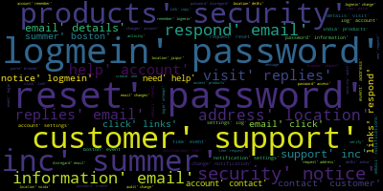

# C:\Users\jkdadhich\Desktop\HR_DEMO_JD\out_put\K_Label_3.png



# C:\Users\jkdadhich\Desktop\HR_DEMO_JD\out_put\K_Label_4.png



# C:\Users\jkdadhich\Desktop\HR_DEMO_JD\out_put\K_Label_5.png

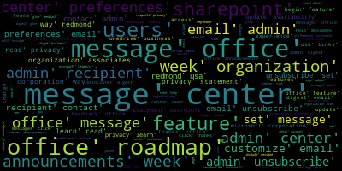

# C:\Users\jkdadhich\Desktop\HR_DEMO_JD\out_put\K_Label_6.png



# C:\Users\jkdadhich\Desktop\HR_DEMO_JD\out_put\K_Label_7.png



# C:\Users\jkdadhich\Desktop\HR_DEMO_JD\out_put\K_Label_8.png



# C:\Users\jkdadhich\Desktop\HR_DEMO_JD\out_put\K_Label_9.png

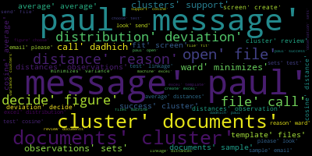

# C:\Users\jkdadhich\Desktop\HR_DEMO_JD\out_put\K_Label_10.png

