Paul Rodriguez

SID: 861152748

CS235 Assignment Report

**Question 1**

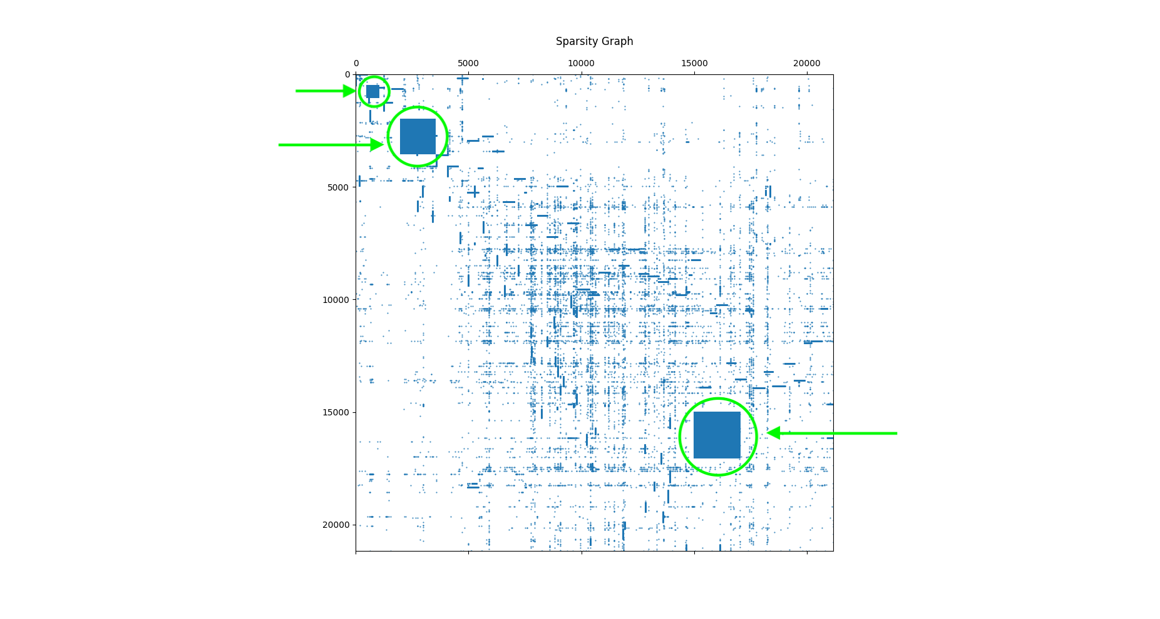

**Question 2**

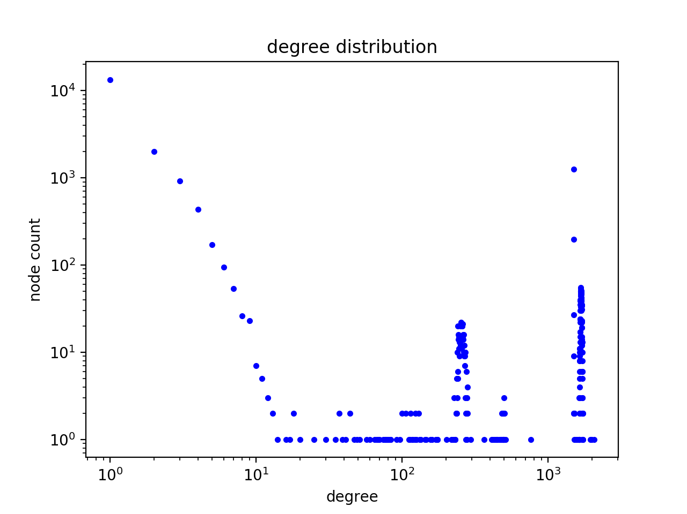

3. There are clear differences between this graph and the clean graph. This graph has an abundance of nodes with high degrees.

4. a.

b.

**Question 3**

2. a. The Rank for which 90% of the original data is reconstructed correctly is 80. The sparsity graph precision is 0.1 meaning that any values less than this value will not be plotted.

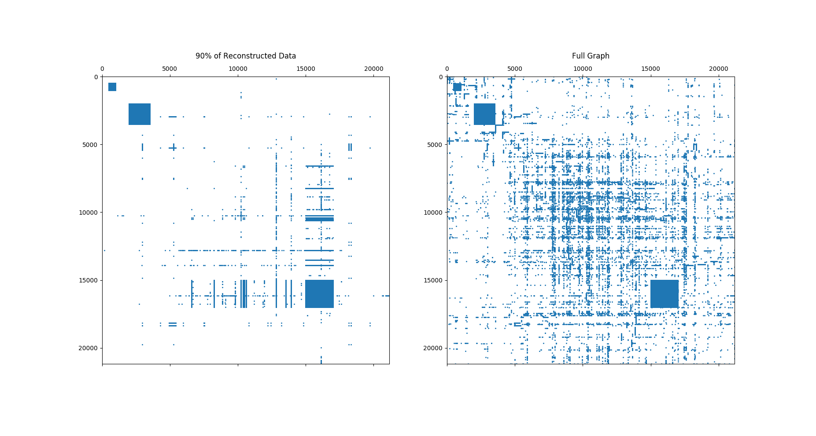

b.