NOTE: Use of internet is not permitted, apart from uploading submission, calculators are permitted and your answers must include worked solutions. If you require extra sheet(s) please write your name and student number at the top of each additional sheet.

**Part A**

**Objective**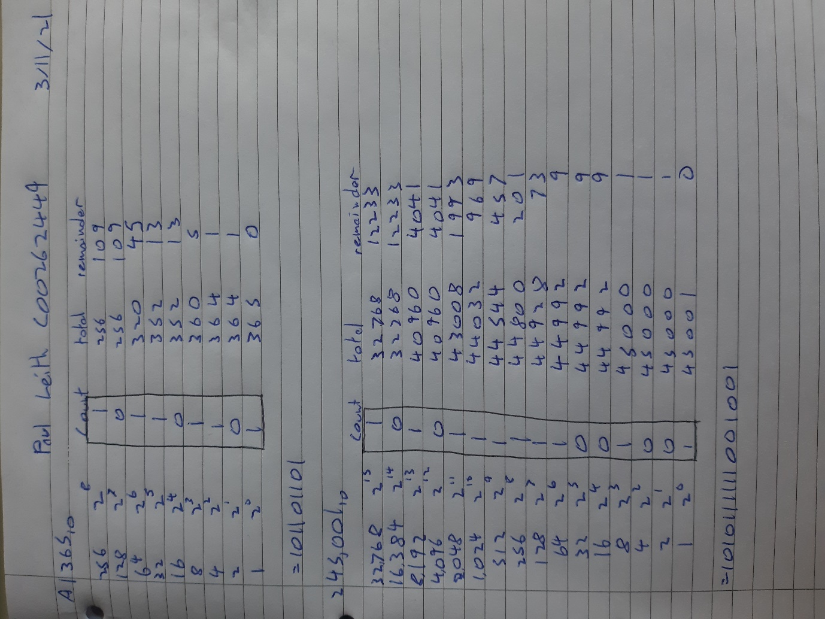

Convert decimal numbers to binary showing in detail the conversion process

|  |
| --- |
| 1. Convert the number of days in a year **36510** to **Base2** |
|  |
| 1. Convert the number of available seats in the new Páirc Uí Chaoimh **45,00110** to **Base2** |
| ­­­ |

**Part B**

**Objective**

Convert numbers base2 to Base10 showing in detail the conversion process

|  |
| --- |
| 1. Convert the number **10110010011101012** to **Base10** |
|  |
| 1. Convert the number **101110.10011110112** to **Base10** |
|  |

**Part C**

**Objective**

Add numbers base2 to base2 showing in detail the addition process

|  |
| --- |
| 1. What is the **Base2** value of addition of **1001 01112**+ **0101 11112** |
|  |
| 1. What is the **Base2** value of addition of **1001.01012**+ **010.1 11012** |
|  |

Hand up this practical report at the end of session and ensure it has been checked

|  |  |  |  |
| --- | --- | --- | --- |
| **Student Name** | **Paul Leith** | **Student Number** | **C00262449** |
| **Date** | **3/11/21** | **Checked** |  |
| **Group** | **A / B** |  |  |