Required software

1. Nodejs @ 16.5.0
2. Yarn @ 1.22.11

Frontend – Installation

* Yarn install
* Yarn start

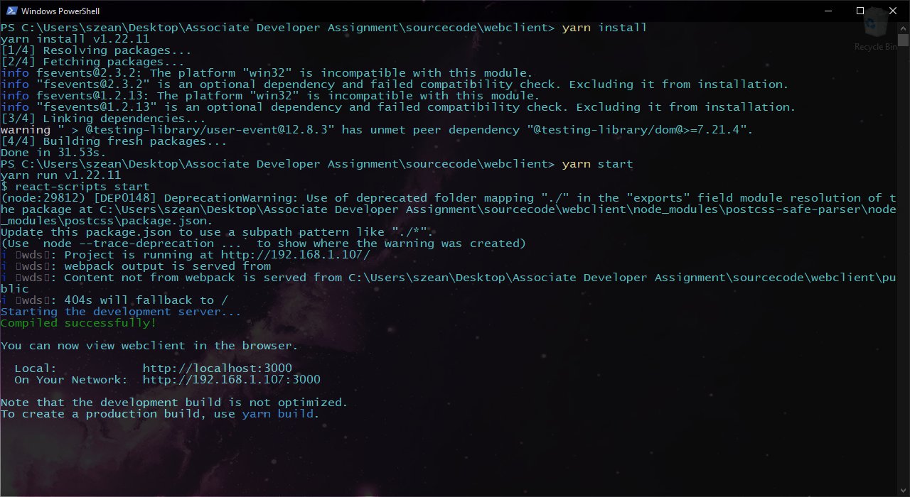

Backend – Installation

* Yarn install
* Yarn dev

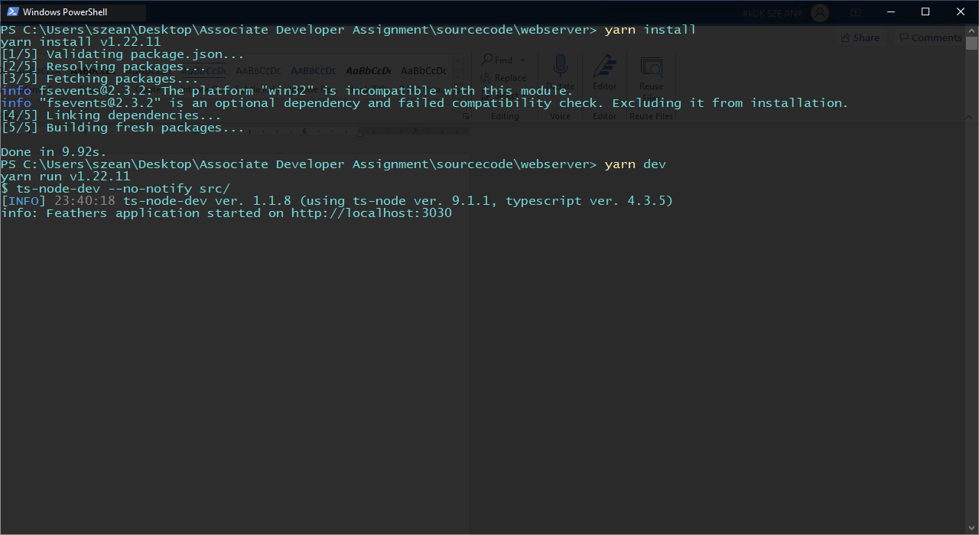

API endpoint

* api/v1/diff/left
  + A post endpoint to create left data
* api/v1/diff/right
  + A post endpoint to create right data
* api/v1/diff
  + A get endpoint to do comparison between the left and right data
  + The comparison code can be found in the webserver/src/helper/dataHelper.ts file
  + Possible result is a json or a null object

{

  “isSame”: false,

  “isSameLength”: true,

  “leftDataLength”: 8,

  “rightDataLength”: 8,

  “initialOffset”: 4,

  “finalOffset”: 7,

  “length”: 3,

}

Improvements – overall

1. Use of docker to host both the frontend and backend system
2. Create test report for both the frontend and backend system
3. Make use of Eslint to fix and enforce coding style for both frontend and backend system

Improvements – Frontend

1. Refactor frontend code to identify common components
2. Add file upload into the input form history (Planned to do but not enough time)
3. Fix the bug on the comparison history as it may not update correctly occasionally

Improvements – Backend

1. Disable unused REST endpoints in the backend server
2. Persist the compare history (Planned to do but not enough time)
3. Data comparison can be done in the frontend to unload server overhead in big scale data processing

Things to note:

* The text will only be highlighted if the two base64 binary data are of the same length
* If the frontend is not able to create data
  + stop the backend using ctrl + c
  + go to “path/to/webserver/data”
  + remove the values for all the .db files (do not delete the files)
  + restart the webserver using yarn dev