Usage

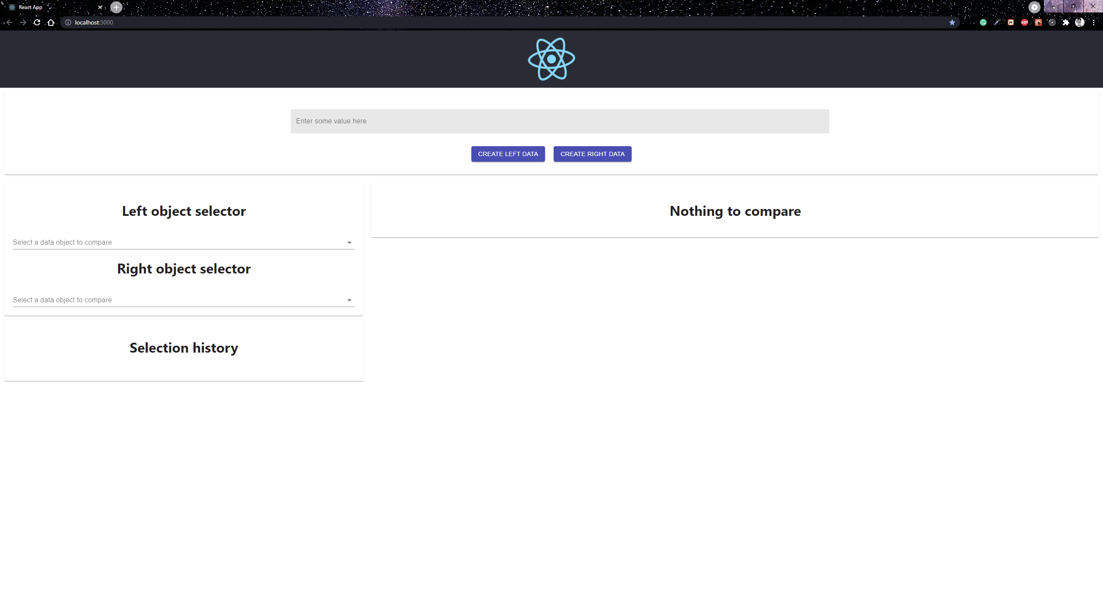

Once the frontend and backend are started and running, you will be greeted with the main page as shown above.

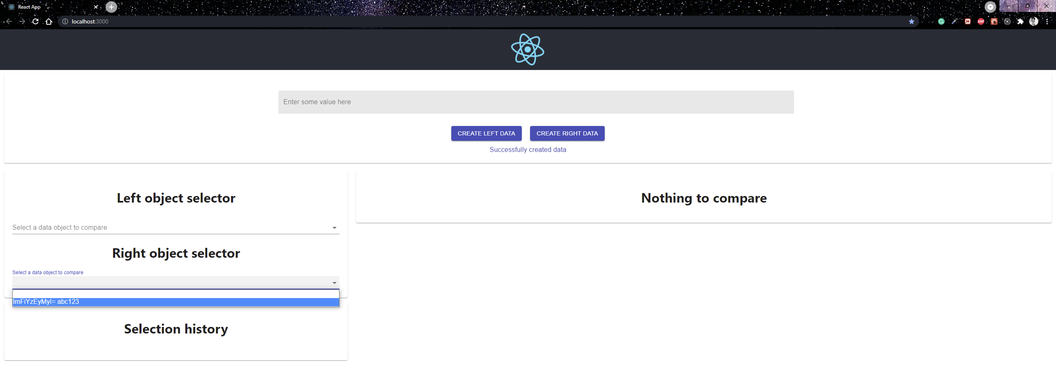

1. Values to create for left/right data
   1. abc123, ab1233, a22333, a33333, a12333, a43213

The left and right button will use axios and promise to post the text field value in an encoded json base64 binary data to the webserver. The posted data will be reflected at the object selector respectively.

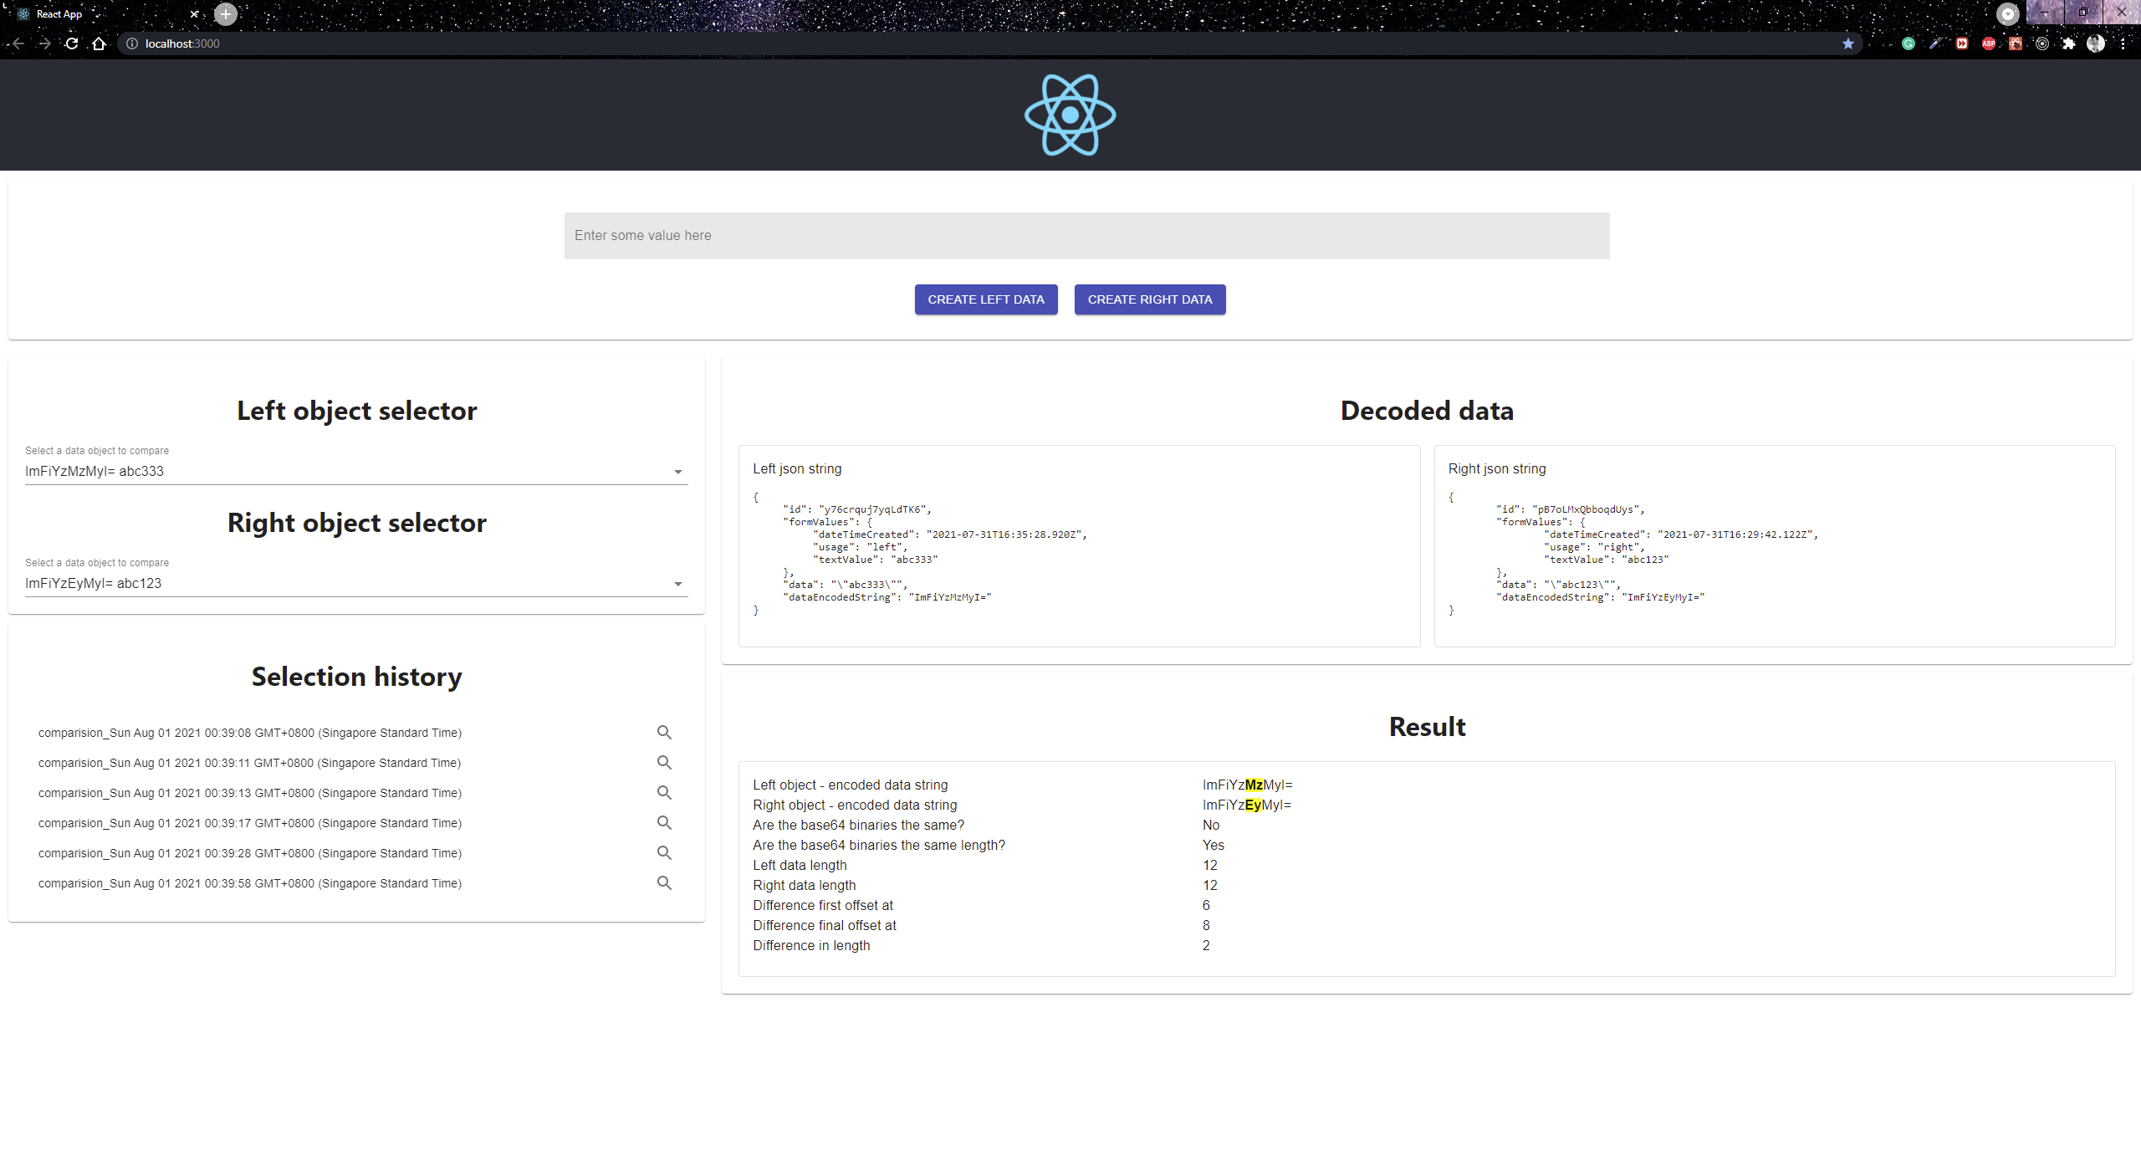

Select the value randomly for the left/right object selector and the result will show on the right. The comparison is display on the selection history but not persist in the webserver.

Things to note:

* The text will only be highlighted if the two base64 binary data are of the same length
* If the frontend is not able to create data
  + stop the backend using ctrl + c
  + go to “path/to/webserver/data”
  + remove the values for all the .db files (do not delete the files)
  + restart the webserver using yarn dev