1. Pull the latest code from release-SP19 branch (Based on sprint [release-SP20, release-SP21] the branch name will vary).
2. Run “npm install” in command prompt from root of the ui application.(*projectfolder*/VBR_Services/vbr-ui).



The command will create node_modules folder.

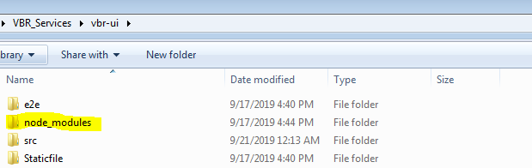

Run “ng serve” to validate application @ <http://localhost:4200>.

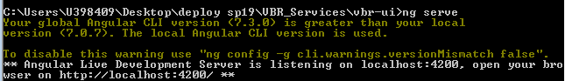

1. After the node modules are downloaded, build the angular application from root of ui application.

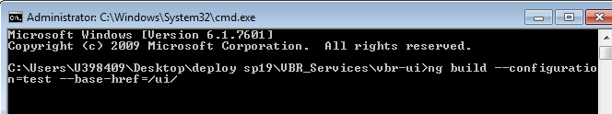

1. **For VBR UI build**

**ng build --configuration=test --base-href=/ui/ (for Test ENV)**

1. **For DUET**

**ng build (no configuration or base)**

The commands for other ENVs could be found in below screenshot.

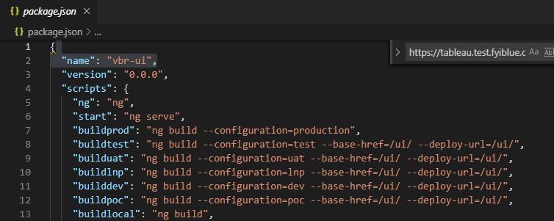

Please make sure the service urls are properly pointed in corresponding environment file.

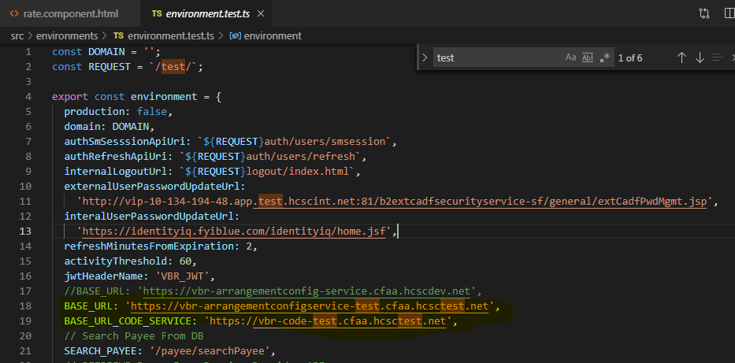

1. The build command will generate dist folder.
   1. **For VBR UI deployment:** Rename the " vbr-ui" folder to "ui" inside the generated "dist" folder after the angular build is completed.
   2. **For DUET deployment:** Noneed to rename the “vbr-ui” folder

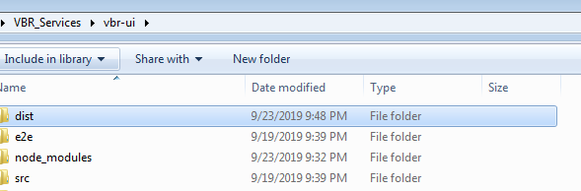

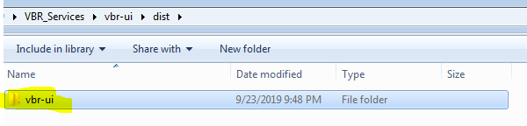

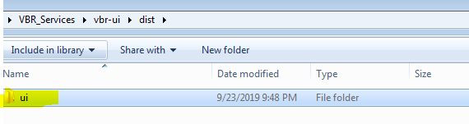

1. For VBR UI deployment

Copy the attached manifest file as per the PCF space inside "dist" folder.





1. For DUET deployment

Copy the attached manifest file inside the “dist/vbr-ui” folder



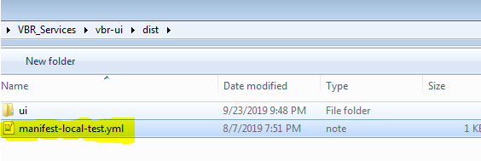

1. Login into PCF pointing to relevant space.

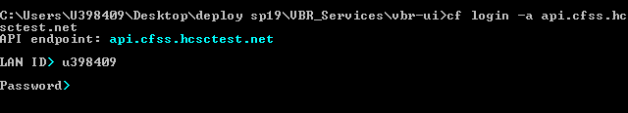

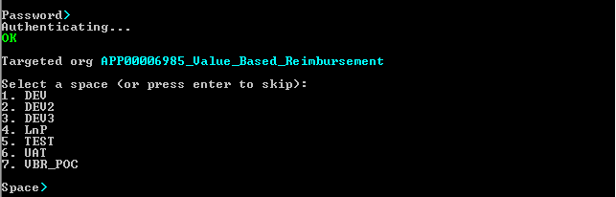

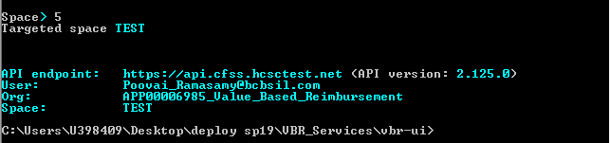

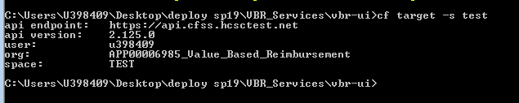

1. Push the code into PCF from "dist" folder using below command.

**cf push –f <manifest_filename>**

EX: **cf push -f manifest-local-test.yml**

