ANGELO C. BANDONG

IAS101

BSIT-3B

**Challenge 1: Adding an End Device to the Network in Packet Tracer**

**Step 1: Open Packet Tracer**

First, open Packet Tracer by double-clicking its icon on your desktop. If you already have a network setup from a previous activity, go ahead and open that file. Otherwise, you can create a new one similar to what you worked on before.

**Step 2: Add a New Device**

Now, let’s add a new end device—this could be a PC, laptop, or another network device. On the left side of the screen, look for the "End Devices" section. Click on it, then drag and drop a device onto the workspace.

**Step 3: Connect the Device to the Network**

Your device needs a connection! Grab a copper straight-through cable (found under the "Connections" section, represented by a lightning bolt icon). Click on the device you just added and choose its Ethernet port. Then, connect the other end of the cable to a switch or router that belongs to an existing LAN (Local Area Network).

**Step 4: Configure Network Settings**

Now that your device is connected, let’s set up its IP address so it can communicate with the network:

Click on the new device.

Go to the Desktop tab.

Click on IP Configuration.

Enter the IP address, subnet mask, default gateway, and DNS server based on the LAN settings. If you’re not sure what values to use, check the configuration of other devices in the network.

Step 5: Test the Connection

Let’s make sure everything is working! Open the **Command Prompt** from the Desktop tab and type:

Ping 192.168.1.2

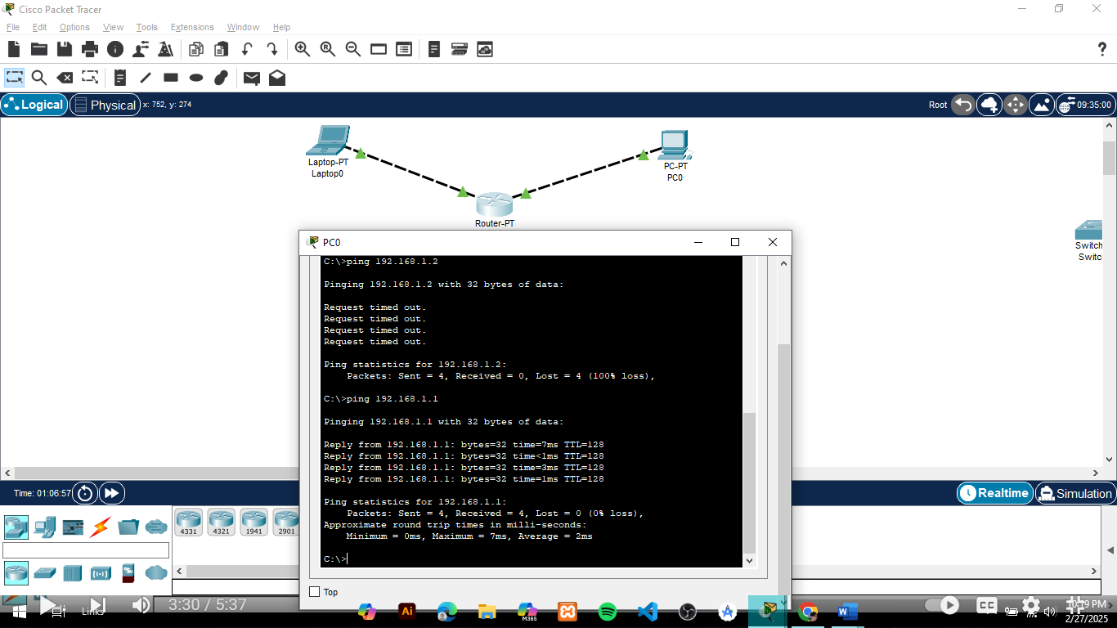

**Challenge 2: Add a New Intermediary Device**

**Step 1: Add the Device**

Think of this like adding a new piece of networking equipment to your setup.

* Open Packet Tracer.
* From the device list, pick an intermediary device (a router or switch).
* Drag and drop it into your workspace, just like placing a new gadget on your desk.

**Step 2: Connect It to the Network**

Now, let’s give it some connections so it can communicate!

* Choose the correct cable type:
* Router to PC/Switch: Use a copper straight-through cable.
* Click on the first device (router/switch), select a port, and connect it to another device (PC, switch, or another router).

**Step 3: Configure the Device**

Now it’s time to set up the device so it knows how to handle network traffic.

* If it’s a router, assign an IP address to each port (so different networks can communicate).
* If it’s a switch, just make sure it’s properly connected (it doesn’t need an IP in most cases).

**Step 4: Test If It Works**

How do we know everything is set up correctly? Let’s test it!

* Open a PC connected to the network.
* Go to the Command Prompt and type

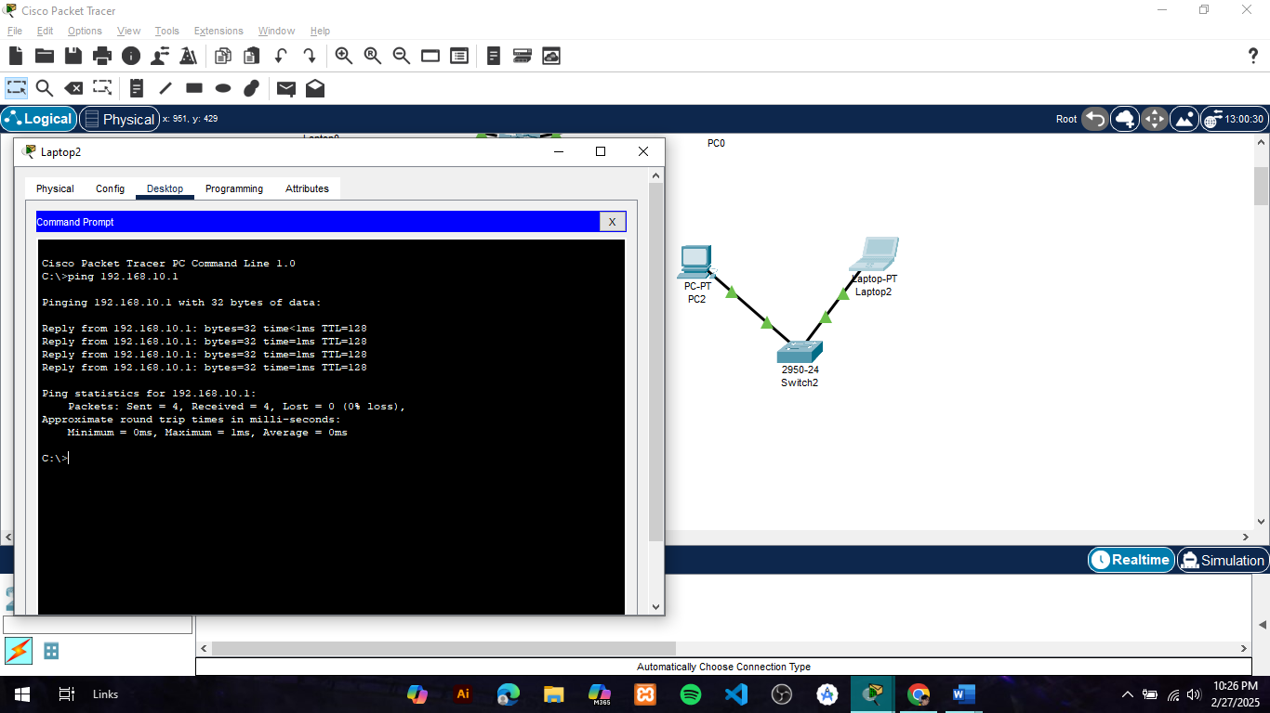

**Step 1: Start Fresh**

Think of this like setting up a new office network from scratch.

* Open Packet Tracer and start a new project.

**Step 2: Create Two LANs (Local Networks)**

Imagine these as two separate offices or departments in a company.

* Add two switches or routers to represent each LAN.
* Connect each switch to some devices like PCs, laptops, or printers.

**Step 3: Link the LANs with a WAN (Wide Area Network)**

Now, let’s connect these two offices using a WAN link, just like an ISP would connect two branch offices.

* Add a router to each LAN (one per office).
* Connect the two routers using a serial or other WAN connection (this acts like an internet link).

**Step 4: Assign IP Addresses**

Think of this like assigning unique phone numbers to each device so they can talk to each other.

* Each LAN should have its own subnet (so they don’t interfere with each other).
* Assign IP addresses to the routers, PCs, and other devices.
* Set up the default gateway on each PC (this tells the device where to send traffic outside its LAN).

Step 5: Test the Connection

• Open a **PC’s Command Prompt** and type:

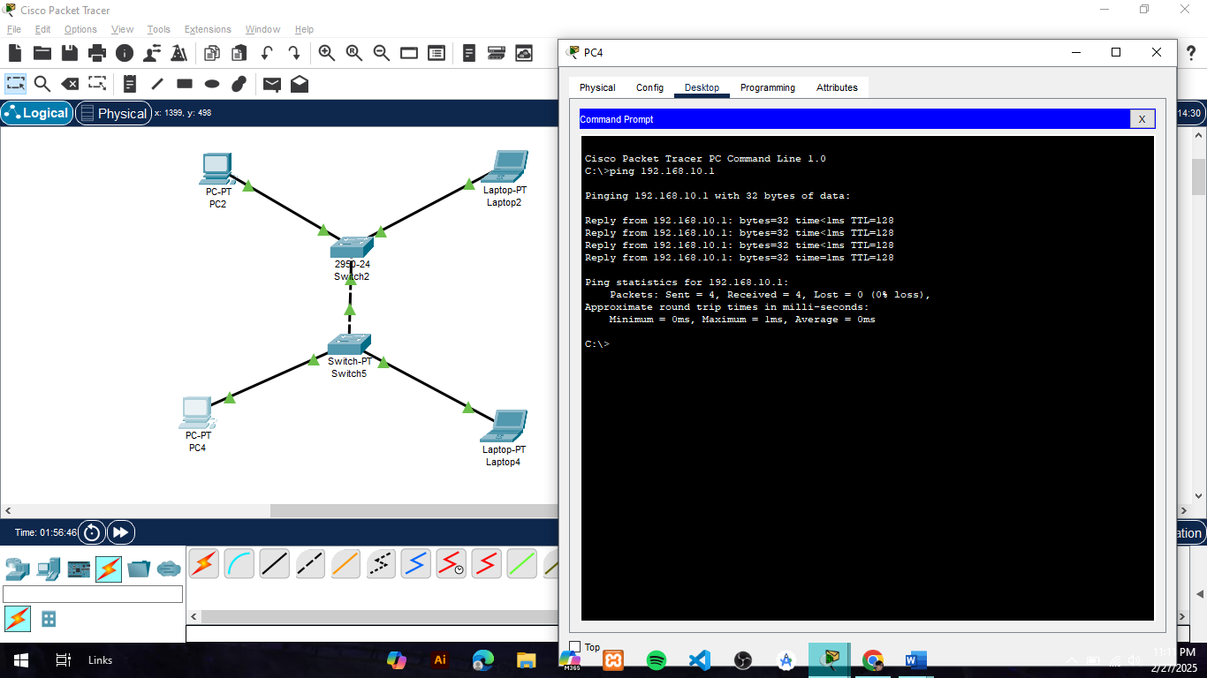• If you get **a reply**, everything is working perfectly!