BANDONG, ANGELO C.  
BSIT 3B

IPT 101

DISPLAY STUDENTS

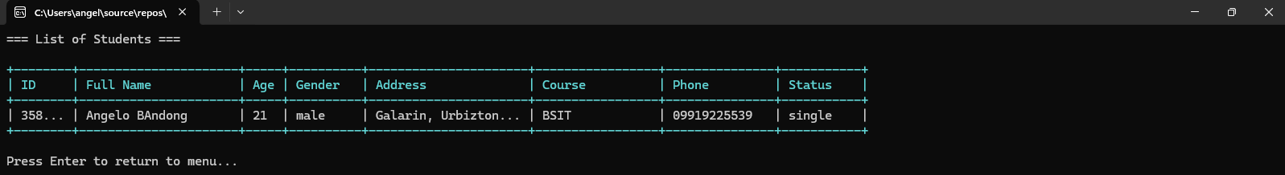

ADD STUDENTS

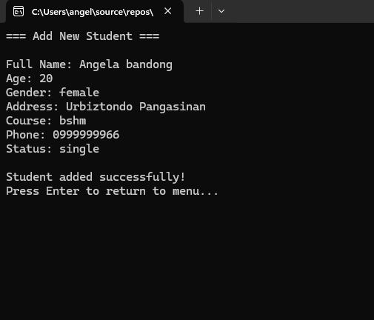

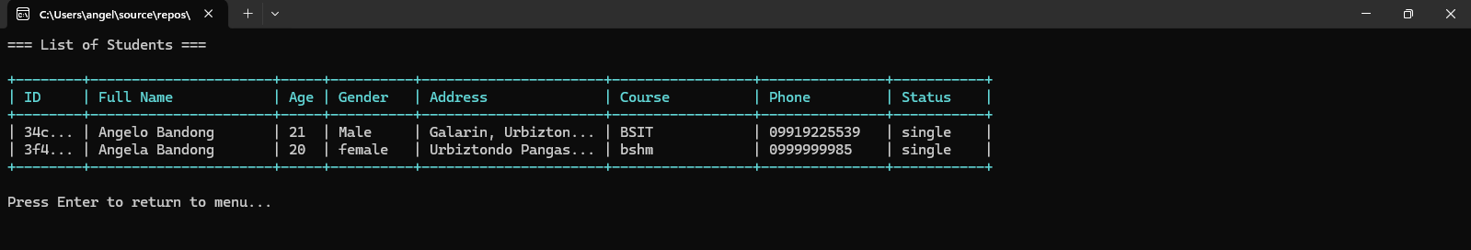

UPDATE STUDENT

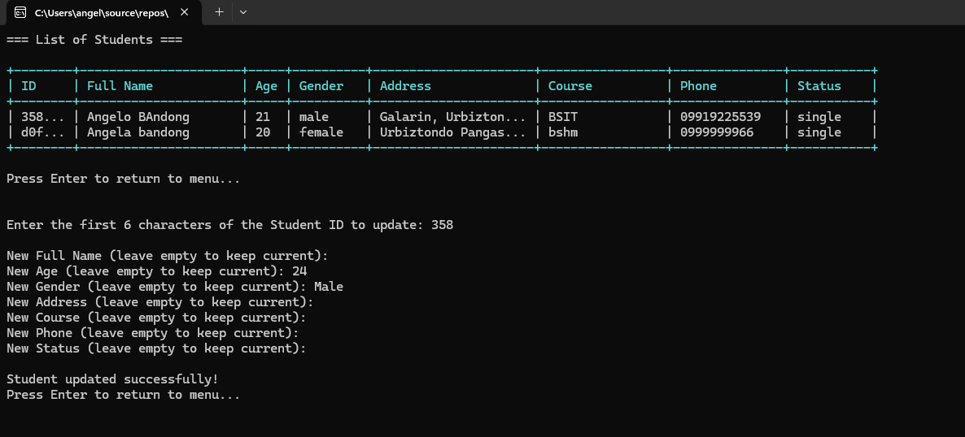

DELETE STUDENTS

