**LEARNING MANAGEMENT SYSTEM FOR UNITED METHODIST CHURCH RAINBOW SCHOOL**

A Capstone Project

Presented to the Faculty of

Information Technology Department

Pangasinan State University, San Carlos Campus

San Carlos City Pangasinan

In partial fulfilment

Of the Requirement of the Degree

Bachelor of Science in Information Technology

JOHN REYVEN C, BACAYCAY  
CLARK CHESTER A. BARRAMEDA  
JETHRO Z. CASTRO

December 2024

**Chapter 1**

**INTRODUCTION**

**1.1 Context of the Project**

Students today are developing in a highly technological environment. Technology plays a crucial role in both teaching and learning, making it easier for teachers to distribute materials and for students to access them. This advancement has significantly enhanced education, transforming it and making technology indispensable for improving educational outcomes.

Before the digital age, teachers and students have to be in the same setting for learning to take place. Today, however, there are plenty of tools that allow instructors and learners to meet remotely. This makes the classroom-based model no longer efficient by itself, and some would suggest, obsolete. For an institution to remain relevant, they have to evolve and embrace online learning and e-learning. They do not have to be fully online they can take the path of blended learning to keep the traditional way of imparting knowledge and skills (Bouchrika, 2024).

An LMS is a software tool that enables students to receive learning content and educational resources to continue their educational endeavors online. The use of LMS in education is a smart choice for educational institutions in today’s world. It allows teachers to deliver customized learning content, leverage different pedagogical models and engage their students much better than before (Obana, 2021). Typically, a learning management system provides an instructor

with a way to create and deliver content, monitor student participation, and assess student performance. LMSs are frequently used by businesses of all sizes, national government agencies, local governments, traditional educational institutions, and online/eLearning-based institutions. The systems can improve traditional educational methods, while also saving organizations time and money. An effective system will allow instructors and administrators to efficiently manage elements such as user registration, content, calendars, user access, communication, certifications, and notifications (Brush, 2019).

An LMS is a software application designed to manage, deliver, and track educational courses, training programs, or Learning and Development programs. It acts as a centralized hub for all educational activities, making it easier for educators, administrators, and learners to access and manage learning content (Singh, 2024). The learning management system (LMS) is a software based on a web server, cloud computing or personal local computer that manages the teaching and learning process in an academic or non-academic program without the constraint of time and place. Due to the fact that most LMSs can be accessed via an internet browser or as a user application, their accessibility is unlimited. Nowadays, there are a large number of LMS developed for the academia and industrial users, which have leveraged new learning styles and increased the student population (Sanchez et al., 2024).

Teaching and learning processes have continuously evolved with technological advances. Correspondingly, the rapid development of information and communication technologies has shaped traditional classrooms into smart learning environments (Tinmaz et al., 2020).

Teachers at the United Methodist Church Rainbow School of San Carlos face challenges in monitoring students and incur high costs for printing learning materials. Teachers and administrators may spend more time on administrative tasks, such as organizing materials and managing grades due to the lack of proper automation and processes from an LMS. Additionally, students experience disruptions when they have to travel to school just to collect these materials.

To address these issues, researchers develop an online learning management system for the Grade 6 students at the school. This system provides students with reliable information and assists teachers in tracking students. Furthermore, it serves as an effective learning tool and platform for the students.

**1.2 Objectives of the Project**

The main objective of this study is to develop and design a Learning Management System for United Methodist Church Rainbow School. The project aimed to provide efficient and effective monitoring of teachers for the grade 6 students, distribution of information, and learning materials. Specifically, this study aimed:

1**.** To Identify the existing process of a Learning Management System,

2**.** To determine the features of the system in terms of functional and non-

functional requirements, and;

3**.** To test the acceptability of the proposed system.

**1.3 Significance of the Project**

This study aimed to enhance learning management by developing a Learning Management System (LMS) for Grade 6 students at the United Methodist Church Rainbow School. The LMS facilitates interaction between teachers and students. Its implementation enabled the efficient and swift delivery of training materials to both students and workers, benefiting the organization as a whole.

There are various people who benefit from this system such as the institution, administrator, teacher, students, as well as the future researchers.

**United Methodist Church Rainbow School.** The study improved the teaching techniques of the grade 6 teachers in UMC Rainbow School. This is beneficial for the institution as it lessen the work and effort of distributing learning materials for the said department.

**Teachers.** The system enabled teachers to distribute information and learning materials to their students, manage assignments and quizzes, and communicate with other teachers and students, all while allowing for the easy and widespread uploading of information.

**Students.** Students can access and obtain learning materials, and interact with other users. The system provides them with full accessibility to all the materials uploaded by their teachers.

**Administrator.** The system enabled administrator to become proficient in managing e-learning platforms and associated technologies, including servers and databases. The system not only strengthens the administrator’s technical capabilities but also makes a valuable asset in the broader tech and education industry.

**Developers.** Developing a Learning Management System (LMS) helps enhance the technical skills and career advancement of the developers. It provides opportunities to work with diverse technologies, solve complex problems, and build a strong portfolio piece, all while expanding professional networks through collaboration with educators and other stakeholders.

**Future Researchers.** The study will serve as a reference for future researchers developing projects related to learning management systems. Overall, it has the potential to enhance the quality of learning and contribute to the development of more efficient and effective learning management practices.

**1.4 Purpose and Description**

The developers aim to deliver and manage instructional content through

this project, encompassing student registration, subject administration, as well as tracking and reporting student progress. The LMS helps gauge progress toward learning or educational goals and ensures easy web-based access for teachers and students.

The LMS streamlines the process of uploading modules, assigning,

and generating a variety of reports, along with managing subject activities. It allows the teachers to send reminders and notifications about class sessions and assignments. Additionally, it maintains class records and monitors individual performance.

**1.5 Scope and Limitation**

The target audience for this study includes the administrator, teachers, and Grade 6 students at the United Methodist Church Rainbow School. Administrator can manage subjects, update student and instructor information, and assign students to subjects. Teachers can add and remove students, create and grade assignments and quizzes, and post announcements. Students can participate in class discussions, complete assignments and tests, and download digital resources.

This study is limited only to students and teachers at United Methodist Church Rainbow School. Only the administrator and teachers in their department have the authority to manage their classes, subject and upload files; It is only applicable with the use of the internet.

**1.6 Definition of terms**

The following terms were technically and operationally defined to

serve as a reference and for a better understanding of the project.

**Learning Management System (LMS).** A Learning Management System (LMS) is a software tool designed to efficiently plan, implement, and evaluate educational processes by supporting teacher monitoring, distributing information, and providing learning materials for effective student learning and supports a holistic approach to education by enhancing both teaching efficiency and learning outcomes. A Learning Management System is a software application or web-based technology designed to plan, implement, and evaluate a specific learning process. The development of the system is intended to provide efficient and effective monitoring of teachers for the grade 6 students, distribution of information, and learning materials.

**Subjects.** Subjects are distinct fields of knowledge, such as mathematics or science, each with a focused curriculum designed to impart specific knowledge and skills. Organizing content by subjects provides a structured, focused approach that enhances both student learning and teacher instruction. Subjects are specific areas of knowledge or fields of study that are taught in educational institutions. Each subject focuses on a particular topic, such as mathematics, science, history, or literature, and includes a curriculum designed to impart knowledge and skills related to that topic. Organizing content by subjects helps provide structured, focused, and engaging learning, supporting both student progress and teacher instruction.

**Education**. Refers to the structured process of delivering, managing, and assessing learning of students through a digital platform. The education through an LMS for promotes accessibility, personalized learning, engagement, and consistency while enhancing both student and teacher productivity. A learning management system provides a structured way to deliver and manage learning, offering accessible, personalized, and engaging education while ensuring consistency and boosting productivity for both students and teachers.

**Chapter 2**

**REVIEW OF RELATED LITERATURE AND STUDIES**

This chapter presented a review of the literature and studies on Learning Management System, its overall functionalities, and factors that affects its efficiency. The researchers gathered materials from online journals, theses and dissertations, and other online sources.

**2.1 Related Literature**

This section included relevant literature and studies that were directly pertinent to the current topic. It provided a comprehensive examination of the significance of this study in relation to existing literature. The information in this chapter was gathered from various sources, including expert articles, books, journals, manuals, and prior thesis projects relevant to the current topic. All these sources established significant connections and contributed substantially to the research.

**Foreign Studies**

Learning with the help of the Internet is part of learning how multimedia is a network-assisted learning system that gets its information from satellites. When data is distributed or searched for, things are simple, fast, and cheap; consequently, anything obtained from the Internet can be utilized as a learning resource. People can connect, share information, and communicate via the internet (Abdulrahman et al., 2021).

The Internet is a world apart and boundless because of the vast amount of information and activity it contains. Software and hardware are also required for the Internet to function correctly and facilitate the dissemination and search of knowledge. Internet technology can help reach many students and generate or develop new values (Conner, 2019).

The use of e-learning platform can help students learn more effectively and efficiently, as well as spend time more effectively and efficiently (Gilakjani, 2020). Furthermore, learning using a device will significantly boost student learning motivation. At the same time, higher motivation leads to more optimum success. E-Learning functions with advantages of instructional media in the learning process include the following: creating solid foundations in thinking to reduce 'verbalism.', increasing student engagement, making classes more enjoyable so that the influence on learning outcomes is fulfilling (Makransky et al., 2022).

With the rise of new e-learning tools and systems, educational institutions from all over the globe are racing to implement them as part of their academic curriculum (Senaidi et al., 2023). English as foreign language (EFL) programmes are also increasingly provided online to provide better assistance and personalised interactions to learners. Learners are also encouraged to engage in individualised and incentivised learning strategies (Abdalla et al., 2021).

The advantages of using e-learning are undeniable and have been the subject of extensive discussion and research by various scientists and educators over the past decade. In a study among students (Liaw, 2020) found that using interactive multimedia education has contributed to improving the effectiveness of learning. The importance and advantages of multimedia elements are presented in. That is why many of the modern e-learning systems provide the opportunity to create interactive multimedia resources, and this opportunity should be considered when creating criteria for evaluation and analysis of LMS frameworks (Wang et al., 2021).

As identified by Hwa et al. (2021) student acceptance of technology is the first step in any educational institution's LMS success, this acceptability is what motivates and encourages students to adopt LMS in their study. Therefore, it's crucial to analyze the factors that affect student intention in accepting LMS, as this is a critical factor in determining its success and improving long-term e-learning usage.

LMS has become a fundamental platform for teachers and students to interact virtually in institutions of higher learning, utilising the internet and other related software as a tool for disseminating a variety of solutions that make learning and knowledge sharing more interactive (Paulsen, 2020). Students' willingness to use technology for education and learning is vital to its effectiveness. As a result, institutions of higher learning now want to integrate a specific intensity and value of innovative technology tools into both their own lecture structure, which encompasses overt and covert learning at all levels and tends to make use of certain communication infrastructure vital services (Tinio et al., 2019). According to Mittal et al., (2022) the use of technology to improve the quality of education has been considered by many researchers.

To enhance the learning experience, educational institutions, and corporate training environments need a well-integrated technology ecosystem that greatly increases effectiveness, engagement, and efficiency. This article discusses some benefits of combining LMS with diverse educational technologies and how such combinations can be made (Apki, 2024).

The system encompasses several modules, each with specific functionalities. The login module ensures users can access their accounts, providing error messages for incorrect information and alerts for invalid input, and redirects users to the homepage upon successful login. The student module allows users to view and download learning materials, upload assignment answers, view grades, and select subjects. The teacher module enables users to create and view learning materials and assignments, input student marks, and select classes. The administrator module supports user management by allowing the registration of new administrators, students, and teachers, as well as managing existing users. The to-do list module displays unfinished assignments and their deadlines to students. The report module generates statistical reports on student grades. Lastly, the subject and class module facilitate the creation and assignment of classes and subjects to users, along with the creation of new classes and subjects (Tucker, 2024).

**Local Studies**

The rapid progression of information and communications technology (ICT) brought significant changes in the field of education from empowering new ways for people to learn and work together (e-learning technology for instance) to transforming teaching and learning processes. While e-learning environment in the Philippines is still in its embryonic stage, it has already adopted and still spearheaded by prominent universities such as University of the Philippines for their UP Open University (UPOU), University of Sto. Tomas for their e-Learning Access Program (e-LeAP), De La Salle University for their integration of Sakai educational software platform and other academic institutions that offer some form of online courses. By proliferating and integrating e-learning technology in the Philippine education system, the transformation of teaching and learning process increases the academic achievements of Filipino college students (Cruz, 2019).

In view of all this, the global education sector has been attempting to gather more and more information on aspects that persuade students not just to incorporate e-learning into their educational journey but also confidently warrant consideration in shaping future e-learning developments (Golja et al., 2022).

Findings of Calbi et al. (2019) stated that the current education presented faces the following challenges: lack of preparation and professional development; excessive academic burden on students; and integration of lessons in the real-life context. It would be a tremendous challenge for all teachers to engage in different training and pursue higher education to manage the changes and ensure that their growth corresponds to the demands of society.

Chahal (2021) states that the goal of a learning management system (LMS) is “to provide a smooth online teaching-learning environment for students and teachers, to create a value-based online platform that promotes the growth of all stakeholders and assists students in achieving success through skill development.”

**2.2 Summary of Related Literature**

**Table 1: Summary of Related Literature**

|  |  |  |
| --- | --- | --- |
| **Title** | **Advantages** | **Disadvantages** |

|  |  |  |
| --- | --- | --- |
| Learning with the help of the Internet | Simple, fast, and cheap access to learning resources; facilitates information sharing and communication; vast amount of information available. | Requires hardware and software to function correctly; can be overwhelming due to the vast amount of information. |
| Internet technology in education | Can reach many students; helps generate or develop new values. | Potential dependency on technology; requires substantial infrastructure. |
| E-learning platform in education | Enhances learning effectiveness and efficiency; increases student engagement and motivation; creates solid foundations in thinking; makes learning more enjoyable. | May require significant resources to implement; potential for increased screen time. |
| E-learning tools and systems | Provides personalized interactions and incentivized learning strategies; encourages individual learning. | Implementation can be challenging for institutions; may require training for both teachers and students. |
| Interactive learning | Improves learning effectiveness; highlights importance and advantages of e-learning elements. | Development of interactive resources can be time-consuming and costly. |
| Student acceptance of technology in LMS | Motivates and encourages students to adopt LMS; crucial for determining the success and long-term usage of e-learning systems. | Acceptance varies among students; requires continuous analysis and adaptation. |
| LMS as a platform for virtual interaction | Facilitates interactive learning and knowledge sharing; integrates innovative technology tools into lecture structures. | Dependence on technology infrastructure; requires consistent updates and maintenance. |
| Technology to improve education quality | Recognized for improving education quality; integrates various technology tools into learning processes. | Implementation and maintenance can be costly; potential resistance from traditional education systems. |
| Specifications of e-learning systems | Defines specific system behaviors and quality attributes; ensures comprehensive system functionality and user management. | Requires detailed planning and continuous evaluation; non-functional requirements can be subjective and variable. |
| E-learning in Philippine education | Transforms teaching and learning processes; increases academic achievements; promotes new ways to learn and work together; spearheaded by prominent universities. | E-learning environment is still in its embryonic stage; requires further development and widespread adoption. |
| Factors influencing e-learning adoption | Provides insights for future e-learning developments; helps shape educational strategies; gathers information to improve student incorporation of e-learning. | Varied factors can complicate analysis; may require extensive research to understand fully. |
| Challenges of education | Identifies specific challenges for improvement; highlights the need for professional development and real-life lesson integration. | Lack of preparation and professional development; excessive academic burden on students; challenging to manage changes. |
| Goals of a learning management system | Creates a smooth online teaching-learning environment; promotes value-based growth; assists in skill development and student success. | Implementation can be complex; requires continuous development and adaptation to meet stakeholder needs. |

**2.3 Synthesis**

The integration of Learning Management Systems (LMS) in education has significantly transformed teaching and learning processes, enabling institutions to provide a smooth, value-based online learning environment that supports student success through skill development. In the Philippines, prominent universities like the University of the Philippines and De La Salle University have adopted e-learning platforms, enhancing academic achievements despite the embryonic stage of e-learning adoption in the country. Despite many advantages, the adoption of Learning Management Systems (LMS) comes with notable challenges, including the necessity for comprehensive professional development for educators and addressing the risk of overburdening students with academic demands. However, their successful deployment hinges on overcoming hurdles related to adequate preparation and seamless integration. With the right support systems and infrastructure in place, LMS hold transformative potential to enhance educational outcomes and reshape the learning landscape.

**2.4 Technical Background**   
 The capstone project was a web-based system aimed at aiding the students at United Methodist Church Rainbow School and the teachers. Learning Management System was a web-based platform that enabled organizations to utilize the most popular coding language in the world. With the support and claim, the developers used PHP as the main development language. PHP, or Hypertext Preprocessor, was the world's most widely used server-side programming language. It was the most used server-side scripting language for web development and was regarded as one of the easiest programming languages. PHP was a popular programming language increasingly used by developers to create new online apps. Well-known social networking sites like Facebook and reputable institutions like Harvard University used PHP, which boosted PHP's popularity and legitimacy. PHP was regarded as a very efficient technology that offered a simple development process and several extra features to help it. PHP was the fifth most popular coding language in the world, according to the Popularity of Programming Languages Index (PPLI). The developers used PHP as their primary development language considering those justifications and assertions. Platform independence, support for open source and dynamic libraries, organization, free availability, database access, ease of understanding and coding, ease of integration, and consistency were just a few of the benefits PHP offered developers.   
 The developers undertook a capstone project to create a web application called “Learning Management System,” utilizing PHP as the primary programming language for development. The choice of PHP brought significant benefits to the project, enhancing the functionality and scalability of the application. JS and CSS frameworks enabled developers to extend program capabilities and create user-friendly interfaces with ease. These frameworks provided built-in template engines that facilitated the development of visually appealing web designs, making them invaluable for web application creation. The selection of PHP and associated front-end frame works was deliberate, chosen for their extensive capabilities and ease of use, empowering developers to expand application functionality efficiently.

**2.5 Gap**

A gap analysis helped to determine where to focus optimization efforts, further insights included a better grasp of stakeholder needs. The developers came up with some of the specific aspects of the study that would be relevant in the creation of the Learning Management System for United Methodist Church Rainbow School using the information acquired from various studies.

**Table 2: Gap**

|  |  |
| --- | --- |
| **Manual Process** | **Proposed System** |

|  |  |
| --- | --- |
| Existing LMS for All Students (Kinder to Grade 6) | Focuses on Grade 6 Students |
| Quizzes are administered to all students from Kinder to Grade 6. | Quizzes specifically tailored for Grade 6 students, with a focus on their graduation requirements. |
| Standardized quizzes include short quizzes across various subjects. | Quizzes will include 10 items per subject, featuring multiple choice and enumeration questions, designed to evaluate the specific competencies of Grade 6 students. |
| Quizzes may not be differentiated or customized according to the needs of graduating students. | Quizzes and assessments will be customized for Grade 6, aligning with their curriculum and graduation criteria. |
| Core Subjects Covered for All Grades | Core Subjects for Grade 6 |
| Core subjects include Math, English, Filipino, Science, and Araling Panlipunan for all students. | The same core subjects (Math, English, Filipino, Science, and Araling Panlipunan) will be emphasized, with tailored content and assessments for Grade 6 students. |
| Subjects may be taught and assessed with a generalized approach for all grade levels. | Subject content and quizzes will be specifically designed to prepare Grade 6 students for their transition to higher education. |
| General LMS Features | Enhanced LMS features for Grade 6 students |
| Basic LMS features include content delivery, quiz administration, and progress tracking for all students. | Enhanced LMS features will include advanced tracking and analytics for Grade 6 student performance, more interactive content, and focused support for core subjects. |
| Limited differentiation in LMS features based on student grade or specific needs of graduating students. | Focused support and features tailored to the unique needs of Grade 6 students, facilitating a smooth transition to secondary education. |

**2.6 Conceptual Mapping**

A concept map is a diagram or graphical tool that depicts the relationships between concepts and ideas visually. Most concept maps display ideas as boxes or circles (also known as nodes) that are organized hierarchically and linked by lines or arrows (also known as arcs). To help illustrate the links between concepts, these lines are labelled with linking words and phrases (Lucid, 2022).

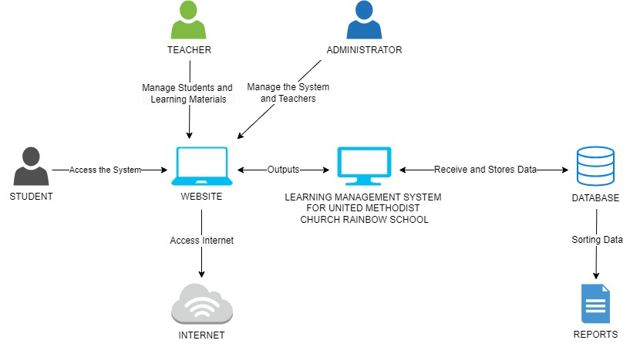

**Figure 1. System Mapping**

The figure 1 system mapping shows the interaction between students, teachers, and administrators with the Learning Management System. The diagram illustrates how users access the website via the internet, with the LMS processing and storing data in a database and producing reports for evaluation. This setup supports a structured and scalable approach to managing education, making learning materials accessible and fostering efficient data handling and reporting.

**Chapter 3**

**METHODOLOGY**

This chapter presented a description of the research selection and description of respondents, research instruments, data collection procedure, and statistical treatments used. It also presented the method, results, and discussion on the development of the system, which the developers used Agile Methodology.

**3.1 Requirement Analysis**

The methodology of the project described the procedures, sources of data, instrumentation and data collection which motives the developer to develop a Learning Management System for Grade 6 students at United Methodist Church Rainbow School. Requirements analysis in system engineering and software engineering refers to the process of identifying the requirements that must be met for a new or modified product or project, taking into account the potentially conflicting requirements of the various stakeholders, as well as the analysis, documentation, validation, and management of software or system requirements. This process considers the potentially conflicting needs of the stakeholders and encompasses the thorough analysis, documentation, validation, and management of system or software requirements. The success or failure of a systems or software project hinges on the outcomes of the requirements analysis. These requirements should be detailed enough to inform system design and must be documented, actionable, measurable, testable, and aligned with

identified business needs or opportunities. It involves determining the anticipated user expectations for a new or updated product, emphasizing specificity, applicability, and measurability.

After the developers gathered the necessary information needed in United Methodist Church Rainbow School, they analyzed the problem and concocted some strategies on how to manage the services efficiently while simultaneously constructing a new idea in developing a new system that aimed to facilitate and improve the manual process of learning management. The developers ensured that they reviewed all the necessary requirements carefully to meet the desired idea for the new system to be developed.

**3.2 Computer Hardware and Software Requirements**

All computer software requires the presence of certain hardware components or other software resources on a computer. These requirements are known as computer system requirements, and they are frequently employed as a guideline rather than an absolute law. Most software typically specifies both minimum and recommended system requirements. These requirements tend to increase over time due to greater demand for enhanced processing power and resources in newer software versions. Industry experts suggest that this trend plays a more significant role than technological advancements in motivating updates to existing computer systems.

The developers carefully outlined the hardware and software requirements that needed to be met in order to meet the expectations for the system. The specification of hardware and software requirements in software deployment allowed the system to perform as intended.

Hardware requirements were statements that specified and dictated the performance of the system to satisfy both clients and system owners. The hardware requirements for the development of Learning Management System for United Methodist Church Rainbow School is important for the development.

***Table 3.1 Hardware Requirements***

|  |  |
| --- | --- |
| Computer Hardware  Components | Computer Software  Specifications |

|  |  |
| --- | --- |
| Operating System | Windows 8 or 10 (64-bit) |
| Screen Size/Resolution | 15.6" Monitor (1920x1080) or larger |
| RAM (Memory) | 4GB RAM or higher |
| Hard Drive | 32 GB or higher (SSD Preferred) |
| Processor | Intel Core i3 or Core i5 |

According to Jact (2020) while it is always recommended that one be using a machine that is fully up to date so as to mitigate any concerns, the operating system, screen size, RAM, etc. must also be compatible with the use of the LMS for the completion of all coursework. Generally, it is highly recommended that the machine must be an Intel Core CPUs like the Core i3 and the Core i5 that will allow for more ability to multitask, considering also the memory to be 4GB RAM or higher and the operating system to be at least windows 8 or 10. These requirements are capable for executing all coursework providing convenience to user as viable for the learning device.

**3.3 Software Requirements for System Development**

A document or set of documentation that describes the features and behavior of a software application. It includes a variety of elements (see below) that attempt to define the intended functionality required by the customer to satisfy their different users. In addition to specifying how the system should behave, the specification also defines (at a high level) the main business processes that will be supported, what simplifying assumptions have been made, and what key performance parameters will need to be met by the system (Inflectra, 2024).

***Table 3.2 Computer Software Requirements***

|  |  |
| --- | --- |
| Computer Software Components | Specification |

|  |  |
| --- | --- |
| Windows operating system | Windows 10 |
| Database | MYSQL |
| Programming Language | js, css, html, php |
| Web Browser | Mozila firefox, edge, chrome |

**3.4 System Framework**

This study aimed to gather data that could be used to answer research questions through qualitative means, focusing on gathering descriptive and subjective information rather than numerical measurements.

The developers used the Scrum methodology. The use of Scrum methodology in developing a Learning Management System (LMS) ensures flexibility and adaptability, allowing the system to evolve with changing educational needs and technologies. It emphasizes user-centered design by involving stakeholders regularly, leading to a more user-friendly product. Agile methodology’s iterative approach integrates early and frequent testing, ensuring higher quality and reliability. Enhanced collaboration and communication among the developer team improve project management, while continuous feedback loops reduce risk by identifying issues early. Agile supports scalable architecture and faster time-to-market through short development cycles and rapid deployment, ultimately delivering a more effective and valuable educational tool.

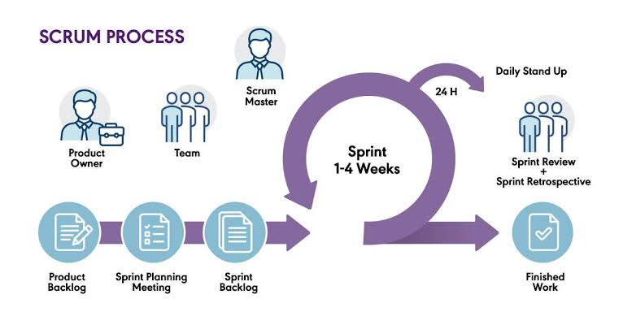

***Figure 3.1 Scrum Methodology***

**Product Backlog.** In the Agile Scrum methodology, the Product Backlog is a prioritized list of features and changes identified by the Scrum team. It contains concise descriptions of all desired functionalities, including sizing, bug fixes, and other details necessary for development. The Product Backlog aligns with the product goal, ensuring the team focuses on achieving specific outcomes and target goals.

All of the requirements of the product are written into a product backlog these requirements are called stories and are used within each sprint. The development team provide time estimates on each of the stories to allow for sprint planning (Welch, 2021).

During these stages, developers use the product backlog to gain a deeper understanding of the system, enhancing communication with the team and stakeholders. They will conduct questionnaires and interviews to gather information about the system’s features.

**Sprint Planning.** During the sprint, which has a predetermined length and sequence of events, the team works towards the product goal. Initially, developers select items from the product backlog for development. These items are then included in sprint planning, a collaborative process involving the product owner and the Scrum team. The layout design must be completed within the sprint, and recommendations and suggestions from interviews will be approved for product development during sprint planning.

The whole team discusses the stories (work) required to ensure understand the brief clearly, prior to starting development. During this, the development team commits to completing the sprint work. Consequently, the amount of work included must be realistic and achievable within the available time (Welch, 2021).

In the sprint planning meeting, developers collaborate with the product owner and Scrum team to discuss the sprint goal and determine the amount of work required to achieve it. User stories are evaluated based on the level of effort needed for development and testing, then prioritized and assigned tasks for inclusion in the Sprint Backlog by the Developer Team.

**Sprint Backlog.** The ongoing progress of the work must align with the developers’ goal to complete their tasks before the sprint ends. Consequently, the sprint backlog can be updated as the team’s understanding and progress evolve.

These events provide clear communication between the development team, project manager and product owner (Welch, 2021).

During the sprint planning phase, developers create a detailed plan for the tasks and review the overall project plan. They recognize the importance of sprint planning in defining the deliverables for the sprint and determining how the work will be accomplished.

**Daily Scrum Meeting.** The daily scrum meeting is a brief session held ideally at the start of the workday, with mandatory participation from all team members contributing to the sprint. Its primary purpose is to enhance team cohesion and synchronize efforts by discussing current tasks. It is not meant for resolving issues; any issues raised are addressed offline to ensure effective communication. The meeting should occur daily, at the same time, and in the same place.

The whole team hold a daily meeting to update everyone on their progress. From this meeting, we glean what each team member did yesterday, what they are doing today, and if they need to raise any issues with the team (Welch, 2021).

The developers review the information and specific topics covered during regular check-ins, aiming to provide valuable feedback and direction. This supports the team in comprehending completed tasks and identifying areas requiring further focus.

**Sprint Retrospective.** In this concluding phase, the focus shifts towards devising strategies to enhance the effectiveness and quality of the product. Consequently, the Scrum Master, Product Owner, and Scrum Team will assess the entirety of data gathered from the product backlog, sprint planning, sprint backlog, increment, and sprint review to chart the course forward. These discussions form the agenda of the sprint retrospective, where the team reflects on successes, areas for improvement, and outlines actionable steps to enhance the product in the upcoming sprint.

At the end of the sprint, the team gets together with the product owner. This is where the developer team demonstrate and discuss the work completed within the sprint. This process provides a platform for continual feedback of the functionality and helps us pick up issues early. The developer team take on board any feedback from the product owner and discuss new stories we need to pick up in future sprints. At the end of the sprint, the team gets together with the product owner. This is where the developer team demonstrate and discuss the work completed within the sprint. This process provides a platform for continual feedback of the functionality and helps pick up issues early. The developer team take on board any feedback from the product owner and discuss new stories we need to pick up in future sprints (Welch, 2021).

In the sprint retrospective, the developers kick-started the session by encouraging all participants to propose actions falling into the categories of start, stop, or continue. This methodology fostered inclusive engagement, with the developers leading the dialogue by prompting each individual to contribute their thoughts on which aspects of the sprint should be initiated, ceased, or sustained.

**3.5 Tools for Data Analysis – Use Case, ERD, Data Dictionary**

The many tools utilize for data analysis were covered in this section of the study. It also offers models for entity connection diagrams and case diagrams that are used to illustrate the workflow of the systems.

**Data Analysis**

Important data were primarily gathered from the Computer Teacher of United Methodist Church Rainbow School. The main respondents for this project were the current grade 6 students of United Methodist Church Rainbow School. Hence, the total number of respondents for this study was 10, which included all the subjects. The respondents were selected through random sampling to ensure their reliability in conducting usability tests. The identities of the respondents were not being revealed for confidentiality purposes. The developers used different data gathering instruments to acquire valuable and relevant information needed for the study. They utilized various methods to obtain the necessary information to complete the study.

**Document Analysis.** Document analysis is essential in academia, journalism, law, and business. It enables individuals to find valuable insights, detect patterns, and derive conclusions from texts ranging from historical manuscripts to contemporary digital documents (John, 2024). The developers underwent a comprehensive analysis of the system’s documents to determine and identify ways to assist and to guide the grade 6 students at United Methodist Church Rainbow School.

**Interview.** An interview is a question-and-answer type of round where a person asks questions, and the other person answers those questions. It can be a one-on-one two-way conversation, or it can be multiple interviewers and multiple participants (Sharma, 2024). The developers interviewed and discussed with the stakeholders and with the clients involved in the study to obtain the necessary data and information to support and strengthen the study. In addition, interviews gave the developers a better response rate than mailed questions, and people who cannot read and write could also answer the questions.

**Internet Sources.** While research was once done primarily in a library, surrounded by books, today, scholars use the internet for a vast majority of their research. There are many different online sources. Some examples include blogs, websites, online articles, online journal articles, and any website a writer could find online. A chat room could even be considered a source! Though most use various sources online, it can still be confusing when thinking about how to cite these sources (Zoeller et al., 2023). The developers used internet websites to gather relevant data and obtain current information and related articles related to academic track selection consultation. Many related studies were found on the internet, which helped the developers to strengthen their points in developing the study.

**Survey.** A survey is a research technique used to collect data from a predetermined sample of respondents to gain information and insights on a variety of topics of interest. They can serve a variety of objectives, and researchers can conduct them in a variety of ways based on the methodology used and the objective of the study (Jun, 2022). The developers utilized surveys to gather information and to avoid biased opinions that might affect the outcome of the study.

**Data Flow Diagram**

A Data Flow Diagram is a visual representation showing how data moves within a process. In process analysis, it is typical to represent the movement of data within a manual process, from input through processing to output. The main objective of a Data Flow Diagram is to illustrate how data is exchanged between various components of a process. The levels of data flow diagrams, such as Level 0 Context Diagram, Level 1 Top Level Diagram, and Level 2 Exploded Diagram, provide a structured perspective of process activities, displaying an overview, main sub-processes, and detailed process interactions in order. The processes represent distinct flow that entails all specified process characteristics. Through the data flow diagram, the complex system over all process can be simplified to be much more decipherable, creating a much more readable environment. The data flow diagram showcases the tasks which the users are tasked to deliver, as well as to elaborate the aspects which will be performed by the users, and the appropriateness of the system process for the system based on all the flowing data that is handled by the users.

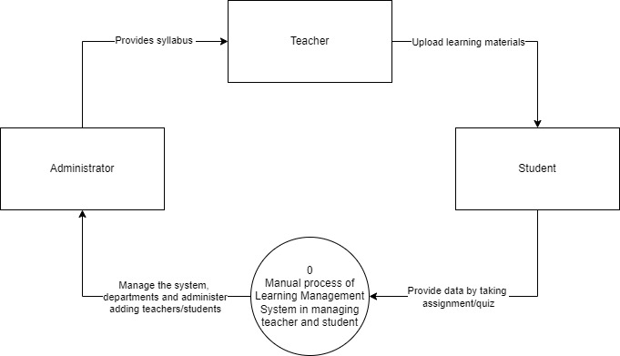

***Figure 3.2 Level 0 Context Diagram***

The manual process illustrated the interactions between the system and its external entities, including Teachers, Students, and Administrators. Teachers provide syllabus and upload learning materials, which are managed by the system. Students interact with the system by submitting assignments and taking quizzes, while Administrators oversee the system’s operations, manage departments, and handle the addition of teachers and students. The LMS processes and manages these interactions to facilitate the efficient delivery of educational content and the tracking of student progress.

The Figure 3.2 Level 0 Context Diagram simplifies the complex interactions within the LMS by representing the entire system as a single process. This high-level view helps stakeholders quickly understand the system’s boundaries and the flow of information, making it easier to grasp the overall functionality without getting bogged down in details.

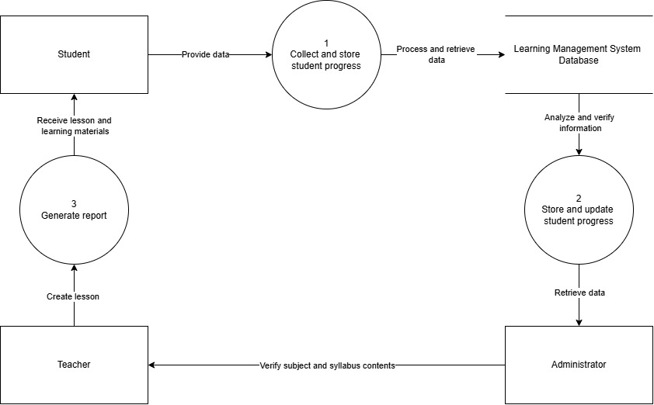

***Figure 3.3 Level 1 Context Diagram***

The Figure 3.3 Level 1 Context Diagram entailed the main system into sub-processes, showing how data flows between these sub-processes and external entities. This illustrates the internal workings of the system and the interactions between its components. Students interact with the system by providing data, such as assignment submissions and quiz answers. This process collects the data provided by students and stores it in the system. Teachers interact with the system by receiving lesson plans and learning materials. This process generates reports based on the data collected and stored, which are then used by teachers to assess student performance. Teachers verify the contents of subjects and syllabi to ensure they are accurate and up to date. Administrators retrieve data from the system to manage and update student progress. This process involved storing and updating the progress of students based on the data retrieved by administrators. Administrators analyse and verify the information to ensure its accuracy and completeness. The database provides learning material data to the system. The database stores the updated progress of students as managed by the system.

The Level 1 context diagram breaks down the main system into specific processes, providing a clearer understanding of how each part of the system functions. [This helps in identifying potential bottlenecks and areas for improvement](https://pulseplots.com/context-diagram-level-0-and-level-1).

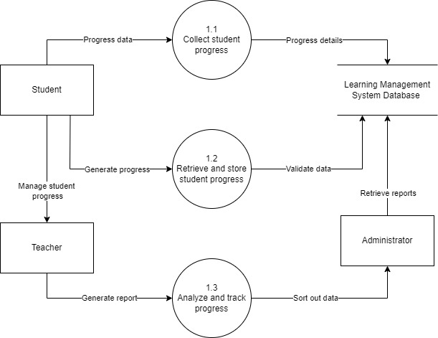

***Figure 3.4 Level 2 Context Diagram***

The Figure 3.4 Level 2 Context Diagram illustrated a detailed view of the system. It breaks down the sub-processes into specific components, showing how data flows between the components and external entities. This helps in understanding the intricate workings of the system and the interactions between its smaller parts. Students provide progress data, such as assignment submissions and quiz results. This process collects the progress data from students and sends the progress details to the Learning Management System Database. Teachers manage student progress by interacting with the system. This process retrieves and stores student progress data, validating it with the Learning Management System Database. Teachers receive reports generated by the system. This process analyzes and tracks student progress, generating reports for teachers. Administrators retrieve reports from the system. This process also involves administrators sorting out data and ensuring its accuracy. The database stores detailed progress data collected from students. The database validates the data retrieved and stored by the system. The database provides reports for administrators to retrieve.

The Level 2 context diagram breaks down the sub-processes into a much specific components, providing a clearer understanding of how each part of the system functions. [This helps in identifying potential bottlenecks and areas for improvement](https://guides.visual-paradigm.com/top-level-dfd-the-power-of-context-diagrams/).

**Use Case Diagram**

The use of a case diagram is one method for summarizing the details of a system and its users. It is typically depicted as a graphical representation of the interactions between various system elements. Use-case diagrams define the events in a system and how they flow, but they do not describe how those events are implemented.

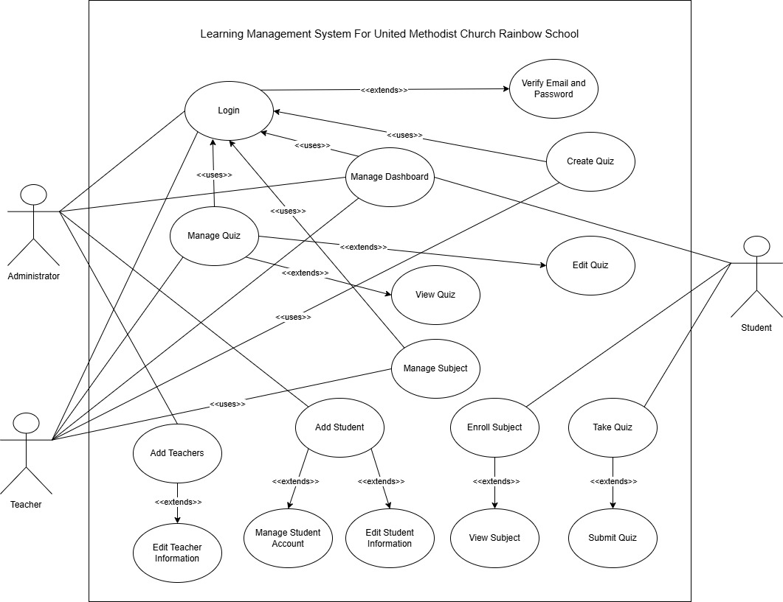

***Figure 3.5 Use Case Diagram***

The Figure 3.5 Use Case Diagram outlined the interactions of teachers and students, as well as the administrator within the system, detailing specific functionalities for each role, such as managing both teachers and students for the administrator, managing subjects and quizzes for teachers, and enrolling in subjects and taking quizzes for students, with clear dependencies and optional actions to ensure comprehensive and user-centric design. The diagram clearly delineates the roles administrator, teacher, student and the interactions with the system, making it easy to understand each role's responsibilities and permissions. The use of extends relationships helps break down complex functionalities like managing quizzes into simpler, more manageable parts, aiding in modular system design. Each role has specific use cases tailored to their needs. For example, administrators have the capability to add and manage teachers and students, ensuring proper user management within the system. Teachers can focus on educational content, such as managing subjects and quizzes, while Students concentrate on engaging with the learning material by taking and submitting quizzes. This separation of concerns ensures that users have access only to the functionalities they need, enhancing both security and usability. The login use case, extended by verify email and password, ensures that only authenticated users can access the system. This is crucial for maintaining the integrity and security of the LMS. Role-specific access further secures sensitive data by restricting functionalities based on user roles, thus preventing unauthorized access to administrative or teacher-specific operations. The use of extends relationships allows for additional functionalities to be easily integrated without disrupting existing operations. For example, new quiz-related functionalities can be added under manage quiz as separate but related actions like view quiz. This modular approach facilitates system maintenance and future enhancements, ensuring the LMS can evolve with changing requirements. The use cases cover essential LMS functionalities, such as user management, quiz management, and subject management, ensuring all critical operations are supported. By capturing the key interactions and workflows within the LMS, the diagram provides a comprehensive overview, ensuring that no critical functionality is overlooked. By clearly defining the interactions and roles, the diagram aids in designing a user-friendly interface. Each role knows exactly what actions they can perform, reducing confusion and improving the overall user experience. The structured approach to managing dashboards and specific functionalities like quizzes and subjects ensures that users can easily navigate and utilize the system. The use case diagram is well-structured and comprehensive. It effectively captures the interactions between different user roles administrator, teacher, student and the system’s functionalities managing quizzes, subjects, and user accounts, ensuring clarity, security, extensibility, and ease of use.

**Entity Relationship Diagram**

The entity relationship diagram is a customized image that depicts the interdependence between entities and databases. It is a representation of the metadata associated with records. Moreover, an entity relationship diagram plays a crucial role in conveying the entire system's structure, enabling developers, analysts, and stakeholders to better understand the flow of data within the system. This holistic view not only aids in database design and optimization but also facilitates effective communication and decision-making throughout the development process. The following entity relationship diagram depicts the relationship between files, volumes, records, and other entities in greater detail. The entity relationship diagram helps elaborate the system whole structure.

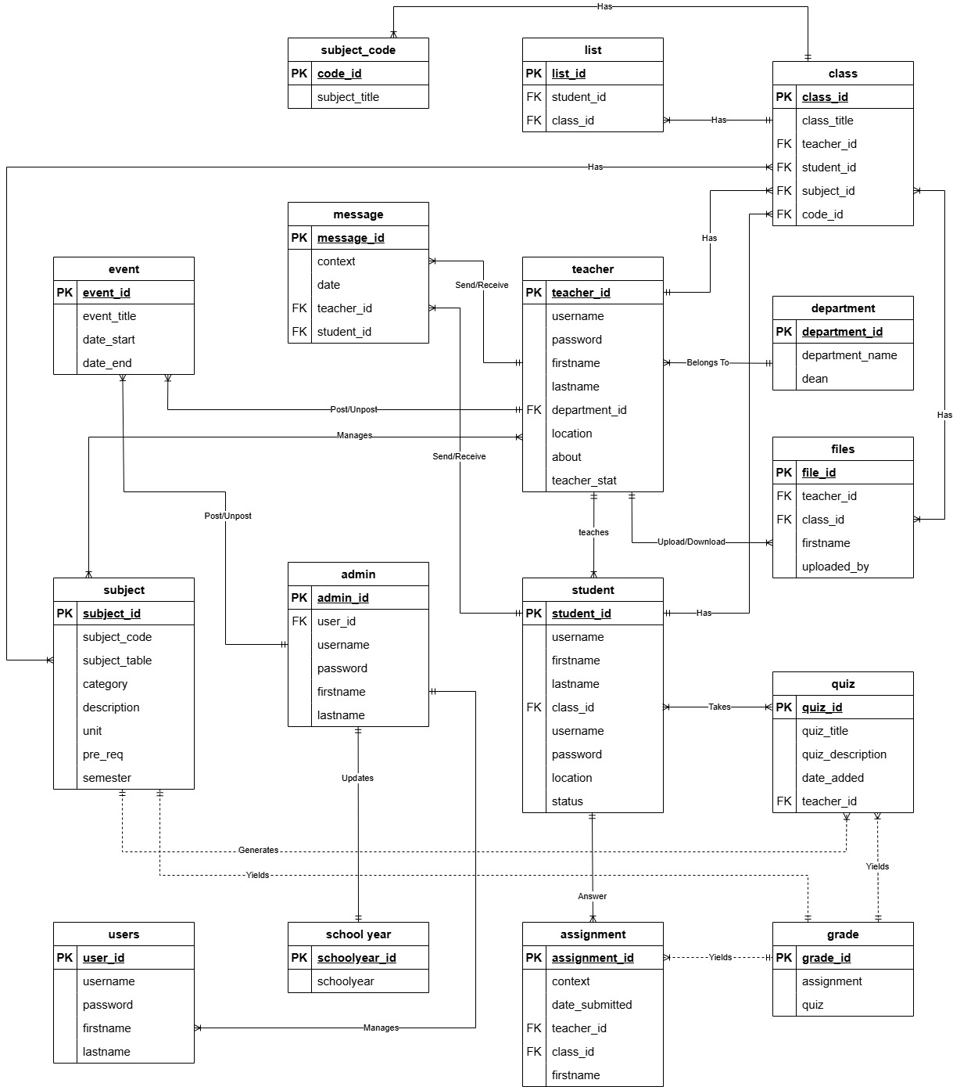

***Figure 3.6 Entity Relationship Diagram***

The Figure 3.6 Entity Relationship Diagram (ERD) represents the key components of the Learning Management System (LMS) such as users, teachers, students, classes, assignments, quizzes, and grades. It outlines the relationships between these entities, allowing for structured management of courses, assessments, communication, and educational data. The system connects students and teachers through classes, tracks student progress via assignments and quizzes, and enables communication and file sharing, ensuring an efficient, centralized approach to managing learning activities.

**Data Dictionary**

A data dictionary is a method of compiling a description of data objects in a data model in order to comprehend what it may contain. It describes the data fields, data types, and responsible values of fields or attributes established in the ERD. A data dictionary is a file or series of files that contain the metadata for a database. The data dictionary contains records about other items in the database, such as data ownership, as well as their relationships to other objects and data.

***Table 3.3 Teacher Table***

|  |  |  |  |  |
| --- | --- | --- | --- | --- |
| **Field Name** | **Data Type** | **Field Length** | **Constraints** | **Description** |
| teacher_id | int | 11 | Primary key | Teacher id, Auto Increment |
| username | varchar | 100 | Not Null | Teacher will login using username |
| password | varchar | 200 | Not Null | Teacher will login using password |
| firstname | varchar | 100 | Not Null | First name of the teacher |
| lastname | varchar | 100 | Not Null | Last name of the teacher |
| department_id | int | 11 | Not Null | Department of the teacher |
| location | varchar | 200 | Not Null | Address of the teacher |
| about | varchar | 500 | Not Null | Teacher information |
| teacher_stat | varchar | 100 | Not Null | Status of the teacher |

The Table 3.3 displayed the specifications regarding the teacher of the system, having the teacher_id as the primary key within the system database. The account information is included for a better access within the system, the status and address are also included for a detailed breakdown of the table.

***Table 3.4 Department Table***

|  |  |  |  |  |
| --- | --- | --- | --- | --- |
| **Field Name** | **Data Type** | **Field Length** | **Constraints** | **Description** |
| department_id | int | 11 | Primary key | Department id, Auto Increment |
| department_name | varchar | 100 | Not Null | Name of the department |
| dean | varchar | 100 | Not Null | Person incharge |

The Table 3.4 displayed the specifications regarding the department of the system, having the department_id as the primary key within the system database. The department information is contained to avoid confusion within the system when accessed, the dean is also included to indicate the person in charge of the department.

***Table 3.5 Subject Table***

|  |  |  |  |  |
| --- | --- | --- | --- | --- |
| **Field Name** | **Data Type** | **Field Length** | **Constraints** | **Description** |
| subject_id | int | 11 | Primary key | Subject id, Auto Increment |
| subject_code | varchar | 100 | Not Null | Subject code |
| subject_table | varchar | 100 | Not Null | Table of the subject |
| category | varchar | 100 | Not Null | Category of the subject |
| description | longtext | 100 | Not Null | Description of the subject |
| unit | int | 100 | Not Null | Unit of the subject |
| Pre-req | varchar | 100 | Not Null | Pre-requisite subject |
| semester | varchar | 100 | Not Null | School semester |
| class_id | int | 11 | Foreign key | Class id |

The Table 3.5 displayed the specifications regarding the subject of the system, having the subject_id as the primary key within the system database. The subject information is contained to avoid confusion within the subject side when accessed, the unit, description, pre-requisite, semester, and class are also included to indicate the specifications within the table.

***Table 3.6 Student Table***

|  |  |  |  |  |
| --- | --- | --- | --- | --- |
| **Field Name** | **Data Type** | **Field Length** | **Constraints** | **Description** |
| Student_id | int | 11 | Primary key | Student id, Auto Increment |
| username | varchar | 255 | Not Null | Student will login using username |
| firstname | varchar | 100 | Not Null | First name of the student |
| lastname | varchar | 100 | Not Null | Last name of the student |
| class_id | int | 11 | Not Null | Class id of the student |
| username | varchar | 100 | Not Null | Username of the student |
| password | varchar | 100 | Not Null | Student will login using  password |
| location | varchar | 100 | Not Null | Address of the student |
| status | varchar | 100 | Not Null | Status of the student |

The Table 3.6 displayed the specifications regarding the student of the system, having the Student_id as the primary key within the system database. The account information is included for a better access within the system, the class, student location or the address, and status are also included for a detailed breakdown of the table.

***Table 3.7 Quiz Table***

|  |  |  |  |  |
| --- | --- | --- | --- | --- |
| **Field Name** | **Data Type** | **Field Length** | **Constraints** | **Description** |
| quiz_id | int | 11 | Primary key | Quiz id, Auto Increment |
| quiz_title | varchar | 50 | Not Null | Quiz title |
| quiz_description | varchar | 100 | Not Null | Description of the quiz |
| date_added | varchar | 100 | Not Null | Date added |
| teacher_id | int | 11 | Not Null | Teacher ID |

The Table 3.7 displayed the specifications regarding the quiz area of the system, having the quiz_id as the primary key within the system database. The quiz information is contained to avoid confusion within the quiz side when accessed, the title, quiz description, date added, and id of the teacher are also included to indicate the specifications within the table.

***Table 3.8 Users***

|  |  |  |  |  |
| --- | --- | --- | --- | --- |
| **Field Name** | **Data Type** | **Field Length** | **Constraints** | **Description** |
| User_id | int | 11 | Primary key | User id, Auto Increment |
| username | varchar | 100 | Not Null | Username of the user |
| password | varchar | 100 | Not Null | Password of the user |
| firstname | varchar | 100 | Not Null | First name of the user |
| lastname | varchar | 100 | Not Null | Last name of the user |

The Table 3.8 displayed the specifications regarding the user of the system, having the User_id as the primary key within the system database. The user account information is included for a better access within the system. All information is indicated to verify and authorize the user access.

***Table 3.9 Admin***

|  |  |  |  |  |
| --- | --- | --- | --- | --- |
| **Field Name** | **Data Type** | **Field Length** | **Constraints** | **Description** |
| admin_id | int | 11 | Primary key | Admin id, Auto Increment |
| user_id | int | 11 | Foreign key | User id |
| username | varchar | 100 | Not Null | Name of the admin |
| password | varchar | 100 | Not Null | Password of the admin |
| firstname | varchar | 100 | Not Null | First name of the admin |
| lastname | varchar | 100 | Not Null | Last name of the admin |

The Table 3.9 displayed the specifications regarding the admin of the system, having the admin_id as the primary key within the system database. The admin account information is included for a better access within the system. All information is indicated to verify and authorize the admin when accessing the system.

***Table 3.10 Class Table***

|  |  |  |  |  |
| --- | --- | --- | --- | --- |
| **Field Name** | **Data Type** | **Field Length** | **Constraints** | **Description** |
| class_id | int | 11 | Primary key | Class id, Auto Increment |
| class_file | varchar | 100 | Not Null | Name of file |
| teacher_id | int | 11 | Foreign key | Teacher id |

The Table 3.10 displayed the specifications regarding the class feature of the system, having the class_id as the primary key within the system database. The class information is contained to avoid confusion within the class side when accessed, the class file, and id of the teacher are also included to indicate the specifications within the table.

***Table 3.11 Event Table***

|  |  |  |  |  |
| --- | --- | --- | --- | --- |
| **Field Name** | **Data Type** | **Field Length** | **Constraints** | **Description** |
| event_id | int | 11 | Primary key | Event id, Auto Increment |
| date_title | varchar | 100 | Not Null | Title of the event |
| date_start | varchar | 50 | Not Null | Starting date of the event |
| date_end | varchar | 50 | Not Null | Ending date of the event |

The Table 3.11 displayed the specifications regarding the event feature of the system, having the event_id as the primary key within the system database. The event information is contained for a seamless update within the event side when accessed.

***Table 3.12 File Table***

|  |  |  |  |  |
| --- | --- | --- | --- | --- |
| **Field Name** | **Data Type** | **Field Length** | **Constraints** | **Description** |
| file_id | int | 11 | Primary key | File id, Auto Increment |
| teacher_id | int | 11 | Foreign key | Teacher id |
| class_id | int | 11 | Foreign key | Class id |
| firstname | varchar | 100 | Not Null | File uploader first name |
| lastname | varchar | 100 | Not Null | File uploader last name |
| uploaded_by | varchar | 100 | Not Null | File uploader |

The Table 3.12 displayed the specifications regarding the file side of the system, having the file_id as the primary key within the system database. The file information is contained to avoid confusion within the file area when accessed, the teacher id, class id, and uploader of the file are also included to indicate the specifications within the table.

***Table 3.13 School Year Table***

|  |  |  |  |  |
| --- | --- | --- | --- | --- |
| **Field Name** | **Data Type** | **Field Length** | **Constraints** | **Description** |
| schoolyear_id | int | 11 | Primary key | School year id, Auto Increment |
| schoolyear | varchar | 50 | Not Null | School year |

The Table 3.13 displayed the specifications regarding the school year feature of the system, having the schoolyear_id as the primary key within the system database. The school year information is contained for a seamless update within the school year side when accessed.

***Table 3.14 Assignment Table***

|  |  |  |  |  |
| --- | --- | --- | --- | --- |
| **Field Name** | **Data Type** | **Field Length** | **Constraints** | **Description** |
| assignment_id | int | 11 | Primary key | Assignment id, Auto Increment |
| context | varchar | 255 | Not Null | Assignment context |
| date_submitted | varchar | 50 | Not Null | Date submitted |
| teacher_id | int | 11 | Foreign key | Teacher id |
| class_id | int | 11 | Foreign key | Class id |
| firstname | varchar | 100 | Not Null | First name |

The Table 3.14 displayed the specifications regarding the assignment feature of the system, having the assignment_id as the primary key within the system database. The class information is contained to avoid confusion within the assignment side when accessed, the assignment context, date submitted, id of the teacher, and id of the class are also included to indicate the specifications within the table.

***Table 3.15 Message Table***

|  |  |  |  |  |
| --- | --- | --- | --- | --- |
| **Field Name** | **Data Type** | **Field Length** | **Constraints** | **Description** |
| message_id | int | 11 | Primary key | Message id, Auto Increment |
| context | varchar | 255 | Not Null | Message context |
| date | varchar | 50 | Not Null | Date received/sent message |
| teacher_id | int | 11 | Foreign key | Teacher id |
| student_id | int | 11 | Foreign key | Student id |

The Table 3.15 displayed the specifications regarding the message side of the system, having the message_id as the primary key within the system database. The message information is contained to avoid confusion within the message area when accessed, the teacher id, student id, context and date uploaded are also included to indicate the specifications within the table.

***Table 3.16 Grade Table***

|  |  |  |  |  |
| --- | --- | --- | --- | --- |
| **Field Name** | **Data Type** | **Field Length** | **Constraints** | **Description** |
| grade_id | int | 11 | Primary key | Grade id, Auto Increment |
| assignment | varchar | 255 | Not Null | Assignment |
| quiz | varchar | 255 | Not Null | Quiz |

The Table 3.16 displayed the specifications regarding the grade side of the system, having the grade_id as the primary key within the system database. The message information is contained to indicate appropriateness within the grade area when accessed, the assignment and quiz are also included to indicate the specifications within the table.

***Table 3.17 Section Table***

|  |  |  |  |  |
| --- | --- | --- | --- | --- |
| **Field Name** | **Data Type** | **Field Length** | **Constraints** | **Description** |
| Section_id | int | 11 | Primary key | Section id, Auto Increment |
| section_title | varchar | 255 | Not Null | Title of the section |
| student_id | int | 11 | Foreign key | Student id |
| teacher_id | int | 11 | Foreign key | Teacher id |

The Table 3.17 displayed the specifications regarding the section side of the system, having the Section_id as the primary key within the system database. The section information is contained to showcase appropriateness within the section area when accessed, the section id, student id, and id of the teacher are also included to indicate the specifications within the table. The structure of the section table provides all the necessary traits for the completeness of a class section.

**Software Used in the System**

The system was created by developers using a variety of programs and software tools. Below are the details of the application:

**PHP.** PHP, short for Hypertext Pre-processor, is an open-source server-side scripting language widely adopted by developers for web development purposes. Additionally, PHP serves as a versatile general-purpose language suitable for various projects, including the creation of Graphical User Interfaces (GUIs) and other applications.

**HTML.** The layout and content of a web page are defined by HyperText Markup Language (HTML), which consists of markup symbols or codes. HTML comprises elements, tags, and attributes that collaborate to identify document sections and provide instructions to browsers on how to render them.

**CSS.** CSS, short for Cascading Style Sheets, is a language used to define the presentation of web pages, encompassing aspects such as colors, layout, and fonts. It enables the customization of presentation across different device types, including large monitors, small screens, and printers. By separating HTML and CSS, it becomes easier to maintain websites, apply consistent styles across pages, and adapt pages for various viewing scenarios.

**Bootstrap.** Bootstrap is a free and open-source front-end development framework utilized for creating websites and web applications. It provides a library of templates and tools aimed at facilitating the responsive development of mobile-first websites.

**MySQL.** MySQL is a relational database management system (RDBMS) that uses the structured query language SQL. It is employed for various purposes including data warehousing, e-commerce, and logging applications. However, its most common use is as a web database.

**XAMPP.** XAMPP is an open-source package providing a web server solution primarily used for testing web applications on a local host server. The name XAMPP stands for Cross-Platform, Apache, MySQL, PHP, and Perl (CPAMP). Developers utilize XAMPP to write and test their code locally before deploying it to a live server.

**3.6 Implementation Plan**

The implementation plan of Learning Management System between the students and instructors were the main goal of the project. The content of the system was adopted to the user’s requirements. The developers were responsible for creating and developing an implementation plan for the development of the system. The developers provided a description of how the information system would be deployed, installed, and turned into a functional system.

Once completed, the table below displayed the suggested Learning Management System deployment method. It described the strategy needed, the tasks performed, the people involved, and the time span for each activity.

***Table 3.18 Implementation Plan***

|  |  |  |  |
| --- | --- | --- | --- |
| STRATEGY | ACTIVITIES | PERSONS INVOLVED | DURATION |

|  |  |  |  |
| --- | --- | --- | --- |
| Approval from  the UMC  Rainbow School | Letter of Approval from  the Developers | Developers, Computer Teacher and UMC Rainbow School President | 1 Hour |
| System’s  Implementation | Installation of the system  and required software  and hardware | Developers, UMCRS Computer Teacher | 5 Hours |
| Information  Distribution | System Manuals | Developers, UMCRS Computer  Teacher | 1 Day |
| 1 Day Training | Training and Lectures of  System Users | Developers,  Instructors, Computer  Teacher and UMCRS President | 1 Day |

The Table 3.18 displayed the specifications regarding the implementation of the plan. The plan information is contained to showcase appropriateness of the strategy to be used, activities to be executed, person involved, and duration of plan are also included to indicate the specifications, as well as detailed plan breakdown. The structure of the implementation plan table provides all the necessary traits for the completeness of concocted plan.

**3.7 Statistical Tool**

This section of the study addressed the study’s population and research setting, which encompassed the location where the study’s data were collected. It also discussed the statistical software employed for data management and analysis in the study.

**Population and Locale of the Study**

This study took place at United Methodist Church Rainbow School, which was located in Mabini Street, San Carlos City, Pangasinan. The study examined how to manage the information and improve the quiz app. It carried out the digital quiz app system in the simplest and most convenient method possible.

**Formula 1** is the technical formula for the weighted mean. In simple terms, the formula can be written as:

Weighted mean = Σ wx/ Σ w

● Σ = summation

● w = the weights

● x = the value

To use the formula:

1. Multiply the numbers in your data set by the weights.

2. Add the numbers in Step 1 up. Set this number aside for a moment.

3. Add up all the weights.

4. Divide the numbers you found in Step 2 by the number you found in

Step 3.

To identify the existing process of a Learning Management System for United Methodist Church Rainbow School, to determine the features of the system in terms of functional and non-functional requirements of the system, and to test the acceptability of the system, the developers used weighted arithmetic mean to determine the average response for each item of the five (5) options in each item in the questionnaires. 5 (Very Satisfied), 4 (Satisfied), 3 (Somewhat Satisfied), 2 (Not Satisfied) and 1 (Very Not Satisfied).

***Table 3.19 Scales and Point in the Instrument***

|  |  |
| --- | --- |
| Scale | Points |

|  |  |
| --- | --- |
| Very Satisfied | 5 |
| Satisfied | 4 |
| Somewhat Satisfied | 3 |
| Not Satisfied | 2 |
| Very Not Satisfied | 1 |

The table 3.9 showed the scales and points to be use in the acceptability test to be conducted on the system. It demonstrates that 5 points is equivalent to very highly satisfied on the questions being ask, 4 points is equivalent to satisfied on the questions being ask, 3 points is equal to neutral on the questions being ask, 2 points is equivalent to not satisfied on the questions being ask, and lastly 1 point is equivalent to very not satisfied on the questions being asked.

**3.8 Network Diagram**

A network diagram visually represents a computer or telecommunications network, illustrating the interconnected components and their interactions. It includes devices such as routers, hubs, firewalls, and other network equipment. The depicted network diagram specifically showcases a wide area network (WAN).

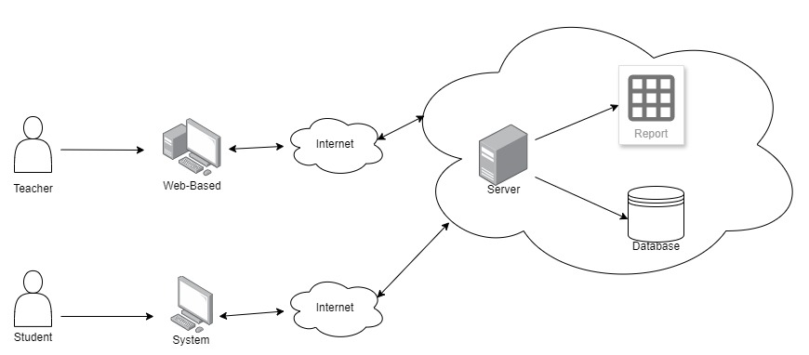***Figure 3.7 Web Network Diagram***

The figure 3.7 network diagram illustrated how teachers and students interact with the system via the internet. Teachers access the LMS through a web-based interface, while students use a system interface. Both connect to the LMS through the internet, which serves as a bridge to the central server. This server is the core of the LMS, handling all user requests, processing data, managing sessions, and ensuring smooth operation. It is connected to a database where all data, including user information, course materials, and grades, is stored. Additionally, the server links to a reporting system that generates various reports, such as performance analytics, grades, and usage statistics. This architecture provides centralized control, making it easier to maintain and update the system. It supports scalability by allowing a large number of users from different locations to access the system without significant performance issues. The database ensures efficient data management, while the reporting system offers valuable insights for administrators. Centralizing the server and database also enhances security by protecting sensitive data from unauthorized access.